THUNDERBOLT™ TECHNOLOGY

Thunderbolt is a revolutionary I/O technology that supports high-resolution displays and high-performance data devices through a single, compact port. It sets new standards for speed, flexibility, and simplicity. And it makes its debut in the new MacBook Pro.
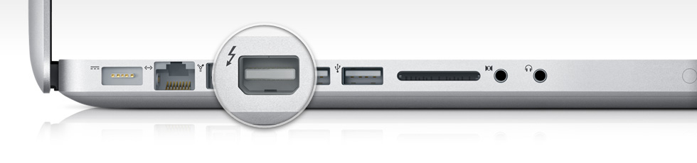

Powerful technology from a powerful collaboration.
Thunderbolt began at Intel Labs with a simple concept: create an incredibly fast input/output technology that just about anything can plug into. After close technical collaboration between Intel and Apple, Thunderbolt emerged from the lab to make its first appearance in MacBook Pro.
Intel co-invented USB and PCI Express, which have become widely adopted technologies for data transfer. Apple invented FireWire and was instrumental in popularizing USB. Their collective experience has made Thunderbolt the most powerful, most flexible I/O technology ever in a personal computer.
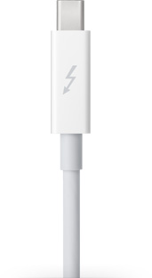

One small port. One giant leap in possibilities.
MacBook Pro now gives you access to a world of high-resolution displays and high-speed peripherals with one compact port. That’s because Thunderbolt is based on two fundamental technologies: PCI Express and DisplayPort.
PCI Express is the technology that links all the high-performance components in a Mac. And it’s built into Thunderbolt. Which means you can connect external devices like RAID arrays and video capture solutions directly to MacBook Pro — and get PCI Express performance. That’s a first for notebooks. Thunderbolt also provides 10 watts of power to peripherals, so you can tackle workstation-class projects on the go. With PCI Express technology, you can use existing USB and FireWire peripherals — even connect to Gigabit Ethernet and Fibre Channel networks — using simple adapters.
And because Thunderbolt is based on DisplayPort technology, the video standard for high-resolution displays, any Mini DisplayPort display plugs right into the Thunderbolt port. To connect a DisplayPort, DVI, HDMI, or VGA display, just use an existing adapter.

Performance and expansion never seen on a notebook before.
Thunderbolt I/O technology gives you two channels on the same connector with 10 Gbps of throughput in both directions. That makes it ultrafast, and ultraflexible. You can move data to and from peripherals up to 20 times faster than with USB 2.0 and more than 12 times faster than with FireWire 800. You also have more than enough bandwidth to daisy-chain multiple high-speed devices, without using a hub or switch. For example, you can connect several high-performance external disks, a video capture device, and even a Mini DisplayPort display to a single Thunderbolt chain while maintaining maximum throughput.

High-Speed I/O Performance
10 Gbps 5 Gbps 0 Gbps
USB 2.0
480 Mbps
FireWire
800
800 Mbps
Express
Card
2.5 Gbps
USB 3.0
5 Gbps
Thunderbolt
10 Gbps

High performance on display.
Thunderbolt I/O technology provides native support for Mini DisplayPort displays. It also supports DisplayPort, DVI, HDMI, and VGA displays through the use of existing adapters. So you can connect your Apple LED Cinema Display or other existing display, along with multiple high-speed devices, all from a single port.

No project is too massive.
Now you can create a professional video setup for your MacBook Pro, just as you would for your Mac Pro. If you’re a video editor, imagine connecting high-performance storage, a high-resolution display, and high-bit-rate video capture devices to handle all the post-production for a feature film — right on your notebook. Thunderbolt I/O technology allows you to daisy-chain up to six new peripherals, such as the Promise Pegasus RAID* or LaCie Little Big Disk,* or five peripherals and an Apple LED Cinema Display.
And that’s just the beginning. With Thunderbolt technology, peripheral manufacturers finally have what they need to take high-performance devices from workstations and top-of-the-line desktops to portable computers.
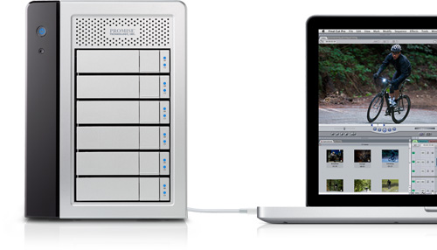

Learn more about Thunderbolt technology. Visit Intel.com

The Fastest Connection To Your PC Experience‡
From the company with the fastest processors comes the fastest way to get information in and out of your PC and peripheral devices.‡ At 10 Gbps, Thunderbolt™ technology gives you great responsiveness with high-speed data and display transfers in each direction—at the same time.‡ With a single cable, connecting a PC to multiple devices is simple, making it easy to get and see what you want, when you want it. Thunderbolt technology gives you incredible flexibility; high performance expansion is just a cable away for new and novel uses, now and in the future.
With the 10 Gbps performance of Thunderbolt products you can
- Transfer a full-length HD movie in less than 30 seconds‡
- Backup 1 year of continuous MP3 playback in just over 10 minutes‡

What is Thunderbolt technology and how does it work
Developed by Intel (under the code name Light Peak), and brought to market with technical collaboration from Apple. Thunderbolt technology is a new, high-speed, dual-protocol I/O technology designed for performance, simplicity, and flexibility. This high-speed data transfer technology features the following:
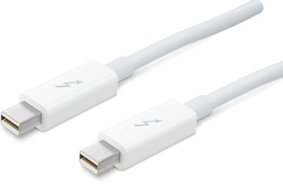
- Dual-channel 10 Gbps per port
- Bi-directional
- Dual-protocol (PCI Express* and DisplayPort*)
- Compatible with existing DisplayPort devices
- Daisy-chained devices
- Electrical or optical cables
- Low latency with highly accurate time synchronization
- Uses native protocol software drivers
- Power over cable for bus-powered devices
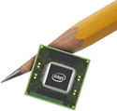
Intel's Thunderbolt controllers interconnect a PC and other devices, transmitting and receiving packetized traffic for both PCIe and DisplayPort protocols. Thunderbolt technology works on data streams in both directions, at the same time, so users get the benefit of full bandwidth in both directions, over a single cable. With the two independent channels, a full 10 Gbps of bandwidth can be provided for the first device, as well as additional downstream devices.
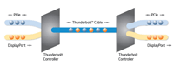
View the full image >
And all Thunderbolt devices share a common connector, allowing users to daisy chain devices one after another with interoperable cables.

What Thunderbolt means to users
Thunderbolt technology enables using the thinnest and lightest laptops and connecting to the extra power and performance of other devices when needed, using a single cable. Adding new performance devices is simple and easy—just plug and play—making Thunderbolt technology powerful and flexible.
Thunderbolt technology was specifically designed with professional audio and video applications in mind, where the inherently low latency and highly accurate time synchronization features play a crucial role.
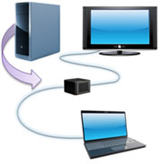
Workstation performance expansion, now with a laptop
With Thunderbolt enabled products, video editing and sharing using Intel® Quick Sync Video technology is even faster and easier.
Data transfers for backup, sharing, and editing are tremendously accelerated using Thunderbolt products, significantly reducing times to complete these tasks.
And Thunderbolt enabled products are compatible with existing DisplayPort devices so you don’t have to go buy a new display to take advantage of a Thunderbolt technology enabled computer.

What does Thunderbolt technology mean for the PC industry
By tapping into the performance and protocols delivered over Thunderbolt technology, designers are free to innovate new PC products and configurations, no longer constrained to the boundaries of the chassis walls. Thunderbolt technology enables engineers to:
- Design standalone performance expansion technologies commonly used in desktops and workstations, using existing native device drivers and interconnected by a single cable.
- Introduce thinner and lighter laptops, expandable through Thunderbolt technology and its miniature connector designed for mobile applications, without sacrificing I/O performance.
- Extend to reach other I/O technologies by using adapters that use widely available PCI Express controllers. It's simple to create a Gigabit Ethernet, or FireWire, or eSATA adapters using existing device PCI Express drivers.
Thunderbolt products require a controller chip supplied by Intel and a small connector that would be included in platforms supporting this technology. The Thunderbolt controller chip provides protocol switching capabilities to support the two protocols over a single cable. Intel is making its controller chip available to the industry, and is working with other component manufacturers to deliver the Thunderbolt connectors and cables.

Industry Support
Several innovative companies have announced Thunderbolt enabled products, or plans to support Thunderbolt in upcoming products including Apple Inc., Promise Technology, Inc., and LaCie. Intel is working with the industry to enable a variety of Thunderbolt enabled products including computers, displays, high speed data storage devices, audio/video devices, and more.
"We're thrilled to collaborate with Intel to bring the groundbreaking Thunderbolt technology to Mac users," said Bob Mansfield, Apple's senior vice president of Mac Hardware Engineering. "With ultra-fast transfer speeds, support for high-resolution displays and compatibility with existing I/O technologies, Thunderbolt is a breakthrough for the entire industry and we think developers are going to have a blast with it."
– Bob Mansfield, Senior Vice President of Mac Hardware Engineering, Apple Inc.
"Welcome to the future, Thunderbolt technology enables the fastest and simplest I/O for connecting AJA's award-winning professional video capture and playback products to your laptop."
– John Abt, CEO, AJA
"Thunderbolt technology is connectivity without compromise and will enable the full promise of Symphony I/O, Apogee's professional digital audio recording platform."
– Betty Bennett, CEO, Apogee
"We are very excited by the capabilities of Thunderbolt technology. To have two 10Gbps, bi-directional, multi-protocol channels in a single cable is a great step forward for high performance audio and video solutions."
– Max Gutnik, Sr. Director, Product Management, Avid Technology
"Thunderbolt technology will revolutionize mobile media creation. It's a game-changer and will accelerate our ability to build the highest quality video creation products that are affordable to everyone."
– Grant Petty, CEO, Blackmagic
"We are excited about Thunderbolt™ technology and feel it will bring new levels of performance and simplicity to the video creation market"
– Hiroo Edakubo, Group Executive, Video Products Group, Canon Inc.
"Thunderbolt technology is a breakthrough in I/O technology and represents the future of mobile computing. Soon you will be able to carry all the power and functionality of desktop environments in compact devices."
– Philippe Spruch, Chairman and General Manager, LaCie
"Pegasus family storage products will be blazingly fast with Thunderbolt technology, consumers and creative professionals alike will experience a remarkable leap in performance."
– James Lee, CEO, Promise Technology
"Technology like this only happens about once a decade. We are thrilled about the performance and simplicity Thunderbolt technology will bring to our award-winning UAD Powered Plug-Ins platform."
– Bill Putnam, CEO, Universal Audio
"Western Digital believes Thunderbolt technology will bring both new performance levels and simpler connectivity for consumers to access and enjoy their digital media in new and innovative ways."
– Dale Pistilli, VP Marketing, Branded Products, Western Digital Corporation

