Chapter 1
- INTRODUCTION
Can we just imagine of having a TV which can be rolled up? Would we not like to be able to read off the screen of our laptop in direct sunlight? Or our mobile phone battery to last much longer? Or our next flat screen TV to be less expensive, much flatter, and even flexible? Well, now it is possible by an emerging technology based on the revolutionary discovery that, light emitting; fast switching diode could be made from polymers as well as semiconductors.
We know ordinary LED emits light when electric current is passed through. Organic displays use a material with self luminous property that eliminates the need of a back light. These result in a thin and compact display. While backlighting is a crucial component to improving brightness in LCDs, it also adds significant cost as well as requires extra power. With an organic display, your laptop might be less heavy to carry around, or your battery lasts much longer compared to a laptop equipped with a traditional LCD screen.
An organic light emitting diode (OLED) is simply a light emitting diode (LED) whose emissive electro luminescent layer is composed of a film of organic compounds. The layers are made up of small organic molecules or macro polymers that conduct electricity. They have conductivity levels ranging from insulators to conductors, so OLEDs are considered as organic semiconductors. The layer of organic semiconductor material is formed between two electrodes, where at least one of the layers is transparent.
Thus, OLEDs are optoelectronic devices based on small molecules or polymers that emit light when an electric current flows through them. Simple OLED consists of a fluorescent organic layer sandwiched between two metal electrodes. Under application of an electric field, electrons and holes are injected from the two electrodes into the organic layer, where they meet and recombine to produce light. They have been developed for applications in flat panel displays that provide visual imagery that is easy to read, vibrant in colors and less consuming of power.
A screen based on PolyLEDs has obvious advantages: the screen is lightweight and flexible, so that it can be rolled up. With plastic chips you can ensure that the electronics driving the screen are integrated in the screen itself. One big advantage of plastic electronics is that there is virtually no restriction on size.
Research and development in the field of OLED is proceeding rapidly and may lead to future applications in heads-up displays, automotive dashboards, billboard-type displays, mobile phones, television screen, home and office lighting and flexible displays.

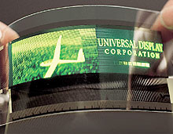
FIG: An OLED Display Panel.

Chapter 2
- DESIGN

  - Brief History
The figure below briefly explains about the different phases and periods of development of OLED along with different research institutes that developed them.
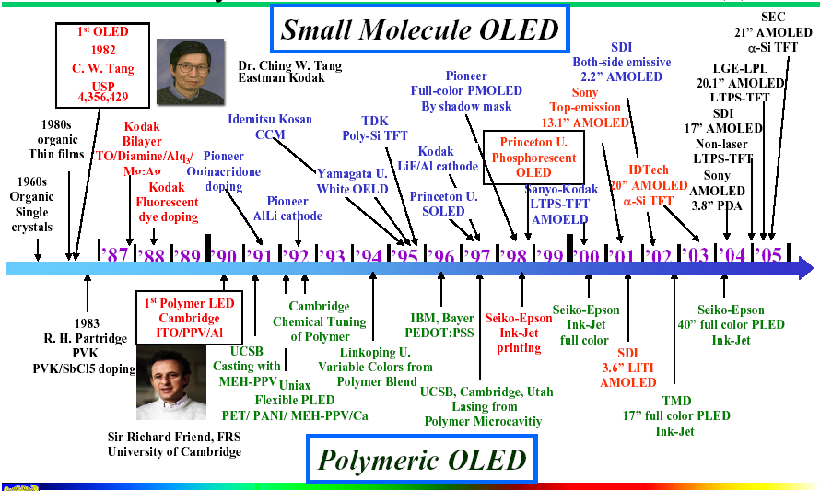
In the late 1970s Eastman Kodak Company scientist Dr. Ching Tang discovered that sending an electrical current through a carbon compound caused these materials to glow. Dr. Tang and Steven Van Slyke continued research in this vein.
In 1987, they reported OLED materials that become the foundation for OLED displays produced today. The first color they discovered in this early OLED research was green.
As early as 1989, the Kodak research team demonstrated color improvements using fluorescent dyes, or dopants, to boost the efficiency and control of color output.

  - Structure
It consists of an emissive layer, a conductive layer, a substrate, and both anode and cathode terminals. The emissive layer, where light is made by the emission of radiation whose frequency is in the visible region is made up of organic plastic molecules that transport electrons from the cathode and the polymer used is polyfluorene.
The conductive layer is made up of organic plastic molecules that transport holes from the anode and the conducting polymer used is polyaniline. The substrate that supports OLED is made up of flexible plastic, inexpensive glass or metal foil. Anode, that removes electrons when a current flows through the device, is generally made up of Indium tin oxide and it is transparent and cathode that injects electrons when a current flows through the device is made up of metals like aluminium and calcium, which may or may not be transparent depending on the type of OLED.

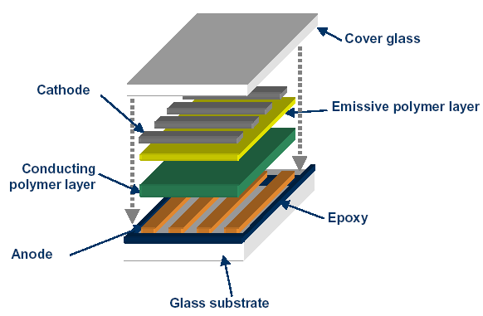
FIG: Showing OLED Structure.
  - Light Emission Principle
OLEDs emit light in a similar manner to LEDs, through a process called electro-phosphorescence. An electrical current flows from the cathode to the anode through the organic layers. When a voltage is applied to OLED, the holes and the electrons are generated from each of the two electrodes, which have a positive and negative electric charge respectively. When they recombine in the emissive layer, organic materials make the emissive layer to turn into a high energy state termed “excitation”. The light is emitted when the layer returns to its original stability. The molecular structure of organic materials has limitless combinations, each of which varies in its color and durability. Within these limitless combinations, identifying organic materials that provide high efficiency and long life will determine its practical application.
A semi-conducting material such as silicon has an energy gap between its lower, filled electrons state called as valence band and its upper, unfilled electrons state called as conduction band. As electrons drop to the lower state and occupy holes, photons of visible light are emitted. The color of the light depends on the type of organic molecule in the emissive layer and the intensity or brightness of the light depends on the amount of electrical current applied.
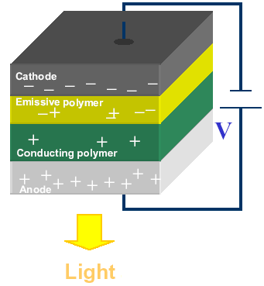
FIG: Showing Light Emission Principle.

  - Creation of Color
OLED has more control over color expression because it only expresses pure colors when electric current stimulates the relevant pixels. The primary color matrix is arranged in red, green and blue pixels which are mounted directly to a printed circuited board. Each individual OLED element is housed in a special micro cavity structure designed to greatly reduce ambient light interference that also improves overall color contrast. The thickness of the organic layer is adjusted to produce the strongest light to give a color picture. Further, the colors are refined with a filter and purified without using a polarizer to give outstanding color purity.
The color of the light depends on the type of organic molecule in the emissive layer. Manufacturers place several types of organic films on the same OLED to make color displays. The intensity or brightness of the light depends on the amount of electrical current applied. The more the current, the brighter is the light. The structure of pixel created is shown below.

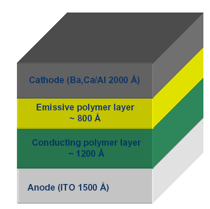
FIG: Showing structure of a Pixel in OLED.

  - Types of OLED
- Passive-matrix OLED
- Active-matrix OLED
- Transparent OLED
- Top-emitting OLED
- Foldable OLED
- White OLED

    - Passive-Matrix OLED
PMOLEDs have strips of cathode, organic layers and strips of anode. The anode strips are arranged perpendicular to the cathode strips. The intersections of the cathode and anode make up the pixels where light is emitted. External circuitry applies current to selected strips of anode and cathode, determining which pixels get turned on and which pixels get turned off. The brightness of each pixel is proportional to the amount of applied current. PMOLEDs are easy to make, but they consume more power than other types of OLED, mainly due to the power needed for the external circuitry. They are most efficient and are used in cell phones, PDAs and MP3 players.
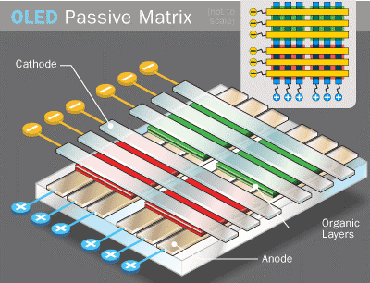
FIG: Showing PMOLED.
    - Active-matrix OLED
AMOLEDs have full layers of cathode, organic molecules and anode, but the anode layer overlays a thin film transistor (TFT) array that forms a matrix. The TFT array itself is the circuitry that determines which pixels get turned on to form an image.
AMOLEDs consume less power than PMOLEDs because the TFT array requires less power than external circuitry, so they are efficient for large displays. They are used in computer monitors, large-screen TVs and electronic signs or billboards. The life expectancy of it is 30,000 hours.
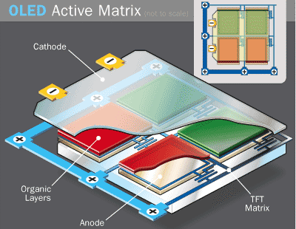
FIG: Showing AMOLED.

    - Transparent OLED
Transparent OLEDs have only transparent components that are substrate, cathode and anode. When turned off, they are 85% as transparent as their substrate. When a transparent OLED display is turned on, it allows light to pass in both directions. This can be either active or passive matrix. This technology can be used for heads-up displays.
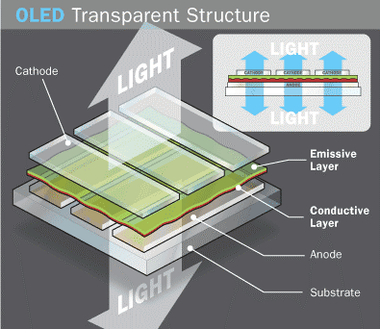
FIG: Showing Transparent OLED.

    - Top-emitting OLED
Top-emitting OLEDs have a substrate that is either opaque or reflective. The top-emitting OLED display includes providing a handling substrate. A composite layer is formed on the handling substrate. An organic light emitting unit is formed on the composite layer. A top electrode is formed on the organic light emitting unit. A reflective type display and fabrication method thereof is provided. The reflective type display includes providing a handling substrate. A composite layer is formed on the handling substrate; a thin film transistor array is formed on the composite layer. These displays are used in smart cards. The efficiency is 500 cd/m² and the life span is 17,000 hours.
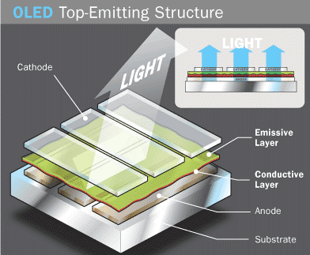
FIG: Showing Top-emitting OLED.
    - Foldable OLED
Foldable OLEDs have substrates made of very flexible metallic foils or plastics. They are very light-weight and durable. Their use in devices such as cell phones and PDAs can reduce breakage, a major cause for return or repair. Potentially, these displays can be attached to fabrics to create smart clothing, such as outdoor survival clothing with an integrated computer chip, cell phone, GPS receiver and OLED display sewn into it. They are less breakable and more impact resistant, than other displays. With glass breakage a major cause of display-containing product returns, this is a highly desirable commercial alternative. They are very flexible. Such displays may be made to bend, flex and conform to many surfaces. The luminance is 200cd/m².
FIG: Showing Foldable OLED.
    - White OLED
White OLEDs emit white light that is brighter, more uniform and more energy efficient than that emitted by fluorescent lights. They also have the true-color qualities of incandescent lighting. They can replace fluorescent lights that are currently used in homes and buildings because they can be made in large sheets. Their use could potentially reduce energy costs for lighting. Its efficiency is 90lm/W at a brightness of 1000cd/m².
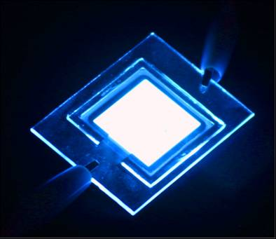
FIG: Showing White OLED.
Chapter 3
- IMPLEMENTATION AND CODE
In modern era there are various fields in which displays are used and moreover if they are light and flexible then that’s the one immediately needed. OLED not only provides both these facilities but there are additional too some of them like brighter and clearer displays, flexible so easily portable etc. Some of the applications in modern day are discussed below.
  - Applications
- Due to its light-weight, they can be used in cellular phones, PDAs, notebooks, digital cameras, DVD players, car stereos, televisions, etc.
- They can be used as solid-state light sources.
- In heads-up displays, automotive dashboards, billboard-type displays, home and office lighting and flexible displays.
- Due to its faster response than LCDs almost 1000 times faster, a device with an OLED display could change information almost in real time.
- In video images for more realistic and constant updates.
Light sources made from organic materials are of immense potential value for a range of applications. Large area, flat light sources with surface brightness have potential applications such as space lighting, back lighting or advertising displays. Organic light emitting devices (OLEDs) offer the potential for such a source. OLEDs promise a cheap, light weight source which potentially can be made any size and on to a range of substrates (including flexible plastic).
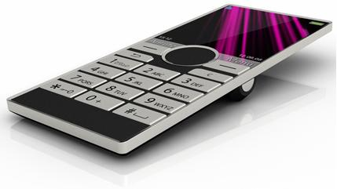
FIG: A Mobile Phone with OLED Display.

Samsung applications
In January 2005, Samsung announced the world's largest OLED TV at the time, at 21 inches (53 cm).^{[1]} This OLED featured the highest resolution at 2.3 million pixels (WUXGA: widescreen ultra-extended graphics array) at the time. In addition, the company adopted AM-based technology for its low power consumption and high-resolution qualities.
In January 2008, Samsung showcased the world's largest and thinnest OLED TV at the time, at 31-inches and 4.3 mm.^{[2]}
In May 2008, Samsung unveiled an ultra-thin 12.1 inch laptop OLED display concept, with a 1,280×768 resolution with infinite contrast ratio.^{[3]} According to Woo Jong Lee, Vice President of the Mobile Display Marketing Team at Samsung SDI, the company expects OLED displays to be used in notebook PCs as soon as 2010.^{[4]}
In October 2008, Samsung showcased the world's thinnest OLED display, also the first to be 'flappable' and bendable.^{[5]} It measures just 0.05 mm (thinner than paper), yet a Samsung staff member said that it is "technically possible to make the panel thinner".^{[6]} To achieve this thickness, Samsung etched an OLED panel that uses a normal glass substrate. The drive circuit was formed by low-temperature polysilicon TFTs. Also, low-molecular organic EL materials were employed. The pixel count of the display is 480 × 272. The contrast ratio is 100,000:1, and the luminance is 200cd/m². The color reproduction range is 100% of the NTSC standard.
In October 2008, Samsung unveiled the world's largest OLED Television at 40-inch with a Full HD resolution of 1920×1080 pixel.^{[7]} In the FPD International, Samsung stated that its 40-inch OLED Panel is the largest size currently possible. The panel has a contrast ratio of 1,000,000:1, a color gamut of 107% NTSC, and a luminance of 200cd/m² (peak luminance of 600cd/m²).
At the Consumer Electronics Show (CES) in January 2010, Samsung demonstrated a laptop computer with a large, transparent OLED display ^{[8]} and an animated OLED display in a photo ID card.^{[9]}

Sony applications
In 2004, Sony released the Sony CLIÉ PEG-VZ90, the first commercial device to feature an OLED screen, and in 2006, Sony introduced the MZ-RH1 Portable Minidisc Recorder, which has an OLED screen.^{[10]}
At the Las Vegas CES 2007, Sony showcased 11-inch (28 cm, resolution 960×540) and 27-inch (68.5 cm, full HD resolution at 1920×1080) OLED TV models.^{[11]} Both claimed 1,000,000:1 contrast ratios and total thicknesses (including bezels) of 5 mm. In April 2007, Sony announced it would manufacture 1000 11-inch OLED TVs per month for market testing purposes.^{[12]} On October 1, 2007, Sony announced that the 11-inch model, now called the XEL-1, would be released commercially;^{[1]} the XEL-1 was first released in Japan in December 2007.^{[13]}
In May 2007, Sony publicly unveiled a video of a 2.5-inch flexible OLED screen which is only 0.3 millimeters thick.^{[14]}At the CES 2008, Sony showcased the Walkman X series with 3” OLED touchscreen.^{[15]}
In April 2008, at "Display 2008", Sony showed a 0.2 mm (0.0079 inch) thick 3.5 inch display with a resolution of 320×200 pixels and a 0.3 mm thick 11 inch display with 960×540 pixels resolution (one-tenth the thickness of the XEL-1).^{[16][17]}
In July 2008, a Japanese government body said it would fund a joint project of leading firms, which is to develop a key technology to produce large, energy-saving organic displays. The project involves one laboratory and 10 companies including Sony Corp. NEDO said the project was aimed at developing a core technology to mass-produce 40 inch or larger OLED displays in the late 2010s.^{[18]}
In October 2008, Sony has published results of research it carried out with the Max Planck Institute over the possibility of mass-market bending displays, which could replace rigid LCDs and plasma screens. Eventually, bendable, transparent OLED screens could be stacked to produce 3D images with much greater contrast ratios and viewing angles than existing products.^{[19]}
  - Code
#include<stdio.h>
#include<stdlib.h>
#include<conio.h>
#include<string.h>
#include<dos.h>
#include<graphics.h>
void main()
{char mess[]="0010 10110011 01010 01011 011010";
clrscr();
textmode(C80);
_setcursortype(_NOCURSOR);
randomize();
double i;
int j,k,x[80],chan=500,len;
len=strlen(mess);
for(i=0;i<80;i++)
x[i]=-(len);
i=1;
do
{clrscr();
// if(i/100==1)chan--;
for(j=0;j<80;j++)
{if(x[j]==-(len)){if(random(chan)==0)x[j]=-(len)+1;}
}
for(j=0;j<80;j++)
{if(x[j]!=-(len))
{for(k=strlen(mess)-1;k>=0;k--)
{gotoxy(j+1,x[j]+k);
if(k==strlen(mess)-1)textcolor(15);
else textcolor(2);
if(x[j]+k<26&&x[j]+k>0)cprintf("%c",mess[k]);
}
}
}
delay(50);
for(j=0;j<80;j++)
{if(x[j]!=-(len))x[j]++;
if(x[j]==25)x[j]=-(len);
}
i++;
}while(!kbhit());
}

Chapter 4
- RESULTS AND DISCUSSION
  - Screenshot

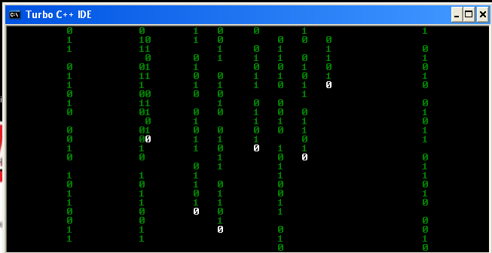
FIG: Showing Screenshot of a display program in C++ depicting working of OLED.

As in the case of above screenshot the digits drop down to take place of the other or if none present then show itself, in the similar fashion in an OLED display takes place.
A semi-conducting material such as silicon has an energy gap between its lower, filled electrons state called as valence band and its upper, unfilled electrons state called as conduction band (here a 0 between two 1). As electrons drop to the lower state and occupy holes, photons of visible light are emitted (1 comes down to fill the 0). When a voltage is applied to OLED, the holes and the electrons are generated from each of the two electrodes, which have a positive and negative electric charge respectively. When they recombine in the emissive layer, organic materials make the emissive layer to turn into a high energy state termed “excitation”. The light is emitted when the layer returns to its original stability.

  - Discussions
A simple comparison with existing lighting systems will serve the purpose of discussion.
 | OLED lighting | Incandescent light bulbs | Fluorescent lamps | LED
Illustration |  |  | 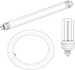
Principle of light emission | Emits light by applying a voltage to organic matter | Emits light by sending an electric current to a metallic filament | Ultraviolet rays generated by an electric current collide with fluorescent material to produce visible light | Emits light by applying a voltage to an inorganic semiconductor
Characteristics | Illuminates large area (surface light source)  Energy efficient  Low heat-generation  Slim, lightweight  Flexible (when plastic substrate used)  Environmentally sound | Illuminates small area (point light source)  High power consumption  High heat-generation  Closely approximates natural light | Size of area illuminated is between point light source and surface light source (linear light source)  Energy efficient  Uses hazardous substance (mercury) | Illuminates small area (point light source)  Energy efficient  Long life  Easy to reduce size  Environmentally sound
Uses | Applications include living spaces, offices, decorative illumination, car interior lighting, | Photographic lighting, living spaces such as dining rooms or bedrooms, etc. | Living spaces, offices, commercial premises, etc. | Indirect lighting, floor level lighting, spotlights for retail spaces, etc.
    - Advantages

- OLEDs are thinner, lighter and more flexible than the crystalline layers in an LED or LCD. The plastic, organic layers of an OLED are 100 to 500 nanometres thick or about 200 times smaller than a human hair.
- They are brighter than LEDs because the organic layers of an OLED are much thinner than the corresponding inorganic crystal layers of an LED. Also they do not require glass for support which absorbs some light.
- It has ability to emit light from a surface, low heat generation, and environmentally sound compared to fluorescent lamps.
- They do not require backlighting like LCDs as they generate light themselves, so they consume much less power than LCDs.
- They are easier to produce and can be made to large sizes because they are essentially plastics, which can be made into large, thin sheets.
- They can enable a greater artificial contrast ratio that is measured in purely dark conditions and have better viewing angle compared to LCDs because OLED pixels directly emit light.
- They have a faster time response than standard LCD screens.

    - Disadvantages

- Limited lifetime of the organic materials. While red and green OLED films have longer lifetimes, blue organics currently have much shorter lifetimes. However, the lifespan of OLED displays can be increased by improving light outcoupling.
- The intrusion of water into displays can damage the organic materials and limit the longevity of more flexible displays. Therefore, improved sealing processes are important for practical manufacturing.
- The fabrication of the substrate is complex and expensive process in the production of TFT LCD, so flexible substrates such as roll-up displays and displays embedded in fabrics or clothing can be used.

Chapter 5
- CONCLUSION AND FUTURE ENHANCEMENTS

Performance of organic LEDs depend upon many parameters such as electron and hole mobility, magnitude of applied field, nature of hole and electron transport layers and excited life-times. Organic materials are poised as never before to transform the world IF circuit and display technology. Major electronics firms are betting that the future holds tremendous opportunity for the low cost and sometimes surprisingly high performance offered by organic electronic and optoelectronic devices.

Further research and development in the field of OLEDs may lead to future applications in heads up displays, automotive dash boards, billboard type displays etc. Because OLEDs refresh faster than LCDs, a device with OLED display could change information almost in real time. Video images could be much more realistic and constantly updated.

Organic Light Emitting Diodes are evolving as the next generation of light sources. Presently researchers have been going on to develop a 1.5 emitting device. This wavelength is of special interest for telecommunications as it is the low-loss wavelength for optical fiber communications. Organic full-color displays may eventually replace liquid crystal displays for use with lap top and even desktop computers. Researches’ are going on, on this subject and it is sure that OLED will emerge as future solid state light source.

Chapter 6
- BIBLIOGRAPHY AND REFERENCES
  - Bibliography

- 1B.W. D’Andrade and S.R. Forrest, Adv. Mater. 16, 1585 (2004).
- 2 J. Thompson, R.I.R. Blyth, M. Anni, G. Gigli and R.Cingolani, Appl. Phys. Lett.,79, 560 (2001).
- 3 Y. Sun, N. Giebink, H. Kanno, B. Wa, M. Thompson, S. Forrest, Nature 440, 908 (2006).
- 4 G. Li and J. Shinar, Appl. Phys. Lett. 83, 5359 (2003).
- 5 K. O. Cheon and J. Shinar Appl. Phys. Lett. 81, 1738 (2002).
- 6 T. Tsuji, S. Naka, H. Okada and H. Onnagawa, Appl. Phys. Lett., 81, 3329 (2002).
- 7 W. Xie, Z. Wu, S. Liu and S. T. Lee, J. Phys. D. 36, 2331 (2002).
- 8 C.W. Tang, S. VanSlyke, C.H. Chen, J.Appl.Phys. 65, 3610 (1989)

  - References

- [1] "World's Largest 21-inch OLED for TVs from Samsung". Physorg.com. 2005-01-04. http://www.physorg.com/news2547.html. Retrieved 2009-08-17.
- [2] Robischon, Noah (2008-01-09). "Samsung's 31-Inch OLED Is Biggest, Thinnest Yet — AM-OLED". Gizmodo. http://gizmodo.com/342912/samsungs-31+inch-oled-is-biggest-thinnest-yet. Retrieved 2009-08-17.
- [3] Ricker, Thomas (2008-05-16). "Samsung's 12.1-inch OLED laptop concept makes us swoon". Engadget.com. http://www.engadget.com/2008/05/16/samsungs-12-1-inch-oled-laptop-makes-us-swoon/. Retrieved 2009-08-17.
- [4] "Samsung: OLED Notebooks In 2010 - Laptop News". TrustedReviews. http://www.trustedreviews.com/notebooks/news/2008/12/03/Samsung--OLED-Notebooks-In-2010/p1. Retrieved 2009-08-17.
- [5] ª ^{b} Takuya Otani, Nikkei Electronics (2008-10-29). "[FPDI] Samsung Unveils 0.05mm 'Flapping' OLED Panel — Tech-On!". Techon.nikkeibp.co.jp. http://techon.nikkeibp.co.jp/english/NEWS_EN/20081029/160349/. Retrieved 2009-08-17.
- [6] "40-inch OLED panel from Samsung". Hdtvinfo.eu. 2008-10-30. http://www.hdtvinfo.eu/news/hdtv-articles/40-inch-oled-panel-from-samsung.html. Retrieved 2009-08-17.
- [7] "Samsung presents world's first and largest transparent OLED laptop at CES". http://www.thedesignblog.org/entry/samsung-presents-worlds-first-and-largest-transparent-oled-laptop-at-ces/. Retrieved 2010-01-09.
- [8] "CES: Samsung shows OLED display in a photo card". http://ces.cnet.com/8301-31045_1-10429565-269.html. Retrieved 2010-01-09.
- [9] "MD Community Page: Sony MZ-RH1". Minidisc.org. 2007-02-24. http://www.minidisc.org/part_Sony_MZ-RH1.html. Retrieved 2009-08-17.
- [10] "Sony announces a 27-inch OLED TV". HDTV Info Europe. 2008-05-29. http://www.hdtvinfo.eu/news/hdtv-articles/sony-announces-a-27-inch-oled-tv.html. Retrieved 2009-08-17.
- [11] CNET News, Sony to sell 11-inch OLED TV this year, April 12, 2007, retrieved on July 28, 2007.
- [12] Engadget, The Sony Drive XEL-1 OLED TV: 1,000,000:1 contrast starting December 1st, October 1, 2007, retrieved on October 1, 2007.
- [13] Australian IT, Sony bends video display, May 28, 2007, retrieved on July 28, 2007.
- [14] "Sony announces the new WALKMAN W and X Series". Sony.co.uk. http://www.sony.co.uk/article/new-walkman-mp3-player-x-and-w-series. Retrieved 2009-08-17.
- [15] Sony's 3.5- and 11-inch OLEDs are just 0.008- and 0.012-inches thin - Engadget.
- [16] AV Watch article (Google translation from Japanese).
- [17] Japanese firms team up on energy-saving OLED panels, AFP July 10, 2008.
- [18] Athowon, Desire (2008). "Sony Working on Bendable, Folding OLED Screens". ITProPortal.com. http://www.itproportal.com/articles/2008/10/04/sony-working-bendable-folding-oled-screens/.

