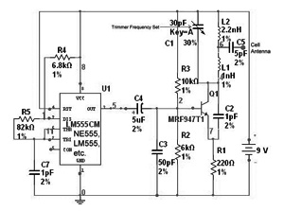
A “Cell Jammer” is just way of saying “Dirty Transmitter” which happens to transmit within the Cellular Phone Bands. Reality is, the dirtier the better.
The 555 timer [8 pin] IC simply makes a noise. It’s coupled via C4 [electrolytic] to modulate the MRF transistor oscillator. With C1 set at roughly 1/3rd, you will be close to 900 MHz. By sweeping the C1 trimmer capacitor, you can swing the output frequency from 800 MHz to 2 GHz with the transistor and values shown.
You could replace the 555 chip with an electret microphone and listen to yourself talk on a scanner, so the unit could easily couple as a UHF Bug. Instead of a single Tapped Coil, I’ve used two molded inductors for ease of construction.Values for C1,C2,L1,L2 are critical for the frequency range.
You might want to build the unit into a metal box, add an on/off switch in the batteries + line, and maybe even add a LED. Connect an old 800 MHz cell phone antenna to C5.
Would you believe the whole thing can be built on top of the 555 IC itself when using surface mount components, and the lot will fit onto a nine volt battery clip. Output is reasonably good, although the current drain is a bit high, so a new 9 Volt battery will only run about an hour, [if you are lucky]. The “Cell Kill Distance” is around 10 – 15 feet, ample for most purposes.
Designer & Author: Special thanks to Laszlo Kirschner.
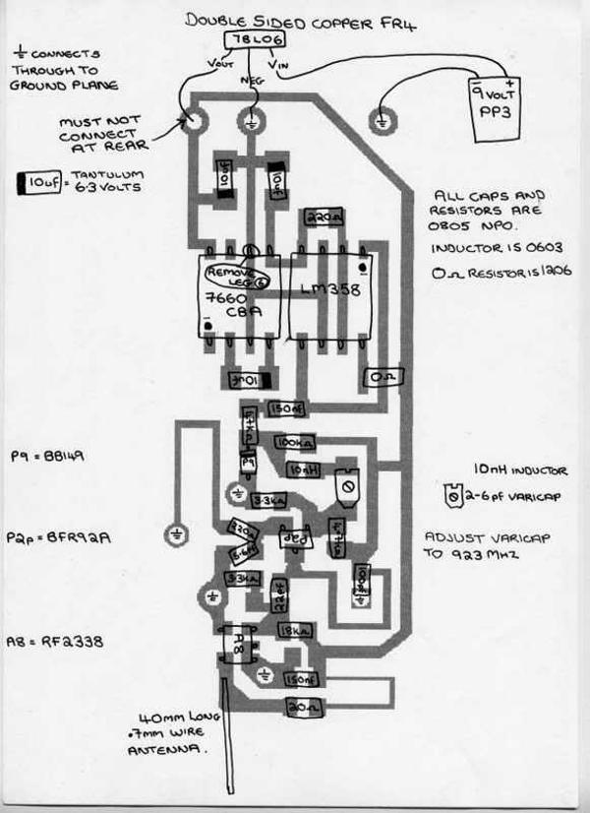
hey this is a great circuit. I am using it as an extra project in my electronics class, but i was just wondering if anybody could tell me or direct me to a website that i can learn how to make a 1 and 2.2 nano henry (nh) coils. ty in advance

jude
there is a simple equation for the winding,
Wheeler's Formula (single layer air core coils)
L(uH) = (r^2) * (N^2) / (9*r 10*h)
where:
r = coil radius (inches)
N = number of turns
h = coil height (or length) in inches
found from this site
http://forum.allaboutcircuits.com/showthread.php?t=12870
hope this will help you!
Did this worked ?

ethan
yah it helped me make the coils the right size, but i still cant get it to knock a signal out. can anyone shed some light as to why this is and any way i could make it more powerful?

Pran
It would been wonderfull if the turns, diameter and the guage of the coils are given for easy construction of an average hobbyist.

Meins321
MRF947T1 = Motorola NPN Low Noise, High Frequency Transistor
Replaced by
PRF947 = Philips Transistor
or
MAS947 = HOPE Microelektronic
I can't find a source, can you help us please?
Farnell?

Remi
I read about the topic and it is really interesting
I would like to know that whether the same technique can be used to jam the cable tv Signals
Please reply
Thanks in advance

sandeep
hi sir
i would like to know wehther the above circuit could be used as a effective jammer for freq. used by gsm companies in india & other asian countries.
i would be highly obliged sir if send me the working and detailed scematics of the jammer circuit shown above
thanks

Charles
Hey i would like to use this as a project for my EE class and would like to know more details; the components i would need and about how much it cost
schmickc@unr.nevada.edu
thanks

di
it will be a great help to email me the whole docs about this jammer. fortunately, our project is about jamming and i find this circuit very simple. this is really urgent. pls send me all yhe important details specially the components. thanks alot

Jack Man
I was just wondering if you could e-mail me a list of all the parts you used for this and were i could get them(Radio Shack?) to ieatmexicans@hotmail.com Please and Thanks

im not telling you, lol
A zenner diode noise source and a power amplifier system would create emissions all across the band upto 2gz easy. you may even like to try adding some mixers and mix two noise sources together, so you get the sum and difference of both noise generators. Makes me laugh when people keep asking for the info, the circuit is right on the page, what elese could they possibly need. Shows a great level of not understanding the fundimentals of electronics engineering, read the books you forign muppets. Is it just me or is there generaly a high level of incompetance assosiated with forginers. Honestly read some books to understand how the ciruit works, otherwise you will always need somebody to hold your hand and do the work for you.

DANIEL MOSCOSO
friend that such you can help me????????????
can you give me but characteristics of the source or battery????????
thank you

anson
1. i would like to use this as a project ,plz give me detail.how it work ?
2.mrf947 TRANSITOR not avible in marcket plz send equivalent

rajvir
please send me information related with LC tuned circuit. how much diameter of copper wire and no of turns we have to consider for 1nH and for 2.2nH COIL.

tarun
1. pless tell the data sheet of mrf947 or any replacements.
2. dia of inductor coil and no. of turns

sonu
hey this 4 indians az im too dont worry if u are unable 2 get this transistor use bfw10/bfw11 fromB.E.L. bharat electronics limited.
any querry mailme at 1234.sonu@gmail.com
(cost of this transistor is just Rs11or12 only now stop crying to b indian

jammer
this looks like the orginal P2JBZ circuit from phonejammer.com do a search

sriharsha
hai this is harsha from kahmmam district i am an ece syudent i lik the project mobile jammer i want to this projct as my mini project which i need to submit to the university as i m belomgimmg to andhrapradesh plz sujjest me the place where can i get that her over plz think of abt my request frns
Marvin
Hi i, looking your circuit and i noticed that you're using an 555 integer with one source of 9v. Remenber that the 555 uses 5V.

Bene
Marvin, the 555 goes to around 18V!! dont tell some shit here

laila taher
what is the kind and name of modulation for this circuit ,kind and specification of the used antenna ,what is the oscillator circuit elements exactly in this circuit.

laila taher
what is the kind and name of modulation for this circuit ,kind and specification of the used antenna ,what is the oscillator circuit elements exactly in this circuit.pleas i want to have the answear quickly at this email : lailataher2009@yahoo.com

iron
Hi last night i made the circuit in the multisim, in the output i have like 2uV and -100.5 dB in AC , in DC i have 3.6 V and 25.5dB,is this correct??
does anybody made the circuit and take values in the output??

kumsa
i want about the winding of the coil ,diameter ,gauge to construct

Mains
There is lot of info missing: Part list, how to wind coils, what kind of antenna, replacement part!!

maurice evans
I think there has been some circuit which are able to detect that there are cellphone jammer in the area, have you heard about this guys?

noggonen
Maurice: try googling 'Gestapo'

kumaresan
can i use MRF547 instead of MRF947

proteek
great friend this ckt really good
we want a jammer that can actually block all mobile & display freq & number of the caller so can u plz help us as we r left with few days for synopsis submision so plz send info as soon as u can

Dan
how the hell do you want to use BC 547 for this project? http://www.bobtech.ro/document...stori.html here you have a catalog with transistors that are usually very common in any country. if you want to jam a phone that works at 800, 900, 1800, 1900, 2100mhz do not chose a transistor that works at 300mhz maximum... (like BC547)

Omkar
Nice simple circuit. Thanks for it. I am also from India and some are spoiling country's name. If you cannot built such a simple circuit, then what you are you doing in your BE EEE? Calling yourself electronics engineers but not able to build even this. This is final year project lol.
Thank the author for posting a schematic and you cannot expect him to personally send you details which has already been posted here!

Rony
some Indians are really making shamefull act here.. i m also an Indian.LITTLE stupid ones are .simply begging to the author for "more details" wht the hell u want more.? damn he has posed a lot for u here..!! he has given all all the details.. wht else u want him to say .? the fundamentls of electroncis for the stupid little engineers ..? dont spoil the name of INDIA AND STOP ASKING DAMN THINGS LIKE -- HELP ME.. HELP ME.. !!
not a single hell is here form my country who want to take the challenge .? every one want to hv details.. in the mails.. --is the author ur servant .? ass holes.. ask to ur faculties.. abt this.. ask to ur father who is spoiling money for u. .every samistor..ur relly nothing but a BULLSHIT..
NOW KEEP UR MOUTH SHUTTT AND START MAKING THE PROJECT.. work hard and find out form books and books and books..by tht way u will learn..intoi ur shit brain..
hope u all can UNDERSTAND ME.. and dont spoil OUR countries name..!!
--Rony

Charles Bronson
Whats the matter wif all dese stupid students - the bloody circuit is there, what more do they want? All foweigners as well.

nabeel
Thank for the Author
I advice the biginers enterested in this project by
the folwoing
use the same circuit to produse 88-108 mhz osillator
and pikup the signal by FM receiver
with BC547 transistor
hence you have chang the inductance
and some capacitance like c2 and use 20 pf
eng_nabeell@yaho.com

fortune
hello.everyone,we would like to intruduce ourself ,we are professioan manufacturer of cell phone jammers.if you interested our products ,we would like to get your reply.thanks

usa
Here's an idea: you could combine this with a cell phone detector so that the jammer will activate only when cell phones are near it. That will save battery power.

Arcisure Engineering
I took a look at the schematic and if im right, this device aint working for blocking a cell phone, because a cell phone has multiple frequency bands. this can bes solved using a 4017 uC, to automaticly change the capaciter value, and so the frequency

mikle
heey i cant know about antenna any thing .....
which type ??!!
what is the rang and CDMA or GSM

WaqaR
hey guys.. i hav just made up this project but cant get it to work...
got the exeact values for the inductor..
used bfw10 transistor.. insted of the mrf one...
n yes plzz tell me the detailz abt the antina...
plzzz

Adnan
Hi can i get an alternative to mrf947. Its not available in the market.

zeeshan
m from pakistan!
u can replace mrf947 with any npn transistor that has max frequency range about 2200Mhz or higher like mrf901, mrf517,
here is a link for a bunch of transistors , but select that one that has freq >2200 Mhz
http://www.datasheetarchive.com/pdf-datasheets/Databooks-2/Book249-5690.html
and also one indian said in this forum to replace it with bfw11
plz dont use that transistor as is has only 1Mhz freq range and also its not an npn transistor
and if any one ask about the detail about this project
plz dont say him as stupid or ant thing else
for those who still wants the detail:
read basic transistor biasing and working articles and little about 555 timer

mustansar
i am electronic engeneering student and i want to know the working of this circuit and hows we can jam all kind frequencies used in mobile phones and jam all kind of phones

Mexicannn
Wow All of the information needed to build this circuit is here in the text. What other information do you need? its all in the schematic. I am amazed at how many people are baffled by this extremely simple circuit. And yes..... you can get these parts at radio shack. as for the 555 timer any electronics savvy person can locate one.

