

**Underwater Acoustic Modem**

# Midpoint Report

Sean Mason – Electrical Engineering

Nicoletti Anicette – Electrical Engineering

Robert Anstett – Computer Engineering

Adviser - Shengli Zhou

Sponsor:

School of Engineering,

University of Connecticut

### Abstract

An acoustic modem sends and receives digital data as sound energy. For our project, we will develop a modem that will communicate wirelessly through, first air (phase 2) and then through water (phase 3, final test bed). The reason for using acoustic energy as our means of data transmission is due to the properties of sound energy in water which make them more desirable than electromagnetic energy. Sound energy propagates more easily through water than air while the opposite is true for electromagnetic energy. As our transmission scheme we have chosen OFDM (Orthogonal Frequency Division Multiplexing), a transmission technique which has several attributes that make it favorable to any other modulation technique.

### Background

As of today there are several products available which provide a means of wireless underwater data transmission. However all existing underwater modems use serial transmission schemes. Introducing OFDM to underwater acoustic data transmission could have several positive consequences including faster transmission rates, fewer occurrences of error, and an expanded range of capabilities for underwater modems.

The software portion of our design process is also unique in that it involves using Simulink, graphical signal processing software, to form our OFDM system. Using a graphical approach should make our software more adaptable to different equipment and different scenarios. This is because modification is easy when the software takes the form of a series of block diagrams. If, for example, we are using an underwater speaker as our transmitter with a center frequency of 12 kHz (kilohertz), and we have to swap it with another speaker with a center frequency of 8 kHz, modifying the software to suit this device change should be relatively easy.

### Approach

Our design process will include three phases and will result in a final demonstration of our communication scheme in a fairly controlled environment. The three design phases are as follows:

* Phase 1: Software development using Matlab and Simulink
* Phase 2: Creation and testing of a physical air-to-air communication system
* Phase 3: Creation and testing of a physical underwater communication system

Our approach in the first phase of the design process will be broken down into several basic steps. In the first step, a baseband system will be built. Here, an OFDM transceiver will be created using QPSK as our modulation scheme. The transmission will be done over a single channel, and no carrier frequency will be applied. In Simulink, several modules must be built. They include:

* Cyclic Prefix Generator
* IFFT Module
* QPSK Modulator
* Channel Module (with additive noise)
* QPSK Demodulator
* FFT Module
* Cyclic Prefix Remover
* Serial to Parallel Converter
* Parallel to Serial Converter
* Synchronization and Timing Module
* Carrier Frequency Offset Estimation Module

Once this system is built it can be tested and analyzed. We will experiment with

different noise levels in the channel, different data packet lengths, and so on until we have a good understanding of how our system will perform at a single channel.

Once the baseband system is perfected, a QPSK block will be created for each carrier

frequency. This will be the focal point of converting our baseband system into a full OFDM system. At this point, several other of the above modules will have to be modified to ensure proper performance of our system.

In phase 2, our software will be used in testing acoustic data transmission in air. The transmitter used will be a personal computer with a speaker, and the receiver will be a PC with a microphone. The testing environment will be very controlled, in that outside noise and multipath distortion (which would have an adverse effect on our system) will me minimized as much as possible, and the distance between the transmitter and receiver will be relatively short (less than 3 meters).

Once data transmission in phase 2 has been perfected, we will move on to phase 3, which involves data transmission in water. Here, the transmitting PC will use an underwater speaker, and the receiving PC will use a hydrophone. This phase, like the previous one, will be done in a very controlled environment. The transmitter and receiver will be placed in water which is less than a meter deep, and the distance between the two will be about one meter. We will need to devise a way to minimize multipath distortion within the water tank, as well. Minimization of outside noise will also be a concern, but shouldn’t weigh as heavily upon our success as in phase 2.

There are several concerns which will be addressed as we move though the three phases of design. One of the cornerstones of our design process will be finding out just how far our frequency spectrum can be divided to allow a maximum amount of data to be transmitted at one time instance without risking data corruption. This will be a factor on which our transmission speed and system reliability will hinge. Along those same lines, we will have to look into suitable means for error prevention both in simulation and in physical applications.

Our goal will be to perfect a scheme for underwater acoustic data transmission using OFDM. At first, the transmitted data will take a basic form, of simple text messages. However, there will be a potential to expand our communication platform to support transmission of other kinds of data, including audible messages.

### Theory

### OFDM

OFDM involves sending several signals at one given time over several different frequency channels, or subcarriers. In our case, the usable frequency range of our equipment will be determined, and that frequency range will be divided into a certain number of channels. At any given time interval during transmission, each subcarrier will be transmitting data. An illustration of OFDM for one time instance is given.

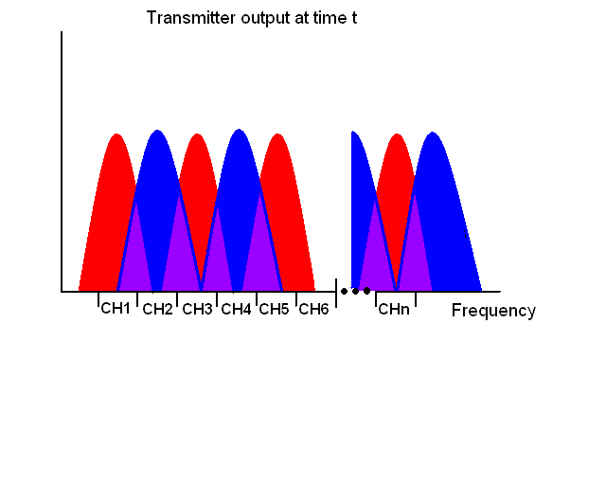

Figure 1

The principle of orthogonality helps to ensure that cross talk does not occur between the carrier frequencies. Despite the fact that the signals overlap in the frequency domain, it is possible, from a receiver’s point of view, to extract data from one specific carrier simply by knowing its frequency.

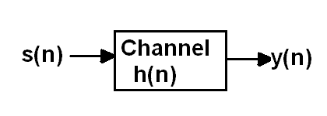

Figure 2: transmitted data, s(n) is convolved with a channel, h(n) as part of the transmission process. The receiver then must extract s(n) from y(n).

Orthogonality alone does not ensure that data won’t overlap. Once a data packet, s(n), (which takes the form of an array) is transmitted, it becomes convolved with the channel, h(n) on which it is sent. The receiver then picks up the useful data convolved with the channel, y(n). The length of this array is now equal to the length of the data packet plus the length of the channel. This means that the transmitter needs to wait for a certain amount of time before sending the next packet of data. This time periods between where the transmitter is sending useful data are known as guard intervals. They can be varied in length to suit various factors in the transmission process. They must be a certain length to ensure transmitted data will not overlap before reaching the receiver. This will make distinguishing between two packets of data almost impossible.

In most transmission schemes, extracting s(n) from y(n) is a matter of deconvolution. The receiver, upon receiving y(n), must analyze the channel, form an array, h’(n), which closely matches h(n) and deconvolve the two to extract s(n). In OFDM this process is somewhat different. Channel analysis is still necessary in order to form h’(n), but from this point, s(n) is attained by dividing y(n) by h’(n). This is due to the properties of what is known as a flat-fading channel.

Determining why this occurs is a matter of examining the mathematics behind it. On a basic level, the process of OFDM takes the following form:

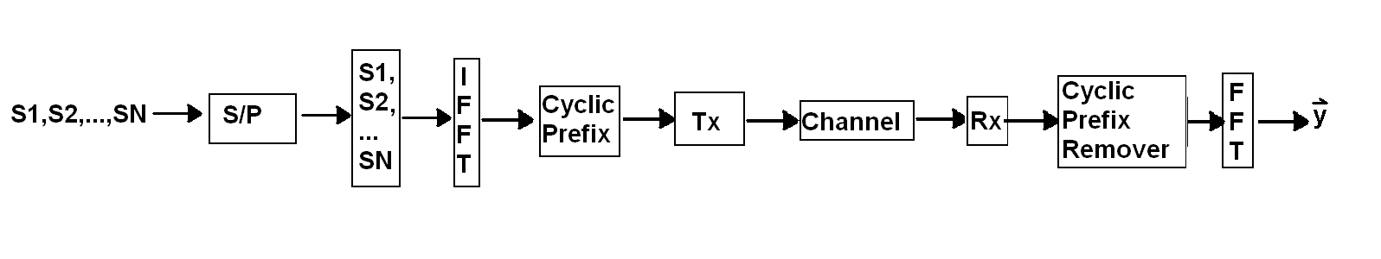

Figure 3

Before transmission, a stream of data is converted to parallel form where each bit is assigned to a carrier frequency. Then the IFFT is taken, a cyclic prefix (which will be discussed further later on) is added to the data, transmission and reception occurs, the cyclic prefix is removed, and the FFT is taken to get y(n). This process can be represented as a series of matrix multiplications of the following form:



After arranging the matrices in the above equation and multiplying through, y(n) takes a new form:

Now s(n) is multiplied by a diagonal matrix. In order for the receiver to extract s(n), it must form the vector h’(n) and divide. This proves to be a much simpler process than deconvolution and is one of the more appealing attributes of an OFDM system.

### Quadrature Phase Shift-Keying (QPSK)

The concept of QPSK is simple; modulate two bits from a signal at a time into one modulated symbol. QPSK uses a constellation shown in figure 4 to determine the phase and qaudrature of the signal. Grey coding will be used in the constellation to reduce the number of bit errors when the signal is demodulated. (The grey coded constellation can be seen in figure 1 as well) QPSK at its most basic will decide what the two bits to be modulated are it will set an *i* value of 1, 2, 3, 4 and then modulates the signal using the following equation.  This allows for each modulation point to be 90o from each other and allows for 45o in error in either phase direction as seen in figure 4. For example the point 01 is at 45o on the circle and point 00 is at 135o on the circle so the difference between the two points is 90o. The decision region between the two points is half way so there can be a maximum of 45o phase shift before the receiver will demodulate the sign wrong causing a symbol error. A symbol error then in tern causes two bit errors because each symbol represents 2 bits. The constellation consists of a four point signal space and each point is set at  where Es is the signal energy.

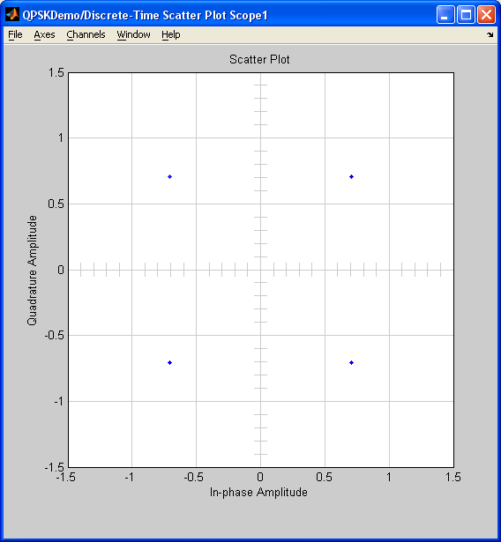

|  |
| --- |
| 00 |

|  |
| --- |
| 01 |

|  |
| --- |
| 10 |

|  |
| --- |
| 11 |

|  |
| --- |
| Figure 4 |

### Modulation (figure 5)

QPSK has two basis functions for modulating and demodulating. One of the functions is a sine and the other is a cosine.

 The 2 basis functions

These basis functions make up the x and y axes. One being a cosine and the other being a sine, they are orthogonal to each other allowing for both to be transmitted at the same time. (This is slightly different from the definition of orthogonal in OFDM) The first basis function is used for the in phase component and the second for the quadrature component of the signal. After each bit has been separated it will go though a filter to assign it to either a (usually 1 is  and 0 is ) This is then multiplied by the two basis functions and then those multiplications are summed together and forms the final QPSK function..

Figure 5

### Demodulation Figure .

Demodulation is just as easily as modulation. To demodulate the signal the basis functions need to be re-injected into the QPSK signal. This will return the  and the decision device will sample the signal at Ts which is set when the system is designed. The decision device will then return a 1 or a 0 based on the  value.

Figure 6

### Synchronization

Synchronization is an essential part of OFDM transmission. Synchronization is defined as the process of adjusting the corresponding significant instants of two signals to obtain the desired phase relationship between these instants.[1][1] This process allows the receiver to make sense of the data it receives, and to single out the useful portions of it. In OFDM, synchronization is performed in two major steps; by the estimation of the timing symbol and by the detection of the carrier frequency offset.

The particular method of synchronization that we will be implementing in our model is known as the Schmidl/Cox method. Developed by Timothy M. Schmidl and Donald C. Cox, it is far less computational than the Classens method[2][2] from which it is derived.

For the receiver, signal recovery relies on training symbols. These symbols are composed of two identical halves in the time domain and are added to the useful data as a prefix (often referred to as a cyclic prefix). These identical halves contain pseudonoise (PN) which has arbitrary values at even frequencies and zeros at odd frequencies. This PN sequence would be transmitted on each subcarrier to generate the time domain samples. These time-domain samples are repeated to form the first training symbol. Then this process is repeated to form the second, identical, training symbol. The PN at the odd frequencies are used to measure the subchannels while the PN at the even frequencies help determine the frequency offset.

Autocorrelation is an important step in estimating the timing symbol. Essentially, autocorrelation finds where there the timing symbols correlate most. This point allows the receiver to determine their starting points. Knowing where the prefix begins and its length allows the receiver to estimate where the useful data begins.

The carrier frequency offset can cause complexities which we will need to account for. In an ideal transmission scheme, the oscillator of the transmitter and receiver are at the exact same rate. However, in a physical environment, the two oscillators will be very close to one another but never quite equal. In order to interpret the received data correctly, the offset between the two oscillators must be accounted for. We will develop a means for this in our software simulation and see how altering the frequencies of the receiver and transmitter will affect our performance. Then, if our system performs satisfactorily, it will be put to the test in a physical environment.

### Budget

We have finalized our budget and decided on the equipment that we will be using. The items selected are listed below.

|  |  |
| --- | --- |
| Product | Price |
| Aquarian Hydrophone System AQ3 | $154.00 |
| Smarthome 8248A32 Underwater Speaker | $700.00 |
| Water tank | $100.00 |
| Sound Blaster Live! SB0490 Sound Card | $47.50 |
| Sherwood Stereo Receiver RX-4105 | 85.00 |
| Shipping | $50.00 |
| **Total** | **$1,136.50** |

The total cost here is close enough to our initial budget to be considered feasible if no additional funding is received. Ordering parts will begin in late April/early May.

1. 1 Webster’s Online Dictionary
2. [2] Uses a trial and error method where the carrier frequency is incremented in small steps over the entire acquisition range until the correct carrier frequency is found