CONCLUSION

This presentation gave an overview of Optical Wireless technology. We started with applications of FSO to provide motivation for its study . Transmitter and receiver designs were discussed .We looked at the challenges faced by this technology and techniques to deal with them Finally had a brief look at the problem of Topology Control and routing of Bandwidth Guaranteed flows.

REFERENCE

- D.J.T.Heatley, D.R.Wisely, I.Neild and P.Cochrane, “Optical wireless: The story so far”, IEEE Communications Magazine 36(12) (1998) 72-82
- H.A.Willebrand and B.S.Ghuman, “Fiber Optics Without Fiber”, IEEE Spectrum Magazine, August 2001, pp 40-45.
- A.Kashyap, M.K.Khandani, K.Lee, M.Shayman, “Profile-Based Topology Control and Routing of Bandwidth-Guaranteed Flows in Wireless Optical Backbone Networks”, University of Maryland
- http://www.freespaceoptics.org/
- http://http://www.fsona.com/

CERTIFICATE

This is to certify that…. Neha Yadav… of Electronics & Communication Engineering
(6th semester) has worked hard under my guidance on the seminar topic assigned to her.

She has been honest and determined throughout the seminar conducted.

GUIDE FACULTY
MR. MAYANK SHRIVASTAVA
PROFESSOR

CONTENT

- Introduction
- What is Optical Wireless?
- Applications

- Transmitter and Receiver
- Topologies
- Point to multipoint topology
- Point to point topology
- Ring with spurs topology
- Mesh topology
- Typical topology in metro

- Challenges and Limitations
- Topology Control and Routing
- Conclusion
- References

ACKNOWLEDGEMENT

When you see a turtle on a fenchpost you know it didn’t get there by itself it means inorder to accomplish a given job you need the support of experienced persons in that field.So my profound thanks goes to Mr.MAYANK SHRIVASTAVA for his help in making this presentation, without whom the proper editing of this presentation would have not been possible.
Besides,I would like to extend thanks to my colleagues Monica Gupta,Pooja Yadav,Saumya Anand,Radhika Agarwal-to whom I owe immense gratitude for helping me in need.
Finally,I would like to acknowledge my family members my parents,my sister Nidhi Yadav who were a source of my inspiration and encouragement throughout the making of this presentation.

REPORT ON-

OPTICAL WIRELESS

Presented by- Submitted to-
Neha yadav Mr.Mayank shrivastava
Roll-no.0803331061 Asso. Professor
EC B

Report –optical communication

Optical Wireless is Free Space Optics (FSO) which refers to the transmission of modulated light beams through the atmosphere to obtain broadband communication here broadband communication is any technology with transmission rates above the fastest speed available over a telephone line.Broadband transmission systems typicaly provide channels for data transmissions in different directions and by many different users. For example, the coaxial CATV system is a broadband system that delivers multiple television channels over the same cable. In addition, it can handle data transmissions (primarily Internet access for home users) in an entirely different frequency s

Largest broadband communication
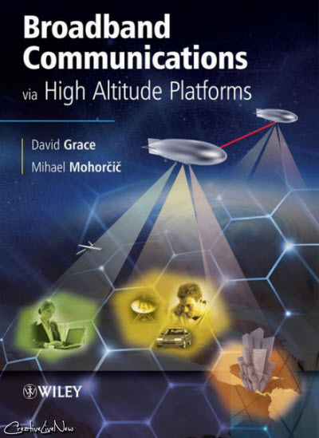

Typical broadband communication systems include the following:
- ISDN (Integrated Services Digital Network) - ISDN is implemented over existing copper telephone cables. The basic rate variety provides two channels of 64-Kbit/sec throughput that can be bonded to form a 128-Kbit/sec data channel. Primary rate ISDN provides additional bandwidth in increments of 64 Kbits/sec.

- ATM (Asynchronous Transfer Mode) - Another high-bandwidth service available from the carriers. The carriers use of ATM benefits everyone, but medium to large companies can install ATM equipment on-site to connect directly into carrier ATM networks and gain all the benefits of those systems. See the "ATM" heading for more information.

- Frame Relay A data networking and voice service offered by the carriers that is widely available. Like ATM, frame relay is primarily used for corporate rather than home connections.

- Leased lines and T Carriers Leased T1 lines provide dedicated throughput of 1.544 Mbits/sec over two-pair twisted wire. Existing telephone cable is usually adequate. T3 provides approximately 45-Mbit/sec throughput. Fractional T1 can be leased in increments of 64 Kbits/sec. See "TDM Networks" for more details.

- DSL (Digital Subscriber Line) DSL is a whole family of high-bandwidth digital services that the telephone companies offer over copper telephone cable. Depending on the service, rates can reach into the multimegabit/sec rates.

- Cable (CATV) Data Networks The cable TV system is a well-established broadband network that now makes its system available for data links and Internet access. Nearly 100 million homes in the U.S. have cable access, and it is estimated that 70 to 75 percent of those homes will be able to support Internet access in the year 2000.

- Wireless Communications A variety of wireless broadband services are now available or under development, including satellite-based systems and terrestrial-based systems that are essentially fixed cellular systems. Broadband wireless uses microwave and millimeter wave technology to transmit signals from base stations to customers. See "Wireless Broadband Access Technologies."

Optical wireless as a line of sight technology
Line-of-sight technology approach uses invisible beams of light to provide optical bandwidth connections. It's capable of sending up to 1.25 Gbps of data, voice, and video communications simultaneously through the air — enabling fiber-optic connectivity without requiring physical fiber-optic cable. It enables optical communications at the speed of light.
And for providing high-speed connections, across Enterprises and between cell-site towers, it is the best technology available.
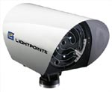
FSO is a line-of-sight technology that uses invisible beams of light to provide optical bandwidth connections that can send and receive voice, video, and data information. Today, FSO technology — the foundation of LightPointe's optical wireless offerings — has enabled the development of a new category of outdoor wireless products that can transmit voice, data, and video at bandwidths up to 1.25 Gbps. This optical connectivity doesn't require expensive fiber-optic cable or securing spectrum licenses for radio frequency (RF) solutions. FSO technology requires light. The use of light is a simple concept similar to optical transmissions using fiber-optic cables; the only difference is the medium. Light travels through air faster than it does through glass, so it is fair to classify FSO technology as optical communications at the speed of light.
Last mile problem
The world-wide demand for broadband communications is being met in many places through the use of installed single mode fiber networks. However, in the developed world there is still a significant ``last-mile" problem, which at present seriously limits the availability of broadband internet access, for example. Digital subscriber (DSL) service and cable modems offer at best, a marginal performance improvement over conventional modem connections. In urban areas in developed countries there is some availability of high data rate connections, for example T-1 lines, for business, government, and research applications. Radio-frequency (RF) and microwave (MW) wireless connections are intrinsically limited to low data rates because of their relatively low carrier frequencies. In much of the world, there is no extensive installed optical fiber infrastructure and the cost of providing such an infrastructure, which can amount to on the order of $1 Million per kilometer for installed fiber in an urban area, limits the availability of such links.
Optical wireless is becoming the accepted term for describing terrestrial, high data rate, optical communication links along free-space paths through the atmosphere. It presents a very attractive solution to the ``last mile" problem in broadband networks. Because free space laser communication links can be easily and quickly redirected, optical wireless networks offer the possibility of re-configurability in a multiply connected topology to provide improved network performance. These systems are also very cost-effective. A good example of how such a network provides network extendability is provided by our own campuses, where additional new buildings could be connected to our existing fiber infrastructure by optical wireless at much lower cost than from the installation of additional fiber. Indeed, the potential of wireless has already been demonstrated by the extension of our network between two adjacent buildings through the use of 155MB/s 1.3 µm and 1.5 µm transceivers of our own development.
Transmitter:
- Laser/LED as coherent light source
- Wavelengths centered around 850nm and 1550nm widely used
- Telescope and lens for aiming light beam to the receiver
- FSO uses same transmitter technology as used by fiber optics.
Receiver:
- Photodiode with large active area
- Narrowband infrared filters to reduce noise due to ambient light
- Receivers with high gain
- Bootstrap receivers using PIN diode and avalanche photodiode (APD) used

Two important applications of optical wireless communication
A) Underwater communication:
In underwater communication the signals that are used to carry digital information through an underwater channel are not radio signals, as electro-magnetic waves propagate only over extremely short distances. Instead, acoustic waves are used, which can propagate over long distances.The three distinguishing characteristics of this channel are frequency-dependent propagation loss, severe multipath, and low speed of sound propagation.
Underwater communication has a range of applications including remotely operated vehicle (ROV) and autonomous underwater vehicle (AUV) communication and docking in the offshore industry. Current underwater transmission techniques is primarily utilise sound waves for large distance at lower frequencies and the velocity of sound in water is approximately 1500m/s the resultant communications have problems with multi-path propagation and low bandwidth problems. The use of electromagnetic (EM) techniques underwater has largely been overlooked because of the attenuation due to the conductivity of seawater. However, for short range applications, the higher frequencies and much higher velocity can prove advantageous. This paper will outline a project which will utilise recent investigations that demonstrate EM wave propagation up to the MHz frequency range is possible in seawater.
Advances in underwater wireless communication
Underwater networks of sensors have the potential to enable unexplored applications and to enhance our ability to observe and predict the ocean. Unmanned or Autonomous Underwater Vehicles (UUVs, AUVs), equipped with underwater sensors, are also envisioned to find application in exploration of natural undersea resources and gathering of scientific data in collaborative monitoring missions. These potential applications will be made viable by enabling communications among underwater devices. Under Water Acoustic Sensor Networks (UW-ASNs) will consist of sensors and vehicles deployed underwater and networked via acoustic links to perform collaborative monitoring tasks.
The single most killer application for Underwater Wireless Communication would be in disaster prevention. Sensor networks that measure seismic activity from remote locations can provide tsunami warnings to coastal areas, or study the effects of submarine earthquakes (seaquakes).
There are major challenges in the design of underwater acoustic networks that include:
• The available bandwidth is severely limited;
• The underwater channel is impaired because of multipath and fading;
• Propagation delay is five orders of magnitude higher than in Radio Frequency (RF) terrestrial channels, and variable;
• High bit error rates and temporary losses of connectivity (shadow zones) can be experienced;
• Underwater sensors are characterized by high cost because of a small relative number of suppliers (i.e., not much economy of scale);
• Battery power is limited and usually batteries cannot be recharged;
• Underwater sensors are prone to failures because of fouling and corrosion.
There has been intensive research on MAC protocols for ad hoc and wireless terrestrial sensor networks in the last decade. However, due to the different nature of the underwater environment and applications, existing terrestrial MAC solutions are unsuitable for this environment. In fact, channel access control in UW-ASNs poses additional challenges due to the peculiarities of the underwater channel, in particular limited bandwidth, very high and variable propagation delays, high bit error rates, temporary losses of connectivity, channel asymmetry, and extensive time-varying multipath and fading phenomena. Existing MAC solutions are mainly focused on Carrier Sense Multiple Access (CSMA) or Code Division Multiple Access (CDMA). This is because Frequency Division Multiple Access (FDMA) is not suitable for UW-ASN due to the narrow bandwidth in UW-A channels and the vulnerability of limited band systems to fading and multipath. Moreover, Time Division Multiple Access (TDMA) shows a limited bandwidth efficiency because of the long time guards required in the UW-A channel. Furthermore, the variable delay makes it very challenging to realize a precise synchronization, with a common timing reference.
B)Intra spacecraft communication:

Optical Wireless Communications have been proposed as a solution for partial or total replacement of conventional wired data transmission links inside the spacecraft. This technology is known generically as OWLS: “Optical Wireless Links for intra-Spacecraft communications”. In the framework of an ESA Activity (Technology Research Program – TRP Contract 19.545/05/NL/JLC) leaded by INTA (National Institute of Aerospace Technology of Spain), a demonstration of several optical wireless networks for TM/TC distributed units has been developed inside a 1:1 scale Venus Express (VEX) mock-up. The selected application to be implemented inside this real spacecraft environment has been chosen after independent trade-off studies leaded by EADS Astrium (Toulouse) and Thales Alenia Space (Cannes). A simulation tool for optical power distribution and time domain signal analysis has been also developed for OWLS by EADS Astrium with background support of Universidad of Las Palmas de Gran Canaria. In this work are highlighted some of the optical and optoelectronic technologies used and developed to achieve the succeed in this OWLS technological demonstrator. A full demonstration of OWLS will be officially presented in ESA/ESTEC by November 2008.
Wireless communications are considered today as a disruptive technology in Space. They are a potential complement or replacement for conventional wired systems for data transmission inside the spacecraft. In this sense, under the ESA contract 19545/05/NL/JLC (started on February 2006, with a duration of 24 effective months and a budget of 1.5 M€) many initiatives have been developed. From the optical point of view two major aspects were developed: An optical simulation tool for the opto-mechanical intra-spacecraft environment; and a full line of adapting and improving optoelectronic COTS (Commercial Off The Shelf) parts. The future success of OWLS and its implantation as a standard solution for future missions, strongly depends on the quick and easy insertion of the optoelectronic COTS in the Space arena
HERITAGE IN OPTICAL WIRELESS FOR SPACE APPLICATIONS
After the first introduction of Optical Wireless technologies for intra satellite communications, made in the frame of the adaptation of Micro/Nanotechnologies (MNT) for Space, ESA exhibited interest in optical wireless as a solution for MNT . As a result, ESA granted some studies to demonstrate the feasibility of these optical technologies inside a spacecraft (Contracts 16.428/02 and 16.431/02) . As a result, three OWLS demonstrators (UPM + INTA in 2000; INTA in 2004 and UPM + EADS Astrium in 2004) based on COTS hardware and software were developed. The next step is to prepare a flight demonstration, which is under development (at Engineering Model – EM) and is one of the main objectives of the actual contract (19545/05/NL/JLC) . INTA has developed two successful OWLS flight experiments for its platform NANOSAT 01 . These technologies are based on COTS optoelectronics components. In October 2007, OWLS flown as a link solution inside the FOTON M3 capsule. OWLS units demonstrate the feasibility of last minute insertion in an already “close” mission, and in less than 8 months a two links experiment was set up. The OWLS success in a such complex environment as that of FOTON capsules is a key proof for the viability of Optical Wireless solutions.
COTS COMPONENTS FOR OWLS
Special effort in this contract has been done in reference to the reliability of parts employed for future flight use. Developing techniques to test and to adapt COTS (Commercial Off The Shelf) Optoelectronics components has been the current approach. All the optoelectronics components have been screened by INTA: their optoelectronic properties and its behavior under irradiation (proton displacement damage) have been the criteria followed [7,8]. A final qualification process is being undertaken by ALTER (formerly Tecnologica). SAFT primary lithium-thionyl batteries has been preliminary screened for flight conditions. Thermal vacuum (INTA), total dose irradiation up to 1 Mrad (SCK-CEN), have been applied to several batteries before testing the full discharge at different temperatures (CEA). A weakness in the availability of adequate single supply operational amplifiers for OWLS detectors have been detected. A major effort in developing future mixed signal analog-digital ASIC should be done.
FUTURE CONCEPTS IN OWLS
Finally, in the scope of this contract, new concepts and trends have been emphasized for future OWLS systems (UPM and UPLCG). A physical demonstration with breadboard units of UPM is also being carried on. With the coming activities of GSTP-5, and In Orbit Demonstration activity is on the program horizon for an In Orbit Demonstration (IOD) of Optical Wireless. The present technology (flight subset developed up to EM) can be upgraded to FM. A non-invasive IOD can be easily planned just to demonstrate a network of OWLS interconnected autonomous sensors inside a medium size satellite.

DIFFERENT TOPOLOGIES-
a)Point to multipoint topology-A point-to-multipoint topology (PMP) is composed of a central base station (BS) supporting multiple subscriber stations (SS), providing network access from one location to many. It is commonly used for last-mile broadband access, private enterprise connectivity to remote offices, and long-range wireless backhaul services for multiple sites. PMP networks can operate using LOS signal propagation or NLOS signal propagation. Each PMP BS has a typical operating range of 8 km (5 miles). 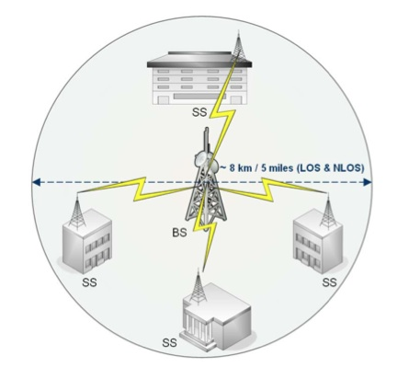

In a multipoint topology the hub can send to one or more systems based on an address. Frame Relay is the most common technology to implement this scheme, and it is typically used as a WAN technology. All the remote connection points are connected to a single Frame Relay switch or router port, and communication between sites is managed by that central point. In hub and spoke, all spokes or only one spoke hears a given transmission. In point to multipoint, any number of remote stations can be accessed.
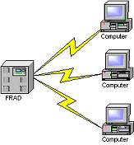

b)Point to point topology(Daisy Chaining)-

Point to Point topologies are simplest and them as a chain of devices and another name for this type of connectivity is called daisychaining. Most computers can 'daisy chain' a series of serial devices from one of its serial ports. Networks of routers are often configured as point-to-point topologies.

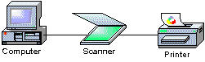

c)Ring topology-
Ring topologies are similar to bus topologies, except they transmit in one direction only from station to station. Typically, a ring architecture will use separate physical ports and wires for transmit and receive.  Token Ring is one example of a network technology that uses a ring topology. | 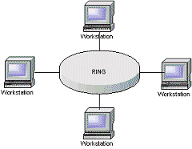
d)Mesh topology
Mesh Network is a network where all the nodes are connected to each other and is a complete network. In a Mesh Network every node is connected to other nodes on the network through hops. Some are connected through single hops and some may be connected with more than one hope.
The mesh topology incorporates a unique network design in which each computer on the network connects to every other, creating a point-to-point connection between every device on the network. The purpose of the mesh design is to provide a high level of redundancy. If one network cable fails, the data always has an alternative path to get to its destination. Figure 6 shows the mesh topology.
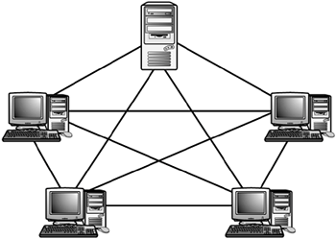

As you see from figure, the wiring for a mesh network can be very complicated. Further, the cabling costs associated with the mesh topology can be high, and troubleshooting a failed cable can be tricky. Because of this, the mesh topology is rarely used. A variation on a true mesh topology is the hybrid mesh. It creates a redundant point-to-point network connection between only specific network devices. The hybrid mesh is most often seen in WAN implementations. Table 5 summarizes the advantages and disadvantages of the mesh topology.
Advantages and Disadvantages of the Mesh Topology
Advantages | Disadvantages
Provides redundant paths between devices | Requires more cable than the other LAN topologies.
The network can be expanded without disruption to current users. | Complicated implementation.

CHALLENGES:
- Physical Obstruction
- Atmospheric Losses
  - Free space loss
  - Clear air absorption
  - Weather conditions (Fog, rain, snow, etc.)
  - Scattering
- Building Sway and Seismic activity

A)PHYSICAL OBSTRUCTION:
Flying birds or construction cranes can temporarily block a single-beam FSO system, but this tends to cause only short interruptions, and transmissions are easily and automatically resumed. Light Pointe's optical wireless products use multi-beam systems (spatial diversity) to address temporary obstructions, as well as other atmospheric conditions, to provide for greater availability.
SOLUTION:
Receiver can recognize temporary loss of connection .In packet-switched networks such short-duration interruptions can be handled by higher layers using packet retransmission. 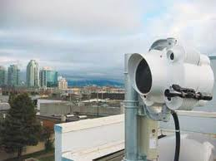

B)FREE SPACE LOSS:
Proportion of transmitted power arriving at the receiver occurs due to slightly diverging beam.
SOLUTION:
High receiver gain and large receiver aperture ,accurate pointing.
c) CLEAR AIR ABSORPTION:
Absorption occurs when suspended water molecules in the terrestrial atmosphere extinguish photons. This causes a decrease in the power density (attenuation) of the FSO beam and directly affects the availability of a system. Absorption occurs more readily at some wavelengths than others.
SOLUTION:
The use of appropriate power, based on atmospheric conditions, and use of spatial diversity (multiple beams within an FSO-based unit) helps maintain the required level of network availability.

D) WEATHER CONDITIONS:
The primary challenge to FSO-based communications is dense fog. Rain and snow have little effect on FSO technology, but fog is different. Fog is vapor composed of water droplets, which are only a few hundred microns in diameter but can modify light characteristics or completely hinder the passage of light through a combination of absorption, scattering, and reflection .Fog causes maximum attenuation, attenuation due to fog is known as Mie scattering.
SOLUTION:
Increasing transmitter power to maximum allowable .Shorten link length to be between 200-500m. The primary answer to counter fog when deploying FSO-based optical wireless products is through a network design that shortens FSO link distances and adds network redundancies. FSO installations in extremely foggy cities such as San Francisco have successfully achieved carrier class reliability.

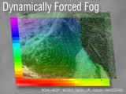

E) SCATTERING
Scattering is caused when the wavelength collides with the scatterer. The physical size of the scatterer determines the type of scattering. When the scatterer is smaller than the wavelength, this is known as Rayleigh scattering. When the scatterer is of comparable size to the wavelength, this is known as Mie scattering. When the scatterer is much larger than the wavelength, this is known as non-selective scattering. In scattering — unlike absorption — there is no loss of energy, only a directional redistribution of energy that may have significant reduction in beam intensity for longer distances.

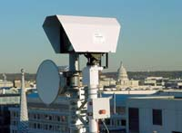

F) BUILDING SWAY AND SEISMIC ACTIITY:
Movements of buildings upsets transmitter-receiver alignment. The movement of buildings can upset receiver and transmitter alignment. Light Pointe's FSO-based optical wireless offerings use a divergent beam to maintain connectivity. When combined with tracking, multiple beam FSO-based systems provide even greater performance and enhanced installation simplicity.
SOLUTION: Use slightly divergent beam
- Divergence of 3-6 milli radians will have diameter of 3-6 m after traveling 1km
- Low cost
Active tracking
- Feedback mechanism to continuously align transmitter- receiver lenses
- Facilitates accelerated installation, but expensive

LIMITATION OF FSO TECHNOLOGY:
- Requires line-of-sight
- Limited range (max ~8km)
- Unreliable bandwidth availability
- BER depends on weather conditions
- Accurate alignment of transmitter- receiver necessary

.

