- INTRODUCTION

Every day, the sun radiates (sends out) an enormous amount of energy—called solar energy. It radiates more energy in one second than the world has used since time began. This energy comes from within the sun itself.
Like most stars, the sun is a big gas ball made up mostly of hydrogen and helium gas. The sun makes energy in its inner core in a process called nuclear fusion.
Only a small part of the solar energy that the sun radiates into space ever reaches the earth, but that is more than enough to supply all our energy needs. Every day enough solar energy reaches the earth to supply our nation’s energy needs for a year!
Solar energy, radiant light and heat from the sun, has been harnessed by humans since ancient times using a range of ever-evolving technologies. Solar radiation, along with secondary solar-powered resources such as wind and wave power, hydroelectricity and biomass, account for most of the available renewable energy on earth. Only a minuscule fraction of the available solar energy is used.
Solar powered electrical generation relies on heat engines and photovoltaics. Solar energy's uses are limited only by human ingenuity. A partial list of solar applications includes space heating and cooling through solar architecture, potable water via distillation and disinfection,daylighting, solar hot water, solar cooking, and high temperature process heat for industrial purposes.To harvest the solar energy, the most common way is to use solar panels.
Solar technologies are broadly characterized as either passive solar or active solar depending on the way they capture, convert and distribute solar energy. Active solar techniques include the use of photovoltaic panels and solar thermal collectors to harness the energy. Passive solar techniques include orienting a building to the Sun, selecting materials with favorable thermal mass or light dispersing properties, and designing spaces that naturally circulate air.

- Principles of Solar Energy

Solar energy is created by light and heat which is emitted by the sun, in the form of electromagnetic radiation.
With today's technology, we are able to capture this radiation and turn it into usable forms of solar energy - such as heating or electricity.
Although one could go into technical dissertations on the subject of electromagnetic radiation, how it is converted into solar energy, and the exact qualities of its electromagnetic rays, this is not something the average person needs or wants to know.
But in order to be able to benefit from the use of solar energy, there are a few facts you should know. Knowing these facts can assist you to make a sound decisions, when looking at the use of solar power as a clean energy source for your home, RV, or whatever the case may be.
1. The first and the foremost advantage of utilizing wind energy is of course that it is not harmful for the environment as nothing is burned to attain the electricity from moving air. Even solid biofuels like sawdust, wood, charcoal, manure and all the others give out polluting gases and particulates that are unhealthy for the environment, but wind energy solves that problem quite effectively.
2. As mentioned before, the main function of wind energy or any other form of renewable source of energy is to reduce the pressure of global demand on fossil fuels that is shortening their already limited life. If the areas that are suitable for harvesting wind energy start to rely on it instead of relying on traditional sources of electricity, then this goal can be achieved effectively.
3. A very significant advantage that windmills have over the traditional power stations is the fact that they require much lesser area to set up. Not only does this advantage make it cheaper to set the mill up as one would require less land, but one must also not forget that the area around the windmill can then be used for setting up adjacent farms also, which in fact is often the case at places like this.
4. Just as with harvesting solar energy, earlier it used to be quite costly to effectively utilize the power of wind. Even then, the total energy that was successfully converted to electricity was hardly enough. In other words, the wind energy conversion rates were poor, but as technology have improved over the years, it has now become possible to utilize and convert wind energy at a much lower cost and a significantly higher conversion ratio.
5. To set up a power station to supply electricity in remote and secluded places at higher altitudes is not an easy job. It would require a lot of money as well as effort and even then it may take quite some time before it can even be successfully operated. This is where the utility of wind turbines are fully realized. Mountainous localities usually have an atmosphere where the wind is very strong as well being reliably consistent. Setting up a wind turbine big enough to serve the electrical needs of the entire locality would not only be cheaper in this case, but it will be much faster and perhaps even more useful as well.
6. The similarity between solar energy and wind energy is that both of them are renewable and free sources of energy; what is more interesting is that it is possible to install a system that will make both the alternative sources of energy work together to offer an even more reliable and powerful energy source. The use of such a hybrid system is not only limited to underdeveloped areas, because even in the developed areas where traditional power stations are already well set up, it could save a lot of money and non-renewable energy.
7. It is hard to believe and may even come as a surprise to someone who does not have the knowledge, but the cost of producing wind energy has become almost 80% cheaper than what it used to be twenty or thirty years ago. As the technology is still developing to make the wind mills more productive and less costly, we can almost assume that the prices will come down further and someday it might even be the cheapest alternative for electricity production in the market.

8. It is no secret that petroleum is chiefly saturated in certain geographical areas which come within the national borders of the countries that are located in that particular geographic area. This has created acertain kind of monopoly and has also raised the price of fuel quite significantly in all the countries that are dependent on it. Wind energy is something that cannot be monopolized in this way as it is free and cannot be confined within the geographical boundaries of a country either. Therefore, if in the near future, wind energy can be made more usable and more efficient, we can also hope to reduce the hiked up oil prices as well.
4. SOLAR ENERGY OVERVIEW
Solar energy is all about harnessing the power of the sun to produce energy. The sun rains enough solar energy on the Earth in one day to power the entire energy needs of the world for one year. Solar energy is considered a renewable energy source because it will exist for as long as our sun does, estimated to be another 4.5 billion years. Solar energy is also considered a clean energy because it does not produce pollutants or byproducts harmful to the environment.
Solar energy was the first energy source used by mankind. Of course, the use was limited to drying things and heating caused by direct contact, but it was a use. In modern times, solar energy has been a power source since the early 1950s, but was not widespread due to technological issues which rendered it an ineffective and expensive energy source. With technology advancements, solar energy is moving to the forefront as a potential alternative to fossil fuels.
The future is indeed bright for solar energy as new solar nanotechnology is close to creating solar platforms that boggle the mind. For instance, a few companies are trying to create solar quantum dots, which will be mixed in the paint you use for your home. Yes, you will actually paint on solar energy panels that will power your home
Currently, solar energy is produced primarily through the use of solar cells, also known as photovoltaic cells. The process works by placing the cells in direct sunlight. Sun hits the cells causing a chemical reaction that creates an electric current. The current is then turned into electricity. The problem with these cells, however, is they are only about 15 percent efficient.
Solar energy is typically classified in two ways, passive solar and active solar. Both approaches produce solar energy, but in very different ways
Passive solar is exactly what it sounds like. It does not involve panel systems or other moving mechanisms to produce solar energy. Instead, passive solar involves planning a structure in such a way as to capture the power of the sun with windows, tanks and so on. These systems can be used to heat homes, water and so on.
Active solar energy systems typically involve some form of solar panels. The panels are oriented to maximize exposure to the sun. Depending on the system, the panels will then either directly convert sunlight to electricity, which is then transformed from direct current electricity to alternate current electricity and stored in batteries or fed into the grid system of the local utility. Active systems are more expensive and complex.
Solar energy has numerous advantages over other energy platforms. It is produces no pollution, requires little maintenance and comes with significant financial incentives in the form of tax deductions, tax credits and rebates from manufactures. In a majority of states, solar energy can also be sold back to utilities per a concept known as net metering. This reduces the need for batteries and significantly cuts utility bills.
Unfortunately, solar energy has some disadvantages as well. The initial cost of purchase and installation can be expensive. Second, areas with limited sunlight are problematic. Third, solar energy obviously can't be produced at night. Despite these disadvantages, solar energy is a booming energy platform.
The largest producers of solar energy in the world are Germany, Japan and the United States. California has recently introduces a solar initiative devoting over three billion dollars to promoting solar energy use by residents in the state. As this overview demonstrates, the solar energy platform is coming on strong.

Solar water heating

Solar water heating (SWH) systems comprise several innovations and many mature renewable energy (or SHW Solar Hot Water) technologies which have been accepted in most countries for many years. SWH has been widely used in Greece, Turkey, Israel, Australia, Japan, Austria and China.
In a "close-coupled" SWH system the storage tank is horizontally mounted immediately above the solar collectors on the roof. No pumping is required as the hot water naturally rises into the tank through thermosiphon flow. In a "pump-circulated" system the storage tank is ground or floor mounted and is below the level of the collectors; a circulating pump moves water or heat transfer fluid between the tank and the collectors.
SWH systems are designed to deliver the optimum amount of hot water for most of the year. However, in winter there sometimes may not be sufficient solar heat gain to deliver sufficient hot water. In this case a gas or electric booster is normally used to heat the water.

Hot water heated by the sun is used in many ways. While perhaps best known in a residential setting to provide hot domestic water, solar hot water also has industrial applications, e.g. to generate electricity.^{[1]} Designs suitable for hot climates can be much simpler and cheaper, and can be considered an appropriate technology for these places. The global solar thermal market is dominated by China, Europe, Japan and India.
In order to heat water using solar energy, a collector, often fastened to a roof or a wall facing the sun, heats working fluid that is either pumped (active system) or driven by natural convection (passive system) through it. The collector could be made of a simple glass topped insulated box with a flat solar absorber made of sheet metal attached to copper pipes and painted black, or a set of metal tubes surrounded by an evacuated (near vacuum) glass cylinder. In industrial cases a parabolic mirror can concentrate sunlight on the tube. Heat is stored in a hot water storage tank. The volume of this tank needs to be larger with solar heating systems in order to allow for bad weather, and because the optimum final temperature for the solar collector is lower than a typical immersion or combustion heater. The heat transfer fluid (HTF) for the absorber may be the hot water from the tank, but more commonly (at least in active systems) is a separate loop of fluid containing anti-freeze and a corrosion inhibitor which delivers heat to the tank through a heat exchanger (commonly a coil of copper tubing within the tank). Another lower-maintenance concept is the 'drain-back': no anti-freeze is required; instead all the piping is sloped to cause water to drain back to the tank. The tank is not pressurized and is open to atmospheric pressure. As soon as the pump shuts off, flow reverses and the pipes are empty before freezing could occur.

Residential solar thermal installations fall into two groups: passive (sometimes called "compact") and active (sometimes called "pumped") systems. Both typically include an auxiliary energy source (electric heating element or connection to a gas or fuel oil central heating system) that is activated when the water in the tank falls below a minimum temperature setting such as 55°C. Hence, hot water is always available. The combination of solar water heating and using the back-up heat from a wood stove chimney to heat water^{[2]} can enable a hot water system to work all year round in cooler climates, without the supplemental heat requirement of a solar water heating system being met with fossil fuels or electricity.
When a solar water heating and hot-water central heating system are used in conjunction, solar heat will either be concentrated in a pre-heating tank that feeds into the tank heated by the central heating, or the solar heat exchanger will replace the lower heating element and the upper element will remain in place to provide for any heating that solar cannot provide. However, the primary need for central heating is at night and in winter when solar gain is lower. Therefore, solar water heating for washing and bathing is often a better application than central heating because supply and demand are better matched. In many climates, a solar hot water system can provide up to 85% of domestic hot water energy. This can include domestic non-electric concentrating solar thermal systems. In many northern European countries, combined hot water and space heating systems (solar combisystems) are used to provide 15 to 25% of home heating energy.
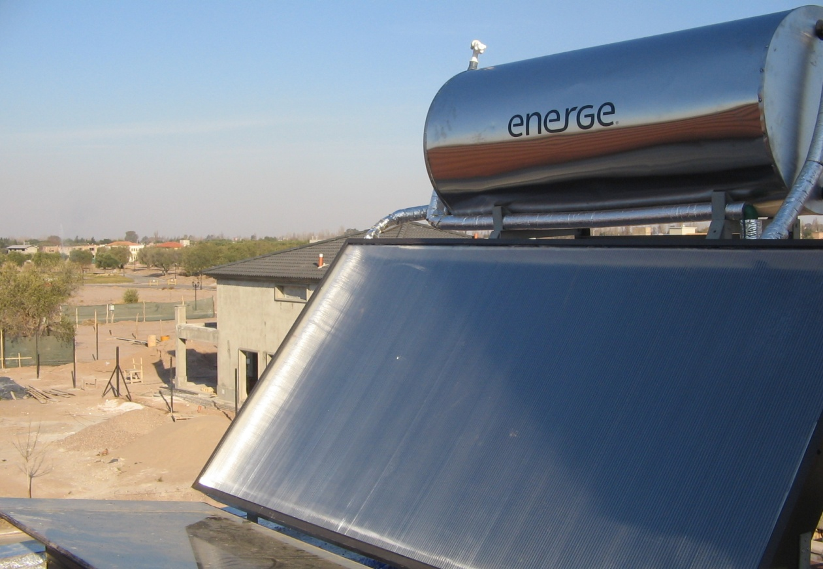
FIG- 1 : solar water heater

SOLAR TOWER
A solar tower, in the context of astronomy, is a structure used to support equipment for studying the sun, and is typically part of solar telescope designs. Generically, the term solar tower has many more uses especially for a type of power production using Earth's Sun. Solar tower observatories are also called vacuum tower telescopes.
Solar towers are used to raise the observation equipment above the atmospheric disturbances caused by solar heating of the ground and the radiation of the heat into the atmosphere. Traditional observatories do not have to be placed high above ground level, as they do most of their observation at night, when ground radiation is at a minimum.
The horizontal Snow solar observatory was built on Mount Wilson in 1904. It was soon found that heat radiation was disrupting observations. Almost as soon as the Snow Observatory opened, plans were started for a 60-foot-tall (18 m) tower that opened in 1908 followed by a 150-foot (46 m) tower in 1912. The 60-foot (18 m) tower is currently used to study helioseismology, while the 150-foot (46 m) tower is active in UCLA'sSolar Cycle Program.
The term has also been used to refer to other structures used for experimental purposes, such as the Solar Tower Atmospheric Cherenkov Effect Experiment (STACEE), which is being used to study Cherenkov radiation, and the Weizmann Institute solar power tower.
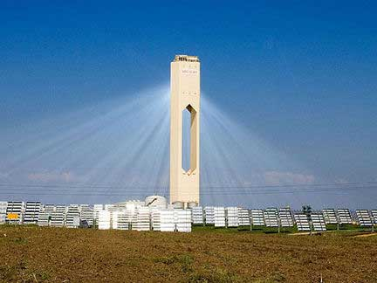
FIG- 2 : solar tower

Solar panel
A solar panel (photovoltaic module or photovoltaic panel) is a packaged interconnected assembly of solar cells, also known as photovoltaic cells. The solar panel can be used as a component of a larger photovoltaic system to generate and supply electricity in commercial and residential applications.
Because a single solar panel can only produce a limited amount of power, many installations contain several panels. Aphotovoltaic system typically includes an array of solar panels, an inverter, may contain a battery and interconnection wiring.
Solar panels use light energy (photons) from the sun to generate electricity through the photovoltaic effect. The structural (load carrying) member of a module can either be the top layer or the back layer. The majority of modules use wafer-based crystalline silicon cells or thin-film cells based on cadmium telluride or silicon. The conducting wires that take the current off the panels may contain silver, copper or other conductive (but generally not magnetic) transition metals.
The cells must be connected electrically to one another and to the rest of the system. Cells must also be protected from mechanical damage and moisture. Most solar panels are rigid, but semi-flexible ones are available, based on thin-film cells.
Electrical connections are made in series to achieve a desired output voltage and/or in parallel to provide a desired current capability.
Separate diodes may be needed to avoid reverse currents, in case of partial or total shading, and at night. The p-n junctions of mono-crystalline silicon cells may have adequate reverse current characteristics that these are not necessary. Reverse currents waste power and can also lead to overheating of shaded cells. Solar cells become less efficient at higher temperatures and installers try to provide good ventilation behind solar panels.^{[1]}
Some recent solar panel designs include concentrators in which light is focused by lenses or mirrors onto an array of smaller cells. This enables the use of cells with a high cost per unit area (such as gallium arsenide) in a cost-effective way.^{[citation needed]}
Depending on construction, photovoltaic panels can produce electricity from a range of frequencies of light, but usually cannot cover the entire solar range (specifically, ultraviolet, infrared and low or diffused light). Hence much of the incident sunlight energy is wasted by solar panels, and they can give far higher efficiencies if illuminated with monochromatic light. Therefore another design concept is to split the light into different wavelength ranges and direct the beams onto different cells tuned to those ranges.^{[2]} This has been projected to be capable of raising efficiency by 50%. The use of infrared photovoltaic cells has also been proposed to increase efficiencies, and perhaps produce power at night.^{[citation needed]}
Sunlight conversion rates (solar panel efficiencies) can vary from 5-18% in commercial products, typically lower than the efficiencies of their cells in isolation. Panels with conversion rates around 18% are in development incorporating innovations such as power generation on the front and back sides.^{[citation needed]} The Energy Density of a solar panel is the efficiency described in terms of peak power output per unit of surface area, commonly expressed in units of Watts per square foot (W/ft²). The most efficient mass-produced solar panels have energy density values of greater than 13 W/ft².
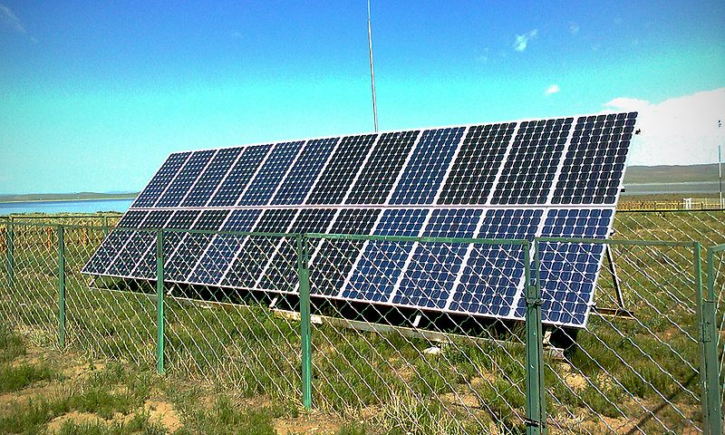
FIG- 3 : solar panel

Energy storage methods

Solar energy is not available at night, and energy storage is an important issue because modern energy systems usually assume continuous availability of energy.^{[96]}
Thermal mass systems can store solar energy in the form of heat at domestically useful temperatures for daily or seasonal durations. Thermal storage systems generally use readily available materials with high specific heat capacities such as water, earth and stone. Well-designed systems can lower peak demand, shift time-of-use to off-peak hours and reduce overall heating and cooling requirements.^{[97][98]}
Phase change materials such as paraffin wax and Glauber's salt are another thermal storage media. These materials are inexpensive, readily available, and can deliver domestically useful temperatures (approximately 64 °C). The "Dover House" (in Dover, Massachusetts) was the first to use a Glauber's salt heating system, in 1948.^{[99]}
Solar energy can be stored at high temperatures using molten salts. Salts are an effective storage medium because they are low-cost, have a high specific heat capacity and can deliver heat at temperatures compatible with conventional power systems. The Solar Two used this method of energy storage, allowing it to store 1.44 TJ in its 68 m³ storage tank with an annual storage efficiency of about 99%.^{[100]}
Off-grid PV systems have traditionally used rechargeable batteries to store excess electricity. With grid-tied systems, excess electricity can be sent to the transmission grid, while standard grid electricity can be used to meet shortfalls. Net metering programs give household systems a credit for any electricity they deliver to the grid. This is often legally handled by 'rolling back' the meter whenever the home produces more electricity than it consumes. If the net electricity use is below zero, the utility is required to pay for the extra at the same rate as they charge consumers.^{[101]} Other legal approaches involve the use of two meters, to measure electricity consumed vs. electricity produced. This is less common due to the increased installation cost of the second meter.
Pumped-storage hydroelectricity stores energy in the form of water pumped when energy is available from a lower elevation reservoir to a higher elevation one. The energy is recovered when demand is high by releasing the water to run through a hydroelectric power generator

5. ADVANTAGES
1. SOLAR ENERGY IS A RENEWABLE RESOURCE
You will never run out of solar energy. Sure, the sun sets at night, and on those dark and gloomy days it may not always be visible, but you can be sure that it will return. Oil, on the other hand, is limited, and once you run out, it is gone forever. Although the amount of power the sun can generate is limited to the amount of sunlight you get, it is possible to generate electricity even on cloudy days.
2. SOLAR POWER IS NON-POLLUTING
Unlike oil, solar power does not emit any sort of toxic gases into the environment. It is a completely environmentally friendly approach to generating electricity. There is even work being done to make the recycling of solar panels more effective.
3. LIGHT FROM THE SUN IS FREE
After the initial costs involved in setting up the solar panels and solar lights etc, you will never have to pay to run them.

4. SOLAR POWER IS QUITE FLEXIBLE
You can have an array of solar panels on your roof to generate power from your home. You can also have smaller solar cells on garden lights or anything else outside that only needs a small amount of electricity. Not having to run a wire can be a huge time saver.

5. SOLAR CELLS REQUIRE MINIMAL MAINTENANCE
Once the solar cells are set up, they require very little maintenance, mainly because there are no moving parts that have to be maintained. Solar cells can last a lifetime and is very easy to install.
6. SOLAR POWER IS SILENT
The methods that are used to find and extract oil are very noisy. Even wind power can create a lot of noise. Solar power is completely silent.
7. SOLAR ENERGY CAN SAVE MONEY IN THE LONG RUN
Solar energy has many advantages, some of them not as common as others. The main reason for this perhaps is that the initial cost is quite high. However, you can save a significant amount of money using solar power, which compares favorably to paying an electricity bill at the end of the month. There is a lot of work that has been done to make solar power more accessible to the common man, with researchers finding ways and means to make this resource a common practice. Solar power is indeed an amazing, natural energy resource with so much potential to be tapped into. It is just a matter of time before solar power becomes a global hit.
THE APPLICATIONS ARE AS FOLLOWS
RURAL ELECTRIFICATION
The provision of electricity to rural areas derives important social and economic benefits to remote communities throughout the world. Power supply to remote houses or villages, electrification of the health care facilities, irrigation and water supply and treatment are just few examples of such applications.
1. WATER PUMPING:
Solar pumps are used principally for two applications: village water supply (including livestock watering), and irrigation. Since villages need a steady supply of water, provision has to be made for water storage for periods of low insolation. In contrast, crops have variable water requirements during the year which can often be met by supplying water directly to produce without the need for a storage tank.
2. LIGHTENING:
In terms of the number of installations, lighting is presently the biggest application of photo-voltaic, with tens of thousands of units installed world-wide. They are mainly used to provide lighting for domestic or community buildings, such as schools or health centers. PV is also being increasingly used for lighting streets and tunnels, and for security lighting.
PROFESSIONAL APPLICATIONS
For some time, photovoltaic modules have proved to be a good source of power for high-reliability remote industrial use in inaccessible locations, or where the small amount of power required is more economically met from a stand-alone PV system than from mains electricity. Examples of these applications include:
1. OCEAN NAVIGATION AIDS: Many lighthouses and most buoys are now powered by solar cells.
2. TELECOMMUNICATION SYSTEMS: radio transceivers on mountain tops or telephone boxes in the country can often be solar powered.
3. REMOTE MONITORING AND CONTROL: scientific research stations, seismic recording, weather stations, etc. use very little power which, in combination with a dependable battery, is provided reliably by a small PV module.
4. CATHODIC PROTECTION: this is a method for shielding metalwork from corrosion, for example, pipelines and other metal structures. A PV system is well suited to this application since a DC source of power is required in remote locations along the path of a pipeline.

GRID CONNECTED SYSTEMS
Two types of grid-connected installations are usually distinguished, centralized PV power stations, and distributed generation in units located directly at the customer's premises(PV in buildings).
1. PV POWER Stations: A PV power station feeds the generated power instantaneously into the utility distribution network (the 'grid') by means of one or more inverters and transformers. PV power stations may be approaching economic viability in locations where they assist the local grid during periods of peak demand, and obviate the need to construct a new power station. This is known as peak shaving. It can also be cheaper to place small PV plants within the transmission system rather than to upgrade it ('embedded' generation).
2. PV In Buildings: PV arrays mounted on roof tops or facades offer the possibility of large-scale power generation in decentralized medium-sized grid-connected units.
The main advantages of these distributed systems over large PV plants are as follows:
Â¢ There are no costs in buying the land and preparing the site.
Â¢ The transmission losses are much lower because the load is on the same site as the supply.
Â¢ The value of the PV electricity is also higher because it is equal to the selling price of the grid electricity which has been replaced, rather that to the cost of generating it.

Disadvantages:
- One of the main disadvantages is the initial cost of the equipment used to harness the suns energy. Solar energy technologies still remain a costly alternative to the use of readily available fossil fuel technologies. As the price of solar panels decreases, we are likely to see an increase in the use of solar cells to generate electricity.

- A solar energy installation requires a large area for the system to be efficient in providing a source of electricity. This may be a disadvantage in areas where space is short, or expensive (such as inner cities).
- Pollution can be a disadvantage to solar panels, as pollution can degrade the efficiency of photovoltaic cells. Clouds also provide the same effect, as they can reduce the energy of the suns rays. This certain disadvantage is more of an issue with older solar components, as newer designs integrate technologies to overcome the worst of these effects.
- Solar energy is only useful when the sun is shining. During the night, your expensive solar equipment will be useless, however the use of solar battery chargers can help to reduce the effects of this disadvantage.
- The location of solar panels can affect performance, due to possible obstructions from the surrounding buildings or landscape.

Solar Conversion Efficiency
- he solar conversion efficiency of a solar cell or a photovoltaic cell is determined by how much of the sunlight the cell is able to convert into electrical energy. In other words, the proportion of the total light energy that a photovoltaic cell is able to convert into usable electricity is the solar conversionefficiency of that particular type of PV cell. It is on the basis of the solar conversionefficiency of a cell and the cost of its production that a PV cell is judged and ranked. The reason why it is so important that the solar conversion efficiency is significantly higher than previous generations is due to the fact that it is an alternative source of power that was invented mainly to reduce the pressure off from non-renewable sources of energy.
- In order to successfully do that, the solar cells need to provide a high solar conversion ratio, so that energy can at times replace the use of oil and coal. There are four main types of photovoltaic cells that are usually used in households and below are the names with a little detail and info about each of them.
- Amorphous Silicon PV Cells — These cells are not constructed with crystalline silicon, but they have a thin silicon film on the top of the metallic semiconductor (copper mainly). The one advantage that the amorphous silicon panels have over some of the others is that their cheaper production costs make them more affordable. However, since their solar conversion efficiency is as low as 5% or 6%, they may not be ideal if you are looking for benefit in the long run.
- Polycrystalline Silicon PV Cells — Also known as multi-crystalline silicon PV cells, these PV cells have metal conductors attached to their sides to stay in contact with the other cells in a panel and also to facilitate electron movement. The Polycrystalline panels have a solar efficiency rate that can be anything in between 12% to 14% and also, they can be the cheapest solar panels that one can buy. Apart from being cheap, it is also easier to replace an individual cell in a panel that consists of many PV cells, thus making the polycrystalline solar panels one of the best panels to install.
- Strong Ribbon Silicon PV Cells — These solar cells are quite similar when compared to the polycrystalline panels as far as the energy efficiency rates are concerned; in fact, they are even similar in the way that they are manufactured. They are however, even cheaper than the polycrystalline panels because these cells are constructed out of strips of silicon and metal connectors instead of being constructed purely out of silicon.
Monocrystalline Silicon PV Cells — Themonocrystalline panel consists of one single sheet of silicon with metals attached to the sides of the sheet only in order to further facilitate electron movement. With solar conversion efficiency rates as high as 18%, monocrystalline silicon solar cells or panels are the most effective in doing the job, but are also the most expensive among the four. However, if one manages to look past the initial setup costs, it can save a lot of money in the long run.

ELECTRIC POWER GENERATION IN SPACE
Photovoltaic solar generators have been and will remain the best choice for providing electrical power to satellites in an orbit around the Earth. Indeed, the use of solar cells on the U.S. satellite Vanguard I in 1958 demonstrated beyond doubt the first practical application of photovoltaics. Since then, the satellite power requirements have evolved from few Watts to several kilowatts, with arrays approaching 100 kW being planned for a future space station.
A space solar array must be extremely reliable in the adverse conditions of space environment. Since it is very expensive to lift every kilogram of weight into the orbit, the space array should also have a high power-to-weight ratio.

RESULTS
1. We can have pollution less world.
2. Avoid the scarcity of fossil fuels.
3. Abundant electricity for all purposes.
4. Supply power in deserts, oceans, and to remote areas.
5. Supply of sufficient power to earth orbiting satellites and space probes.

7. CONCLUSION
Solar cells are long lasting sources of energy which can be used almost anywhere particularly useful where there is no national grid and also where there are no people such as remote site water pumping or in space, provide cost effective solutions to energy problems in places where there is no mains electricity. Moreover they are totally silent and non-polluting. They have no moving parts they require little maintenance and have a long lifetime when compared to other renewable sources they also possess many advantages; wind and water power rely on turbines which are noisy, expensive and liable to breaking down. We are living in a society where there is a tremendous pollution ,with the scarcity of fossil fuels and resources .To overcome those problems we need to change our life styles. Since the solar energy is abundant and is free of cost, we can utilize the solar power to give a rebirth to mankind.

- BIBLIOGRAPHY
1. http://www.wikipedia.org
2.Google.com
3.Principles of electronics by Sze
4. http://www.greenblog.com

