Gear Propulsion Solar Car
Introduction:  MiniScience's Solar Racer activity introduces students to alternative energy concepts while incorporating problem solving, design and modeling. In addition, students will experience using hand tools as they construct their solar vehicle. | 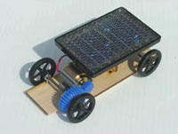
Students can explore:
- Propulsion types and drive concepts
- Basic soldering techniques and electronic concepts
- Alternative energies like solar power
Teacher Preparation:  During construction of the solar racer vehicle, students can experiment and comprehend methods of power transfer, soldering (optional), gear alignment and calculating gear ratios. It is up to the teacher to make sure this background information is provided to students in some manner. | 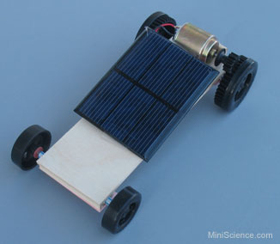
Background
The federal government has encouraged alternative forms of transportation due to a limited supply of oil and increasing environmental pollution. Solar cars are just one of many transportation concepts emerging. Solar cars use solar cell panels instead of gasoline as the fuel. As a result, exhaust fumes and oil consumption are eliminated.
The solar cell panel generates an electrical charge that is stored in a battery and used to provide energy as the vehicle is driven. The lighter the vehicle, the less energy used and the farther the vehicle will travel. In cloudy days, or at night, energy can be drawn from reserve batteries. In the future, charge stations will be located on the road sides for quick battery charging.
Materials Checklist:
Before using the kit please make sure you have all the items listed below. This kit has the supplies to build at least one type of solar car model. Solar cars may be propelled using a pulley/ rubber band method or some types of interlocking gears.
- Solar Cell
- DC motor
- Rear Slicks 1 9/16" diameter x 5/8" wide (1/2" wide for geared slicks)
- Front Wheels 1 3/8" diameter
- 1/8" dowel for axles
- Traction Bands (for non-geared slicks)
- Eyelets or washers
- Straw
- Wood Sheet 5" x 2" x 3/32" (or larger, so you can cut to any size)
- Basswood 5mm x 5mm x 20cm stick
- Motor Mount (With straps if needed)
- Procedure Sheet
Propulsion Systems:
Propulsion systems include using a solar cell and toy motor with a:
- gear drive
- Pulley and Rubber band drive
Advanced students are encouraged to experiment with different size pulleys, and gears if available.
Basic Tools Required
These items may be required to build the solar vehicle: (You can make your solar car model without them as well)
- craft knife, used to cut or trim soft wood.
- White glue, wood glue or glue gun
- Soldering Iron, needed if you need to solder wires.
- Pliers, used to connect and twist wires together if needed
- rulers, used for measurements
- Pencil, used for marking
Safety Recommendations
During the construction of the solar vehicle, the following safety precautions should be observed.
- Wear safety glasses
- Use care with sharp cutting blades
- Avoid touching the tip of the glue gun or soldering gun
- Put safety first
Competition Categories
Competition between students can be based on design, drawings, final appearance, distance-traveled, speed, etc.
Races can be held between cars that have similar or different types of propulsion Systems.
In addition, teachers could implement a problem-solving category for advanced or older students. Teachers would provide students with the solar racer kit then instruct students to make use of additional materials in the classroom to construct a customized solar vehicle. additional items could include wood scraps, stickers, paint, CD, colored wheels and more. How elaborate or complex the solar cars are depends on imagination and resources.
Standard Assembly Steps
Make your solar car model in 3 simple steps.
Step 1: | Construct the basic car chassis with 4 wheels  Cut a strip of wood that is 2" (5cm) wide. Mark the location of axles by drawing two lines, one on each end of the car, parallel to the front or back side. On the axle lines, mark two points that are 1/4" (6mm) away from each side. Insert one eye screw in each of the points. 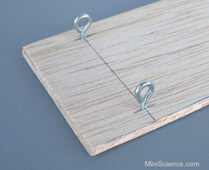  Eye screws are used to hold the axles. Insert the axle and make sure it is level and it can spin freely. If necessary, adjust the eye screws. 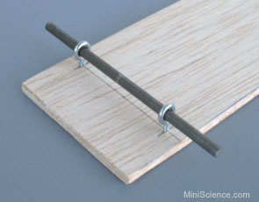  Cut some plastic tubes or straws and use them as the spacer in both sides. 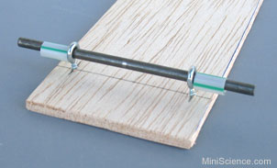  Insert the wheels. Wheels may be inserted while the axle is in position. 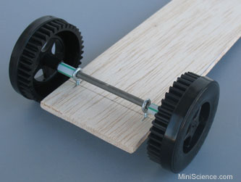  You can also insert the axle into one wheel and then pass it through the eye screws. 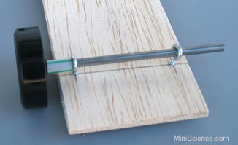  At the end your simple car will look like this. You can use it the way it is or you can turn it over as shown in the picture bellow. 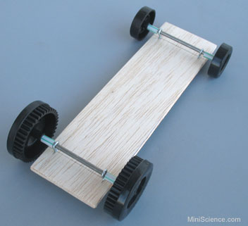  In the model shown here, the gears are built in the rear slicks (rear wheels). With plain wheels, you had to insert a pulley or gear in the same axle with one wheel. If you don't need to install pulleys or gears, continue with step 2. 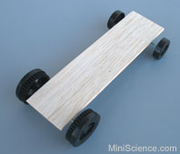  To mount a pulley or gear next to one wheel, it is a good idea to cut some space for that on your chassis; otherwise, one wheel will stand out and your model will not have a symmetrical shape. The size of this space may vary depending on the size of your pulley or gear. (3/8" x 1 1/2" cut is shown in this example) 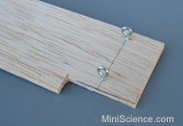  This is how a pulley or gear may be mounted beside one of the wheels. The pulley or gear must have a hole matching the axle diameter and must feet snugly. Some pulleys and gears require a plastic insert and some drilling in order to adapt the diameter of the axle you are using. 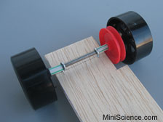  After mounting, make sure that the wheels can spin freely. If necessary, mount a metal washer between the spacer and eye screws. 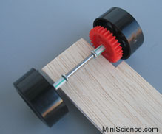  Other methods of mounting the axle  You may not have eye screws for mounting the axles. This is an alternate method for mounting wheels and axle. Insert the axle in one wheel, slide a washer onto it. Insert a 5 1/2" straw over it and finally insert another washer and another wheel. 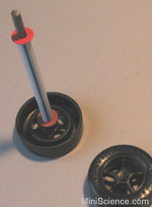  Your final wheels and axle will look like this. Hold the straw and spin the wheels. Make sure the wheels can spin freely. If necessary, make some adjustments. 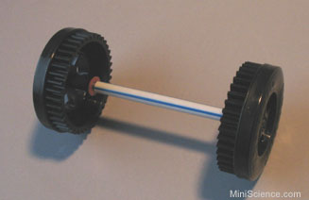  Cut 4 pieces of 2" (5cm) long wood strips and glue them about 1/5" (5mm) apart where you want to mount the axles. 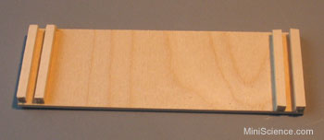  Insert the axle in the space between the strips and secure them in place using some glue. Cover it with a strip of cardboard or heavy construction paper. 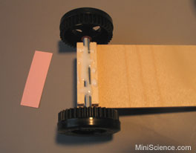  Note that the glue will touch the straw, not the axle. This is how the bottom of your car will look like after covering the axle holder with a strip of paper. 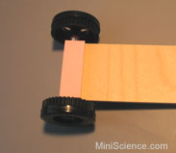

Step 2: | Mount the motor  Insert the small gear or pulley onto the motor's shaft. Place the motor on the self adhesive motor mount and strap it securely and snugly. 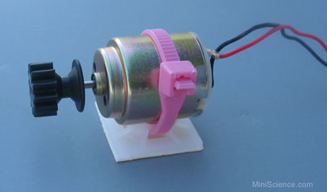  Place the motor on the car while the car is on a flat surface. Move it towards the gears until the gears engage. Mark the location of the motor. Avoid too much pressure on the gears because it will increase the friction and make it difficult for the car to move. 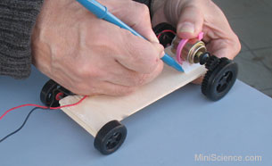  If you use pulleys to transmit force, motor must be mounted away from the pulley so that the rubber belt is slightly stretched. Carefully peal off the protective cover of the adhesive pad. Make sure you will not remove the adhesive pad itself. Place the motor where you already marked. Push it down firmly to stick in place. 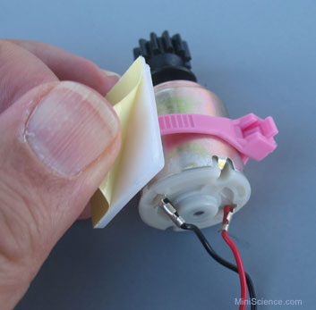

Step 3: | Mount the solar panel  Place the solar panel on the car. Connect the solar panel to the motor (if they are not already connected). 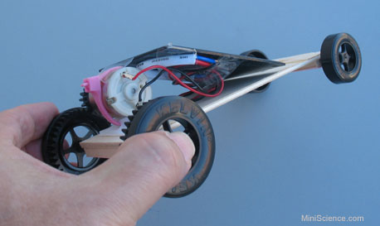  The solar panel may be mounted horizontally or slanted. It may be secured in place using a few pieces of clear tape. Take the car outside in a sunny location and test it. Does the motor run while you have the car in your hand? Do the wheels spin? Now place the car on a smooth flat surface so that the solar panel is faced to the sun. Does it run on the ground? 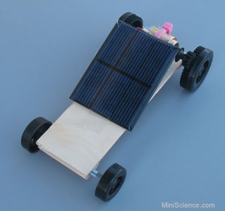  You can test your car indoor by replacing the sunlight with a strong portable light you may buy from a hardware store. Just position the lamp about 2 feet above the car and see how it works. For best results the portable lamp must have at least a 120 Watt bulb and a reflector. The final solar car you make may be different based on the materials you use, the design implementation and additional decorations you may add. 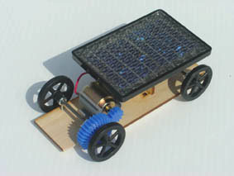  Decoration may include wooden or cardboard pieces you can add or paints you may use. 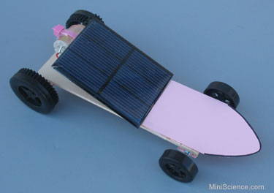
Alternate Assembly Procedure for gear driven solar car
The following steps relate to the construction of the basic solar racer vehicle. Steps relating to the completion of the propulsion systems are left to the student's discretion.
- Make sure your kit contains the items listed.
- Locate the grid planning sheet in the kit.
- Using a pencil and ruler, design the body of the vehicle and propulsion system.
Remember, the lighter the vehicle's body, the further it will travel.
- Show the drawing to the teacher when ready.
- Locate the balsawood sheet from the kit
- Transfer the vehicle body pattern to the balsawood.
- Using the craft knife and straight-edge, carefully cut out the vehicle body.
- Locate the straw from the kit. Also get scissors and glue gun.
- Cut straw in half
- Using the glue gun, attach the straws to the bottom of vehicle, one at each end (parallel to the end)
- Locate the axles through each straw.
- Push one wheel into each axle.
- Insert and axle through each straw.
- Carefully place the remaining wheel onto each axle.
Note: This completes construction of the basic solar vehicle.
- Locate the solar cell Panel and the required parts for the propulsion system chosen gears, pulleys, propeller, or rubber band. (Gears are supplied, Pulleys and propellers are optional.
- Assemble and attach the propulsion system as designed.
- Finish your solar racer as desired using paint, markers, etc.
- Race the assembled vehicle on a flat surface in a sunny day.

