CHAPTER 1. INTRODUCTION

The Skybus project was envisioned while looking at the pathetic road condition created by the metro infrastructure put in place on the wide roads which has caused enormous hardship and delays, traffic jams for the daily road users. The concept of metro as the solution to the city traffic jams as well as to handle large people movement from one area of the city to the other end seems very bright when looked upon from the surface level, whereas in reality people who owned the cars as well as the public transport bus system operated by the government will not evaporate overnight on the inauguration of metro.
The government may reduce a few number of buses in specific routes to accommodate the metro. Whereas private car owners under no circumstance would like to part with their personal cars, viewing this scenario traffic congestion in metro routes is not going to reduce substantially. Whereas installation and commissioning of metro has eroded road space by placing pillars along the road to run the metro overhead on the elevated platform. This concept of eroding road space will under all circumstances create narrow spaces on the important roads for car and bus utility. If the metro was put in place at least a decayed ago many city dwellers would have not gone in for purchase of personal four wheelers. With this in mind we thought about to build a system where the space erosion by a mask rapid transport system should provide extra road facility to improve the traffic condition as well as provide alternate transport system as metro.

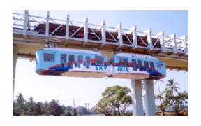

This type of system has been successfully implemented in certain countries, where road has been added along with introduction of metro type transport system. These systems are called as Sky Bus or Air Bus in high density metro polis cities in advance South East Asian countries.

1.1 EVOLUTION.

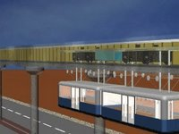

The under-frame with standard railway wheel-set running on railway track..Evolve into Skybus an improved railway.The under-frame remains same, railway wheels run on the same track, the coach is firmly attached to the under-frame positively.

chapter 2 Skybus technology

The basic concept of Sky Bus Metro is derived from the concept of Sky-Wheels presented in 1989 at World Congress for Railway Research.
In the Sky Bus technology, as can be seen in Fig.2.1, the median in the middle of road is used to raise columns to support 9.4 m wide concrete box 2.4 m high, which houses sky-guides and a powered bogie and can run on the sky-guides at speed upto 100 Kmph .The coaches are suspended from the bogie frame running overhead and thus are designed for lighter crush loads as compared to normal railway coaches. Tremendous savings are achieved in systems design.
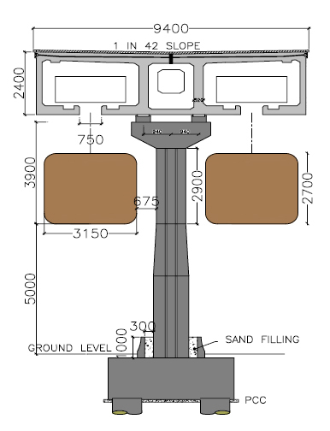
Fig2.1:Schematic arrangement of skybus

2.1 THE COMPONENTS OF SKY BUS
The system Sky Bus Metro consists of several conventional and some new proven technologies, which makes the Sky bus more efficient. These are designed so that to keep the sky bus moving without any defect and to give the passengers the ultimate comfort along with other luxurious facilities which they can not get in the local buses or in trains.
The components used in this are,
Sky way
Sky bogies
Sky coaches
Sky stations
Switching arrangements for change of tracks
2.1.1 Sky Way
The sky way consists of a concrete box structure carried over a series of piers at a height of about 10 m above existing road level. In the middle of roadway pile foundations support columns spaced at 15-25 m along the roadway in the median of the road. Two rails fixed with appropriate fastenings within the concrete box support and guide the sky bogie. There are no points & crossings.
2.1.2 Sky Bogie
Standard two axle bogies as used in Metros for speeds up to 100 Kmph are used (but can have higher speeds, if required up to 160 Kmph)- of Standard Gauge. 3 Phase AC motors with regenerative power capability.
Braking
a) Disc brakes (Planned for series production) b) Emergency mechanical brakes

2.1.3 Sky Coaches
Double walled light shells with wide large windows are suspended from the sky bogies.Air conditioned and with automatic doors. Audio visual information to passengers. Special 4m or 2x2m wide sliding doors for quick entry and exit of passengers. Each pair can carry up to 300 passengers.

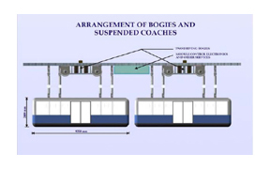
Fig2.2 arrangement of bogies and suspended coaches.

2.1.4 Sky Station
Unlike conventional mass transit systems, Sky Bus needs smaller stations. Service is at every 2 to 3 minute thereby there is virtually no waiting time for passengers. Completely automated with access control by me ans of electronic prepaid cards. Stations act as access facilities only and not as passenger holding areas.
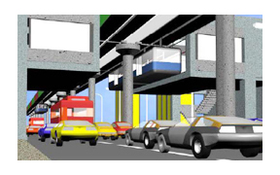
FIG2.3 SKY STATION
2.1.5 Switching arrangements
There are no points and crossings in Sky Bus Metro. The switching arrangements in the form of traverser or Y-connection/linearly shifting traverser/angular switch are provided at appropriate locations to shift the Sky Bus consists between track for the operational requirements and also for balancing the loads/ changing routes too as well as shift units to depot lines etc.
2.2 PROVEN TECHNOLOGIES USED IN SKY BUS METRO
Well proven 3 Phase AC motor technology,Well established structural design norms and proven technologies of prefabricated and pre-stressed concrete technologies, Konkan Railway's Anti-Collision Device technology.
2.3 CURRENT STATUS OF SKY BUS METRO
For optimization of Sky Bus Metro Technology and its commercial implementation, KRCL is seeking “ Global Expression of Interest “ for forging strategic business alliance on revenue sharing basis or similar model on its commercial deployment.

Chapter3 working principle of skybus

The under-frame remains same, railway wheels run on the same track,the coach is firmly attached to the under-frame positively
The under-frame with standard railway wheel-set running on railway track

Standard Railway coach running on railway track…

Chapter 4 Salient features
- Braking: Electrical re-generative braking, coupled with compressed air disk
mechanical brakes and emergency/ idling mechanical brakes for stabling.

- Capacity of 20m long train unit: Each Skybus unit 20m long having two compartments( 3.25m x 9.5m) of 9.5 m , can carry almost 400 persons at 7 persons/sq.m density peak.

- Signal & train control: Simple three aspect signal system driven by line of sight by motorman, with additional unique safety layer of Raksha Kavach, capable of providing 40 sec headway- but planned 60 sec.

- Route Capacity: A Sky bus route can thus be designed even at 60 sec headway, to carry 20,000 to 70,000 passengers per hour per direction in peak period.

- Security and safety: Continuous computerized central monitoring & control with provision of audio/visual access for each coach for security.
Distributed intelligence systems with redundancy to provide
protection against swinging under wind loads/emergecy localised
control/ prevent over-loading/ emergency evacuation guidance.

- Easy Access: Access is from existing footpaths, climb limited to 6 m for passengers- within 500 to 600m from wherever you are on the road having Skybus route.

- Stations are located with access from existing footpaths, and over
and above existing roadways, none of them longer than 60m to cater to next 100 years of requirements
\
- Power requirements: Typically for tropical climate conditions, for a module of 10 km route, 15 MW power needed covering traction and all services including comfort air-conditioning loads at stations.

Chapter 5 Safety measures
- Compared to conventional railway systems, the centre of gravity of the mass being carried on the wheels is brought down to be closer to the wheel support. hence dynamic safety is many time improved .
- In conventional railway wind can topple the trains. In Sky Bus wind cannot topple- there is positive link between the rail guidance system and the Bus Coaches- with 400%.
- The railway bogies in conventional system have propensity to lose control on derailment, but additional safety in Sky Bus bogie is that we have derailment arresters, which prevents the wheel from jumping off the rails. So we are ensuring that there is no derailment. safety factor built into multiple suspenders.
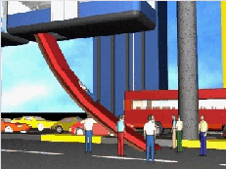
But, if there will be any problem occurs in the skybus during its running and it has to be stopped between two sky station, then there are the safety air bags provided with each coaches for emergency exit of the passengers in the mid way.

Chapter 6 advantages

Fast Transportation
Every two - three minute passengers to get Air Conditioned up to 100 km/h speed travel facility, covering distances at about 45 km/hr average speed.
Minimal Land Acquisition Problems
In this new technology of `Sky Wheels’, Minimal land acquisition will be required, except for providing for right of way on existing roadways.
No Vandalism
Not vulnerable to vandalism on track / moving gears are inaccessible.
No capsizing
If at all derails cannot fall down coach keeps hanging. Hence no capsizing takes place as compared to railways and underground metros.
Construction
a. Skybus uses factory produced pre- fabricated technologies with post tensioning and causes least disturbance to the daily life of city during construction.
b. It takes only 24 months to complete because of minimum problems of land and parallel activities of pre-fabricated structures. Other metro rails take 5 to 7 years!

Charges
a. At Rs 250 per person per 500 km of air-condition travel anywhere to anywhere, in a month, it is affordable for regular city commuter.
b. Minimum entry charges of Rs 5 will apply and floating or occasional users will be charged at Rs 2 per km.

6.1 SKY BUS IN NEAR FUTURE
After the successful test run of the sky bus in its test track in Madgaon Goa , The Indian Railway has recognized its work efficiency and found it as the future of mass communication in the urban areas. The Skybus has proved its effectiveness in various sectors in all the tests it has gone through. Hence the Skybus has proposed by the Railway department in following cities of India,Ahmedabad,Pune,Kochi,Kolkata,Lucknow,Mumbai,Pondicherry,Ranchi,Shimla,Thane,Bhubaneswar,Banglore,Chennai Coimbatore Delhi, Goa, Gurgaon,Hyderabad.

Chapter 7 CONCLUSION

The Skybus is the technology breakthrough that India has achieved. Skybus is an improved railway technology, eliminating the problems of existing metro rail systems, like, derailments collisions, and capsizing crushing people. Old conventional railway men, who remained basically operating and maintenance experts, may take a little time to appreciate, but the fact remains. Skybus is an improved railway technology eliminating their fears of derailments and capsizing from which they suffered for decades!
Financially Skybus Metro makes urban transport a dream come true for administrators- virtually free gift to people without Government fund in
What needs to be done is to eliminate the doubting Thomas in our minds, and adopt the Skybus, if we want to really solve the urban transport crisis. The Sky Bus metro is one single technology which can change the face of our cities, take out almost 10 million road vehicles in the cities and make the cities livable, improving quality of life and attract and sustain economic activity to generate wealth.

reference

Rail International -Brussels May 1983:- A simple approach to study rail wheel interaction - Author- B Rajaram
Rail International -Brussels April 1984:- A New Theory of Rail Wheel Interaction - Author- B Rajaram
www. konkanrailway.com
http://skybus.blogspot.com
http://skybus.metro.googlepages.com

