Dr.Ram Manohar Lohia Awadh University, Faizabad
Institute of Engineering and Technology
Electronics and Communication Department

Optical Fiber Communications

Seventh Semester 2009/2010

http://en.wikipedia.org/
To Open source community
B tech Community

Table of Content

TABLE OF CONTENT

ACKNOWLEDGEMENT
3

1.0
2.0
3.0
4.0
5.0
Introduction
History of Optical Fiber
Construction of Optical Fiber
Guiding Mechanism in Optical Fiber
Basic Components of OFC
4
5
8
9
11

5.1
5.2
5.3
5.4
Transmitter
Fiber
Receiver
Process
11
11
11
12

6.0
Principle of optical transmission
12

6.1
6.2
6.3
6.4
6.5
6.6
Refractive Index
Snell’s Law
Critical Angle
Total Internal Reflection
Acceptance Cone
Numerical Aperture
12
13
13
14
15
17

7.0
Advantage of optical fiber communication
19

7.1
Advantage of optical fiber communication
22

8.0
Dispersion
24

8.1
8.2
8.3

Material
Mode
Waveguide

25
25
25

9.0
Attenuation
26

9.1
9.2
9.3
Absorption loss
Light Scattering
Bending loss
27
28
29

10.0 Fiber
10.1 Multi Mode
10.2 Single Index
11.0 Optical Resources
11.1 LED
11.2 LASER
12.0 Optical Detectors
12.1 Photo Detectors
12.2 Photo Diodes
13.0 Limitations of Optical Fiber Technology
14.0 Application
CONCLUSION
REFERENCES
30
30
31
32
32
34
37
37
38
41
41

Acknowledgements

First and foremost I offer my sincerest gratitude to my teachers who has
supported me throughout my report, with his patience and knowledge. I
attribute the level of my bachelor degree to his encouragement and effort
and without him this report, too would not have been completed or
written. One simply could not wish for a better or friendlier .
The authors also wish to thank the other faculty members , for their
valuable suggestions and directions.
I am also indebted to the many countless contributors to the Internet,
online optical fiber community, PDF file editors, Microsoft office for
providing the numerous documents and tools I have used to produce
both my report, data and figure.
Department of Electronics and Communications has provided the
support I have needed to produce and complete my seminar report.
I also thanks for my batch mates for providing constant encouragement,
Support and valuable suggestions during the development of the report.
Finally, I thank my parents, uncle for supporting me throughout my
report through various methods.

1.0 Introduction of Optical Fiber:-

Our current “age of technology” is the result of many brilliant inventions
and discoveries, but it is our ability to transmit information, and the
media we use to do it, that is perhaps most responsible for its evolution.
Progressing from the copper wire of a century ago to today’s fiber optic
cable, our increasing ability to transmit more information, more quickly
and over longer distances has expanded the boundaries of our
technological development in all areas.
An optical fiber (or fiber) is a glass or plastic fiber
that carries light along its length. Fiber optics is the

overlap
of
applied
science
and
engineering

concerned with the design and application of optical
fibers. Optical fibers are widely used in fiber optic
communications, which permits transmission over
longer distances and at higher bandwidths (data rates) because light has
high frequency than any other form of radio signal than other forms of
communications. Light is kept in the core of the optical fiber by total
internal reflection.. This causes the fiber to act as a waveguide. Fibers are
used instead of metal wires because signals travel along them with less
loss, and they are also immune to electromagnetic interference, which is
caused by thunderstorm. Fibers are also used for illumination, and are
wrapped in bundles so they can be used to carry images, thus allowing

viewing in tight spaces. Specially designed fibers are used for a variety
of other applications, including sensors and fiber lasers.

2.0 History of Fiber Optic Technology:-

In 1870, John Tyndall, using a jet of water that flowed from one
container to another and a beam of light, demonstrated that light used
internal reflection to follow a specific
path. As water poured out through the
spout of the first container, Tyndall
directed a beam of sunlight at the path of
the water. The light, as seen by the
audience, followed a zigzag path inside
the curved path of the water. This simple
experiment, illustrated in Figure, marked the first research into guided
transmission of light.

In the same year, Alexander Graham Bell developed an optical voice
transmission system he called the photo phone. The photo phone used
free-space light to carry the human voice 200 meters. Specially placed
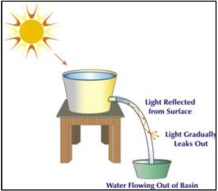

mirrors reflected sunlight onto a diaphragm attached within the
mouthpiece of the photo phone.
At the other end, mounted within a
parabolic reflector, was a light
sensitive selenium resistor. This
resistor was connected to a battery
that was, in turn, wired to a telephone receiver. As one spoke into the
photo phone, the illuminated diaphragm vibrated, casting various
intensities of light onto the selenium resistor. The changing intensity of
light altered the current that passed through the telephone receiver which
then converted the light back into speech. Bell believed this invention
was superior to the telephone because it did not need wires to connect
the transmitter and receiver. Today, free-space optical links find
extensive use in metropolitan applications.

The first practical all-glass fiber was devised by Brian O'Brien at the
American Optical Company and Narinder Kapany (who first coined
the term 'fiber optics'in 1956) and colleagues at the Imperial College of
Science and Technology in London. Early all-glass fibers experienced
excessive optical loss, the loss of the light signal as it traveled the fiber,
limiting transmission distances.
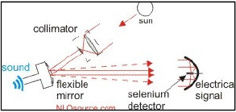

In 1969, several scientists
concluded that impurities in the
fiber material caused the signal
loss in optical fibers. The basic
fiber material did not prevent the light signal from reaching the end of
the fiber. These researchers believed it was possible to reduce the losses
in optical fibers by removing the impurities.
Jun-ichi Nishizawa, a Japanese scientist at Tohoku University, was the
first to propose the use of optical fibers for communications in 1963.
Nishizawa invented other technologies that contributed to the
development of optical fiber communications as well. Nishizawa
invented the graded-index optical fiber in 1964 as a channel for
transmitting light from semiconductor lasers over long distances with
low loss.
Fiber optics developed over the years in a series of generations that can
be closely tied to wavelength. Below Figure shows three curves. The
top, dashed, curve corresponds to early 1980's fiber, the middle, dotted,
curve corresponds to late 1980's fiber, and the bottom, solid, and curve
corresponds to modern optical fiber.
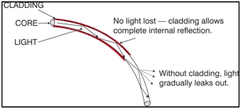

The earliest fiber optic systems were developed at an operating
wavelength of about 850 nm. This wavelength corresponds to the so-
called 'first window'in a silica-based optical fiber. This window refers to
a wavelength region that offers low optical loss. As technology
progressed; the first window became less attractive because of its
relatively high loss. Then companies jumped to the 'second window'at
1310 nm with lower attenuation of about 0.5 dB/km. In late 1977 the
'third window'was developed at 1550 nm. It offered the theoretical
minimum optical loss for silica-based
fibers. A 'fourth window,'near 1625
nm, is being developed. While it is
not lower loss than the 1550 nm
window, the loss is comparable, and
it might simplify some of the

complexities
of
long-length,

multiple-wavelength.
3.0 Construction of Optical Fiber Cable:-

Figure:-Construction of Fiber
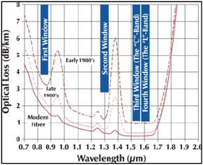

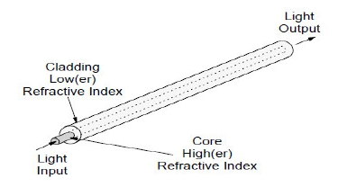

An optical fiber is a very thin strand of silica glass in geometry quite like
a human hair. In reality it is a very narrow, very long glass cylinder with
special characteristics. When light enters one end of the fiber it travels
(confined within the fiber) until it leaves the fiber at the other end.
An optical fiber consists of two parts: the core and the cladding. The
core is a narrow cylindrical strand of glass and the cladding is a tubular
jacket surrounding it. The core has a (slightly) higher refractive index
than the cladding. Light travelling along the core is confined by the
mirror to stay within it even when the fiber bends around a corner.
A fiber optic cable has an additional coating around the cladding called
the jacket. The jacket usually consists of one or more layers of
polymer. Its role is to protect the core and cladding from shocks that
might affect their optical or physical properties. It acts as a shock
absorber. The jacket also provides protection from abrasions, solvents
and other contaminants. The jacket does not have any optical properties
that might affect the propagation of light within the fiber optic cable.

4.0 Guiding Mechanism in optical fiber:-

Light ray is injected into the fiber optic cable on the right. If the light
ray is injected and strikes the core-to-cladding interface at an angle
greater than an entity called the critical angle then it is reflected back

into the core. Since the angle of incidence is always equal to the angle of
reflection the reflected light will again be reflected. The light ray will
then continue this bouncing path down the length of the fiber optic
cable. If the light ray strikes the core-to-cladding interface at an angle
less than the critical angle then it passes into the cladding where it is

attenuated
very
rapidly
with
propagation
distance.

Light can be guided down the fiber optic cable if it enters at less than the
critical angle. This angle is fixed by the indices of refraction of the core

and cladding and is given by the formula:

The critical angle is measured from the cylindrical axis of the core. By
way of example, if n1 = 1.446 and n2= 1.430 then a quick computation
will show that the critical angle is 8.53 degrees, a fairly small angle.

Figure:-Mechanism of Light wave guide in Fiber

Of course, it be noted that a light ray enters the core from the air outside,
to the left of Figure. The refractive index of the air must be taken into
account in order to assure that a light ray in the core will be at an angle
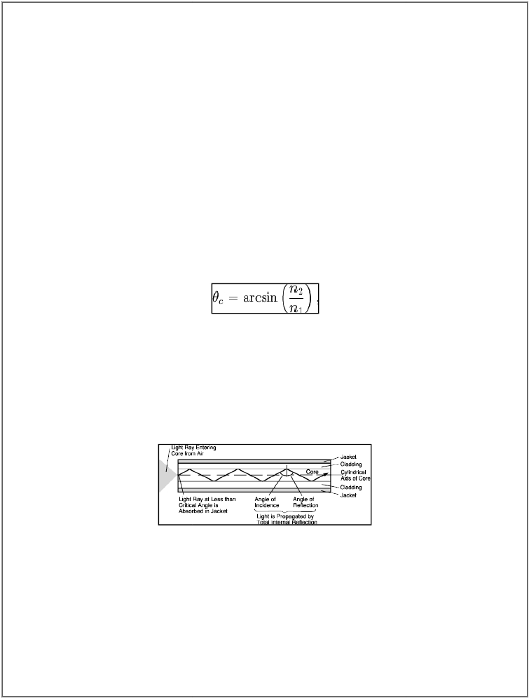

less than the critical angle. This can be done fairly simply. Suppose a
light ray enters the core from the air at an angle less than an entity called
the external acceptance angle It will be guided down the core.

5.0 Basic Component of Optical Fiber Communication:-

5.1 Transmitters: -
Fiber optic transmitters are devices that include an LED or laser source,
and signal conditioning electronics, to inject a signal into fiber. The
modulated light may be turned on or off, or may be linearly varied in
intensity between two predetermined levels.

Figure:-The basic components of an optical fiber communication
5.2 Fiber:-
It is the medium to guide the light form the transmitter to the receiver.
5.3 Receivers:-Fiber optic receivers are instruments that convert light into
electrical signals. They contain a photodiode semiconductor, signal
conditioning circuitry, and an amplifier at the receiver end.
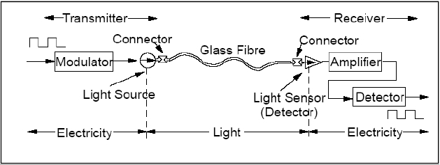

5.4 Process of Optical Fiber Communication:-
A serial bit stream in electrical form is presented to a modulator, which
encodes the data appropriately for fiber transmission.
A light source (laser or Light Emitting Diode - LED) is driven by
the modulator and the light focused into the fiber.
The light travels down the fiber (during which time it may
experience dispersion and loss of strength).
At the receiver end the light is fed to a detector and converted to
electrical form.
The signal is then amplified and fed to another detector, which
isolates the individual state changes and their timing. It then
decodes the sequence of state changes and reconstructs the original
bit stream.
The timed bit stream so received may then be fed to a using device

6.0 Principle of optical transmission

6.1 Index of refraction:-

This is the measuring speed of light in respective medium. it is
calculated by dividing speed of light in vacuum to the speed of light in
material. The RI for vacuum is 1, for the cladding material of optical
fiber it is 1.46, the core value of RI is 1.48(core RI must be more than
cladding material RI for transmission. it means signal will travel around
200 million meters per second. it will 12000 km in only 60 seconds.

other delay in communication will be due to communication equipment
switching and decoding, encoding the voice of the fiber.
6.2 Snell's Law:-

In order to understand ray propagation in a fiber. We need one more
law from high school physics. This is Snell'slaw.

n1 sin .01 = n2 sin .02
Where n denotes the refractive index of the material.01/02 are angles in
respective medium. Higher Refractive Index means denser medium.
1) When light enters in lighter medium from denser it inclines
towards normal.
2) When light enters in denser medium from lighter it inclines away
to normal

6.3 Critical Angle:-

If we consider we notice above that as the angle 01 becomes larger and
larger so does the angle 02. Because of the refraction effect 02.
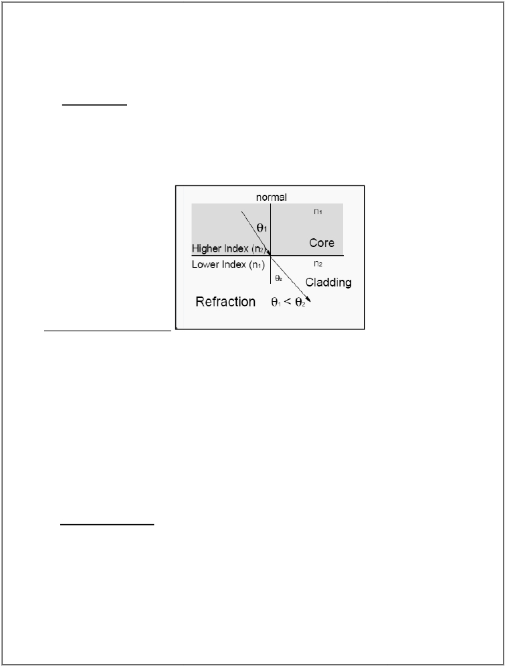

becomes larger more quickly than 01 .At
some point 02 will reach 90° while 01 is
still well less than that. This is called the
“critical angle”. When 01is increased
further then refraction ceases and the
light starts to be reflected rather than refracted. Thus light is perfectly
reflected at an interface between two materials of different refractive
index if:

1. The light is incident on the interface from the side of higher refractive
index.
2. The angle is greater than a specific value called the “critical angle”.
Glass refractive index is 1.50 (critical angle is 41.8), Diamond critical
angle is 24.4 degree.

6.4Total Internal reflection (TIR):-

When light traveling in a dense medium hits a boundary at a steep angle
(larger than the "critical angle “for the boundary), the light will be
completely reflected. This phenomenon is called total internal
reflection. This effect is used in optical fibers to confine light in the
core. Light travels along the fiber bouncing back and forth off of the
boundary; because the light must strike the boundary with an angle
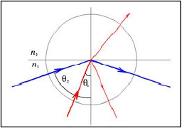

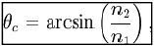

greater than the critical angle, only light that enters the fiber within a
certain range of angles can travel down the
fiber without leaking out.. Total internal
reflection occurs when light enters from
higher refractive index to lower refractive
index material, i.e from glass to air total
internal reflection is possible but it is not
possible in air to glass.

Figure-1(optical rays leaks out from core i.e. is loss)

Fig-2 (Optical rays reflected back due to TIR)

If we now consider above Figures we can see the effect of the critical
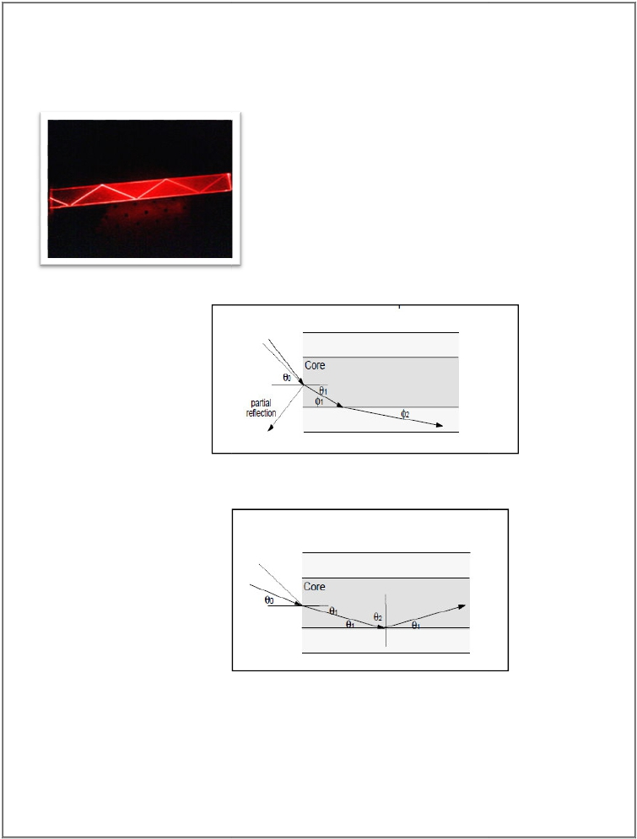

angle within the fiber. In Figure 2 we see that for rays where angle01 is
less than a Critical value then the ray will propagate along the fiber and
will be “bound” within the fiber. In Figure 1 we see that where the angle
01 is greater than the critical value the ray is refracted into the cladding
and will ultimately be lost outside the fiber. This is loss.

6.5 Acceptance Cone:-

Figure 3: Acceptance cone
When we consider rays entering the fiber from the outside (into the end
face of the Fiber) we see that there is a further complication. The
refractive index difference between the fiber core and the air will cause
any arriving ray to be refracted. This means that there is a maximum
angle for a ray arriving at the fiber end face at which the ray will
propagate. Rays arriving at an angle less than this angle will propagate
but rays arriving at a greater angle will not. This angle is not a “critical
angle” as that term is reserved for the case where light arrives from a
material of higher RI to one of lower RI. (In this case, the critical angle
is the angle within the fiber.) Thus there is a “cone of acceptance” at the
end face of a fiber. Rays arriving within the cone will propagate and
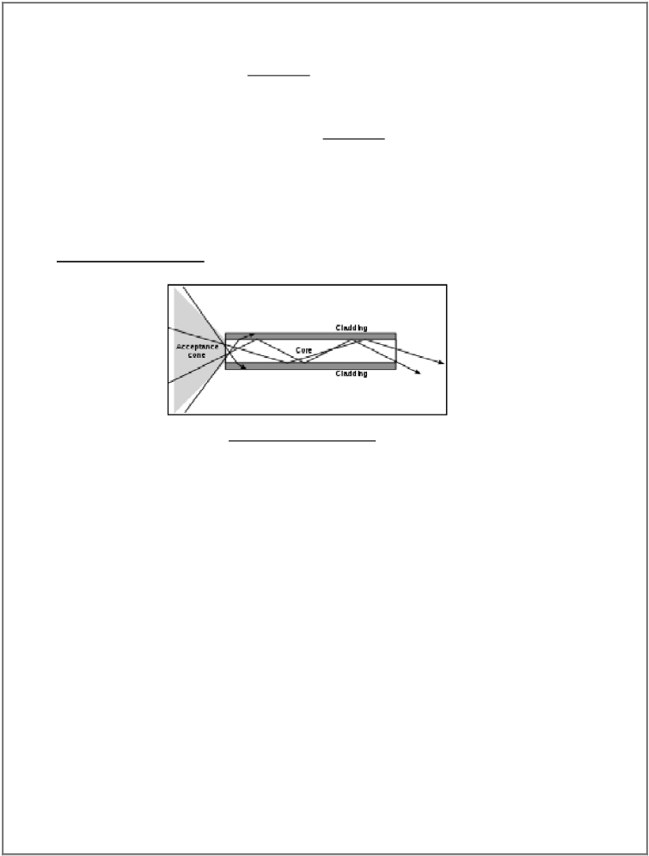

ones arriving outside of it will not. The size of acceptance cone is
function of difference of RI of core and cladding.
6.6 Numerical aperture (NA):-

Figure: - 4 (Numerical aperture)

One of the most often quoted characteristics of an optical fiber is its
“Numerical Aperture”. The NA is intended as a measure of the light
capturing ability of the fiber. However, it is used for many other
purposes. For example it may be used as a measure of the amount of loss
that we might expect on a bend of a particular radius etc.
Figure 2 on shows a ray entering the fiber at an angle close to its axis.
This ray will be refracted and will later encounter the core-cladding
interface at an angle such that it will be reflected. This is because the
angle 02 will be greater than the critical angle. The angle is greater
because we are measuring angles from a normal to the core-cladding
boundary not a tangent to it.
Figure 1 on shows a ray entering at a wider angle to the fiber axis. This
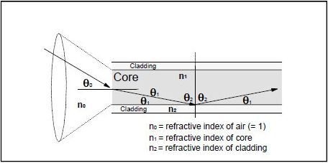

One will reach the core-cladding interface at an angle smaller than the
critical angle and it will pass into the cladding. This ray will eventually
be lost. It is clear that there is a “cone” of acceptance (illustrated in
Figure 3 ). If a ray enters the fiber at an angle within the cone then it will
be captured and propagate as a bound mode. If a ray enters the fiber at
an angle outside the cone then it will leave the core and eventually leave
the fiber itself.
The Numerical Aperture is the sine of the largest angle contained within
the cone of acceptance. In figure 4 it is SINE 0O

We know that sin 02 =n2/n1
Because 02 is the critical angle
And n0 sin 00 = n1 sin 01 from Snell's Law
Now, cos 01 = sin 02 =n2/n1
We know that sin x = (1 − cos2x )1/2(Rule)
Therefore sin 01 = (1 –n22/n12)1/2
Since n0 = 1 then sin 00 = n1 (1 –n22/n12)1/2
Therefore NA = (n12-n22)1/2
Where n1 = refractive index of the core
n2 = refractive index of the cladding

Typical NA for single-mode fiber is 0.1. For multimode, NA is between
0.2 and 0.3(usually closer to 0.2)

6.6.1 Significance of NA with fiber characteristics:-

It is a measure of the ability of the fiber to gather light at the input
end.
Because it is a measure of the contrast in RI between the core and
the cladding. It is a good measure of the light guiding properties of
the fiber. The higher the NA the tighter (smaller radius) we can
have bends in the fiber before loss of light becomes a problem.
The higher the NA the more modes we have rays can bounce at
greater angles and therefore there are more of them. This means
that the higher the NA the greater will be the dispersion of this
fiber (in the case of Multi Mode fiber).
In Single Mode(SM) fiber a high RI contrast usually implies a high
level of dopant in the cladding. Since a significant proportion of
optical power in SM travels in the cladding we get a significantly
increased amount of attenuation due to the higher level of dopant.
Thus (as a rule of thumb) the higher the NA of SM fiber the higher
will be the attenuation of the fiber.

7.0 Advantage of Optical fiber:-

Fiber optic transmission systems a fiber optic transmitter and receiver,
Connected by fiber optic cable offer a wide range of benefits not offered
by traditional copper wire or coaxial cable. These include:

Less Expensive. First, fiber optics are less expensive than copper
wire. This is because many miles of optical cable are easier and
less expensive to install than the same amount of copper wire or
cable.
Thinner. Fiber optics is thinner than copper wire cables, so they
will fit in smaller, more crowded places. This is important for
underground cable systems, like in cities, where space needs to be
shared with sewer pipes, power wires, and subway systems.
Higher Carrying Capacity. More information can also be carried
over fiber optic systems. This can be especially important for
computers, since a computer has to send so much information at
one time. Also, more phone lines can be in one optical fiber. Many
people use the same optical cable for phone conversations at the
same time.
Less signal degradation . Information gets lost over distances an
any kind of wire. But, fiber optic cables don’t lose as much signal
(information) as other kinds of wires and cables.
Use Light Signals . Because fiber optics use light signals instead of
electricity, the signals don’t interfere with each other. This makes
the signals clearer and easier to understand.
Low Power. Optical fiber signals are created using low-power
transmitters because the signal degrades less (instead of high-

power electric transmitters used for copper wires). Lower power
use saves money for users and providers.
Digital Signals . Computer networks need digital information, since
fiber optic cables send information digitally; they are the best thing
to use for computer networks.
Non-flammable. Since fiber optics send light instead of electricity,
fiber optics are non-flammable. This means there is not a fire
hazard. Fiber optics also does not cause electric shocks, because
they do not carry electricity.
Light weight. Fiber optics is easier to install and transport than
copper wires. That is good news for technicians
Flexible. Since fiber optics is more flexible, they can go around
corners and into tighter places than traditional cable. This is
important in computer and very big office networks.

Other benefits are:-

The fiber is totally immune to virtually all kinds of
interference, including lightning, and will not conduct
electricity. It can there- fore come in direct contact with high
voltage electrical equipment and power lines. It will also not
create ground loops of any kind.
As the basic fiber is made of glass, it will not corrode and is
unaffected by most chemicals. It can be buried directly in

most kinds of soil or exposed to most corrosive atmospheres
in chemical plants without significant concern.
Fiber optic cables are virtually unaffected by outdoor
atmospheric conditions, allowing them to be lashed directly
to telephone poles or existing electrical cables without
concern for extraneous signal pickup.

Fiber optic cable is ideal for secure communications systems
because it is very difficult to tap but very easy to monitor. In
addition, there is absolutely no electrical radiation from a
fiber.

7.1 Advantage of optical fiber communication:-

Wider bandwidth: The information carrying capacity of a
transmission system is directly proportional to the carrier
frequency of the transmitted signals. The optical carrier frequency
is in the range 1013 to 1015 Hz while the radio wave frequency is
about 106 Hz and the microwave frequency is about 1010 Hz. Thus
the optical fiber yields greater transmission bandwidth than the
conventional communication systems and the data rate or number
of bits per second is increased to a greater extent in the optical

fiber communication system. Further the wavelength
division

multiplexing operation by the data rate or information carrying
capacity of optical fibers is enhanced to many orders of magnitude.

Low transmission loss: Due to the usage of the ultra low loss fibers
and the erbium doped silica fibers as optical amplifiers, one can
achieve almost lossless transmission. In the modern optical fiber
telecommunication systems, the fibers having a transmission loss
Of 0.002 dB/km are used. Further, using erbium doped silica fibers
over a short length in the transmission path at selective points;
appropriate optical amplification can be achieved. Thus the
repeater spacing is more than 100 km. Since the amplification is
done in the optical domain itself, the distortion produced during
the strengthening of the signal is almost negligible.
Dielectric waveguide: Optical fibers are made from silica which is
an electrical insulator. Therefore they do not pickup any
electromagnetic wave or any high current lightning. It is also
suitable in explosive environments. Further the optical fibers are
not affected by any interference originating from power cables,
railway power lines and radio waves. There is no cross talk
between the fibers even though there are so many fibers in a cable
because of the absence of optical interference between the fibers.
Signal security: The transmitted signal through the fibers does not
radiate. Further the signal cannot be tapped from a fiber in an easy
manner. Therefore optical fiber communication provides hundred
per cent signal security.

Small size and weight: Fiber optic cables are developed with small
radii, and they are flexible, compact and lightweight. The fiber
cables can be bent or twisted without damage. Further, the optical
fiber cables are superior to the copper cables in terms of storage,
handling, installation and transportation, maintaining comparable
strength and durability.

8.0 Dispersion:-

Figure:-5 Effect of Dispersion

Dispersion occurs when a pulse of light is spread out during
transmission on the fiber. A short pulse becomes longer and ultimately
joins with the pulse behind, making recovery of a reliable bit stream
impossible. (In most communications systems bits of information are
sent as pulses of light. 1 = light, 0 = dark. But even in analogue
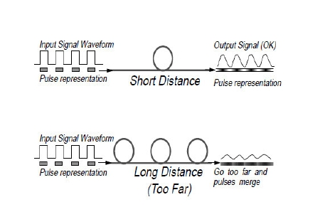

transmission systems where information is sent as a continuous series of
changes in the signal, dispersion causes distortion.)
There are many kinds of dispersion, each of which works in a different
way, but the most important three are discussed below:
8.1Material dispersion (chromatic dispersion):-
Both lasers and LEDs produce a range of optical wavelengths (a band
Of light) rather than a single narrow wavelength. The fiber has different
refractive index characteristics at different wavelengths and therefore
each wavelength will travel at a different speed in the fiber. Thus, some
wavelengths arrive before others and a signal pulse disperses (or smears
out).
8.2 Intermodal dispersion (Mode Dispersion):-
When using multimode fiber, the light is able to take many different
paths or “modes” as it travels within the fiber. The distance traveled by
light in each mode is different from the distance travelled in other
modes. When a pulse is sent, parts of that pulse (rays or quanta) take
many different modes (usually all available modes). Therefore, some
components of the pulse will arrive before others. The difference
between the arrival times of light taking the fastest mode versus the
slowest obviously gets greater as the distance gets greater.
8.3 Waveguide dispersion:-
Waveguide dispersion is a very complex effect and is caused by the
shape and index profile of the fiber core. However, this can be

controlled by careful design and, in fact, waveguide dispersion can be
used to counteract material dispersion.

Dispersion in different fibers:

Mode dispersion > .material dispersion > waveguide dispersion.

9.0Attenuation:-

Figure:-6. Fiber Infrared Absorption Spectrum. The lower curve shows the characteristics of a single-mode
fiber made from a glass containing about 4% of germanium dioxide (GeO2) dopant in the core. The upper
curve is for modern graded index multimodefibre. Attenuation in multimode fiber is higher than in single-
mode because higher levels of dopant are used. The peak at around 1400 nm is due to the effects of traces of
water in the glass.

Attenuation in fiber optics, also known as transmission loss, is the

reduction in intensity of
the light
beam with respect
to
distance

travelled through a transmission medium. Attenuation coefficients in
fiber optics usually use units of dB/km through the medium due to the
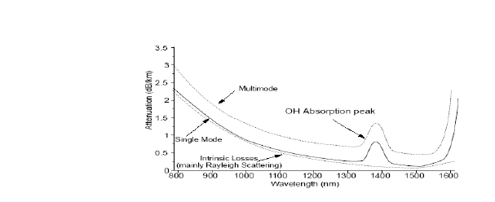

relatively high quality of transparency of modern optical transmission
media.

Attenuation in an optical fiber is caused by absorption, scattering, and
bending losses. Attenuation is the loss of optical power as light travels
along the fiber. Signal attenuation is defined as the ratio of optical input
power (Pi) to the optical output power (Po). Optical input power is the
power injected into the fiber from an optical source. Optical output
power is the power received at the fiber end or optical detector.

Each mechanism of loss is influenced by fiber-material properties and
fiber structure. However, loss is also present at fiber connections i.e.
connector, splice, and coupler losses.

9.1 Absorption loss:-

Absorption in optical fibers is explained by three factors:

Imperfections in the atomic structure of the fiber material
The intrinsic or basic fiber-material properties
The extrinsic (presence of impurities) fiber-material properties

Imperfections in the atomic structure induce absorption by the presence
of missing molecules or oxygen defects. Absorption is also induced by
the diffusion of hydrogen molecules into the glass fiber.
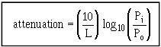

9.1.1 Intrinsic Absorption. -

Intrinsic absorption is caused by basic fiber-

material properties. If an optical fiber were absolutely pure, with no
imperfections or impurities, then all absorption would be intrinsic.
Intrinsic absorption sets the minimal level of absorption.

9.1.2Extrinsic Absorption.

- Extrinsic absorption is caused by impurities

introduced into the fiber material. Trace metal impurities, such as iron,

nickel, and chromium, OH ions
are introduced into the fiber during

fabrication. Extrinsic absorption is caused by the electronic transition of
these metal ions from one energy level to another.

9.2 Light scattering:-

Basically, scattering losses are caused by the interaction of light with
density fluctuations within a fiber. Density changes are produced when
optical fibers are manufactured. During manufacturing, regions of higher
and lower molecular density areas, relative to the average density of the
fiber, are created. Light traveling through the fiber interacts with the
density areas as shown in Light is then partially scattered in all direction.

Figure: - 7(Scattering process)
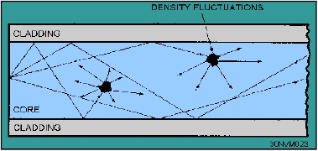

In commercial fibers operating between 700-nm and 1600-nm
wavelength, the main source of loss is called Rayleigh scattering.. As
the wavelength increases, the loss caused by Rayleigh scattering
decreases. If the size of the defect is greater than one-tenth of the
wavelength of light, the scattering mechanism is called Mie scattering.

9.3 Bending loss:-

As light travels along the fiber, it is reflected from the interface between
the core and cladding whenever it strays from the path straight down the
Center. When the fiber is bent, the light only stays in the fiber because
of this reflection. But the reflection only works if the angle of incidence
is relatively low. If you bend the fiber too much the light escapes.
The amount of allowable bending is specific to particular cables because
it depends on the difference in refractive index, between core and
cladding. The bigger the difference in refractive index, the tighter the
allowable bend radius. There is a tradeoff here because there are many
other reasons that we would like to keep this difference as small as
possible. Two types of losses are there.microbend loss or macro bend
loss.
Micro bends losses are small microscopic bends of the fiber axis that
occur mainly when a fiber is cabled. Micro bend losses are caused by
small discontinuities or imperfections in the fiber. External forces are
also a source of micro bends.

Figure:-8 Bending loss

10.0 Fiber:-
Fiber is the medium to guide the light form the transmitter to the
receiver. It is classified into two types depending on the way the light is
transmitted: multimode fiber and single-mode fiber.

10.1 Multimode Fiber:-
Multimode fiber designed to transmit more than one light at a time.
Fiber diameter ranges from 50-to-100 micron. Multimode fibers can be
divided in to two categories Multimode Step-index Fiber and Multimode
Graded-index Fiber .
In Multimode Step-index Fiber the lights are sent at angles lower
than the critical angle or straight (or simply the angle is zero). Any light
angle exceed the critical angle will cause it to penetrate through cladding
(refracted) and being lost as shown in Figure 9. Obviously light with
lower angle which has less number of reflection, reach the end faster
than those with larger angle and this will result in unstable wave light.
To avoid this problem there should be spacing between the light pulses,
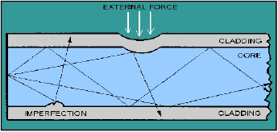

but this will limit the bandwidth and because of that it is used for very
short distance.

Figure 9 :- Multimode Step-index Fiber

The Multimode Graded-index Fiber designed to reduce the
problem in Multimode Step-Index fiber by making all the beams
reaching the receiver at the same time. This can be done by slowing
down the ones with shorter distance and increasing the speed for ones
with longer distance, see Figure 10. This is done in fiber implementation
by increasing its refractive index at the center and gradually decreases it
toward the edges. In the Figure 10 we can see the light near the edges is
curved until it is reflected, this is due to the refraction caused by the
change in density.

Figure 10:- Multimode Graded-Index Fiber

10.2 Single-Mode Fiber:-
In single-mode, only one light is transmitted in the fiber which
diameter ranges from 8.3 to 10 microns, see Figure 11. Since there is
only one light the problem associated with the multimode fiber does not
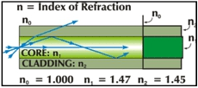

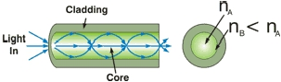

exist and by this we can have a higher transmission rate and also it can
be used for longer distance.

Figure 11:- Single-Mode Fiber
11.0 Optical Sources:-
There are two kinds of devices that are used as light sources: Lasers and
LEDs.

11.1 LED: -
LED is just a forward biased p-n junction. There is a

recombination of holes and electrons. This recombination requires
energy possessed is the unbound free electron is transferred to another
state. In all semiconductor p-n junctions some of this energy will be
given off as heat and some in the form of photons .In silicon and
germanium greater percentage is given up in the form of heat and the
emitted light is insufficient. In other material, such as gallium arsenide
phosphide (GaAsP) or gallium phosphide (GaP) , the number of photos
of light energy emitted is sufficient to create a very visible light source.
The process of giving off light by applying an electrical source of energy
is called electroluminescence.
11.1.1 Operation of LEDs:-

The wavelength of light emitted by the LED is inversely proportional to
the band gap energy. The higher the energy the shorter the wavelength.
The formula relating electron energy to wavelength is given below.
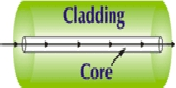

The materials of which the LED is made determine the wavelength of
light emitted. The following table shows energies and wavelengths for
commonly used materials in semiconductor LEDs and lasers.

11.1.2 Heterojunctions (Practical LEDs):- Heterojunction

means that a p-n

junction is formed by a single crystal such that the material on one side
of the junction differs from that on the other side of the junction. In the
modern GaAs diode lasers, a hetero junction is formed between GaAs
and GaAlAs. This type of p-n junction diode laser or LED is used at 800
m wavelength. At longer wavelengths, InP-InGaAsP heterojunction
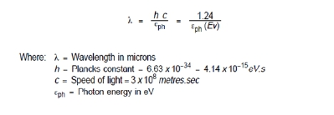

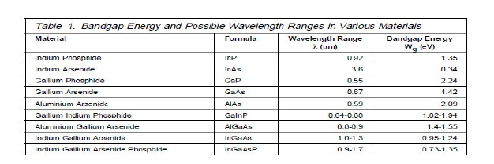

Figure: Hetrojunction LED

diodes are used. Generally heterojunction LEDs have minimum
threshold current density (10 A/mm2), high output power (10 mW) even
with low operating current (<500 mA) high coherence and high
monochromaticity, high stability and longer life.
Characteristics of LEDs:-
Low Cost
Low Power
Relatively Wide Spectrum Produced
Incoherent Light
Digital Modulation
Analogue Modulation

11.2 Lasers:-

LASER is an acronym for “Light Amplification by the

Stimulated Emission of Radiation”. Lasers produce far and away the
best kind of light for optical communication. Ideal laser light is single-
wavelength only. This is related to the molecular characteristics of the
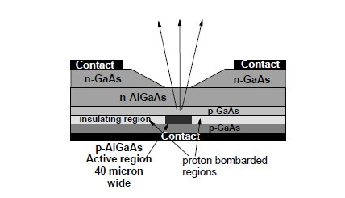

material being used in the laser. It is formed in parallel beams and is in a
single phase. That is, it is “coherent”.
Lasers can be modulated (controlled) very precisely (the record is a
pulse length of 0.5 femto seconds.
Lasers can produce relatively high power. Indeed some types of
laser can produce kilowatts of power. In communication
applications, semiconductor lasers of power up to about 20 mill
watts are available. This is many times greater power than LEDs
can generate. Other semiconductor lasers (such as those used in
“pumps” for optical amplifiers) have outputs of up to 250 mill
watts.
Because laser light is produced in parallel beams, a high
percentage (50% to 80%) can be transferred into the fiber.

11.2.1 Principle of the LASER:-
1.An electron within an atom (or a molecule or an ion) starts in a low
energy stable state often called the “ground” state.
2. Energy is supplied from outside and is absorbed by the atomic
structure whereupon the electron enters an excited (higher energy) state.
3. A photon arrives with energy close to the same amount of energy as
the electron needs to give up reaching a stable state. (This is just another
way of saying that the wavelength of the arriving photon is very close to
the wavelength at which the excited electron will emit its own photon.)

Figure:-Principle of operation of laser

Figure: Spontaneous Emission
4. The arriving photon triggers a resonance with the excited atom. As a
result the excited electron leaves its excited state and transitions to a
more stable state giving up the energy difference in the form of a
photon.
The critical characteristic here is that when a new photon is emitted it
has identical wavelength, phase and direction characteristics as the
exciting photon.
Note: The photon that triggered (stimulated) the emission itself is not
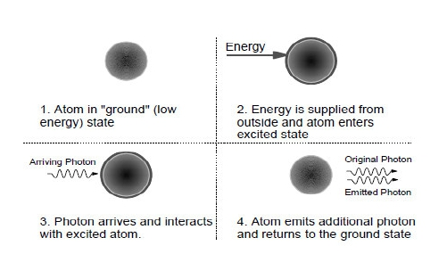

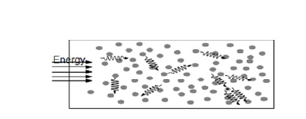

absorbed and continues along its original path accompanied by the
newly emitted photon.

12.0 Optical Detectors:-

The predominant types of light detector used in communications systems
rely on the principle of ionization in a semiconductor material. When
discussing photo detectors there are four important parameters:
Detector Responsivity:-This is the ratio of output current to input
optical power. Hence this is the efficiency of the device.
Spectral Response Range:-This is the range of wavelengths over which
the device will operate.
Response Time:-This is a measure of how quickly the detector can
respond to variations in the input light intensity.
Noise Characteristics:-
12.1 Photoconductors:-

Photoconductors are the simplest conceivable optical detector. The
device consists of a piece of (undoped) semiconductor material with
electrical contacts attached. A voltage is applied across the contacts.
When a photon arrives in the semiconductor it is absorbed and an
electron/hole pair is created. Under the influence of the electric field
between the two contacts the electron and the hole each migrate toward
one of the contacts. Wave length depends on amount of light falling .

Figure: Photoconductor detector
12.2 Photodiodes:-
Photodiodes convert light directly to electric current. An ideal (p-i-n)
diode can convert one photon to one electron of current
12.2.1 P-N Diodes:-
The principle involved in a PIN diode is simply the principle of the LED
in reverse. That is, light is absorbed at a p-n junction rather than emitted.
The big problem here is that the depletion zone in a p-n junction is
extremely thin. But current produced is insufficient and devices are not
fast enough for current communications.

12.2.2 P-I-N Diodes:-
Figure:- Silicon P-I-N Diode Schematic
The answer to the problem created by the extreme thinness of a p-n
junction is to make it thicker! The junction is extended by the addition of
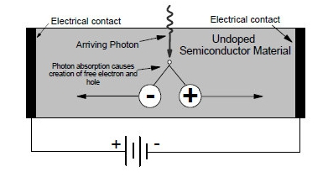

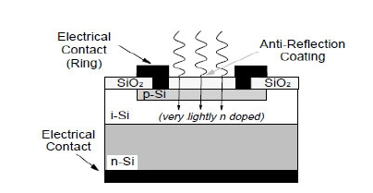

a very lightly doped layer called the intrinsic zone between the p and n
doped zones. Thus the device is called a p-i-n diode rather than a p-n
diode. The wide intrinsic (i) layer has only a very small amount of
dopant and acts as a very wide depletion layer. There are a number of
improvements here:
It increases the chances of an entering photon being absorbed
because the volume of absorbent material is significantly
increased.
Because it makes the junction wider it reduces the capacitance
across the junction. The lower the capacitance of the junction the
faster the device response. Increasing the width of the depletion
layer favors current carriage by the drift process which is faster
than the diffusion process. The result is that the
Addition of the “i” layer increases the responsivity and decreases
the response time of the detector to around a few tens of
picoseconds.
12.3 Avalanche Photodiodes (APDs):-

APDs amplify the signal during the detection process. They use a
similar principle to that of “photomultiplier” tubes used in nuclear
radiation detection.
Methodology of Conduction in APDs:-
1. A single photon acting on the device releases a single electron.

2. This electron is accelerated through an electric field until it strikes a
target material.

Figure:- Avalanche Photodiode (APD)
3. This collision with the target causes “impact ionization” which
releases multiple electrons.
4. These electrons are then themselves accelerated through the field until
they strike another target.
5. This releases more electrons and the process is repeated until the
electrons finally hit a collector element.
APDs develop a very high electric field in the intrinsic region as well as
to impart more energy to photoelectrons to produce new electron-hole
pairs by impact ionization. This impact ionization leads to avalanche
breakdown in the reverse biased diode. So the APDs have high
sensitivity and high responsivity over p-i-n diodes due to the avalanche
multiplication.
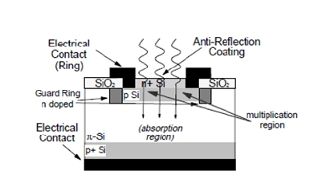

13.0 Limitations of Optical Fiber:-

1. The terminating equipment is still costly as compared to copper wire.
2. Delicate so has to be handled carefully.
3. Communication is not totally in optical domain, so repeated electric
to optical to electrical conversion is needed.
4. Optical amplifiers, splitters, MUX-DEMUX are still in development
stages.
5. Tapping is not possible. Specialized equipment is needed to tap a
fiber.
6. Optical fiber splicing is a specialized technique and needs expertly
trained manpower.
7. The splicing and testing equipments are very expensive as compared
to copper equipments.
8. Bending Cables
9. Gamma Radiation
10. Electrical Fields
11. Sharks Eat the Cable
12. Gophers (and Termites) Really Do Eat the Cable

14.0 Applications of Optical Fiber:-
Due to the advantages of fiber optic over the traditional
connectivity networks, networks are being changed to the new

technology of fiber optic. Here is some applications use fiber optics for
the communication:
Long Haul telecommunication systems on land and at sea to
carry many simultaneous telephone calls (or other signals) over
long distances. These include ocean spanning submarine cables
and national backbone networks for telephone and computer
data transmission.
Interoffice trunks that carry many telephone conversations
simultaneously between local and regional switching facilities.
Connections between the telephone N/W and antennas for
mobile telephone service.
Links among computers and high resolution video-terminals
used for such purposes as computer aided design.
Transmission of signals within ships and aircraft.
Local area Networks operating at high speeds or over large
areas, and backbone systems connecting slower local area
Networks.
High speed interconnections between computer and peripherals
devices, or between computers, or even within segments of
single large
Cable TV,CCTV ,Optical Fiber Sensors, X-ray Imaging ,Night
Vision

Other uses of optical fibers
Fibers are widely used in illumination applications. They are
used as light guides in medical and other applications where
bright light Some buildings, optical fibers are used to route
sunlight from the roof to other parts of the building .
Optical fiber illumination is also used for decorative
applications, including signs, art, and artificial Christmas trees.
Optical fiber is also used in imaging optics i.e. an endoscope,
which is used to view objects through a small hole. Medical
endoscopes are used for minimally invasive exploratory or
surgical procedures (endoscopy). Industrial endoscopes are used
for inspecting anything hard to reach, such as jet engine
interiors.
In spectroscopy, optical fiber bundles are used to transmit light
from a spectrometer to a substance which cannot be placed
inside the spectrometer itself, in order to analyze its
composition.
A spectrometer analyzes substances by bouncing light off of
and through them. By using fibers, a spectrometer can be used
to study objects that are too large to fit inside, or gasses, or
reactions which occur in pressure vessels.

Future Applications of Optical Fiber Communication:-
Today, however, lower costs and higher production volumes mean that
fiber optics can now make sense in areas where it didn't before,
including relatively short distances.
Advancement in Communications: -
Fiber technologies provide higher bandwidth, higher speed, and
increased reliability over existing DSL technology, which uses
Copper wires for communication.
In future it will be possible to have Wave length Band in Radio
compare to FM band (where synchronizing is done through
frequency).In Wavelength band Channels will have Different
wavelengths (earlier, it was once just one wavelength of light
traveling through the fiber, today it is more like 160 wavelengths
traveling at once.).So as research is going on number of
wavelength per fiber is increasing.

In cars, fiber optics is replacing copper as a lighter
alternative for entertainment systems, CD players, and
global positioning systems.
Research is going on to integrate semiconductor devices, including
a transistor, inside micro structured optical fibers. Then it will be
possible to manipulate signals inside optical fibers. After these
developments there will be not any need of electronic switching

devices at both ends of fiber. So signal will never leave fiber. This
results in faster cheaper and more efficient operation.
INTEL has developed new technology to connect PC USB to
Optical Fiber. So direct communication can be achieved between
users through Optical Fiber

Advancement in Fiber Optics: -

In the research world, fiber is enabling the creation of clocks that
are more accurate than ever before, By combining a laser with an
optical fiber, these clocks allow scientists to measure time more
accurately than they've been able to previously, enabling better,
more precise.
By using Fiber optics it is possible to prepare more reflective and
shining cloths.
Room Lighting may improve. Now you can imagine a home with
cheerful splashes of natural sunlight in every room at once.
Lighting Colour wili be changed. So, by using some almost
invisible optical fibers to an outside light source, they could bring
natural, outside light to a space that needs.
This is new way to get sunlight into a place that wouldn'totherwise
have it. Such as a dark, interior room.

Fiber-optic light bulbs have already been developed, and may be
an additional way to tap into fiber optics for household lighting.

Conclusion:-
The age of optical communications is a new era. In several
ways fiber optics is a pivotal breakthrough from the electric

communication we have been accustomed to.
Instead of

electrons moving back and forth over a regular copper or
metallic wire to carry signals, light waves navigate tiny fibres of
glass or plastic to accomplish the same purpose.
With a bandwidth and information capacity a thousand times
greater than that of copper circuits, fiber optics may soon
provide us with all the communication technology we could
want in a lifetime, at a cost efficient price.
At present there are many optical fiber communication links
throughout the world without using optical solutions. When we
introduce optical solutions as light pulses through the fibers, we
can achieve high quality telecommunication at a lower cost. We
can expect a great revolution in optical fiber communication
within a few years by means of solutions.

References:-

From paper written by Harry J. R. Dutton for International Technical

Support
Organization
titled
as
Understanding
Optical

Communications by IBM.
http://en.wikipedia.org/wiki/Optical_fiber
http://www.fiber-optics.info/articles/wdm.htm
http://www.arcelect.com/fibercable.htm
From paper Optical fiber communication—An overview by M
ARUMUGAM (Department of Physics), Anna University.
An educational resource published by Communications Specialties,
Inc.paper titled Introduction to Fiber Optics

