WiTricity Technology: The Basics
Understanding what WiTricity technology is—transferring electric energy or power over distance without wires—is quite simple. Understanding how it works is a bit more involved, but it doesn’t require an engineering degree. We’ll start with the basics of electricity and magnetism, and work our way up to the WiTricity technology.
Electricity: The flow of electrons (current) through a conductor (like a wire), or charges through the atmosphere (like lightning). A convenient way for energy to get from one place to another!
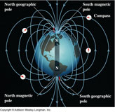
An illustration representing the earth's magnetic field
Magnetism: A fundamental force of nature, which causes certain types of materials to attract or repel each other. Permanent magnets, like the ones on your refrigerator and the earth’s magnetic field, are examples of objects having constant magnetic fields.
Oscillating magnetic fields vary with time, and can be generated by alternating current (AC) flowing on a wire. The strength, direction, and extent of magnetic fields are often represented and visualized by drawings of the magnetic field lines.
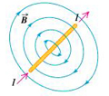
As electric current, I, flows in a wire, it gives rise to a magnetic field, B, which wraps around the wire. When the current reverses direction, the magnetic field also reverses its direction.
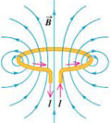
The blue lines represent the magnetic field that is created when current flows through a coil. When the current reverses direction, the magnetic field also reverses its direction.
Electromagnetism: A term for the interdependence of time-varying electric and magnetic fields. For example, it turns out that an oscillating magnetic field produces an electric field and an oscillating electric field produces a magnetic field.
Magnetic Induction: A loop or coil of conductive material like copper, carrying an alternating current (AC), is a very efficient structure for generating or capturing a magnetic field.
If a conductive loop is connected to an AC power source, it will generate an oscillating magnetic field in the vicinity of the loop. A second conducting loop, brought close enough to the first, may “capture” some portion of that oscillating magnetic field, which in turn, generates or induces an electric current in the second coil. The current generated in the second coil may be used to power devices. This type of electrical power transfer from one loop or coil to another is well known and referred to as magnetic induction. Some common examples of devices based on magnetic induction are electric transformers and electric generators.
Energy/Power Coupling: Energy coupling occurs when an energy source has a means of transferring energy to another object. One simple example is a locomotive pulling a train car—the mechanical coupling between the two enables the locomotive to pull the train, and overcome the forces of friction and inertia that keep the train still—and, the train moves. Magnetic coupling occurs when the magnetic field of one object
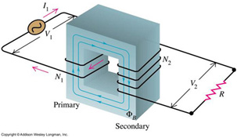
An electric transformer is a device that uses magnetic induction to transfer energy from its primary winding to its secondary winding, without the windings being connected to each other. It is used to “transform” AC current at one voltage to AC current at a different voltage.
interacts with a second object and induces an electric current in or on that object. In this way, electric energy can be transferred from a power source to a powered device. In contrast to the example of mechanical coupling given for the train, magnetic coupling does not require any physical contact between the object generating the energy and the object receiving or capturing that energy.
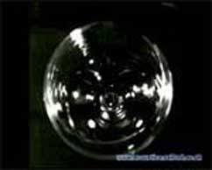

Resonance
This video shows how a wine glass captures sound energy that ocillates at its natural resonant frequency, converts it to mechanical energy that causes the glass to deform at that same frequency and eventually causing it to shatter.
Resonance: Resonance is a property that exists in many different physical systems. It can be thought of as the natural frequency at which energy can most efficiently be added to an oscillating system. A playground swing is an example of an oscillating system involving potential energy and kinetic energy. The child swings back and forth at a rate that is determined by the length of the swing. The child can make the swing go higher if she properly coordinates her arm and leg action with the motion of the swing. The swing is oscillating at its resonant frequency and the simple movements of the child efficiently transfer energy to the system. Another example of resonance is the way in which a singer can shatter a wine glass by singing a single loud, clear note. In this example, the wine glass is the resonant oscillating system. Sound waves traveling through the air are captured by the glass, and the sound energy is converted to mechanical vibrations of the glass itself. When the singer hits the note that matches the resonant frequency of the glass, the glass absorbs energy, begins vibrating, and can eventually even shatter. The resonant frequency of the glass depends on the size, shape, thickness of the glass, and how much wine is in it.
Resonant Magnetic Coupling: Magnetic coupling occurs when two objects exchange energy through their varying or oscillating magnetic fields. Resonant coupling occurs when the natural frequencies of the two objects are approximately the same.
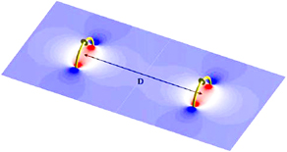
Two idealized resonant magnetic coils, shown in yellow. The blue and red color bands illustrate their magnetic fields. The coupling of their respective magnetic fields is indicated by the connection of the colorbands.
WiTricity Technology: WiTricity power sources and capture devices are specially designed magnetic resonators that efficiently transfer power over large distances via the magnetic near-field. These proprietary source and device designs and the electronic systems that control them support efficient energy transfer over distances that are many times the size of the sources/devices themselves.
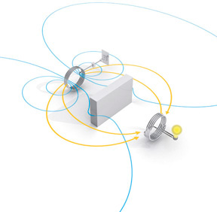
The WiTricity power source, left, is connected to AC power. The blue lines represent the magnetic near field induced by the power source. The yellow lines represent the flow of energy from the source to the WiTicity capture coil, which is shown powering a light bulb. Note that this diagram also shows how the magnetic field (blue lines) can wrap around a conductive obstacle between the power source and the capture device.

