Wibree(Bluetooth Low Energy Technology)

Komal Gunjal, Nandkishor Patil

Matoshree, Sinhgad  
Address Including Country Name

1 first.author@first-third.edu

3 third.author@first-third.edu

**ABSTRACT**

The wireless world continues to grow as engineers develop faster, more robust technologies to free us from wires for greater simplicity, convenience, and efficiency. Wibree is a radio technology and an open industry initiative that complements close range communication up to 10m (local connectivity), extending Bluetooth device connectivity to small devices while keeping energy consumption at minimum.

Wibree is the first open technology offering connectivity between mobile devices or PCs as well as small, button cell battery power devices such as watches, wireless keyboards, toys and sports sensors.

Wibree is designed to work side by side with and complement Bluetooth. It operates in 2.4 GHz ISM band with physical layer bit rate of 1Mbit/s. It can be built into products such as watches, wireless keyboards, gaming and sports sensors, which can then connect to host devices such as mobile phones and personal computers.

**INTRODUCTION**

Bluetooth as a wireless technology has already penetrated into the personal space and led to the emergence of WPAN or Wireless Personal Area Networks. Bluetooth Low Energy was designed with an aim to dig deeper into everyday lives by covering daily use devices like watches, remotes and other Human Interface Devices (HIDs) which operate on battery power or solar power. The biggest challenge in this design was obviously achieving very low power and energy levels of operation in order to be able to achieve the objective.

**1.1 Bluetooth**

Bluetooth is a wireless communication protocol technology for short range and low cost communication. The standards are developed by the Bluetooth Special Interest Group (SIG)

**1.2 WIBREE (Bluetooth Low Energy)**

The Wibree is a new short-range wireless technology, by NOKIA. It is lot more power efficient than Bluetooth, which means it could be used in smaller and less costly devices. It can also use the same radio and antenna components as Bluetooth, helping keep costs down further. Wibree could compete with Bluetooth in the workplace as a way to link keyboards and other peripherals to computers. But it could also have more interesting applications for consumers in devices such as wrist watches, toys and sports equipment. Wibree is a radio technology and an open industry initiative that complements close range communication up to 10m (local connectivity), extended Bluetooth device while keeping energy consumption at minimum. Wibree is the first open technology offering connectivity between mobile devices such as watches, wireless keyboards, toys and sports sensors. The complementary technology has two implementations- as dual-mode or stand –alone alternatives. For dual mode implementations, the Wibree functionality is an add-on feature in side Bluetooth circuitry. The dual modes are targeted at mobile phones, multimedia computers, and PC’s,. Meanwhile, stand-alone implementations are power and cost optimized designs targeted at, for example, sports, wellness, and human interactive device product categories.

The technology, developed by Nokia Research Centre, operates in 2.4GHz ISM band with physical layer bit rate of 1 Mbps and provides link distance of 5-10m. Consuming only a fraction of the power used by other radio technologies. Wibreee enables smaller and less costly implementations while allowing easy integration with Bluetooth solutions. Wibree technology is an important development that opens up new market opportunities and a whole new range of possibilities for mobile users.

The aim of Nokia is to establish an industry standard faster than ever before by offering an interoperable solution that can be commercialized and incorporated into products quickly.

A few principles used in achieving the *low energy* target are as follows

1. Changing crucial parameters like FSK Modulation Index, Symbol Rate, Transmission Power, among others,
2. Using additional frequencies within the band and disallowing frequency hopping,
3. Having different classes of devices and exploiting the system *idle* by switching off devices, and
4. Using lower duty cycles.

**1.3 Background**

In 2001, Nokia researchers determined that there were various scenarios that contemporary wireless technologies did not address. To address the problem, the Nokia Research Center started the development of a wireless technology adapted from the Bluetooth standard which would provide lower power usage and price while minimizing difference between Bluetooth and the new technology. The results were published in 2004 using the name Bluetooth Low End Extension. After further development with partners, e.g., within EU FP6 project MIMOSA, the technology was released to public in October 2006 with brand name Wibree. After negotiations with Bluetooth members, in June 2007, an agreement was reached to include Wibree in future Bluetooth specification as a Bluetooth ultra-low-power technology, now known as Bluetooth Low Energy Technology.

In December 2009, the Bluetooth SIG announced the adoption of Bluetooth low energy wireless technology as the hallmark feature of the Bluetooth Core Specification Version 4.0. Samples of sensors utilizing this specification are available from some silicon manufacturers today and shipments are anticipated to follow closely behind. Integration of Bluetooth low energy technology with the Core Specification will be completed in early 2010 and the first Bluetooth low energy enabled products should be available before the end of the calendar year. Upon completion, mobile phone and PC manufacturers may enhance their Bluetooth product offerings with support for Bluetooth low energy wireless technology. End-user devices with Bluetooth v 4.0 are expected to reach the market in late 2010 or early 2011.

**1.4 Need of another wireless standard**

Now that wireless connections are established solutions in various sectors of consumer electronics, the question arises whether devices that draw long life from a small battery could find benefit as well in a global standard for wireless low energy technology. Makers of sensors for sports, health and fitness devices have dabbled in wireless but not together, while manufacturers of products like watches have never even considered adding wireless functionality because no options were available.

Several wireless technologies have tried to address the needs of the button cell battery market, but most were proprietary and garnered little industry support. However, none of these technologies let smaller manufacturers plug in to a global standard that provides a viable link with devices like mobile phones and laptops. What’s more, companies that want to make their small devices wireless need to build and sell either a dedicated display unit or an adapter that connects to a computing platform such as a mobile phone, PC or iPod. There have been few successful products that followed this route to a mass market.

A new flavor of Bluetooth technology may be just the answer, and a more efficient alternative for yet another wireless standard. In the ten years since engineers from a handful of companies came together to create the first Bluetooth specification, Bluetooth technology has become a household term, a globally recognized standard for connecting portable devices. The Bluetooth brand ranks among the top ingredient technology brands worldwide, recognized by a majority of consumers around the world. A thriving global industry of close to 11,000 member companies now designs Bluetooth products and works together to develop future generations of the technology, found in well over 50 percent of mobile phones worldwide and with more than two billiondevices shipped to date. Bluetooth wireless technology has established the standard for usability, ease of setup and compatibility across all manufacturers. A well-established set of Bluetooth profiles define the communication needs for a wide range of applications, making it easy for a manufacturer to add Bluetooth wireless connectivity to new devices — from phones to headsets to printers — with a minimum of programming and testing work.

Bluetooth technology’s consumer brand recognition and its years long experience of software development, testing and validation, are tremendous advantages for any device that bears the Bluetooth logo. The current Bluetooth radio delivers a combination of fast data rate and low power consumption that has proven to be the right choice for a range of mobile phone and PC applications, including hands-free communication, streaming music, printing and file transfer. But its speed is wasted in applications that require only small bits of information to be sent infrequently.

The Bluetooth Special Interest Group (SIG) recognizes that no single radio design will ever offer both maximum data rate and maximum battery life. With this in mind, the Bluetooth SIG has focused efforts on uniting several wireless technologies under a single Bluetooth wireless umbrella. In June 2007, the Bluetooth SIG announced it would bring Nokia’s Wibree under the Bluetooth umbrella to create a low energy version of Bluetooth wireless technology. The result: a wireless technology with a considerable battery life that will be measured in years and even lower power consumption than other standards based technologies, but able to communicate with over a billion of Bluetooth devices shipped each year.

Consumers should be able to purchase the first Bluetooth low energy enabled products later in 2009. In addition to creating a vast market for sensors, watches and other existing devices, Bluetooth low energy technology’s ability to connect low power devices to the mobile phone will open new applications. The mobile phone, after all, is quickly becoming the computing hub of the future, combining entertainment, connectivity and data storage in a single device. In the home, the mobile phone can serve as a remote control for the TV, thermostat and even household appliances, or simply direct a smart house to power up or down according to the presence of occupants.

The demand for embedded wireless technology capable of long lasting, power-independent functionality has existed for some time. Bluetooth low energy technology promises a new answer, one with a proven global standard at its heart.

**LITERATURE SURVEY**

Wireless technologies represent a rapidly emerging area of growth and importance for providing ubiquitous access to the network for all of the campus community. Personal-area-networking (PAN) and peer-to-peer communication over unlicensed radio communication channels is already widely used in static installations, e.g., between keyboards and PCs and in a mobile setting to communicate to wireless headsets.

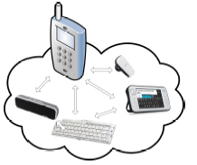

**A Mobile PAN network**

Wireless technologies represent a rapidly emerging area of growth and importance for providing ubiquitous access to the network for all of the campus community. Personal-area-networking (PAN) and peer-to-peer communication over unlicensed radio communication channels is already widely used in static installations, e.g., between keyboards and PCs and in a mobile setting to communicate to wireless headsets. The Bluetooth standard is presently the dominant solution for PAN communication but other technologies like ZigBee address specific market segments, like home automation. The trend towards wireless communication with even smaller devices like watches, sport sensors and the like has induced the need to revisit the radio technology itself to meet the price and resource consumption constraints (especially battery drain) of these device classes.

Wibree is a new radio technology that is positioned to meet the demands of communication with small accessories and sensors. Compared to other technologies for local wireless connectivity such as Bluetooth and Zigbee, Wibree consumes a fraction of the power enabling wireless capabilities to be added to smaller and less costly devices than was otherwise possible. Wibree complements existing standards by focusing on low-power control and sensor applications.

A comparison of the various wireless technologies is helpful when deciding which technology to implement or products to purchase (special attention has been paid to the automotive application domain).

**1. Bluetooth**

Bluetooth is a short-range radio frequency standard for wireless communication between devices which permit transmission speeds up to 3Mbits/sec between devices within a 30-foot range of one another. It was initially developed as a personal area network protocol for low-power, short-range wireless peer-to-peer connection. However, its applicability for interconnecting several communication and electronic devices within a vehicle under the harsh automotive conditions has resulted in its rapid adoption by the automakers globally for supporting hands-free calling.

**2.** [**WiFi**](http://www.wi-fi.org/): WiFi is the short-form for Wireless Fidelity and is the trademark for product compatibility standards for wireless local area networks. Although it was initially developed for connecting mobile devices with local area networks, its applicability for supporting a host of automotive applications is being actively investigated by the automotive industry participants in North America. It is being perceived as the wireless protocol that holds the potential of significantly enhancing the inter-vehicular communication capabilities of the next generation of vehicles offered in the North American light vehicle market.

**3.** [**WiMax**](http://www.wimaxforum.org/home/)**:** WiMax is a wireless technology that offers high data throughput over long distances within a metropolitan area, and is designed to complement WiFi, wired Ethernet, token ring, and cable modems, which use the same logical link control. While WiFi’s network range is covered in square meters, WiMax’s range is expressed in square miles. WiMax is the commercial name for the IEEE 802.16 networks that enable the vehicle to be connected with other vehicles and stationary information centers within a metropolitan area while it is on the move and within the range of the WiMax coverage area.

**4. UWB**:  Ultra-Wideband (UWB) is a short-range wireless communications technology which can be applied in vehicles to greatly reduce wiring between electronic systems and offer high-speed, high-bandwidth data transfer link to outside information and information sources. While Bluetooth offers a maximum of 3 Mbits/sec, UWB in comparison features network speeds of 50-100 Mbits/sec and in short ranges it can support data speeds of almost 480 Mbits/sec.

**5.** [**ZigBee**](http://www.zigbee.org/en/index.asp)**:** Zigbee is a published specification set of high level communication protocols designed to use small, low power digital radios based on the IEEE 802.15.4 standard for wireless personal area networks (WPANs). Zigbee is considered to be an ideal wireless protocol for short message applications like sensors and controls and nodes can be placed in a larger area as compared to that in Bluetooth networks. Connecting sensors using Zigbee can reduce wiring complexities and also result in cost-savings by facilitating re-configuration and eliminating the need for re-wiring once installed.

**6. Wireless USB**: Wireless USB is an extension to the USB and ultra-wide band technologies. It enables the universal serial bus networking in a wireless manner thereby reducing wiring complexities and thereby enabling effective portable device connectivity with the vehicle’s infotainment systems. The wireless USB technology supports a dual-role model where a device is also allowed to offer limited host capabilities thereby enabling mobile devices to access services with a central host supporting the services and also allowing devices to access data outside a cluster by creating a second cluster as a limited host.

**WIBREE DEVICE ARCHITECHURE**

Wibree specification has been created by having two equally important implementation alternatives in mind, namely dual-mode and stand-alone. In the dual mode implementation the wibree functionality is an add-on feature inside Bluetooth circuitry sharing a great deal of existing functionality resulting in minimal cost increase compared to existing products. The dual modes are targeted at mobile phones multimedia computes and PCs. The stand-alone implementations are power and const optimized designs targeted at for example, sports wellness, and human interactive device product categories.

**3.0 WIBREE Radio Specification**

Wibree radio specification enables dual mode implementations to reuse Bluetooth RF part but also to guarantee ultra low power consumption for devices with embedded standalone implementation of the Wibree specification. Wibree operates in 2.4 GHz ISM band with physical layer bit rate of 1 Mbps and provides link distance of 5-10 meters.

**3.1 WIBREE Link Layer Specification**

Wibree link layer provides ultra lowpower idle mode operation, simple devicediscovery and reliable point -to- multipoint datatransfer with advanced power-save andencryption functionalities. The link layerprovides means to schedule Wibree traffic inbetween Bluetooth transmissions.

**3.2 WIBREE Host and Profile Specification**

In the first phase, Wibree provides sensor, human interactive device and watch user interface profiles.

**3.3 WIBREE Chips**

The chips will be available for testing according to respective semiconductor vendor’s schedules once the first official version of the specification has been made available. According to the current estimate, the first commercial version of the interoperability specification will be available during first quarter of 2008. The design of the Wibree protocol stack means there’s no need for TCP/IP stacks, web browsers or anything else in the display as a mobile phone to run, but it also means that it’s easy to implement at very low cost. Mobile phone to run, but it also means that So it could be put onto your shopping trolley with nothing more complex than a 8-bit microprocessor and a display – all of which can be part of a single Wibree chip. It’s a good example of how Wibree makes interoperability and wireless functionality cheap.

**3.4 Technical Details**

Wibree technology complements close range communication with Bluetooth like performance within 0-10m range and data rate of 1Mbps Wibree is optimized for applications requiring extremely low power consumption, small size and low cost. The small devices like watches and sports sensors will be based on stand-alone chip whereas Bluetooth devices will take benefit of the dual mode solution, extending Bluetooth device connectivity to new range of smallest devices.

The technology is being designed to communicate with a phone or other devices within 10 meters, and can transfer data at 1Mbps. It can be implemented in a stand-alone chip or as a dual-mode chip that includes both Bluetooth and Wibree. Bluetooth has inherent power limitations because it includes a fixed packet-size and frequency-hopping technology. Wibree uses a different modulation technique that does a better job of avoiding interference, which helps reduce its power requirements. Several companies are working with Nokia to define the Wibree specification, including Broadcom Corp., Epson Corp., and Nordic Semiconductor ASA, Nokia said. They hope to submit the technology to a standardization process, which could help it to gain wider support.

Wibree is the first wireless technology to solve the following needs in a single solution.

1. Ultra low peak average and idle mode power consumption
2. Ultra low cost and small size for accessories and human interface device (HID)
3. Minimal cost and size addition to mobile phones and PCs.
4. Global, intuitive and secure multivendor interoperability.

Bluetooth low energy is designed with two equally important implementation alternatives: single-mode and dual-mode. Small devices like tokens, watches and sports sensors based on a single-mode Bluetooth low energy implementation will enjoy the low-power consumption advantages enabled for highly integrated and compact devices. In dual-mode implementations Bluetooth low energy functionality is integrated into Classic Bluetooth circuitry. The architecture will share Classic Bluetooth technology radio and antenna, enhancing currently chips with the new low energy stack—enhancing the development of Classic Bluetooth devices with new capabilities.

**3.4.0 Data Rate**

Wibree technology is optimized to offer ultra low peak, average, and idle mode power consumption. Transfer rate is not the key criterion in those use cases where ultra-low power consumption is needed and data-intensive applications with data rates higher than 1 Mb/s would sacrifice the long battery life.

**3.5 Standardization**

In the market of proprietary connectivity solutions, Bluetooth low energy technology differentiates itself through its:

1. widely adopted industry standard for protocols (Bluetooth SIG)
2. internationally adopted industry standard for transmission (IEEE 802.15.1)
3. Low price through single chip integration
4. Compatibility with yet deployed Bluetooth devices via updates

**3.6 Connections and Communication Events**

When a connection is requested, all the information about this connection is contained in one packet transmitted from the initiating master device to the slave. This includes the adaptive frequency hopping channel map and the communication event interval for the subsequent connection. This included information means that no additional negotiation of the connection parameters needs to be performed before sending real application data. This saves time by not having to negotiate these parameters after the link has been established, and also saves energy.

Communication events are points in time when two devices have agreed to transmit or receive packets for synchronization and latency requirements. In classic Bluetooth technology, these communication events are used in sniff mode and have a minimum time period when both devices have to listen or transmit to each other even if neither have anything to say.

**Comparison between Classic Bluetooth**

**and Bluetooth low energy**

|  |  |  |
| --- | --- | --- |
| **Technical Specification** | **Classic Bluetooth** | **Bluetooth low energy** |
| Distance/Range | 100 m (330 ft) | 200 m (660 ft) |
| Over the air data rate | 1-3 Mb/s | 1 Mb/s |
| Application throughput | 0.7-2.1 Mb/s | 0.26 Mb/s |
| Active slaves | 7 | Not defined; implementation dependent |
| Security | 64/128-bit and application layer user defined | 128-bit AES with Counter Mode CBC-MACand application layer user defined |
| Robustness | Adaptive fast frequency hopping, FFC, fast ACK | Adaptive frequency hopping, Lazy Acknowledgement, 24-bit CRC, 32-bit Message Integrity Check |
| Latency (from a non connected state) | Typically 100 ms | 6 ms |
| Total time to send data (det.battery life) | 100 ms | 6 ms |
| Voice capable | Yes | No |
| Network topology | Scatternet | Star-bus |
| Power consumption | 1 as the reference | 0.01 to 0.5 (depending on use case) |
| Peak current consumption | <30 Ma | <20 mA (max 15 mA to run on coin cell battery) |
| Service discovery | Yes | Yes |
| Profile concept | Yes | Yes |
| Primary use cases | Mobile phones, gaming, stereo audio streaming, automotive, PCs, security, proximity, healthcare, sports & fitness, etc. | Mobile phones, PCs, watches, sports and fitness, healthcare, security & proximity, automotive, home electronics, automation, Industrial, etc. |

In Bluetooth low energy, each packet includes a “more data” bit that states if the sending device has got more data to send, and whether it wants the other device to carry on talking. This enables direct control over the specific duty cycles at each communication event to be optimized exactly to the flow of data that is ready to be sent at this time. When a slave device does not have any data to transmit, it doesn’t even have to bother listening to the master device’s communication event packets. This enables the slave device to stay in the lowest possible power mode for as long as possible, further saving significant amounts of power. However, if it does have something important to say, then it can wake up at the next appropriate communication event and transmit its data very quickly. This enables an excellent compromise between ultra low power operation and low latency transmission of data. Another significant optimization of Bluetooth low energy is the acknowledgement scheme. When a packet is transmitted in classic Bluetooth technology or other short range wireless standards, the next packet has to indicate if this packet was correctly received or not. If that acknowledgement packet didn’t include any application data, then an empty packet is transmitted, wasting time and energy. Bluetooth low energy uses a lazy acknowledgement scheme which means that packets are only acknowledged when absolutely necessary. This reduces the real world duty cycle by 50% when a slave is transmitting data to the master device.

**THE BLUETOOTH PROTOCOL STACK**

The Bluetooth standard has many protocols grouped loosely into layers. The layer structure does not follow the OSI model, the TCP/IP model, the 802 model, or any other know model. The basic Bluetooth protocol architecture as modified by the 802 committee is shown in Fig. 4.1.

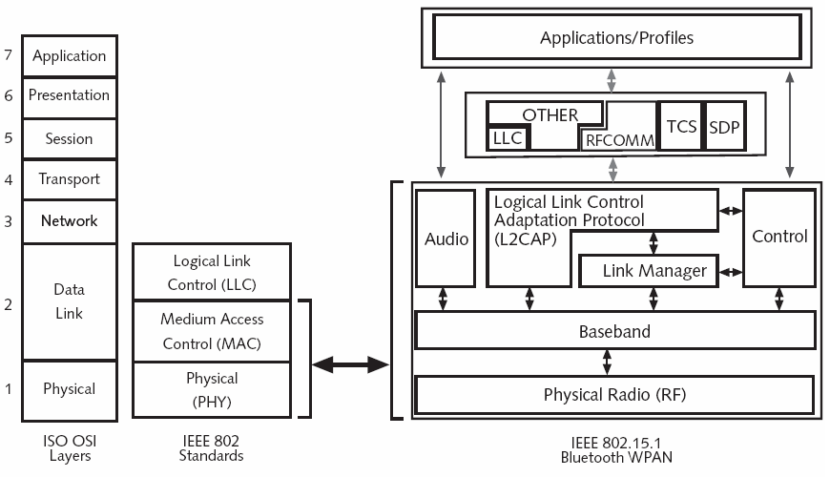

**Bluetooth Protocol Stack**

The bottom layer is the physical radio layer, which corresponds fairly well to the physical layer in the OSI and 802 models. It deals with radio transmission and modulation. Many of concerns here have to do with the goal of making the system inexpensive so that it can become a mass market item.

The base band layer somewhat analogous to the MAC sublayer but also includes elements of the physical layer. It deals with how the master controls time slots and how these slots are grouped into frames. Next comes a layer with a group of somewhat related protocols. The link manager handles the establishment of logical channels between devices, including power management, authentication and quality of service. The logical link control adoption protocol shields the upper layers from the details of transmission. It it analogous to the standard 802 LLC sublayer, but technically different from it. As the names suggest, the audio and control protocol directly, without having to go through the L2CAP protocol.

The next layer up is the middleware layer, which contains a mix of different protocols. The 802 LLC was inserted here by IEEE for compatibility with its other 802 networks. The RFcomm, telephony and service discovery protocols are native. RFcomm is the protocol that emulates the standard serial port found on PCs for connecting the keyboard, mouse and modem among the other devices. It has been designed to allow legacy devices to use it easily. The telephony protocol is a real time protocol used for the three speech oriented profiles. It also manages call setup and termination. They make use of protocols in lower layers to get their work done. Each application has its won dedicated subset of the protocols. Specific devices such as headset, usually contain only those protocols needed by that application and no others.

**4.1 Bluetooth Baseband Layer**

The baseband layer is the closest thing Bluetooth has to a MAC sublayer. It turns the raw bit stream into frames and defines some key formats. In the simplest form, the master in each piconet defines a series of 625 microsec time slots, with the master transmission starting in the even slots and the slaves transmissions starting in odd ones.

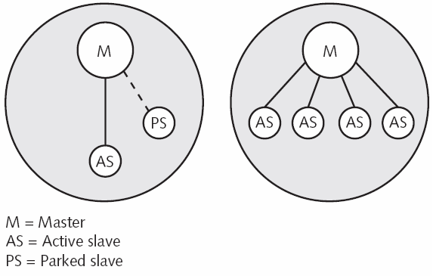

**Bluetooth Piconet**

This is traditional time division multiplexing, with master getting half the slots and the slaves sharing the other half. Frames can be 1, 3 or 5 slots long.

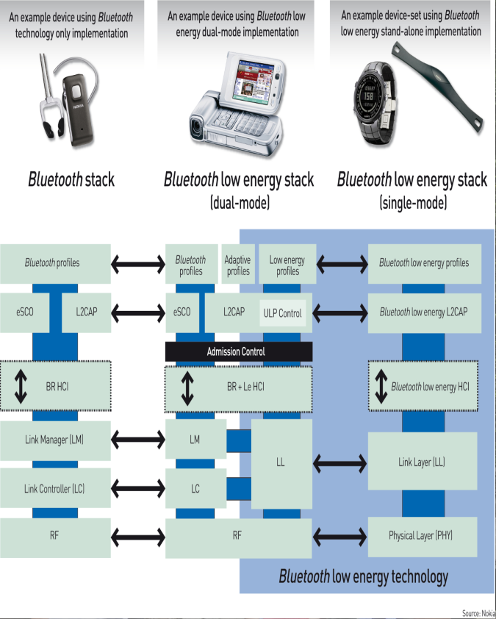

**Dual-Mode Chips will use the Bluetooth low energy part of their architecture to communicate with single mode devices**

There are two types of chips that together form Bluetooth low energy architecture: single mode and dual mode. A single mode device is a Bluetooth low energy-only chip that's brand new to the Bluetooth specification – it's the part of the technology optimized for ULP operation. Single mode chips can communicate with other single mode chips and dual-mode chips when the latter are using the Bluetooth low-energy technology part of their architecture to transmit and receive. (See figure 1.) Dual-Mode Chips will also have the capability of communication with Classic Bluetooth technology and other dual-mode chips using their conventional Bluetooth architecture.

Dual-Mode Chips will be used anywhere a Classic Bluetooth chip is used today. The consequence is that cell phones, PCs, Personal Navigation Devices (PNDs) or other applications fitted with a dual-mode chip will be capable of communicating with all the legacy Classic Bluetooth devices already on the market as well as all future Bluetooth low energy devices. However, because they are required to perform Classic Bluetooth and Bluetooth low energy duties, dual-mode chips are not optimized for ULP operation to the same degree as single-mode devices.

Single-mode chips can operate for long periods (months or even years) from a coin cell battery such as a 3V, 220mAh CR2032. In contrast, Classic Bluetooth technology (and Bluetooth low energy dual mode devices) typically requires the capacity of at least two AAA cells (which have 10 to 12 times the capacity of a coin cell and much higher peak current tolerance), and often more, to power them for days or weeks at most (depending on the application). (Note: There are some highly specialized Classic Bluetooth applications that can run on batteries with a lower capacity than AAA cells.)

**4.2 The Technology of Ultra Low Power Wireless**There are three characteristics of Bluetooth low-energy technology that underlie its ULP performance:

1. Maximized standby time,
2. Fast connection, and
3. Low peak transmit/receive power.

Switching the radio "on" for anything other than very brief periods dramatically reduces battery life, so any transmitting or receiving that has to be done needs to be done quickly. The first trick Bluetooth low-energy technology uses to minimize time on air is to employ only three "advertising" channels to search for other devices or promote its own presence to devices that might be looking to make a connection. In comparison, Classic Bluetooth technology uses 32 channels.

This means Bluetooth low-energy technology has to switch "on" for just 0.6 to 1.2ms to scan for other devices, while Classic Bluetooth technology requires 22.5ms to scan its 32 channels. Consequently, Bluetooth low-energy technology uses 10 to 20 times less power than Classic Bluetooth technology to locate other radios.

Note that the use of three advertising channels is a slight compromise: it's a trade between "on" time (and hence power) and robustness in what is a very crowded part of the spectrum (with fewer advertising channels there is a greater chance of another radio broadcasting on one of the chosen frequencies and corrupting the signal). The specification's designers are confident they have balanced this compromise – they have, for example, chosen the advertising channels such that they don't clash with Wi-Fi's default channels.

Bluetooth low-energy technology's advertising channels have been carefully chosen to avoid clashes with Wi-Fi. Once connected, Bluetooth low-energy technology switches to one of its 37 data channels. During the short data transmission period the radio switches between channels in a pseudo-random pattern using the Adaptive Frequency Hopping (AFH) technology pioneered by Classic Bluetooth technology (although Classic Bluetooth technology uses 79 data channels).

Another reason why Bluetooth low-energy technology spends minimal time on air is because it features a raw data bandwidth of 1Mbps – greater bandwidth allows more information to be sent in less time. An alternative technology that features a bandwidth of 250kbps, for example, has to be "on" for eight times as long (using more battery energy) to send the same amount of information.

Bluetooth low-energy technology can "complete" a connection (i.e. scan for other devices, link, send data, authenticate, and "gracefully" terminate) in just 3ms. With Classic Bluetooth technology, a similar connection cycle is measured in hundreds of milliseconds. Remember, more time on air requires more energy from the battery.

Bluetooth low-energy technology also keeps a lid on peak power in two other ways: by employing more "relaxed" RF parameters than its big brother, and by sending very short packets. Both technologies use a Gaussian Frequency Shift Keying (GFSK) modulation, however, Bluetooth low-energy technology uses a modulation index of 0.5 compared to Classic Bluetooth technology 0.35. An index of 0.5 is close to a Gaussian Minimum Shift Keying (GMSK) scheme and lowers the radio's power requirements (the reasons for this are complex and beyond the scope of this article).  Two beneficial side effects of the lower modulation

|  |  |  |  |
| --- | --- | --- | --- |
| Frequency  (MHZ) | Bluetooth Low Energy Advertising  Channel | Bluetooth Low Energy Data Channel | Wi-Fi  Channel |
| 2480 | 39 |  |  |
| 2478 |  | 36 |  |
| 2476 |  | 35 |  |
| 2474 |  | 34 |  |
| 2472 |  | 33 | 11 |
| 2470 |  | 32 | 11 |
| 2468 |  | 31 | 11 |
| 2466 |  | 30 | 11 |
| 2464 |  | 29 | 11 |
| 2462 |  | 28 | 11 |
| 2460 |  | 27 | 11 |
| 2458 |  | 26 | 11 |
| 2456 |  | 25 | 11 |
| 2454 |  | 24 | 11 |
| 2452 |  | 23 | 11 |
| 2450 |  | 22 |  |
| 2448 |  | 21 | 6 |
| 2446 |  | 20 | 6 |
| 2544 |  | 19 | 6 |
| 2442 |  | 18 | 6 |
| 2440 |  | 17 | 6 |
| 2438 |  | 16 | 6 |
| 2436 |  | 15 | 6 |
| 2434 |  | 14 | 6 |
| 2432 |  | 13 | 6 |
| 2430 |  | 12 | 6 |
| 2428 |  | 11 | 6 |
| 2426 | 38 |  |  |
| 2424 |  | 10 |  |
| 2422 |  | 9 | 1 |
| 2420 |  | 8 | 1 |
| 2418 |  | 7 | 1 |
| 2416 |  | 6 | 1 |
| 2414 |  | 5 | 1 |
| 2412 |  | 4 | 1 |
| 2410 |  | 3 | 1 |
| 2408 |  | 2 | 1 |
| 2406 |  | 1 | 1 |
| 2404 |  | 0 | 1 |
| 2402 | 37 |  | 1 |

**Bluetooth low-energy technology's advertising channels have been carefully chosen to avoid clashes with Wi-Fi**

index are increased range and enhanced robustness.

Classic Bluetooth technology uses a long packet length. When these longer packets are transmitted the radio has to remain in a relatively high power state for a longer duration, heating the silicon. This changes the material's physical characteristics and would alter the transmission frequency (breaking the link) unless the radio was constantly recalibrated. Recalibration costs power (and requires a closed-loop architecture, making the radio more complex and pushing up the device's price).

In contrast, Bluetooth low-energy technology uses very short packets - which keeps the silicon cool. Consequently, a Bluetooth low energy transceiver doesn't require power consuming recalibration and a closed-loop architecture.

**APPLICATIONS**

**5.1 The Applications of WIBREE (Bluetooth Low Energy Technology) are:**

1. 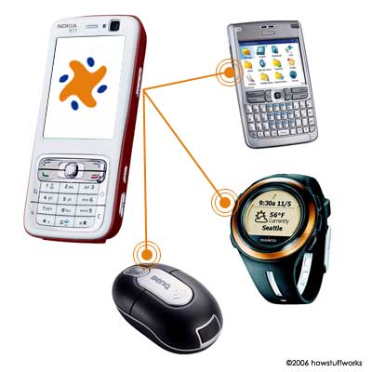Wireless keyboards
2. Wireless mice
3. Electronic toys
4. Medical devices, possibly implanted
5. Watches
6. Cell phones
7. Sports sensors

**Fig 5.1.**

**1. Sports and Healthcare:** Sensors fixed to the human body, shoes, and other fitness gears can gather data on heart rate, distance, speed, and acceleration, and send the information to a mobile phone and/or PC for storage and further processing. Healthcare monitoring equipments and sensors in the form of Wibree stand-alone devices can send vital health related information (blood pressure, glucose level) to Bluetooth-Wibree dual-mode, which can store and process this information and send alerts to mobile phones of patients and caretakers. Everything from shoes and heart rate straps to weight scales and bicycle computers. These devices will now connect with mobile phones and watches enabling easier and more complete monitoring of physical performance. This market also includes health maintenance devices like blood oxygen meters and blood glucose meters that can raise alarms about negative trends that may indicate physical problems and send data to healthcare monitoring web services or to physicians for monitoring of long-term trends.

**2. Home** - Bluetooth low energy technology will enable use of a mobile phone as a remote control for an entertainment system as well as for monitoring the temperature and controlling the heating and ventilation systems within a home. The key element in this is that the phone can act as a remote control for all these devices.

**3. Office** - Typical implementations of Bluetooth low energy technology in the office will be in wireless mice and keyboards, which will use the power savings benefits of Bluetooth low energy technology to increase battery  performance. Like home systems, which will use Bluetooth low energy technology to control heating and ventilation, Intelligent energy use will also be made possible in office buildings, which will use the technology to monitor the presence of workers and visitors around the building and use the presence data to adapt the environmental conditions such as humidity or temperature to maintain a comfortable workspace while at the same time saving energy and reducing costs .

**4. Automotive** - By enabling manufactures to replace the heavy copper and other weighty wired systems with wireless applications for monitoring remote functions such as tire pressure functions in vehicles, Bluetooth low energy technology will reduce the weight of the wiring harness.  This reduction of weight  can provide significant energy savings for vehicles, improving gas mileage and reducing carbon emissions.  Bluetooth low energy technology can also be used to wirelessly enable interior controls such as rear seat entertainment.

**5. Entertainment:** The ability of Bluetooth low energy technology to interface seamlessly to the mobile phone creates a brand new application category that merges sports sensors with the entertainment features of mobile phones.

**6. Watches:** Wibree’s ultra-low power consumption will bring wireless connectivity to watches without compromising battery lifetime. Bluetooth low energy technology, an open radio technology for small devices with very low power requirements will open up new possibilities for the integration of high-tech applications like sensors and entertainment devices, turning small devices like watches into portable, wearable information hubs comparable with mobile phones or PDAs. Watches featured with Bluetooth low energy will provide several advantages for device manufacturers focusing on the sports, fitness and health care sectors. When a watch connects a heart rate monitor and pedometer used to track physical performance, Bluetooth technology makes transfer of the data collected during your run to a Smartphone or PC for analysis and storage both simple and fast. The only wearable computer that most people will readily accept is the watch. Bluetooth low energy technology has been designed alongside watch companies to ensure that the technology meets their requirements. With Bluetooth low energy technology, watches can display caller ID information and allow the wearer to accept or reject calls to her mobile phone, all without once looking at the phone itself. Bluetooth enabled watches can also be used to control devices such music players, enabling volume and track changes

**5.2 Two potential applications where Wibree can be used : Proximity Alarm and Indoor Location**

Dual-Mode chips are being adopted by cell phone and portable PC makers because they'll cost only very slightly more than Classic Bluetooth technology yet offer so much more functionality. This will allow cell phone makers to offer a security device comprising a Bluetooth low energy powered watch that periodically communicates with the cell phone. If the cell phone moves out of range - and hence can't contact the watch worn by the user – it would automatically lock and the watch would emit an alarm. This would prevent the cell phone being accidentally left behind and prove a major deterrent for any would-be thief.

The proximity alarm application could be extended to a portable PC that locks when the user moves out of range (and perhaps unlocks to be ready for use when the approaching user presses a button on their watch). The application could also be used as a child safety device where the child's watch communicates with a parent's while they remain in range with an alarm sounding if the child wanders away. The low cost and low maintenance (because batteries require only infrequent changes) of Bluetooth low energy sensors will encourage widespread use in public places. One key application could be indoor location (where there is no GPS signal) whereby sensors around a large public building (such as an airport or rail station) constantly broadcast information about their location. A Bluetooth low energy equipped cell phone passing within range could then display that information to its owner. Sensors could transmit other information such as flight times and gates, location of amenities, or special offers from nearby shops.

**ADVANTAGES**

Bluetooth low energy technology is the hallmark feature of v4.0 of the Bluetooth Core Specification. Being more than just an innovative enhancement to the global, open Bluetooth wireless standard it offers developers the opportunity to build on the installed base of Bluetooth technology and the enormous global strength and awareness of the Bluetooth brand while at the same enable applications for many new markets such as health, sports and fitness and smart energy.

**Built-in connectivity** - Bluetooth technology is already present in most mobile phones and portable computers and this installed base gives a huge advantage for using low energy technology to connect phones and PCs with other consumer devices and sensors.  Implementations in these types of devices will be both efficient and at low cost and will not require additional dongles or software applications.

**Low power** – Bluetooth technology has always utilized as low amounts of power as possible and the power consumption of Bluetooth technology has improved with each specification version.  Bluetooth technology is already  the most power efficient standard for its current applications and Bluetooth low energy technology will dramatically improve the energy efficiency reducing the power needed for making devices connectable and discoverable. Low energy technology will also enable devices to send a small quantity of data very quickly from a disconnected state. Together, these new features will benefit not only power consumption levels of the technology, but will also enable new applications for requiring transmission of only small amounts of data.

**Coin cell battery operation** is made possible by the very low power consumption of Bluetooth low energy technology. The peak power current has been demonstrated by several suppliers to be below the 15 mA typically required for coin cell operation. Additionally, the sleep current is measured in microamperes, which means battery life in many applications can be measured in years rather than days.  This means regular charging is no longer required and that energy harvesting may now be possible for many applications.

**Low cost** – Bluetooth technology has always been the lowest cost standard short range wireless technology. With no royalties or specification patents, the Specification is designed for mass production using bulk CMOS technology. Bluetooth low energy technology will further reduce any associated development costs by relaxing important Specification parameters and by reducing the implementation size to half of Classic Bluetooth technology. Additionally, the huge volumes of Bluetooth technology will continue to reduce costs dramatically compared to other technologies.

**Range** – Bluetooth technology has never attempted to be a long-range technology. By concentrating on short range applications (up to 100 meters), it has successfully created the first, truly ad hoc technology. Any device can connect with any other device, create a temporary or permanent relationship, and transfer data quickly and easily. Bluetooth low energy technology enables similar ranges as Classic Bluetooth technology, but they are still fairly modest compared with cellular radio links. Although the specification defines radio parameters, range can be increased to hundreds of meters by tuning and improving those to support the use case they are enabling.

**Worldwide** – Bluetooth technology can be used and sold in almost every country on the planet. Bluetooth technology therefore enables a single, seamless market for wireless devices providing developers and manufacturers with a huge, mass market. This is a benefit over competitive technologies that may limit implementations to country or regional specifications or devices.

**Robust** – Bluetooth devices just work. Having a robust radio is essential when you are trying to gather a measurement from a sensor, or control something. Robust technologies are what the consumers demand and, with Bluetooth technology it is something that people can take for granted.

**Frequency hopping** was first used in military communications to combat eavesdropping and intentional jamming. It is also a very useful way to deal with unintentional jamming (interference), which is the primary reason for using frequency hopping in a communications protocol like Bluetooth technology. Frequency hopping is increases the robustness of a wireless technology, a critical factor with some fixed installations. With all wireless devices there is a phenomena called “multi path fading” that causes, in certain positions, the signal to cancel itself out through bouncing on walls and other objects. For a thermostat on a wall, this simply means it will not work in certain positions and must be moved in order to function. Bluetooth technology avoids this problem by automatically avoiding the frequencies that cause multipath problems.

**CONCLUSIONS & FUTURE SCOPE**

**7.1 Conclusion**

Bluetooth low energy technology is the long-awaited ultra low power version of the Bluetooth technology standard that will enhance existing markets and enable greater penetration of underrepresented markets with functionality such as sensor connectivity for a broad variety of applications. Bluetooth low energy is very efficient. It is efficient because it has optimized the time required for a radio to be connectable and discoverable, resulting in a maximum 15 decrease in energy usage for slave devices. It creates a new advertising model that allows applications data to be transmitted without having to be in a connection. It has also decreased the time required before sending application data by placing as much useful information in the connection request packet, reducing the time required to configure the link, saving time and energy. It also has optimized the communication events to enable a device to signal when it has no more data to send and therefore can drop down into a lower power state immediately. Combined with the more efficient packets and more efficient acknowledgement schemes, these features make Bluetooth low energy the most efficient standards based radio for short range wireless communications.

Bluetooth low energy technology is the only choice that offers:

1. A global and royalty-free standard
2. Wireless Internet communications for sensors via both computers and mobile phones
3. Ultra low power consumption.

Several silicon vendors are well advanced in the design of Bluetooth low-energy chips, and have released samples and development kits to selected customers. The current specification for Bluetooth Version 4.0 allows these companies to qualify their silicon to the Bluetooth low energy specification.

Nordic, for example, offers sample availability of its µBlue ("MicroBlue") Bluetooth low energy chips (and a µBlue Prototype Kit for key customers). The first product in the µBlue family is the nRF8001 – a single mode peripheral solution in a 32-pin 5 by 5mm QFN package incorporating a fully embedded radio, link controller, and host subsystem - suitable for watches, sensors, and remote controls among other applications.

* 1. **Future Scope**

The final piece of the Bluetooth low-energy puzzle is imminent. The Bluetooth SIG says the first profiles – such as Proximity Alarm - will start appearing within months. That means electronics designers will get their hands on fully qualified chips to begin their actual product development towards the end of the year.

Once the fully qualified silicon reaches the market, expect a tsunami of Bluetooth low energy products to follow. Analyst IMS estimates that by 2013, a billion Bluetooth low energy devices will be sold every year. That represents the fastest adoption of any wireless technology by far.

**REFERENCES**

**Book**

1. Andrew S Tanenbaum, “Computer Networks”, Prentice Hall, India, 5th Edition, Pp27-53

**Journal/Magzine/Periodicals**

1. Electronics Today , April 2007, Page 58-61.
2. Srihari Yechangunja, “Low Power Implementation Of Aes Algorithm For Bluetooth Low Energy (Wibree) Applications”.
3. By Robert Ebisch, “Technology That’s Good For You: Tiny, Low Energy Health Sensors On The Way”.
4. Daidi Zhong -- Member Of Research Staff, Jukka H. Salminen, “Bluetooth® Low Energy Technology Brings New Opportunities For Mobile Devices In Sports And Fitness Industry”, 2008.
5. Rory Glenn B. Pascua, “Research Study To Determine Whether Wireless Usb And Wibree Are Viable Standards To Compete With Bluetooth”, Oct. 2006.
6. G. A. Kulkarni, Asst. Professor, A. S. Bhide, Lecturer, D. G. Agrawal,Lecturer SSGBCOET, Bhusawal, “Wibree – A New Wireless Technology”, International Conference on “Emerging Techniques in Computing Electronics, Embedded System & VSLI Design, March 2008.