Definiton
Ergonomics derives from two Greek words: ergon, meaning work, and nomoi, meaning natural laws, to create a word that means the science of work and a person’s relationship to that work.
That is not the most efficient definition of what ergonomics is. Let us keep things simple. Ergonomics is the science of making things comfy. It also makes things efficient. And when you think about it, comfy just another way of making things efficient. However for simplicity, ergonomics makes things comfortable and efficient.
What is ergonomics?
At its simplest definition ergonomics literally means the science of work. So ergonomists, i.e. the practitioners of ergonomics, study work, how work is done and how to work better.
It is the attempt to make work better that ergonomics becomes so useful. And that is also where making things comfortable and efficient comes into play.Ergonomics is commonly thought of in terms of products. But it can be equally useful in the design of services or processes.

Example of ergonomics.
- What Not to Do
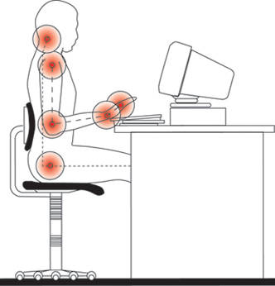
An illustration of an improper computer workstation setup.
Poor posture, lack of proper equipment and incorrect ergonomic information are all contributing factors to an improper computer setup. You can see, as illustrated here, that working at a computer can cause a lot of distress in a number of different parts of the body. With that in mind here are some key things not to do:
- Avoid existing ergonomic guidelines unless they make scientific sense. Ergonomics should be based on fact, research, experimentation and theory using body mechanics as a base line.
- Remember that ergonomics is personal. What works for someone else may not work for you.
- Do not settle for a desk without a keyboard tray or some other way to set the keyboard height and angle correctly. If your employer complains about the cost ask them to compare it to the cost of workman's compensation.

- Do not place the keyboard on top of the desk.
- Do not place the monitor above your head.
- Do not sit in a rigid and upright position.
- Do not lean forward.
- Do not work for long periods of time without moving. You need to take frequent breaks. They keep you awake, productive and healthy and keep you from developing Deep Vein Thrombosis.
- The Monitor
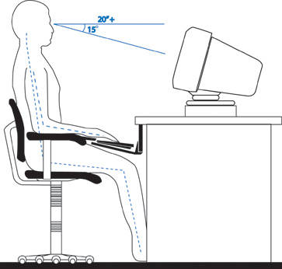

The proper ergonomic setup of a computer monitor.

- Position the monitor to minimize glare by placing it at a right angle to light sources or windows
- Place the monitor as far away from you as possible while maintaining the ability to read without consciously focusing. Keep a minimum distance of 20 inches.
- Place the center of the screen at a 15 degree down angle from your eyes with your neck only slightly bent holding your head perpendicular to the floor.
- Align the monitor and the keyboard / mouse
- Lighting
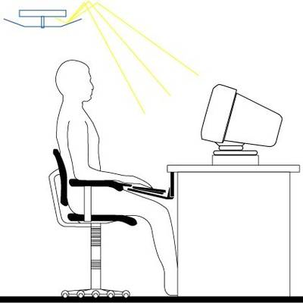

Lighting Needs for Computer Work
- The office should be moderately bright (20-50 foot candles or equal to a nice day where sunglasses aren’t needed).
- Do not use task lighting for computer work.
- A mix of incandescent and fluorescent lights reduces flicker and provides good light color.

- The Keyboard
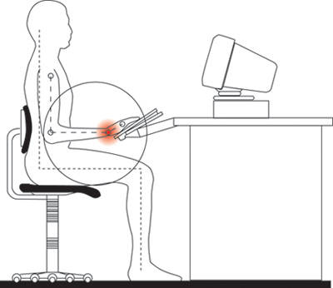

An ergonomically improper keyboard setup.

- Position the keyboard slightly below the elbow and at a negative angle to allow the wrists to remain straight when you sit in a slightly reclined posture
- Do NOT use a wrist rest while actively typing. It’s meant to rest on not to lean on when working. Hold your hands and arms off of any supports while typing.
- Do NOT use the keyboard supports to raise the back up. Do NOT tilt the keyboard tray so that the back of the keyboard is higher than the front. Though design and a lot of prevailing information say you should tilt the keyboard to a positive angle like this, it is wrong. A negative angle that allows the wrists to stay in their natural wrist position is better. A positive angle is an repetitive stress injury waiting to happen.

- The Mouse
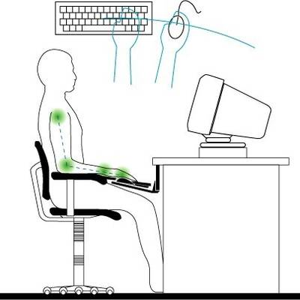

Good Ergonomic Computer Mouse Placement

- Place the mouse on the same level as and immediately next to the keyboard tray.
- Keep the mouse in the arc line of the keyboard so that you can reach it when rotating your arm from the elbow.
- Do NOT use a wrist rest while using the mouse. Your forearm needs to be free to move so you do not strain the wrist.

- Chair Setup & Posture
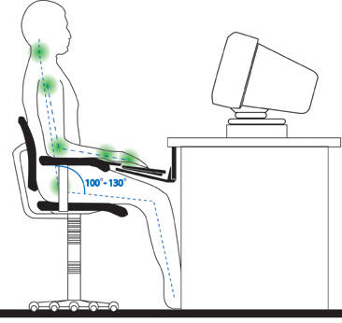

The proper ergonomic posture at a computer.

- Use arm rests.
- Place the lumbar support slightly below the waist line.
- Adjust the height of the chair so your feet can rest completely on the floor.
- Allow 1-3 inches between the edge of the seat and the back of your knees.
- Use a high back chair that supports your shoulder blades if at all possible
- Position your hips so that they are slightly higher than your knees while your feet are flat on the floor.
- Don’t keep your feet flat on the floor. Move them around often. Use a foot rest if you have one, but only part of the time. Do NOT cross your ankles.

