Ergonomics is the study of designing equipment and devices that fit the human body, its movements, and its cognitive abilities.

Definition of Ergonomics
Ergonomics derives from two Greek words: ergon, meaning work, and nomoi, meaning natural laws, to create a word that means the science of work and a person’s relationship to that work.

What is ergonomics?
Ergonomics is a science concerned with the ‘fit’ between people and their work. It puts people first, taking account of their capabilities and limitations. Ergonomics aims to make sure that tasks, equipment, information and the environment suit each worker.

To assess the fit between a person and their work, ergonomists have to consider many aspects. These include:
- the job being done and the demands on the worker;
- the equipment used (its size, shape, and how appropriate it is for the task);
- the information used (how it is presented, accessed, and changed);
- the physical environment (temperature, humidity, lighting, noise, vibration); and
- the social environment (such as teamwork and supportive management).
Ergonomists consider all the physical aspects of a person, such as:
- body size and shape;
- fitness and strength;
- posture;
- the senses, especially vision, hearing and touch; and
- the stresses and strains on muscles, joints, nerves.
Ergonomists also consider the psychological aspects of a person, such as:
- mental abilities;
- personality;
- knowledge; and
- experience.
By assessing these aspects of people, their jobs, equipment, and working environment and the interaction between them, ergonomists are able to design safe, effective and productive work systems.

How can ergonomics improve health and safety?
Applying ergonomics to the workplace:
- reduces the potential for accidents;
- reduces the potential for injury and ill health; and
- improves performance and productivity.

Ergonomics can reduce the likelihood of an accident. For example, in the design of control panels, consider:
- the location of switches and buttons - switches that could be accidentally knocked on or off might start the wrong sequence of events that could lead to an accident;
- expectations of signals and controls - most people interpret green to indicate a safe condition. If a green light is used to indicate a ‘warning or dangerous state’ it may be ignored or overlooked;
- information overload - if a worker is given too much information they may become confused, make mistakes, or panic. In hazardous industries, incorrect decisions or mistaken actions have had catastrophic results.

Ergonomics can also reduce the potential for ill health at work, such as aches and pains of the wrists, shoulders and back. Consider the layout of controls and equipment; these should be positioned in relation to how they are used. Those used most often should be placed where they are easy to reach without the need for stooping, stretching or hunching.
Failure to observe ergonomic principles may have serious repercussions, not only for individuals, but whole organisations. Many well-known accidents might have been prevented if ergonomics had been considered in designing the jobs people did and the systems within which they worked.

What kind of workplace problems can ergonomics solve?
Ergonomics is typically known for solving physical problems. For example, ensuring that work surfaces are high enough to allow adequate clearance for a worker’s legs. However, ergonomics also deals with psychological and social aspects of the person and their work. For example, a workload that is too high or too low, unclear tasks, time pressures, inadequate training, and poor social support can all have negative effects on the person and the work they do. The following examples highlight some ‘typical’ ergonomic problems found in the workplace:

Display screen equipment
- The screen is poorly positioned - it is too high/low/close/far from the worker, or is offset to one side.
- The mouse is placed too far away and requires stretching to use.
- Chairs are not properly adjusted to fit the person, forcing awkward and uncomfortable postures
- There is glare on the screen from overhead lights or windows, increasing the risk of eyestrain.
- Hardware and/or software are not suitable for the task or the person using it, causing frustration and distress.
- Not enough breaks or changes of activity.
These problems may result in mistakes and poor productivity, stress, eye strain, headaches and other aches or pains

Manual handling
- The load is too heavy and/or bulky, placing unreasonable demands on the person.
- The load has to be lifted from the floor and/or above the shoulders.
- The task involves frequent repetitive lifting.
- The task requires awkward postures, such as bending or twisting.
- The load cannot be gripped properly.
- The task is performed on uneven, wet, or sloping floor surfaces.
- The task is performed under time pressures and incorporates too few rest breaks.

These problems may result in physical injuries such as low back pain or injury to
the arms, hands, or fingers. The problems may also contribute to the risk of slips,
trips, and falls.
Work-related stress
- Work demands are too high or too low.
- The employee has little say in how they organise their work.
- Poor support from management and/or colleagues.
- Conflicting demands, eg high productivity and quality.
Poor control of the risks causing work-related stress could lead to ill health and reduced performance and productivity.
Managing the working day
- Insufficient recovery time between shifts.
- Poor scheduling of shifts.
- Juggling shifts with domestic responsibilities.
- Employees working excessive overtime.
These problems may lead to tiredness or exhaustion, which can increase the likelihood of accidents and ill health.

How do I identify ergonomic problems?
There are many ways in which ergonomic problems can be identified. These can range from general observations and checklists to quantitative risk assessment tools.
Ideally, several approaches should be used:
- talking to employees and seeking their views. Employees have important knowledge of the work they do, any problems they have, and their impact on health, safety, and performance;
- assessing the work system by asking questions such as:
  - Is the person in a comfortable position?
  - Does the person experience discomfort, including aches, pain, fatigue, or stress?
  - Is the equipment appropriate, easy to use and well maintained?
  - Is the person satisfied with their working arrangements?
  - Are there frequent errors?
  - Are there signs of poor or inadequate equipment design, such as plasters on workers’ fingers or ‘home-made’ protective pads made of tissue or foam?
- examining the circumstances surrounding frequent errors and incidents where mistakes have occurred and people have been injured. Use accident reports to identify details of incidents and their possible causes;
- recording and looking at sickness absence and staff turnover levels. High numbers may result from the problems listed earlier and/or dissatisfaction at work.

What can I do if I think I have identified an ergonomic problem?
- Look for likely causes and consider possible solutions. A minor alteration may be all that is necessary to make a task easier and safer to perform. For example:
  - provide height-adjustable chairs so individual operators can work at their preferred work height;
  - remove obstacles from under desks to create sufficient leg room;
  - arrange items stored on shelving so those used most frequently and those that are the heaviest are between waist and shoulder height;
  - raise platforms to help operators reach badly located controls;
  - change shift work patterns; and
  - introduce job rotation between different tasks to reduce physical and mental fatigue.
- Talk to employees and get them to suggest ideas and discuss possible solutions. Involve employees from the start of the process - this will help all parties to accept any proposed changes.
- Always make sure that any alterations are properly evaluated by the people who do the job. Be careful that a change introduced to solve one problem does not create difficulties elsewhere.
- You don’t always need to consult ergonomics professionals, and the expense of making changes can often be kept low. However, you may need to ask a qualified ergonomist if you are unable to find a straightforward solution or if a problem is complex.
- HSE has published a range of guidance material, some of which is free. Aimed at employers and employees, this guidance provides help on how to achieve safe and healthy work environments. It includes practical evaluation checklists and advice.
- Good ergonomics sense makes good economic sense. Ergonomics input does not necessarily involve high costs, and can save money in the long term by reducing injuries and absence from work.

An understanding of ergonomics in your workplace can improve your daily work routine. It is possible to eliminate aches, pains, and stresses at work and improve job satisfaction. Ergonomic solutions can be simple and straightforward to make -even small changes such as altering the height of a chair can make a considerable difference.

Relating Productivity to Ergonomics

Many companies have heard about the cost savings associated with preventing musculoskeletal disorders (MSDs) in the work place. The savings these companies have most likely heard about have been focused on reduced workers' compensation claims, lower insurance premiums, less employee turnover, and possibly avoiding regulatory fines. What some companies haven't heard is that improving ergonomics almost always can improve a company's productivity.
Any ergonomics intervention must be viewed in light of its effect on productivity, and the best ergonomics solutions will often improve productivity. Simply put, reducing unnecessary or awkward postures and exertions almost necessarily reduces the time it takes to complete a given task, thus improving productivity.
Body motions, visibility, workload, and other important ergonomic parameters will also affect the quality of work, and the quality of work product. When a task is matched with the ability of the people that will perform it, they will make fewer errors and produce less waste. Ergonomic design considerations have also been shown to influence employee recruitment and retention. The following table shows examples of successful performance approaches.

Company | Intervention | Results
Applied Materials (supplier to the silicon chip industry) | Properly designed and tested casters for manually moving 7,000 lb. clean room manufacturing equipment | 400% increase in productivity, in terms of man hours, reduced potential for workmanship errors
Applied Materials (supplier to the silicon chip industry) | Researched and selected a better torque hand driver tool | 50% increase in productivity
Telecommunications plant | Ergonomic redesign of four workstations | Increased production, reduced data entry error rates and improved job satisfaction
Fast Food provider | Redesign of workstation to include anthropometric dimension of worker | A 20% increase in productivity
Steel Company | Ergonomic redesign of an observation pit | Save over $150,000 in 1 year through reduced waste and higher productivity
Toy Manufacturing Plant | Product design change | A savings of $0.11 per part

Ergonomics – Setting Furniture to Improve Productivity

Hand Positions – Keyboard
The wrist should be straight.
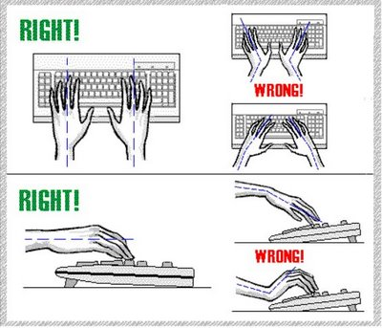

Arm Positions – Mouse
Mouse should be parallel to the keyboard, not far back.
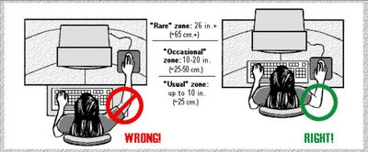

Hand Positions – Mouse
Same rules again, wrist should be straight.

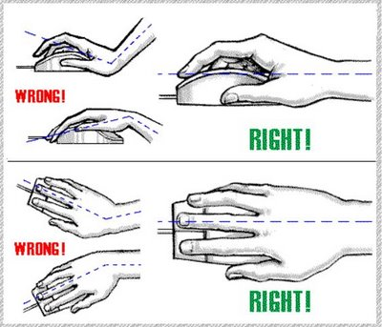

Sitting Chair
Instructions in the figure (image).

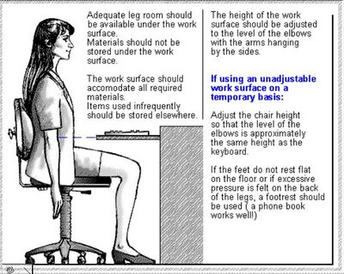

Computer Screen
The screen should NOT be placed above your eye level. The distance mattered in the old days of Monitors which weakened the eye-sights of many. Now in the LCD era, the distance doesn’t matter much.

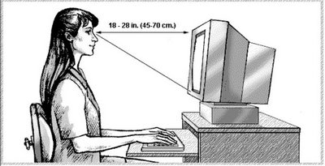

Table Setting
Virtually distribute your table into three parts.
Usual Zone should contain items which you use frequently, like your mouse, keyboard, pen etc.
Occasional Zone would contain items which are slightly less used, like a glass of water.
Rare Zone is for the extra stuff.
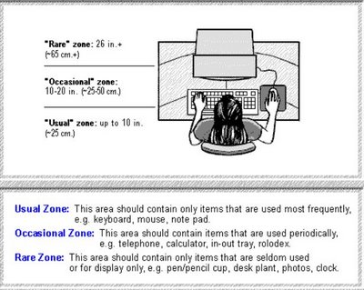

Light Source

Light source should be above the monitor screen, even the table lamps should be above it. And the source should not face you, in fact the direction should be where you are seeing so that the room would look bright.
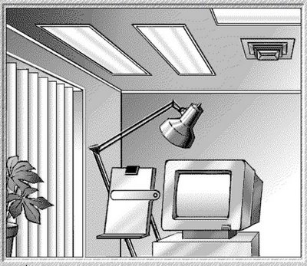

Ocean In A Drop
