Heat Exchanger
Heat exchangers are devices built for efficient heat transfer from one fluid to another and are widely used in engineering processes. Some examples are intercoolers, preheaters, boilers and condensers in power plants. The fluids may be separated by a wall so that they never mix or they may be in direct contact. They are widely used in space heating, refrigeration, air conditioning, power plants, chemical plants, petrochemical plants, petroleum refineries, natural gas processing, and sewage treatment. The classic example of a heat exchanger is found in an internal combustion engine in which a circulating fluid known as engine coolant flows through radiator coils and air flows past the coils, which cools the coolant and heats the incoming air.
Shell and tube heat exchangers are usually used when larger flows of fluids are involved and it is the most important type of exchanger used in the process industries. This type of heat exchanger consists of a shell (a large pressure vessel) with a bundle of tubes inside it. One fluid runs through the tubes, and another fluid flows over the tubes (through the shell) to transfer heat between the two fluids. The simplest shell-and-tube exchanger is the one shell pass and one tube pass shown in figure below. The cold fluid enters and flows inside through all the tubes in parallel in one pass. The hot fluid enters at the other end and flows countercurrently with the other fluid across the tubes.
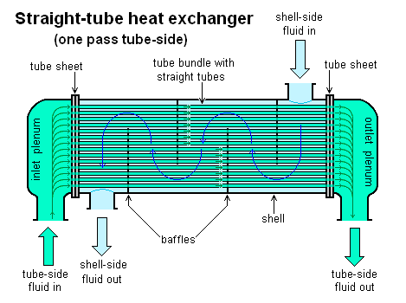
Figure 3. One Pass Tube Side Heat Exchanger

The type of heat exchanger that will be used is a 1-shell 2-tube pass tube heat exchanger. The heat exchanger is shown in figure below. As seen from the figure, the cold fluid which passes at the tube side of the heat exchanger passes twice through the fluid in the shell. In this case, depending on the orientation of the inlet flow of the cold and hot fluid, the cold fluid is in parallel flow with the hot fluid (as shown in figure) then at the second pass becomes counterflow.
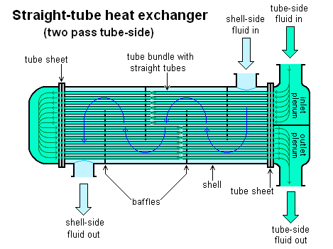
Figure 3. Two Pass Tube Side Heat Exchanger

There are often baffles directing flow through the shell side so the fluid does not take a short cut through the shell side leaving ineffective low flow volumes.

Coolant Outlet Temperature as a Function of Flowrate in the Heat Exchanger
The heat gained by the cold fluid in the heat exchanger would be
$Q_{C}=ρ_{C}ϕ_{V_{C}}C_{C}\left(T_{co}-T_{ci}\right)$ [1]
and the heat lost by the hot fluid in the exchanger is calculated by
$Q_{H}=ρ_{H}ϕ_{V_{H}}C_{H}\left(T_{hi}-T_{ho}\right)$ [2]
Assuming no heat is lost in the environment and other losses,
$Q_{H}=Q_{C}$
Substituting equations 1 and 2 we get
$ρ_{C}ϕ_{V_{C}}C_{C}(T_{co}-T_{ci})=ρ_{H}ϕ_{V_{H}}C_{H}\left(T_{hi}-T_{ho}\right)$ [3]
Rearranging equation 3 to get T_{co}
$T_{co}=\frac{ρ_{H}ϕ_{V_{H}}C_{H}}{ρ_{C}ϕ_{V_{C}}C_{C}}\left(T_{hi}-T_{ho}\right)+T_{ci}$ [4]
$let K=\frac{ρ_{H}ϕ_{V_{H}}C_{H}}{ρ_{C}ϕ_{V_{C}}C_{C}}$
$T_{co}=K\left(T_{hi}-T_{ho}\right)+T_{ci}$ [5]
Differentiation of equation 5 yields
$\frac{dT}{dt}=K\frac{dT_{co}}{dt}$ [6]
The equation describing the behavior of the hot fluid in the jacket of the reactor is given by:
$\frac{dT}{dt}=\frac{F_{in}}{V}\left(T_{in}-T\right)+\frac{Q}{ρVC_{P}}$ [7]
Combining equations 6 and 7, we get
$VK\frac{dT_{co}}{dt}=F_{in}\left(T_{ho}-T_{hi}\right)+\frac{Q}{ρC_{P}}$ [8]
Equation [5] is rearranged to get T_{hi} and substituting to equation [8]
$VK\frac{dT_{co}}{dt}=F_{in}[T_{ho}-K(T_{co}-T_{ci})-T_{ho}]+\frac{Q}{ρC_{P}}$ [9]
$VK\frac{dT_{co}}{dt}={-F}_{in}K(T_{co}-T_{ci})+\frac{Q}{ρC_{P}}$ [10]
Simplifying,
$V\frac{dT_{co}}{dt}{+F}_{in}(T_{co}-T_{ci})=\frac{Q}{KρC_{P}}$ [11]
Where,
$F_{in}$ = mass flowrate of cold fluid entering the tube side of the exchanger
$T_{ci}=$ inlet temperature of the cold fluid in the exchanger
$T_{co}=$ outlet temperature of the cold fluid in the exchanger

