PLATE TYPE HEAT EXCHANGER
A plate heat exchanger is a type of heat exchanger that uses metal plates to transfer heat between two fluids. This has a major advantage over a conventional heat exchanger in that the fluids are exposed to a much larger surface area because the fluids spread out over the plates. This facilitates the transfer of heat, and greatly increases the speed of the temperature change. Plate heat exchangers are now common and very small brazed versions are used in the hot-water sections of millions of combination boilers. The high heat transfer efficiency for such a small physical size has increased the domestic hot water (DHW) flowrate of combination boilers. The small plate heat exchanger has made a great impact in domestic heating and hot-water. Larger commercial versions use gaskets between the plates, smaller version tend to be brazed.
The concept behind a heat exchanger is the use of pipes or other containment vessels to heat or cool one fluid by transferring heat between it and another fluid. In most cases, the exchanger consists of a coiled pipe containing one fluid that passes through a chamber containing another fluid. The walls of the pipe are usually made of metal, or another substance with a high thermal conductivity, to facilitate the interchange, whereas the outer casing of the larger chamber is made of a plastic or coated with thermal insulation, to discourage heat from escaping from the exchanger.
The plate heat exchanger (PHE) was invented by Dr Richard Seligman in 1923 and revolutionised methods of indirect heating and cooling of fluids. Dr Richard Seligman founded APV in 1910 as the Aluminium Plant & Vessel Company Limited, a specialist fabricating firm supplying welded vessels to the brewery and vegetable oil trades.
Design:
The plate heat exchanger (PHE) is a specialized design well suited to transferring heat between medium- and low-pressure fluids. Welded, semi-welded and brazed heat exchangers are used for heat exchange between high-pressure fluids or where a more compact product is required. In place of a pipe passing through a chamber, there are instead two alternating chambers, usually thin in depth, separated at their largest surface by a corrugated metal plate. The plates used in a plate and frame heat exchanger are obtained by one piece pressing of metal plates. Stainless steel is a commonly used metal for the plates because of its ability to withstand high temperatures, its strength, and its corrosion resistance. The plates are often spaced by rubber sealing gaskets which are cemented into a section around the edge of the plates. The plates are pressed to form troughs at right angles to the direction of flow of the liquid which runs through the channels in the heat exchanger. These troughs are arranged so that they interlink with the other plates which forms the channel with gaps of 1.3–1.5 mm between the plates.
The plates produce an extremely large surface area, which allows for the fastest possible transfer. Making each chamber thin ensures that the majority of the volume of the liquid contacts the plate, again aiding exchange. The troughs also create and maintain a turbulent flow in the liquid to maximize heat transfer in the exchanger. A high degree of turbulence can be obtained at low flow rates and high heat transfer coefficient can then be achieved.
The total rate of heat transfer between the hot and cold fluids passing through a plate heat exchanger may be expressed as:
Q = UA∆Tm
where U is the overall heat transfer coefficient, A is the total plate area, and ∆Tm is the temperature difference. U is dependent upon the heat transfer coefficients in the hot and cold streams
Applications
  - Power - Auxiliary cooling circuit isolation, co-generation applications, geothermal applications, lubrication oil cooling, diesel engine cooling, heat recovery.
  - HVAC - Cooling tower isolation, free cooling, heat pump systems, sea water isolation, thermal storagesystems, pressure Interceptor.
  - Marine - Seawater isolation exchanger, central cooling, jacket fresh water cooling, lube oil cooling, camshaft lube, oil cooling.

Industrial

Mining - Plating heaters & coolers, analyzing heaters & coolers, strike solution cooling, quench oil coolers, sulfuric acid, hydrochloric acid, hydrogen peroxide, titanium dioxide, chloride alkaline, soda ash, steel.
Refinery - Brine cooling, crude oil/water interchanger, treated crude oil / untreated crude oil interchanger.
Dairy - Milk pasteurization, milk reception, cultured milk treatment, UHT, cream pasteurization, ice-cream mix treatment, cheese milk heat treatment.

Marine heat exchanger
Marine heat exchangers are the most common way to cool a boat's/ship engine, using the lake, river or Sea water in which the boat floats. Direct cooling of the cylinders and heads by sea-water is unsatisfactory because sea water will eventually ruin the cylinder block and heads. Since this water may be corrosive the engine may be cooled by a sealed mixture of distilled/Fresh water and antifreeze. Heat from the water-antifreeze mixture is then transferred to the Sea (or lake or river) water which flows into a heat exchanger. The water-antifreeze mixture runs through the heat exchanger dumping heat, but remaining separate from corrosive salts and chemicals found in the water the boat is floating in. If the Sea water eventually corrodes and ruins the heat exchanger it can be replaced at a fraction of the cost of replacing the engine.
Advantages:
- Simple and Compact in size
- Heat transfer efficiency is more
- Can be easily cleaned
- No extra space is required for dismantling
- Capacity can be increased by introducing plates in pairs
- Leaking plates can be removed in pairs, if necessary without replacement
- Maintenance is simple
- Turbulent flow help to reduce deposits which would interfere with heat transfer
Disadvantages:
- Initial cost is high since Titanium plates are expensive
- Finding leakage is difficult since pressure test is not as ease as tube coolers
- Bonding material between plates limits operating temperature of the cooler
- Pressure drop caused by plate cooler is higher than tube cooler
- Careful dismantling and assembling to be done
- Over tightening of the clamping bolts result in increased pressure drop across the cooler
- Joints may be deteriorated according to the operating conditions
- Since Titanium is a noble metal, other parts of the cooling system are susceptible to corrosion

Plate type heat exchanger
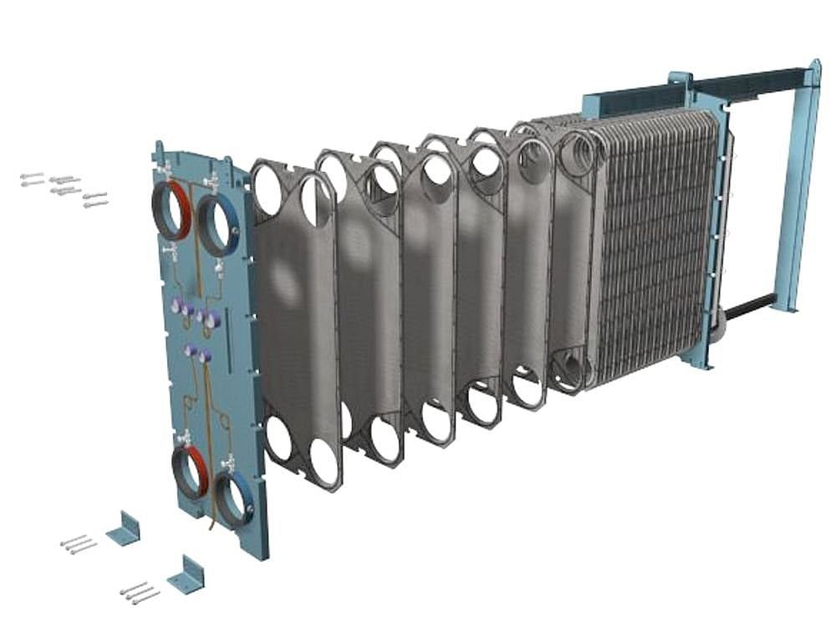

FINS
Finned surfaces are commonly used in practice to enhance heat transfer, and
they often increase the rate of heat transfer from a surface severalfold. The car
radiator is an example of a finned surface. The closely packed thin metal sheets attached to the hot water tubes increase the surface area for convection and thus the rate of convection heat transfer from the tubes to the air many times.

PIN FIN
A pin fin heat sink is a heat sink that has pins that extend from its base. The pins can be cylindrical, elliptical or square. A pin is by far one of the more common heat sink types available on the market. A second type of heat sink fin arrangement is the straight fin. These run the entire length of the heat sink. A variation on the straight fin heat sink is a cross cut heat sink. A straight fin heat sink is cut at regular intervals.
In general, the more surface area a heat sink has, the better it works. However, this is not always true. The concept of a pin fin heat sink is to try to pack as much surface area into a given volume as possible.As well, it works well in any orientation. Kordyban has compared the performance of a pin fin and a straight fin heat sink of similar dimensions. Although the pin fin has 194 cm² surface area while the straight fin has 58 cm², the temperature difference between the heat sink base and the ambient air for the pin fin is 50 °C. For the straight fin it was 44 °C or 6 °C better than the pin fin. Pin fin heat sink performance is significantly better than straight fins when used in their intended application where the fluid flows axially along the pins rather than only tangentially across the pins.

APPLICATIONS:
Fins are most commonly used in heat exchanging devices such as radiators in cars and heat exchangers in power plants. They are also used in newer technology such as hydrogen fuel cells.Nature has also taken advantage of the phenomena of fins. The ears of jackrabbits and Fennec Foxes act as fins to release heat from the blood that flows through them.
Fin and tube heat exchangers are used widely in residential, commercial and industrial HVAC applications.
One major application of highly finned tubes is in air cooled heat exchangers. Atmospheric air like all low pressure gases give very low value of heat transfer coefficient at normal velocity. By contrast, the tube side fluid usually a liquid to be cooled or vapour to be condensed may have a coefficient upto 100 times more. Therefore highly finned tubes are used in this case to increase heat transfer and to reduce the overall size of heat exchanger.
Low and medium finned tubes are used in variety of sensible, condensing, and boiling services in shell and tube exchangers. A typical sensible heat transfer application would be cooling a compressed gas in a compressor in a compressor intercooler.
Low finned tubes are used for condensing organic vapors , which have condensing coefficients only a third or a quarter of that of cooling water inside the tubes. In addition to providing heat transfer are , fins provide drip points that facilitate the drainage of condensate
Finned tubes are also used in the boiling services, especially when condensing t steam is the heating medium inside the tubes.
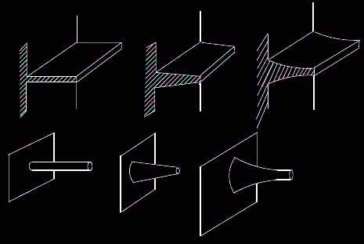
Different types of fin

In bikes:
Most air-cooled motorcycles take advantage of air blowing past the cylinder and cylinder head while in motion to disperse heat. Frequent, sustained stationary periods may cause over-heating. Some models (mostly scooters) are equipped with fans that force the air to go past the cylinder block, which solves the problem of city driving. The cylinders on air-cooled bikes are designed with fins (heat sinks) to aid in this process. Air-cooled bikes are cheaper, simpler and lighter than their water-cooled counterparts.
Fins used in other applications:
- Hydrocarbon process and steam condensers
- Large engine radiators
- Turbine lube oil coolers
- Turbine intercoolers
- Natural gas and vapor coolers
- Combustion pre-heaters
- Flue gas re-heaters

DOUBLE PIPE HEAT EXCHANGERS
A heat exchanger is a device built for efficient heat transfer from one medium to another, whether the media are separated by a solid wall so that they never mix, or the media are in direct contact. They are widely used in space heating, refrigeration, air conditioning, power plants, chemical plants, petrochemical plants, petroleum refineries, and natural gas processing. One common example of a heat exchanger is the radiator in a car, in which a hot engine-cooling fluid, like antifreeze, transfers heat to air flowing through the radiator

A typical double-pipe heat exchanger is shown in . Essentially, it consists of one pipe placed concentrically inside another one of larger diameter, with appropriate end fittings on each pipe to guide the fluids from one section to the next. The inner pipe may have external longitudinal fins welded to it either internally or externally to increase the heat transfer area for the fluid with the lower heat transfer coefficient. The double-pipe sections can be connected in various series or parallel arrangements for either fluid to meet pressure-drop limitations and LMTD requirements To make an Unit very Compact, The Arrangement is made Multiple Times and Continues Serial and Parallel flow.
This is also called as a hairpin heat exchanger. These are may have only one inside pipe, or it may have multiple inside tubes, but it will always have the doubling back feature shown. In some of the Special Cases the Fins also Used in Tube side.

Types of Double Pipe Heat Exchangers
- Counter flow and
- Parallel Flow Heat Exchanger
Counter flow
The main advantage of a hairpin or double pipe heat exchanger is that it can be operated in a true counter flow pattern, To get More Efficiency, In the mean Time, it will give the highest overall heat transfer coefficient for the double pipe heat exchanger design. In counter-flow heat exchangers the fluids enter the exchanger from opposite ends. The counter current design is most efficient, in that it can transfer the most heat.
Parallel Flow
In parallel-flow heat exchangers, the two fluids enter the exchanger at the same end, and travel in parallel to one another to the other side
Parallel Flow double pipe heat exchangers are focused to handle high pressures and temperatures applications. Also we can Achieve High Log mean Temperature using this
APPLICATIONS
Heat Exchangers in Industry
Heat exchangers are widely used in industry both for cooling and heating large scale industrial processes. The type and size of heat exchanger used can be tailored to suit a process depending on the type of fluid, its phase, temperature, density, viscosity, pressures, chemical composition and various other thermodynamic properties.
In many industrial processes there is waste of energy or a heat stream that is being exhausted, double pipe heat exchangers can be used to recover this heat and put it to use by heating a different stream in the process. This practice saves a lot of money in industry as the heat supplied to other streams from the heat exchangers would otherwise come from an external source which is more expensive and more harmful to the environment.
Heat exchangers are used in many industries, some of which include:
- Waste water treatment
- Refrigeration systems
- Wine-brewery industry
- Petroleum industry
In the waste water treatment industry, heat exchangers play a vital role in maintaining optimal temperatures within anaerobic digesters so as to promote the growth of microbes which remove pollutants from the waste water. The common types of heat exchangers used in this application are the double pipe heat exchanger as well as the plate and frame heat exchanger
The major use of double-pipe exchangers is for sensible heating or cooling of theprocess fluid where small heat transfer areas (typically up to 50 m.) are required. They mayalso be used for small amounts of boiling or condensation on the process fluid side. Theadvantages of the double-pipe exchanger are largely in the flexibility of application andpiping arrangement, plus the fact that they can be erected quickly from standardcomponents by maintenance crew
Advantages
- Less expensive as compared to Plate type coolers
- Can be used in systems with higher operating temperatures and pressures
- Pressure drop across a tube cooler is less
- Tube leaks are easily located and plugged since pressure test is comparatively easy
- Tubular coolers in refrigeration system can act as receiver also.
- Using sacrificial anodes protects the whole cooling system against corrosion
- 7Tube coolers may be preferred for lubricating oil cooling because of the pressure differential
Disadvantages
- Heat transfer efficiency is less compared to plate type cooler
- Cleaning and maintenance is difficult since a tube cooler requires enough clearance at one end to remove the tube nest
- Capacity of tube cooler cannot be increased.
- Requires more space in comparison to plate coolers
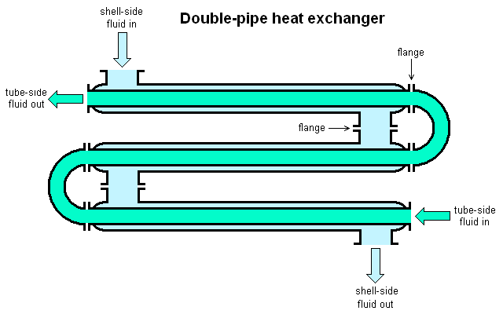

EMISSIVITY
The emissivity of a material (usually written ε or e) is the relative ability of its surface to emit energy by radiation. It is the ratio of energy radiated by a particular material to energy radiated by a black body at the same temperature. A true black body would have an ε = 1 while any real object would have ε < 1. Emissivity is a dimensionless quantity.
In general, the duller and blacker a material is, the closer its emissivity is to 1. The more reflective a material is, the lower its emissivity. Highly polished silver has an emissivity of about 0.02
Emissivity depends on factors such as temperature, emission angle, and wavelength. A typical physical ] assumption is that a surface's spectral emissivity and absorptive do not depend on wavelength, so that the emissivity is a constant. This is known as the "gray body assumption".
Although it is common to discuss the "emissivity of a material" (such as the emissivity of highly polished silver), the emissivity of a material does in general depend on its thickness. The emissivities quoted for materials are for samples of infinite thickness (which, in practice, means samples which are optically thick) — thinner samples of material will have reduced emissivity.
When dealing with non-black surfaces, the deviations from ideal black body behavior are determined by both the geometrical structure and the chemical composition, and follow Kirchhoff's law of thermal radiation: emissivity equals absorptive (for an object in thermal equilibrium), so that an object that does not absorb all incident light will also emit less radiation than an ideal black body.
Most emissivities found in handbooks and on websites of many infrared imaging and temperature sensor companies are the type discussed here, total emissivity. However, the distinction needs to be made that the wavelength-dependent or spectral emissivity is the more significant parameter to be used when one is seeking an emissivity correction for a temperature measurement device.
Thus, it is important to understand the distinction between total and spectral emissivity and where they apply

Emissivity of Earth's atmosphere
The emissivity of Earth's atmosphere varies according to cloud cover and the concentration of gases that absorb and emit energy in the thermal infrared (i.e., wavelengths around 8 to 14 micrometres). These gases are often called greenhouse gases, from their role in the greenhouse effect. The main naturally-occurring greenhouse gases are water vapor, carbon dioxide, methane, and ozone. The major constituents of the atmosphere, N₂ and O₂, do not absorb or emit in the thermal infrared.
A black body is an idealized physical body that absorbs all incident electromagnetic radiation. Because of this perfect absorptive at all wavelengths, a black body is also the best possible emitter of thermal radiation, which it radiates incandescently in a characteristic, continuous spectrum that depends on the body's temperature. At Earth-ambient temperatures this emission is in the infrared region of the electromagnetic spectrum and is not visible. The object appears black, since it does not reflect or emit any visible light.
For surfaces which are not black bodies, one has to consider the (generally frequency dependent) emissivity factor . This factor has to be multiplied with the radiation spectrum formula before integration. If it is taken as a constant, the resulting formula for the power output can be written in a way that contains as a factor:

Fields where concept of emissivity is used:
Radiant barriers:
Radiant barriers are materials that reflect radiation, and therefore reduce the flow of heat from radiation sources
The effectiveness of a radiant barrier is indicated by its reflectivity or emissvity, which is the fraction of radiation reflected. A material with a high reflectivity (at a given wavelength) has a low emissivity (at that same wavelength), and vice versa. At any specific wavelength, reflectivity = 1 - emissivity. An ideal radiant barrier would have a reflectivity of 1, emissivity=0, and would therefore reflect 100 percent of incoming radiation.
Radiative cooling
Radiative cooling is the process by which a body loses heat by radiation. It is an important effect in the Earth's atmosphere. In the case of the Earth-atmosphere system, it refers to the process by which long-wave (infrared) radiation is emitted to balance the absorption of short-wave (visible) energy from the Sun.
Low-emissivity windows
Window glass is by nature highly thermal emissive as indicated in the table above. To improve thermal efficiency (insulation properties) thin film coatings are applied to the raw soda-lime glass. There are two primary methods in use: Pyrolytic CVD and Magnetron Sputterin.The first involves deposition of fluorinated tin oxide (SnO2:F see Tin dioxide uses) at high temperatures. Pyrolytic coatings are usually applied at the Float glass plant when the glass is manufactured. The second involves depositing thin silver layer(s) with antireflection layers. Magnetron sputtering uses large vacuum chambers with multiple deposition chambers depositing 5 to 10 or more layers in succession. Silver based films are environmentally unstable and must be enclosed in an Insulated glazing or Insulated Glass Unit (IGU) to maintain their properties over time. Specially designed coatings, are applied to one or more surfaces of insulated glass. These coatings reflect radiant infrared energy, thus tending to keep radiant heat on the same side of the glass from which it originated, while letting visible light pass. This results in more efficient windows because radiant heat originating from indoors in winter is reflected back inside, while infrared heat radiation from the sun during summer is reflected away, keeping it cooler inside.

Glass can be made with differing thermal emissivities, but this is not used for windows. Certain properties such as the iron content may be controlled changing the thermal emissivity properties of glass. This is "naturally" low thermal emissivity, found in some formulations of borosilicate or Pyrex. Naturally low-e glass does not have the property of reflecting NIR/thermal radiation, instead this type of glass has higher NIR transmission leading to undesirable heat loss (or gain) in a building window.
Reflective thermal insulation
Reflective thermal insulation is typically fabricated from aluminum foil with a variety of core materials such as low-density polyethylene foam, polyethylene bubbles, fiberglass, or similar materials. Each core material presents its own set of benefits and drawbacks based on its ability to provide a thermal break, deaden sound, absorb moisture, and resist combustion during a fire. When aluminum foil is used as the facing material, reflective thermal insulation can stop 97% of radiant heat transfer. Recently, some reflective thermal insulation manufacturers have switched to a metalized polyethylene facing. The long-term efficiency and durability of such facings are still undetermined.
Reflective thermal insulation can be installed in a variety of applications and locations including residential, agricultural, commercial, and industrial structures. Some common installations include house wraps, duct wraps, pipe wraps, under radiant floors, inside wall cavities, roof systems, attic systems and crawl spaces. Reflective thermal insulation can be used as a stand-alone product in many applications but can also be used in combination systems with mass insulation where higher R-values are required.

CONTENTS:

1. Plate Type Heat Exchanger:
- Principle
- Design
- Applications
- Advantages and disadvantages

2. Fins:
- Principle
- Applications

3. Double Pipe Heat Exchangers:
- Principle
- Types
- Applications
- Advantages and disadvantages

4. Emissivity:
- Principle
- Fields emissivity concept used.

