Introduction:-

This report shows us different types of heat exchangers and explains some advantages and disadvantages of each type.

Radiator type water\air heat exchanger:-
The most familiar example of an air to liquid heat exchanger is a car radiator. The coolant flowing in the engine picks up heat from engine block and carries it to the radiator. From the radiator, the hot coolant flows into the tube side of the radiator (heat exchanger). The relatively cool air flowing over the outside of the tube picks up the heat, reducing the temperature of the coolant.
Because air is such a poor conductor of heat, the heat transfer area between the metal of the radiator and the air must be maximized. This is done by using fins on the outside of the tubes the fins improves the efficiency of a heat exchanger and are commonly found on most liquid to air heat exchangers and in some high efficiency liquid to liquid heat exchangers.

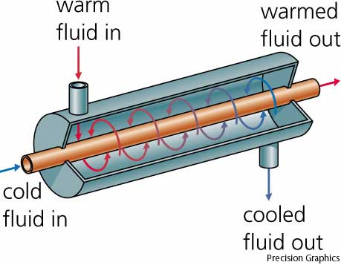
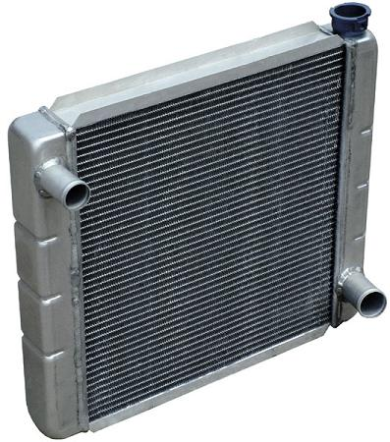
Shell and tube heat exchanger:-
Two fluids, of different starting temperatures, flow through the heat exchanger. One flows through the tubes (the tube side) and the other flows outside the tubes but inside the shell (the shell side). Heat is transferred from one fluid to the other through the tube walls, either from tube side to shell side or vice versa. The fluids can be either liquids or gases on either the shell or the tube side. In order to transfer heat efficiently, a large heat transfer area should be used, leading to the use of many tubes. In this way, waste heat can be put to use. This is an efficient way to conserve energy.
Heat exchangers with only one phase (liquid or gas) on each side can be called one-phase or single-phase heat exchangers. Two-phase heat exchangers can be used to heat a liquid to boil it into a gas (vapor), sometimes called boilers, or cool a vapor to condense it into a liquid (called condensers), with the phase change usually occurring on the shell side. Boilers in steam engine locomotives are typically large, usually cylindrically-shaped shell-and-tube heat exchangers. In large power plants with steam-driven turbines, shell-and-tube surface condensers are used to condense the exhaust steam exiting the turbine into condensate water which is recycled back to be turned into steam in the steam generator.
Shell and tube heat exchanger design:-
U-tube heat exchanger:-
In nuclear power plants called pressurized water reactors, large heat exchangers called steam generators are two-phase, shell-and-tube heat exchangers which typically have U-tubes. They are used to boil water recycled from a surface condenser into steam to drive a turbine to produce power. Most shell-and-tube heat exchangers are 1, 2, or 4 pass designs on the tube side. This refers to the number of times the fluid in the tubes passes through the fluid in the shell. In a single pass heat exchanger, the fluid goes in one end of each tube and out the other.

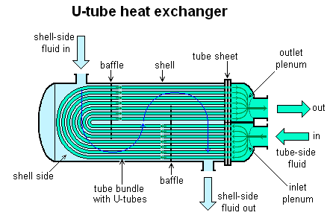

Straight –tube heat exchanger (one pass tube side):-
Surface condensers in power plants are often 1-pass straight-tube heat exchangers. Two and four pass designs are common because the fluid can enter and exit on the same side.

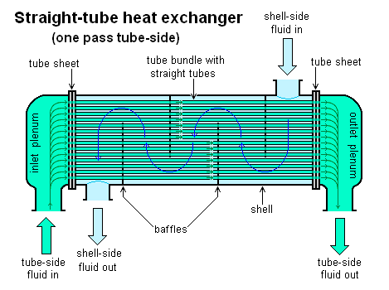
Straight –tube heat exchanger (two pass tube side):-
There are often baffles directing flow through the shell side so the fluid does not take a short cut through the shell side leaving ineffective low flow volumes. These are generally attached to the tube bundle rather than the shell in order that the bundle is still removable for maintenance.
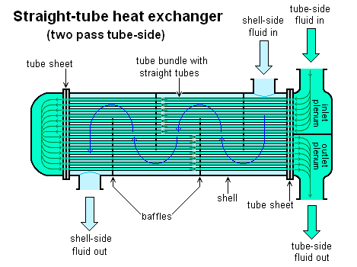
Advantages:-
- Less expensive as compared to Plate type coolers
- Can be used in systems with higher operating temperatures and pressures
- Pressure drop across a tube cooler is less
- Tube leaks are easily located and plugged since pressure test is comparatively easy
- Tube coolers may be preferred for lubricating oil cooling because of the pressure differential

Disadvantages:-
- Heat transfer efficiency is less compared to plate type cooler
- Cleaning and maintenance is difficult since a tube cooler requires enough clearance at one end to remove the tube nest
- Capacity of tube cooler cannot be increased.
- Requires more space in comparison to plate coolers.

Concentric tube heat exchanger:-
The concentric tube heat exchanger consists of two tubes that are concentrically arranged. One of the fluid (either hot or cold fluid) flows through the tube and the other through the annulus. For a CTHX, two types of flow arrangements are possible - co-current and counter-current flow. In the parallel or co-current arrangement, the flow direction of the hot fluid will be the same as that of the cold fluid. In the counter-current arrangement, the flow directions of the hot and the cold fluids are opposite to each other.
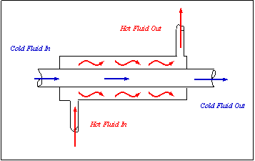
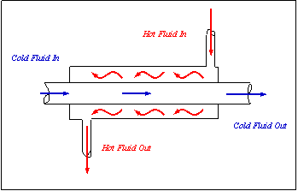
Plate type heat exchanger:-
A plate heat exchanger is a type of heat exchanger that uses metal plates to transfer heat between two fluids. This has a major advantage over a conventional heat exchanger in that the fluids are exposed to a much larger surface area because the fluids spread out over the plates.

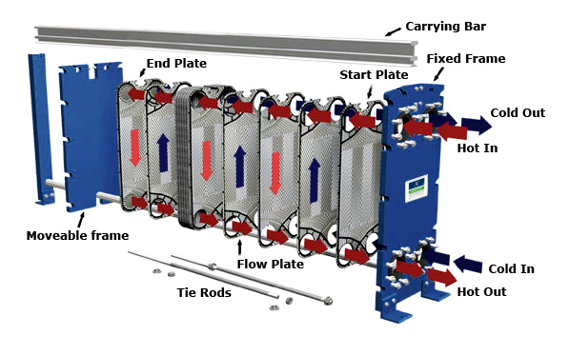

Advantages
- Simple and Compact in size
- Heat transfer efficiency is more
- Can be easily cleaned
- No extra space is required for dismantling
- Capacity can be increased by introducing plates in pairs
- Leaking plates can be removed in pairs, if necessary without replacement
- Maintenance is simple
- Turbulent flow help to reduce deposits which would interfere with heat transfer

Disadvantages
- Initial cost is high since Titanium plates are expensive
- Finding leakage is difficult since pressure test is not as ease as tube coolers
- Bonding material between plates limits operating temperature of the cooler
- Pressure drop caused by plate cooler is higher than tube cooler
- Careful dismantling and assembling to be done
- Over tightening of the clamping bolts result in increased pressure drop across the cooler
- Joints may be deteriorated according to the operating conditions
- Since Titanium is a noble metal, other parts of the cooling system are susceptible to corrosion

