DOUBLE PIPE HEAT EXCHANGER
Heat exchangers are devices that exchange the heat between two fluids of different temperatures that are separated by a solid wall. The temperature gradient or the differences in temperature facilitate this transfer of heat. They are widely used in space heating, refrigeration, air conditioning, power plants, chemical plants, petrochemical plants, petroleum refineries, natural gas processing, and sewage treatment.
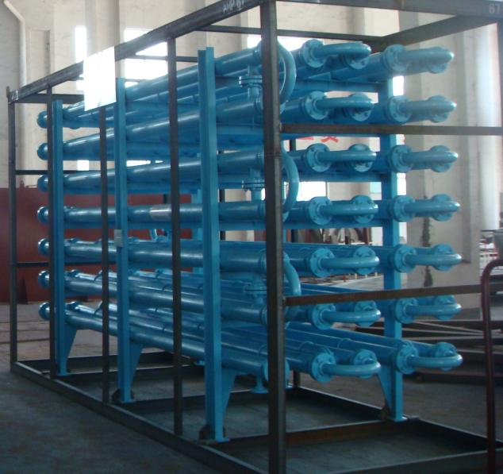
1.0 INTRODUCTION
Figure 1 Multi Double Pipe Heat Exchanger
The double-pipe heat exchanger is one of the simplest types of heat exchangers. This is a concentric tube construction. It is called a double-pipe exchanger because one fluid flows inside a pipe and the other fluid flows between that pipe and another pipe that surrounds the first.
2.0 EXPLANATION
In heat transfer process the analysis of a heat exchanger begins with an energy and material balance. Before doing a complete energy balance a few assumptions can be made. The first assumption is that the energy lost to the surroundings from the cooling water or from the U-bends in the inner pipe to the surroundings is negligible. We also assume negligible potential or kinetic energy changes and constant physical properties such as specific heats and density. These assumptions also simplify the basic heat-exchanger equations. The determination of the overall heat-transfer coefficient is necessary in order to determine the heat transferred from the inner pipe to the outer pipe.
This coefficient takes into account all of the conductive and convective resistances (k and h, respectively) between fluids separated by the inner pipe, and also takes into account thermal resistances caused by fouling (rust, scaling, i.e.) on both sides of the inner pipe. For a double-pipe heat exchanger the overall heat transfer coefficient, U, can be expressed as

$$\frac{1}{Uo}=\frac{1}{ho}+\left(\frac{Ao}{Am}\right)*\left(\frac{ro-ri}{Kw}\right)+\frac{Ao}{Ai}\left(\frac{1}{hi}\right)$$

2.1 HEAT DUTY
It is the heat transfer with respect to the time of the flow of fluid in heat exchanger.
$$Q=mCp(∆T)$$
3.0 CONTRUCTION
The double pipe heat exchanger is constructed by using metals or alloys that have good heat resistance and corrosive resistance properties. Normally the size of double pipe heat exchanger is between 100 – 200 ft².
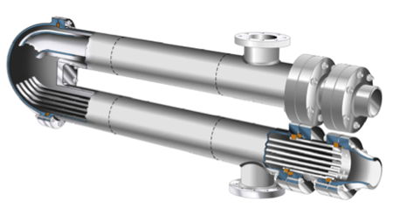
Figure 2 Cross-Sectional view of Double Pipe Heat Exchanger

3.1 EQUIPMENTS
The following is a list of all pieces of equipment for the double-pipe heat exchanger.
- Pump
- Double pipe heat exchanger
- Valves
  - Gate valves
  - Disk blow valves
  - Ball valves
  - Computer controlled valves
- Flow meters
- Thermocouples
- Low pressure steam
- Computer

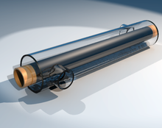
4.0 FLUID MOVEMENT
Figure 3 Tubular Heat Exchanger
There are two flow configurations co-current is when the flow of the two streams is in the same direction, counter current is when the flow of the streams is in opposite directions.
4.1 COUNTER CURRENT FLOW
Fluids flow in opposite directions. These are used for liquid-liquid, condensing and gas cooling applications. Usually the counter current movement is used as the rate of heat transfer is more as compared to co-current movement.
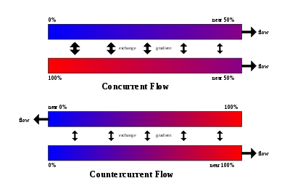
4.2 CO-CURRENT FLOW
In the concurrent flow exchange mechanism, the two fluids flow in the same direction. This type of flow is usually used when the less heat transfer is required. The co-efficient of heat transfer is low in co-current flow.

Figure 4 Concurrent and countercurrent flow
5.0 MAINTENANCE
Maintenance of commercial heat exchangers is done by tracking the overall heat transfer coefficient. The overall heat transfer coefficient tends to decline over time due to fouling.
$$U=\frac{Q}{AΔTlm}$$
By periodically calculating the overall heat transfer coefficient from exchanger flow rates and temperatures, the owner of the heat exchanger can estimate when cleaning the heat exchanger will be economically attractive.

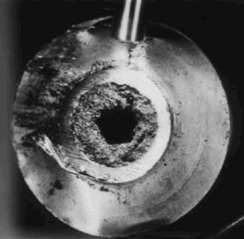
5.1 FOULING
Figure 5 Fouling
Fouling occurs when impurities deposit on the heat exchange surface. Deposition of these impurities can be caused by the following factors
- Low wall shear stress
- Fluid velocity
- Fluid precipitation
- Suspended particles in fluid
- Impurities in fluid
- Reaction with exchanger material and fluid
- Other pressure and temperature conditions
6.0 APPLICATIONS
- Double pipe heat exchanger utilizes true counter-current flow to which maximizes the temperature differences between the shell side and the tube side fluids, resulting in less surface area required for a given duty.
- Double Pipe exchangers are especially suitable for extreme temperature crossing, high pressure, high temperature, and low to moderate surface area requirements. So when your process calls for a temperature cross when the hot fluid outlet temperature is below the cold fluid outlet temperature, a hairpin heat exchanger is the most efficient design and will result in fewer sections and less surface area.
- Double-pipe heat exchangers use a single pipe within a pipe design and are commonly used for high fouling services such as slurries, where abrasive materials are present, and for smaller duties. Standard shell diameters typically range from 2” to 6”.
- In commercial aircraft heat exchangers are used to take heat from the engine's oil system to heat cold fuel. This improves fuel efficiency, as well as reduces the possibility of water entrapped in the fuel freezing in components.
- The classic example of a heat exchanger is found in an internal combustion engine in which a circulating fluid known as engine coolant flows through radiator coils and air flows past the coils, which cools the coolant and heats the incoming air.

7.0 ADVANTAGES
- Easy to operate.
- Counter currents are obtained easily.
- It can withstand high pressure and temperature.
- Modular structure.
- Maintenance is easy and repairing also easy
- Easily displace from one place to another if required.
- It can be adjusted according to the process need.
- Occupy less space.
- Structure is simple and heat transmission is large.
- Provides shorter deliveries than shell and tube due to standardization of design and construction.
- Many suppliers are available worldwide
8.0 DISADVANTAGES
- Double pipe heat exchanger is expensive for heavy duties.
- The use of two single flow areas leads to relatively low flow rates and moderate temperature differences.
- Can’t be used in handling dirty fluids.
- It is difficult to readily inspect the shell side of the tubes for scaling or tube damage.
9.0 CONCLUSION
As the consequences of the above mentioned detailed properties, applications advantages and disadvantages the double pipe heat exchanger is used according to the needs of the process in industry as well as other heat exchanging processes.

REFERENCES
- http://www.scribd.com/doc/56011858/4/DOUBLE-PIPE-HEAT-EXCHANGERS
- http://en.wikipedia.org/wiki/Heat_exchanger#Applications
- http://brazedplateheatexchangers.wordpress.com/2010/03/01/shell-and-tube-heat-exchanger-advantages-and-disadvantages/
- http://wiki.answers.com/Q/What_are_the_Advantage_and_disadvantages_of_double_pipe_heat_exchanger
- Emerson Process Management product guide.http://www.emersonprocess.com/ brooks/ products/products3d.html (accessed Sept 2002).
- deNevers, N., Fluid Mechanics, McGraw Hill, (1991).

