***CELL PHONE BASED VOTING SYSTEM***

*a*

*Mini Project report*

*Submitted in partial fulfillment of the requirements*

*for the award of B.Tech Degree in*

**Electronics & Communication Engineering**

*by*

GOPIKRISHNA.B.WARRIER







APRIL 2010

**Department of Electronics & Communication Engineering**

**ADI SHANKARA**

**INSTITUTE OF ENGINEERING & TECHNOLOGY**

**(An ISO 9001:2008 Certified Institution)**

KALADY, KERALA

**ADI SHANKARA**

**INSTITUTE OF ENGINEERING & TECHNOLOGY**

**(An ISO 9001:2008 Certified Institution)**

KALADY, KERALA



**Certificate**

Certified that this is the Bonafied Record of the mini Project entitled “Cell phone based voting system” submitted during the year 2010 in partial fulfillment for the award of Bachelor of Technology in Electronics & Communication Engineering under Mahatma Gandhi University.

Name: Gopikrishna.b.warrier

Register No: 56025

Semester and branch: S6, Electronics & Communication Engineering

HOD In-charge

Internal examiner External examiner

Place: Kalady

Date:…./…./….

**ACKNOWLEDGEMENT**

It is with profound joy and immense pleasure that I place my gratitude and respect to all those who have guided and inspired me for the project work.

I take this opportunity to extend my deep gratitude to Dr.S.G.Iyer, Principal, ASIET for granting me permission to undertake this project. I also express my sincere thanks to Mr. Venugopal, Head of the Department, Electronics and Communication Department, for giving me the opportunity to utilize all resources for the completion of this project.

I am deeply indebted to my project guides,Mr. Bipin and Miss. Soumya of Electronics and Communication Department for their guidance,timely advice and support rendered during all stages of project work. I express my sincere gratitude to them. I extend my thanks to Mrs.Sheeja.K.S, Lab assistant, for her valuable assistance during the course of my work.

Finally, I convey my thanks to my parents and friends who had directly or indirectly helped me in the successful completion of this project.

Above all I thank God almighty who showered his blessings upon me in every lap of my life.

**GOPIKRISHNA.B.WARRIER**

ABSTRACT

Using SMS Based Voting machine we can vote from our home just by sending a sms a specified format from our mobile. The entire voters will be provided with a unique password (pin) and identification number. For voting we have to send a sms in a predefined format. The voting machine will receive this messages and decode the message and verify the the Pin number and identification number if both number matches the voting machine will accept the vote else the message is rejected by the machine.

The voting machine is implemented using pic microcontroller. A GSM MODEM is used to receive messages from voters. The microcontroller accepts this message and verifies the message and keep updates. A key is activated used to view the result. An LCD is used to display the final result.

**CONTENTS**

PAGE

1. Introduction 6
2. Proposed System Features

2.1 Block Diagram 7

2.2 Block Diagram Explanation

1. Hardware Implementation
   1. Circuit Diagram 20
   2. Circuit Operation 21
2. PCB Design

4.1 Design of PCB 24

4.2 PCB Design And Fabrication 28 4.3 PCB Layout 38

4.4 PCB Component Layout 39

1. Conclusion and Future Enhancement 40

6. References 41

Appendix A 42

Appendix B 47

Appendix C 48

INTRODUCTION

India is world’s largest democracy. Fundamental right to vote or simply voting in elections forms

the basis of Indian democracy. In India all earlier elections a voter used to cast his vote by using

ballot paper. This is a longtime-consuming process and very much prone to errors. This situation

continued till election scene was completely changed by electronic voting machine. No more ballot paper, ballot boxes, stamping,etc.all this condensed into a simple box called ballot unit of the electronic voting machine. Cell phone based voting machine is capable of saving

considerable printing stationery and transport of large volumes of electoral material. It is easy to

transport, store, and maintain. It completely rules out the chance of invalid votes. Its use results

reduction of polling time, resulting in fewer problems in electoral preparations, law and

order, candidates' expenditure,etc. and easy and accurate counting without any mischief at the

counting centre. The aim of our project is to design & develop a mobile based voting machine. In

this project user can dial the specific number from any land line or mobile phone to cast his

vote. Once the user is connected to the voting machine he can enter his password & choice of

vote. If he has entered a valid choice & password his vote will be caste with two short duration

beeps. For invalid password/choice long beep will be generated. User is allotted 15 seconds to

enter his password & choice. A reset button is provided for resetting the system. A total key is

provided to display the result

BLOCK DIAGRAM

MOBILE

PIC

16F876A

LCD

GSM

MODEM

KEY

SERIAL

INTERFACE

BLOCK DIAGRAM EXPLANATION

**PIC MICROCONTROLLERS**

Microchip Technology Inc. is a leading provider of microcontroller and analog semiconductors, providing low-risk product development, lower total system cost and faster time to market for thousands of diverse customer applications worldwide.

PIC devices are grouped by the size of their instruction word length **Classification**

Base line: 12 bit instruction word length.Mid-range: 14 bit instruction word length. High-end: 16 bit instruction word length.

Each part of PIC can be placed into one of the three groups

* Core
* Peripherals
* Special Features

The core includes the basic features that are required to make the device operate. These include

* Device Oscillator
* Reset logic
* CPU (Central Processing Unit) operation
* ALU (Arithmetic Logical Unit) operation
* Device memory map organization
* Interrupt operation
* Instruction set

Peripherals are the features that add a differentiation froma microprocessor. These include

* General purpose I/O
* Timer0
* Timer1
* Timer2
* Capture, Compare, and PWM (CCP)
* Synchronous Serial Port (SSP)
* USART
* Analog to Digital (A/D) Converter**Peripherals**

Special features are the unique features that help to

* Decrease system cost
* Increase system reliability
* Increase design flexibility

The Mid-Range PIC offers several features such as

* On-chip Power-on Reset (POR)
* Brown-out Reset (BOR) logic
* Watchdog Timer
* Low power mode (Sleep)
* In-Circuit Serial Programming™ (ICSP™)
* **Special Features**
* **CPU Architectures….PIC16F876**

**PPPPPP PIC** 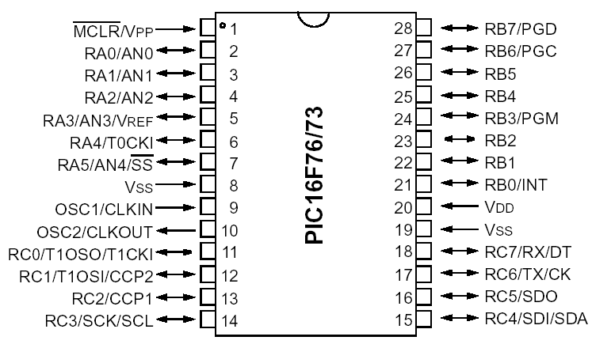

* **PIC**–Peripheral Interface Controller
* **16**–Midrange series
* **F**–Flash memory
* **873**–28 pin,10bit adc, with internal EEPROM
* **12**–Base line
* **16**–Midrange
* **17/18**–High end
* **C**–EPROM
* **CR**–ROM
* **F**–Flash
* **7X**–28 pin,8bit adc, without internal EEPROM
* **87XX**-28 pin,10bit adc, with internal EEPROM **Naming of PIC**

**Core features**

* 4K -Program memory
* 192 bytes -Data memory
* 128 bytes –EEPROM Data Memory
* 8-bit RISC ALU
* Harvard architecture
* 28 pins with 22 I/O pins

**I/O PORTSPORTS**

A port is a group of pins on a microcontroller on which the desired combinations of zeros and

ones can be set simultaneously or the present status can be read.

PIC16F873 has 3 ports

* PORTA -6 bit
* PORTB -8 bit
* PORTC -8 bit

**TRIS REGISTERS**

* TRIS registers are control registers for ports
* TRIS registers are in BANK1
* TRISA control register for PORTA
* TRISB control register for PORTB
* TRISC control register for PORTC
* If a bit of TRIS Register = 1,corresponding
* PORT pin will be configured as input
* If a bit of TRIS Register = 0,corresponding
* PORT pin will be configured as output

**PORT A**

* PORTA is a 6-bit wide bi-directional port.
* The corresponding data direction register is TRISA.
* Setting a TRISA bit (=1) will make the corresponding PORTA pin an input
* Clearing a TRISA bit (=0) will make the corresponding PORTA pin an output
* Multiplexed with 5-channel 10-bit ADC(PA0, PA1, PA2, PA3, PA5)

**PORT B**

* PORTB is an 8-bit wide, bi-directional port.
* The corresponding data direction register is TRISB.
* Setting a TRISB bit (=1) will make the corresponding PORTB pin an input
* Clearing a TRISB bit (=0) will make the corresponding PORTB pin an output
* Three pins of PORTB are multiplexed with the Low Voltage Programming function; RB3/PGM, RB6/PGC and RB7/PGD.
* Four of PORTB‟s pins, RB7:RB4, have an interrupt on change feature.
* RB0/INT is an external interrupt input pin
* Each of the PORTB pins has a weak internal pull-up. A single control bit can turn on all the pull-ups.

**PORT C**

* PORTC is an 8-bit wide, bi-directional port.
* The corresponding data direction register is TRISC.
* Setting a TRISC bit (=1) will make the corresponding PORTC pin an input
* Clearing a TRISC bit (=0) will make the corresponding PORTC pin an output

**INTERRUPTS**

* Interrupts are mechanisms of a microcontroller which makes it possible to respond to some events at the moment when they occur, regardless of what microcontroller is doing at the time.Each interrupt changes the flow of program execution, after executing an interrupt subprogram (interrupt service routine) it continues from the same point .
* **INTCONRBIF**: RB Port Change Interrupt Flag bit1 = At least one of the RB7: RB4 pins changed state 0 = None of the RB7: RB4 pins have changed state **INTF**: RB0/INT External Interrupt Flag bit1 = The RB0/INT external interrupt occurred 0 = The RB0/INT external interrupt did not occur**T0IF**: TMR0 Overflow Interrupt Flag bit1 = TMR0 has overflowed 0 = TMR0 did not overflow**RBIE**: RB Port Change Interrupt Enable bit1 = Enables the RB port change interrupt0 = Disables the RB port change interrupt
* **INTE**: RB0/INT External Interrupt Enable bit
* 1 = Enables the RB0/INT external interrupt
* 0 = Disables the RB0/INT external interrupt
* **T0IE**: TMR0 Overflow Interrupt Enable bit
* 1 = Enables the TMR0 interrupt
* 0 = Disables the TMR0 interrupt
* **PEIE**: Peripheral Interrupt Enable bit
* 1 = Enables all peripheral interrupts
* 0 = Disables all peripheral interrupts
* **GIE**: Global Interrupt Enable bit
* 1 = Enables all interrupts
* 0 = Disables all interrupts

**TIMERS**

PIC16F876 has 3 Timers

* TIMER0 -8 bit
* TIMER1 -16 bit
* TIMER2 -8 bit

**TIMER 0**

TIMER 0

* 8-bit timer/counter
* Readable and writable
* 8-bit software programmable prescaler
* Interrupt on overflow from FFh to 00h**TIMER 0 CONFIGURATION**
* Configure the OPTION REGISTER
* Load the count value
* Wait for overflow flag to set
* Clear the overflow flag

**PS2:PS0**: Prescaler Rate Select bits

**PSA**: Prescaler Assignment bit1 = Prescaler is assigned to the WDT0 = Prescaler is assigned to the Timer0 module**T0SE**: TMR0 Source Edge Select bit1 = Increment on high-to-low transition on T0CKI pin0 = Increment on low-to-high transition on T0CKI pin**T0CS**: TMR0 Clock Source Select bit1 = Transition on T0CKI pin0 = Internal instruction cycle clock (CLKOUT)**INTEDGRBPU**

**OPTION_REG**Configuration Register BANK1**TMR0**Count Register BANK0**INTCON*(2ndbit)***Overflow Flag BANK0**INTCON*(5th bit)***Interrupt Enable BANK0

TIMER1

Is a 16-bit timer consisting of two 8-bit registers (TMR1H and TMR1L)

The TMR1 Register pair (TMR1H:TMR1L) increments from 0000h to FFFFh

**TMR1ON**: Timer1 On bit1 = Enables Timer10 = Stops Timer1**TMR1CS**: Timer1 Clock Source Select bit1 = External clock from pin RC0/T1OSO/T1CKI (on the rising edge)0 = Internal clock (FOSC/4)**T1SYNC**: Timer1 External Clock Input Synchronization Control bitTMR1CS = 11 = Do not synchronize external clock input0 = Synchronize external clock inputTMR1CS = 0This bit is ignored. Timer1 uses the internal clock when TMR1CS = 0.

**T1OSCEN**: Timer1 Oscillator Enable Control bit1 = Oscillator is enabled0 = Oscillator is shut off**T1CKPS1:T1CKPS0**: Timer1 Input Clock Prescale Select bits11 = 1:8 Prescale value10 = 1:4 Prescale value01 = 1:2 Prescale value00 = 1:1 Prescale value**Unimplemented:** Read as ‟0‟

**T1CON** Configuration Register BANK0

**TMR1L & TMR1H**Count Register BANK0

**PIR1 *(0thBIT)***Overflow Flag BANK0

**PIE1 *(0th BIT)***Interrupt Enable BANK1

**INTCON**Interrupt Control BANK0

**ER 2**

TIMER 2

is an 8-bit timer with a prescaler and a postscaler.

The Timer2 module has an 8-bit period register PR2.

Timer2 increments from 00h until it matches PR2 and then resets to 00h on the next increment cycle.

**T2CKPS1:T2CKPS0**: Timer2 Clock Prescale Select bits

00 = Prescaler is 1

01 = Prescaler is 4

1x = Prescaler is 16

**TMR2ON**: Timer2 On bit

1 = Timer2 is on

0 = Timer2 is off

**TOUTPS3:TOUTPS0**: Timer2 Output Postscale Select bits

0000 = 1:1 Postscale

0001 = 1:2 Postscale

0010 = 1:3 Postscale

1111 = 1:16 Postscale

**Unimplemented:** Read as '0'

**T2CON** Configuration Register BANK0**TMR2**Count Register BANK0**PR2**Period Register BANK1**PIR1 *(1st BIT)***Overflow Flag BANK0**PIE1 *(1st BIT)***Interrupt Enable BANK1**INTCON**Interrupt Control BANK0

**USARTUSART**

The Universal Synchronous Asynchronous Receiver

Transmitter (USART) module is one of the two serial I/O modules. (USART is also known as a Serial Communications Interface or SCI).

The USART can be configured as a full duplex asynchronous system that can communicate with peripheral devices such as CRT terminals and personal computers.

**TXST**

**TRANSMIT STATUS AND CONTROL REGISTER**

**TX9D:** 9th bit of transmit data. Can be parity bit.**TRMT**: Transmit Shift Register Status bit1 = TSR empty0 = TSR full**BRGH**: High Baud Rate Select bitAsynchronous mode1 = High speed0 = Low speedSynchronous modeUnused in this mode**Unimplemented:** Read as '0

**SYNC**: USART Mode Select bit

1 = Synchronous mode

0 = Asynchronous mode

**TXEN**: Transmit Enable bit

1 = Transmit enabled

0 = Transmit disabled

**TX9**: 9-bit Transmit Enable bit

1 = Selects 9-bit transmission

0 = Selects 8-bit transmission

**CSRC:** Clock Source Select bit

Asynchronous mode

Don‟t care

Synchronous mode

1 = Master mode (Clock generated internally from BRG)

0 = Slave mode (Clock from external source)

**RECEIVE STATUS AND CONTROL REGISTER**

**RX9D:** 9th bit of received data (Can be parity bit)**CREN**: Continuous Receive Enable bitAsynchronous mode1 = Enables continuous receive0 = Disables continuous receive**SREN**: Single Receive Enable bitAsynchronous modeDon‟t care**RX9**: 9-bit Receive Enable bit1 = Selects 9-bit reception0 = Selects 8-bit reception**SPEN:** Serial Port Enable bit1 = Serial port enabled 0 = Serial port disabled

**SPBRG:Baud Rate Generator RegisterTXREG:Transmit BufferRCREG: Receive Buffer**

**TXSTA** Configuration Register BANK1**RCSTA** Configuration Register BANK0**TXREG**Transmit Buffer BANK0**RCREG**Receive Buffer BANK0**SPBRG**Baud Rate BANK1**TXSTA *(1st BIT)*** Transmit FlagBANK1**PIR1 *(5th BIT)***Receive Flag BANK0**PIE1 *(4th5th BIT)***Interrupt Enable BANK1**INTCON**Interrupt Control BANK0

STEP1: Configure TXSTA and RCSTASTEP2: Set Baud rateSTEP3: Load TXREG with the data to be transmittedSTEP4: Wait for TRMT

STEP1: Configure TXSTA and RCSTASTEP2: Set Baud rateSTEP3: Wait for receive flag RCIF in PIR1STEP4: Take the value from receive buffer RCREG

**ANALOG TO DIGITAL CONVERTERC**

* The Analog-to-Digital (A/D) Converter module has five inputs for the 28-pin devices and eight for the other devices.
* The analog input charges a sample and hold capacitor. The output of the sample and hold capacitor is the input into the converter. The converter then generates a digital result of this analog level via successive approximation. The A/D conversion of the analog input signal results in a corresponding 10-bit digital number.

The A/D module has four registers.

* A/D Result High Register (ADRESH)
* A/D Control Register0 (ADCON0)
* A/D Result Low Register (ADRESL)
* A/D Control Register1 (ADCON1)

**ADON**: A/D On bit1 = A/D converter module is operating0 = A/D converter module is shutoff and consumes no operating current**Unimplemented**: Read as '0„**GO/DONE:** A/D Conversion Status bit1 = A/D conversion in progress 0 = A/D conversion completed

**CHS2:CHS0**: Analog Channel Select bits

* 000 = channel 0, (RA0/AN0)
* 001 = channel 1, (RA1/AN1)
* 010 = channel 2, (RA2/AN2)
* 011 = channel 3, (RA3/AN3)
* 100 = channel 4, (RA5/AN4)

**ADCS1:ADCS0: A/D Conversion Clock Select bits**

* 00 = FOSC/2
* 01 = FOSC/8
* 10 = FOSC/32
* 11 = FRC (clock derived from an RC oscillation)**ADCON1 REGISTER**

**PCFG3:PCFG0**: A/D Port Configuration Control bits

**Unimplemented: Read as ’0’ADFM: A/D Result format select**1 = Right Justified. 6 most significant bits of ADRESH are read as „0‟.0 = Left Justified. 6 least significant bits of ADRESL are read as „0‟.

* **ADCON1** Configuration Register BANK1
* **ADRESH**Output Register BANK0
* **ADRESL** Output Register BANK0
* **ADCON0** Configuration Register BANK

STEP1: Configure Port A as input according to the number of channels required.STEP2: Configure ADCON0 & ADCON1STEP3: Transition delay of 20usSTEP4: Start conversionSTEP5: Wait for DONESTEP6: Take the output from ADRESH

MAX 232

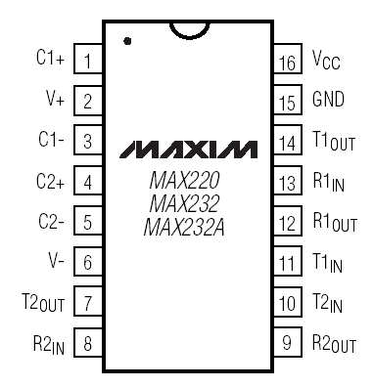

The **MAX232** is an [integrated circuit](http://en.wikipedia.org/wiki/Integrated_circuit) that converts signals from an [RS-232](http://en.wikipedia.org/wiki/RS-232) serial port to signals suitable for use in [TTL](http://en.wikipedia.org/wiki/Transistor-transistor_logic) compatible digital logic circuits. The MAX232 is a dual driver/receiver and typically converts the RX, TX, CTS and RTS signals. The drivers provide RS-232 voltage level outputs (approx. ± 7.5 V) from a single + 5 V supply via on-chip [charge pumps](http://en.wikipedia.org/wiki/Charge_pump) and external capacitors. This makes it useful for implementing RS-232 in devices that otherwise do not need any voltages outside the 0 V to + 5 V range, as power supply design does not need to be made more complicated just for driving the RS-232 in this case. The receivers reduce RS-232 inputs (which may be as high as ± 25 V), to standard 5 V [TTL](http://en.wikipedia.org/wiki/Transistor-transistor_logic) levels. These receivers have a typical threshold of 1.3 V, and a typical [hysteresis](http://en.wikipedia.org/wiki/Hysteresis) of 0.5 V.The later MAX232A is backwards compatible with the original MAX232 but may operate at higher [baud](http://en.wikipedia.org/wiki/Baud) rates and can use smaller external capacitors – 0.1 [μF](http://en.wikipedia.org/wiki/Farad) in place of the 1.0 μF capacitors used with the original device.[[1]](http://en.wikipedia.org/wiki/MAX232#cite_note-0)The newer MAX3232 is also backwards compatible, but operates at a broader voltage range, from 3 to 5.5V.

LCD



This is the first interfacing example for the Parallel Port. We will start with something simple. This

example doesn't use the Bi-directional feature found on newer ports, thus it should work with most,

if not all Parallel Ports. These LCD Modules are very common these days, and are quite simple to

work with, as all the logic required to run them is on board.The LCD panel's Enable and Register Select is connected to the Control Port. The Control Port isan open collector / open drain output. While most Parallel Ports have internal pull-up resistors, there is a few which don't. Therefore by incorporating the two 10K external pull up resistors, the circuit is more portable for a wider range of computers, some of which may have no internal pull up resistors. We make no effort to place the Data bus into reverse direction. Therefore we hard wire the R/W line of the LCD panel, into write mode. This will cause no bus conflicts onthe data lines. As a result we cannot read back the LCD's internal Busy Flag which tells us if the LCD has accepted and finished processing the last instruction. This problem is overcome by inserting known delays into our program. The 10k Potentiometer controls the contrast of theLCD panel. Nothing fancy here. As with all the examples, I've left the power supply out. You can use a bench power supply set to 5v or use an onboard +5 regulator. Remember a few de-coupling capacitors, especially if you have trouble with the circuit working properly.

GSM MODEM

A GSM modem is a wireless modem that works with a GSM wireless network. A wireless modem behaves like a dial-up modem. The main difference between them is that a dial-upmodem sends and receives data through a fixed telephone line while a wireless modem sendsand receives data through radio waves. A GSM modem can be an external device or a PC Card PCMCIA Card. Typically, an external GSM modem is connected to a computer through a serial cable or a USB cable. A GSM modem in the form of a PC Card / PCMCIA Card is designed for use with a laptop computer. It should be inserted into one of the PC Card / PCMCIA Card slotsof a laptop computer. Like a GSM mobile phone, a GSM modem requires a SIM card from a wireless carrier in order to operate. As mentioned in earlier sections of this SMS tutorialcomputers use AT commands to control modems. Both GSM modems and dial-up modems support a common set of standard AT commands. You can use a GSM modem just like a dial-up modem.In addition to the standard AT commands, GSM modems support an extendedset of AT commands.

These extended AT commands are defined in the GSM standards. With the extended AT

commands, you can do things like:

* Reading, writing and deleting SMS messages.
* Sending SMS messages.
* Monitoring the signal strength.
* Monitoring the charging status and charge level of the battery.
* Reading, writing and searching phone book entries.

The number of SMS messages that can be processed by a GSM modem per minute is very low -- only about six to ten SMS messages per minute.

CIRCUIT DIAGRAM

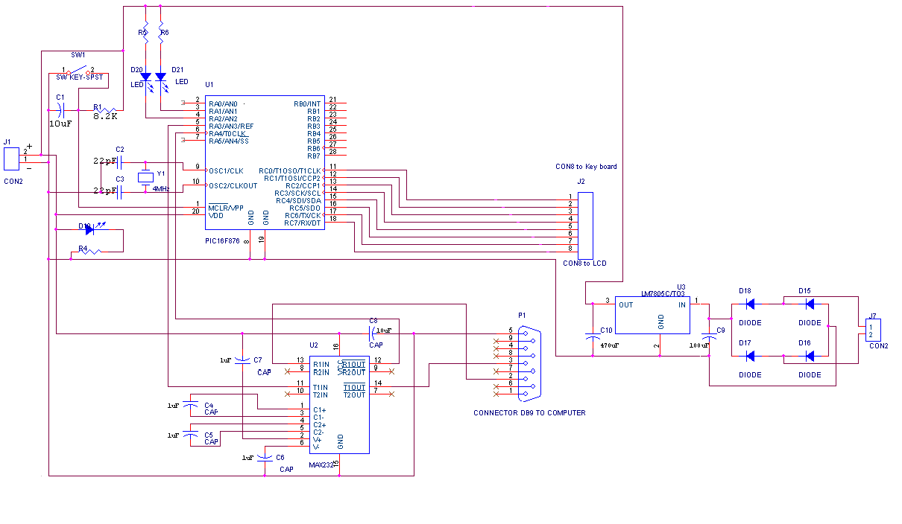

CIRCUIT OPERATION

PIC16F873 has 3 ports

* PORTA -6 bit
* PORTB -8 bit
* PORTC -8 bit

The first pin of port A is connected to reset key. Third and fourth pin is connected to led’s. Led

connected to the third blinks if the circuit is working properly.A3 and A4 of port A is connected to transmitter pin and receiver pin of MAX 232.Ninth and tenth pin is connected to the crystal oscillator. Twentieth pin is connected to a led which is the indicator of power supply.

Port B is not used in this circuit. In port C eleventh to eighteenth pins are connected to lcd.Eight and nineteenth pin of pic is grounded.Max 232 is used in this circuit for serial communication. In this circuit capacitors connected between the first and third pin and also between fourth and fifth pin.Eleventh pin is connected to A3 of pic. Thirteenth, fourteenth and fifteenth pins are connected to DB 9 connecter. Fifteenth pin is grounded. Crystal oscillator is used for generating the clock frequency for pic.Crystal oscillator frequency for pic is 4Mhz.Capacitors in crystal oscillator is used to avoid damping.

First supply is given. The rectifier circuit converts ac power into dc.Here bridge rectifier is used for increasing the efficiency.Dc voltage generated is passed through a 7805 voltage regulator, output of which is 5volts.The indicator led connected to portA starts blinking.Programme for voting procedure is embedded on the pic.Name of the candidates appears in the lcd screen. Then we cast the vote through the cell phone in a prescribed format.

The format is”*user password$candidate number”. The pic has been programmed in such a way that no user can vote more than once. When the message is sent,Max 232 receives the message and transmits this message to pic.Then according to the programme candidates votes are incremented and the final result appears on the lcd.

**POWER SUPPLY**

**7805 VOLTAGE REGULATOR** The **78xx** (also sometimes known as **LM78xx**) series of devices is a family of self-contained fixed [linear voltage regulator](http://en.wikipedia.org/wiki/Linear_regulator) [integrated circuits](http://en.wikipedia.org/wiki/Integrated_circuits). The 78xx family is a very popular choice for many electronic circuits which require a regulated power supply, due to their ease of use and relative cheapness. When specifying individual ICs within this family, the *xx* is replaced with a two-digit number, which indicates the output [voltage](http://en.wikipedia.org/wiki/Voltage) the particular device is designed to provide (for example, the 7805 has a 5 volt output, while the 7812 produces 12 volts). The 78xx line are positive voltage regulators, meaning that they are designed to produce a voltage that is positive relative to a common ground. There is a related line of **79xx** devices which are complementary negative voltage regulators. 78xx and 79xx ICs can be used in combination to provide both positive and negative supply voltages in the same circuit, if necessary.78xx ICs have three terminals and are most commonly found in the [TO220](http://en.wikipedia.org/wiki/TO220) form factor, although smaller surface-mount and larger [TO3](http://en.wikipedia.org/wiki/TO3) packages are also available from some manufacturers. These devices typically support an input voltage which can be anywhere from a couple of volts over the intended output voltage, up to a maximum of 35 or 40 volts, and can typically provide up to around 1 or 1.5 [amps](http://en.wikipedia.org/wiki/Ampere) of [current](http://en.wikipedia.org/wiki/Electric_current) (though smaller or larger packages may have a lower or higher current rating).

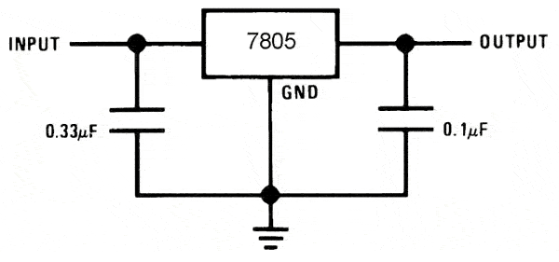

BRIDGE RECTIFIER

A **diode bridge** is an arrangement of four [diodes](http://en.wikipedia.org/wiki/Diode) in a [bridge](http://en.wikipedia.org/wiki/Bridge_circuit) configuration that provides the same [polarity](http://en.wikipedia.org/wiki/Polarity_%28physics%29) of output for either polarity of input. When used in its most common application, for conversion of an [alternating current](http://en.wikipedia.org/wiki/Alternating_current) (AC) input into [direct current](http://en.wikipedia.org/wiki/Direct_current) a (DC) output, it is known as a bridge [rectifier](http://en.wikipedia.org/wiki/Rectifier). A bridge rectifier provides [full-wave rectification](http://en.wikipedia.org/wiki/Rectifier#Full-wave_rectification) from a two-wire AC input, resulting in lower cost and weight as compared to a rectifier with a 3-wire input from a [transformer](http://en.wikipedia.org/wiki/Transformer) with a [center-tapped](http://en.wikipedia.org/wiki/Center_tap) secondary winding.[[1]](http://en.wikipedia.org/wiki/Bridge_rectifier#cite_note-AOE-0)

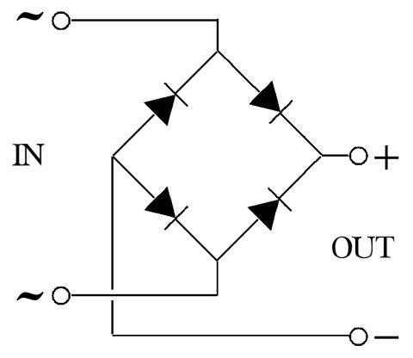

**TRANSFORMER**

**PRINCIPLE OF THE TRANSFORMER**

Two coils are wound over a Core such that they are magnetically coupled. The two coils are known

as the primary and secondary windings.

In a Transformer, an iron core is used. The coupling between the coils is source of making a path for

the magnetic flux to link both the coils. A core as in fig.2 is used and the coils are wound on the

limbs of the core. Because of high permeability of iron, the flux path for the flux is only in the iron

and hence the flux links both windings. Hence there is very little „leakage flux‟. This term leakage

flux denotes the part of the flux, which does not link both the coils, i.e., when coupling is not

perfect. In the high frequency transformers, ferrite core is used. The transformers may be step-up,

step-down, frequency matching, sound output, amplifier driver etc. The basic principles of all the

transformers are same.

**4. PCB DESIGN**

**4.1 DESIGN OF PCB**

**1. PRINTED CIRCUIT BOARDS**

The miniaturization in electronic equipment design has introduced a new technique known as PRINTED CIRCUIT BOARD. Printed circuit board is used to interconnect various electronic circuit printed on it and is provided with holes to accommodate various electronic components.

Printed circuit board (PCB) consists of an insulating base substrate, which is rigid, with metallic circuitry photo chemically formed up on the substrate. Interconnections between components are achieved by means of conducting paths (thin Cu film) running on or through the substrate called tracks. The width of the tracks depends on the amount of current it has to carry. The tracks meet components to which they are to be connected by means of Land or pads which takes form of larger area of Cu. The lands may be of different shapes and sizes and have holes drilled through them. These holes can either accommodate component leads or via-holes. The via -holes also known as plated through holes (PTH) provide connections through the substrate to other track areas. These aroused in case of double sided and multilayer PCBs only.

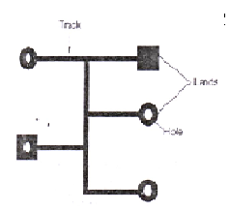

Fig. 4.1 PCB features

Once PCB is designed and fabricated, the circuit can be assembled easily by mounting and soldering the component in the holes provided for them.

**2. ADVANTAGES AND DISADVANTAGES OF USING PRINTED CIRCUIT BOARDS**

Advantages

1. Phase saving of wire: In PCB the interconnection between the components is made through copper tracks instead of using a number of wires carrying electric circuit.

2. Saving of space: The circuit layout of PCB is designed such that it occupies least space. Also the use of Cu tracks in place of wires makes the interconnections less bulky. Thus printed circuit board occupies less space and thus has less weight than the circuit assembled on general-purpose circuit board.

3. Saving of time: Much time is saved in assembling a circuit over a PCB as compared to conventional method.

4. Tight connection: As the connections are made automatically through Cu tracks, there is no chance of loose connection or short circuit

5. Low cost: Mass production can be achieved at lower cost.

6. Reliability: All the above factors bring reliability in performance of the equipment

7. Now-a-days component wiring and assembly can be mechanized by wave soldering of vapour phase reflow soldering.

**Disadvantages**

1. As the copper tracks are very thin, they can carry little current. Hence a PCB cannot be used for circuit with heavy currents because in that case the strips will be heated up and can cause problems.

2. Soldering needs precautions as the risk of strips being overheated and destroyed is always there.

**3. TYPES OF PCB**

There are four types of printed circuit boards

1. Single sided PCB

2. Double sided PCB

3. Multilayered PCB

4. Flexible PCB

1. Single sided PCB: In single sided boards, as the name suggests, copper is coated on one side of the board or laminate. So the circuitry is only on one side of the board and thus is the simplest form of PCB. These are simplest to manufacture and hence have least cost of production.

In these PCB’s, to jump over the Cu tracks jumper wires may be used. Use of jumper is restricted as far as possible because it decreases the reliability and if their number is more than a few, the use of double sided PCB should be considered.

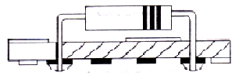

Fig.4.3.1 Single sided PCB

2. Double sided PCB: These are used where space is more important than cost of the PCB. Double sided boards are Cu-coated on both sides. Circuit is etched on both sides but components are mounted only on one side. Tracks on one side can be joined to tracks on the other side by means of wire links. Now - a - days, plated through holes (PTH) are available which do the same thing, but their use makes the PCB expensive. So the total number of PTH should be kept to a minimum for reasons of economy and reliability.

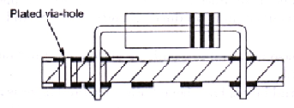

Fig. 4.3.2 Double sided PCB

3. Multilayered PCB: In multilayered boards, two or more boards with circuitry formed upon them are carefully aligned, stacked up and bonded together. These boards are used where a very large circuit has to be fabricated on a single board. At the same time, they are the most complex from manufacturing point of view. Here also, components are mounted on only one side of the board. Electrical connections are established from one side of the board to the other and to the inner layer circuitry by using PTH.

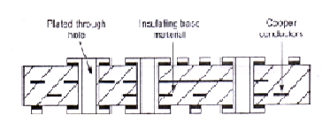

Fig.4.3.3 Multi-layered PCB

4. Flexible PCB: This is basically a highly flexible variant of the conventional rigid PCB. The flexible boards are of two types, static and dynamic. Static flexible circuits can be bent into particular configuration which remains constant throughout product life and results in space saving. Dynamic flexible circuits can be deformed continuously during operations and are used to interconnect devices which need to he moved relative to each other.

4. LAMINATES

The board on which the circuit is etched consist of base material\laminate on which conductor foils are bonded or deposited by some process.

(a) Base material: PCB’s are laminates, i.e., they are made from two or more sheets of base materials stuck together. There are many materials used for making laminates for PCBs. Commonly used materials are phenolic resin reinforced with paper filler (phenolic laminates) for low cost, melamine resin reinforced with glass filler (melamine laminates) for abrasion resistance, epoxy resin reinforced with glass filler (epoxy laminations ) for higher mechanical strength, low dimensional change and fungus resistance; Teflon reinforced with glass (Teflon laminations) for microwave applications; silicon resin reinforced with glass (silicon laminates) for high temperatures. Reliability of PCB greatly depends on the quality of base material used.

(b) Conducting material: The conducting materials used for coating the laminate are copper, silver, gold, brass and aluminum. However, the most widely used material is high purity electrolytic copper and the laminates coated with copper foil are called as Cu clad laminates.

5. MAKING OF COPPER CLAD LAMINATES

The copper clad laminate is manufactured in a heated press which has highly polished stainless steel press plates.

1. The manufacturing process starts by placing a sheet of copper foil on the lower press plate. This copper sheet is produced by rolling out a piece of copper or by electroplating. Electroplating is preferred as it produces more uniform and controllable thickness film.

2. Next the layers of base material are built up on the top of copper foil until required board thickness is achieved.

3. Once the base material layers have been built up, a final layer is added. For single sided boards, this final layer is a material, which acts as a release film. And for double-sided boards, the final layer is a second sheet of copper foil.

4. Finally, the entire assembly is pressed between the two press plates. The heat treatment of this assembly bonds the different layers into a complete board i.e., the Cu clad laminate.

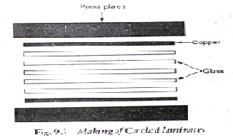

Fig. 4.5.1 Making of Cu clad laminate

**4.2 PCB DESIGN AND FABRICATION**

4.2.1 Design of PCB layout\Pattern

Before designing a PCB layout, complete circuit diagram must be available with the designer. The design of the layout is done on the computer using CAD (Computer Aided Design) or a standard drawing program. The layout is designed in such a way as to accommodate the whole circuit in minimum space, avoiding use of jumpers as far as possible. Besides the complete outlines and interconnections, the layout should include information on:

a. Component hole diameter

b. Conductor width

c. Minimum spacing to be provided between the tracks.

Finally take the print out of the pattern \ layout on a normal A4 size paper. Also make sure that it is the correct size; Check the layout carefully. This printout is called as positive film.

4.2.2 Film making or Mask making

The film negative which is finally used as a mask for the direct exposure of the photo resist-coated PCB is called Film Master. Making of a Negative film (Film master) from a positive involves the steps listed below. All these steps are preformed in a dark room.

Step 1: Film maker machine: Collect the positive film from the CAD lab. Cut lyth film on which the negative is to be made to the size equal to the positive film. Start the machine for 5 seconds. Take the negative film out of the machine by lifting it from the corners.

Step 2: Development: Take a developing tray. Put sufficient developer in the tray so that the negative film is dipped completely in it. The film should be handled at its corners with the help of forceps. Now slide the negative film through the developing solution. Turn the tray quickly and lift the tray on each side of rotation. This is continued throughout the developing time (1-1.5min).

Step 3: Stop bath: After the development is over, the film is lifted above the developing tray (with the help of forceps) for a few seconds so that the excess developer drops out. Immediately thereafter, the film is immersed in to the stop bath (plain water taken in a tray) for 1 min. This will effectively stop the development action.

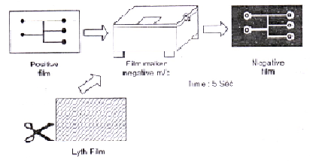

Making Negative Film a Positive Film

Step 4: Fixing: Now mix 1 cap of fixer solution in 1 glass of water in a tray. Place the film in this fixing bath for 0.5 min.

Step 5: Washing: Take out the film from the fixer bath and wash it in running water. Washing is and important stage in film master preparation because if some chemicals remain on it, they will decompose and attack the image, causing stained and faced film.

4.2.3 Making of Printed Circuit Boards

Various steps involved in the making of PCB are:

1. Preprocessing

2. Photolithography

3. Etching

4. Stripping

5. Tin plating

6. Drilling

7. Testing

8. Loading of components

9. Soldering

Step 1: Preprocessing:As its name, this step involves all the initial preparation to be made before actual processing of copper clad laminate starts, such as

a. Collect the printout of the layout from the CAD lab.

b. Cut the copper clad laminate to the required size using a cutter.

c. Clean the board by scrubbing with steel wool or very fine wet sand paper. Dry the board thoroughly. Make sure that the board is clean and free from fingerprints or any traces of contamination.

d. Drill tooling\mounting holes.

Step 2: Photolithography: Photolithography is typically the transfer of the copper track and land pattern from the negative film to a photo sensitive material by selective exposure to a radiation source such as UV light. It includes the following steps:

a. Pattern transfer:

Apply photo resist. Coat the Cu surface of the Cu clad laminate with a photosensitive material in a dip coating machine. In lithography, the photosensitive material used is typically a photo resist (also called resist). Both positive and negative photo resist can be used, but the negative photo resist which become insoluble on exposure with UV light is almost universally used. Now place the photo resist- coated board in the oven for 10 minutes to dry the photo resist. Exposure to UV light: Remove the board from the oven and place it in ultraviolet exposure machine with the photo resist side facing up. Now place the mask (i.e. the negative film) over the board and correctly align it with the board’s geometry. Masking tapes can also be used to keep the negative film in position. Switch on the UV exposure machine for 3 minutes. The UV light falls on the photo resist only through the lighter or transparent part of the mask. Thus the photo resist changes its properties only where exposed to radiation. Take out the board from the UV enclosure by holding it from the edges (using forceps).

b. Development

After exposure, the image of the pattern transferred on the photoresist needs to be developed. The development stage involves removal of less soluble unexposed area of resist in case of negative resist and exposed areas in case of positive resist. Here, we are using a negative photo resist.

Method: Take a tray and put sufficient developer solution in it such that the board can be completely dipped in it. Developer solution is prepared by mixing liquid photoresist developer concentrate with 1 part developer to 9 part of water.

Place the board into the white developer solution. The board should be handled at its corners with the help of forceps. Now lift the tray on each side in rotation so that the liquid developer is flowed over and back on the board. This id continued throughout the developing time (1 min). During development, the developer solution etches away the unexposed region of the negative photoresist showing copper and the PCB layout will be revealed. After the development is over, lift the board and wash it in stop bath. This will effectively stop the development action.

c. Fixing

To fix the pattern on the board, mix 1 cap of fixer (blue die solution) in 1 glass of water in tray. Place the board in the solution for at least 0.5 min. Remove the board from the fixer bath and wash it under running water.

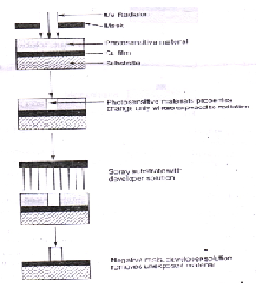

Photolithography: pattern transfer on negative photo resist

Step 3: Etching

This process is used for removal of PCB’s copper surface, which is not protected by the photo resist. Thus final Cu pattern is formed on the board after etching.

The board obtained after photolithography is dipped in an etching solution and gitated for 6-10 min. at 400C. The solution etches \ dissolves away the exposed\ undesired copper areas, leaving the desired copper pattern on the board. The different

Types of etching solution used are:

a. Ferric Chloride (FeCl3)

b. Chromatic Chloride

c. Cupric Chloride (CuCl2)

d. Alkaline Ammonia

Out of these four, ferric chloride is the most commonly used etchant.

The reaction of FeCl3 and CuCl2 etching solutions with copper are:

FeCl3 + Cu → FeCl2 + CuCl

Ferric chloride Copper Ferrous chloride

CuCl2 + CuCl → 2CuCl

Chromatic acid etching is usually carried out with the addition of Sulphuric acid. Hence it is called chromic Sulphuric acid. The choice of suitable etchant solution for PCB production depends on factors like etching speed, copper dissolving capacity, etchant price etc

Step 4: Stripping

After etching, the negative photo resist coating left on the copper pattern can be removed using a tube of photo resist stripper and the PCB is washed clean under tap water and dried using tissue paper.

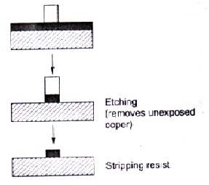

Pattern transfer by etching

Step 5: Tin Plating (optional)

This is done to provide a fine finish and to protect the copper from oxidation. Also soldering will appear neater and will flow better. For this, pour a solution made up of fine tin powder mixed with water into a basin. Place the board in the solution for 10 minutes. The board should then have a silver finish.

Step 6: Drilling

Drilling is used to create the component lead holes and through holes in a PCB. These holes pass through the land areas and should be positioned correctly. The drilling process can be performed by using manually operated drilling machines or by using CNC drilling machines. For a particular PCB, a wide range of drill holes may be required e.g. smaller holes are required for component leads whereas larger diameter holes are required for bolting heat sinks, connectors etc.

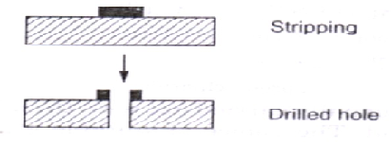

Drilling

Step 7: Bare Board Testing

Before mounting the components on the PCB, this bare board needs to ensure that the required connections exist (i.e. visual inspection), and that there are no short circuit (i.e. continuity testing) and that drill holes are properly placed. After drilling and testing, the board the board is now ready to stuff components.

Step 8: Loading Component

Loading of components on a PCB is the process of inserting components in to the holes in the board. This loading can be done by hand or by machine. Machine is used when there is mass production of boards of the same pattern.

Step 9: Soldering

Solder the components loaded on the PCB by using either manual soldering or wave soldering technique. Manual soldering is done with the help of soldering iron, while in wave soldering, large number of joints are made simultaneously using a older bath. Wave soldering is a more efficient method and is used in large scale industry where high productivity is required. During the soldering process, an external medium is used to increase the flow properties of molten solder or to improve the degree of wetting. Such a medium is called flux.

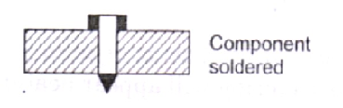

Component soldered

7. MANUFACTURING OF SINGLE SIDED PCB’S

From the discussion in section 6.3, the manufacturing of single sided PCB can be illustrated using this block diagra

Collect the printout of layout from CAD lab

Make the negative film(mask) using film makerm/c.

Cut the Cu clad laminate to the size and drill tooling holes

clean the board

Apply photo resist

Expose to UV light through the mask

Develop the image

Etch unwanted copper

Stop resist

Tin plating

Drill holes

Test bare board

Load the components

Solder the components

Block diagram for manufacturing single sided PCB

8. MANUFACTURING OF DOUBLE SIDED PCB Making of double sided PCB is similar to single sided but require some additional manufacturing processes.Layout design: Unlike the single sided boards, the double sided boards have layout designs for both side of the board; one is called the component side pattern and the other wiring side pattern. While designing on the computer, first the pattern of the component side and the wiring side is made in one sheet of the drawing using different colour.Prepare negative film for both side patterns on the separate lyth film. Cut the double sided board to correct size. Clean the board surfaces and drill the cooling holes.Apply photoresist coating on both sides of the board and expose them to UV light through their respective negative film. After developing the image, etching is done to remove the exposed copper areas. Now the board is placed on CNC machine to drill holes. Unlike single sided PCBs, doubled sided boards have copper tracks on both sides of the board which need to be interconnected. Thus additional holes are required along with normal holes for component insertion. These additional holes are used to connect copper tracks on opposite sides of the board and are known as via holes. The electrical connection between the two sides of the board is achieved by plating process. Thus these holes are also referred to as plated through holes (PTH).The through hole is the way of connecting with the part, which connects the component side pattern and the wiring side pattern through a thin metallic pipe.

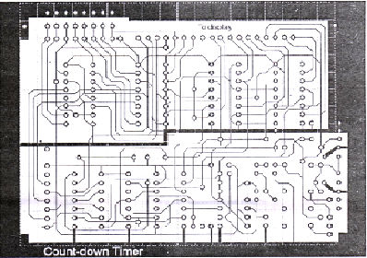

Layout design of a double-sided PCB

Now separate the pattern drawing of the wire side on and the one sheet and the component side

on the other sheet.

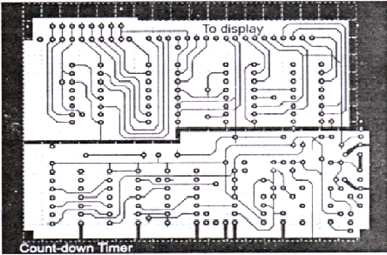

(a) Wiring side layout

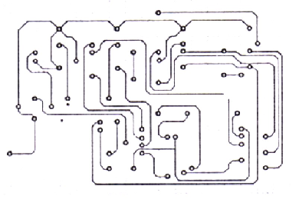

(b) Component side layout

* 1. **PCB Layout of cell phone based voting system**



**4.3 PCB Component Layout of cell phone based voting system**



5. CONCLUSION AND FUTURE ENHANCEMENTS

This report describes the functional and constructional details of Cell phone based voting system using 16F876A PIC.

The system can be further modified to enhance its utility. The enhancements are:

* Number of candidates could be increased
* It can be interfaced with printer to get the hard copy of the result almost instantly from the machine itself.
* It can also be interfaced with the personal computer and result can be stored in the central server
* Once the result is on the server it could be relayed on the network to various offices of the election conducting authority.thus our project can make results availale at any corner of the world in a matter of seconds.

##### **REFERENCES**

[1]. Ramakand Gaykwad, “Op-Amps and Linear Integrated Circuits”,

Prentice Hall India Publishing Company

[2]. Roy Choudhuri, ”Linear Integrated Circuits”,

New Age International Pvt Ltd

Websites:

1. <http://www.housestuffs.com>

2. <http://www.nationalSemiconductors.com>

3. <http://www.datasheetcatalog.com>

APPENDIX A

#include <16F876A.h>

#device adc=8

#use delay(clock=4000000)

#fuses XT,NOWDT,NOPUT,NODEBUG,NOPROTECT,NOBROWNOUT,NOLVP,NOCPD,NOWRT

#use rs232(baud=9600,parity=N,xmit=PIN_A3,rcv=PIN_A4,bits=8,stream=gsm)

#define max 4

#include<lcdx.c>

int1 pwd0=0,pwd1=0,pwd2=0,pwd3=0,pwd4=0,pwd5=0,pwd6=0,pwd7=0,flag=0;

int1 blink=0;

int count[4]={0,0,0,0};

#int_TIMER1

TIMER1_isr()

{

blink=~blink;

output_bit(PIN_A1,blink);

}

char timed_getc() {

long timeout;

timeout=0;

while(!kbhit()&&(++timeout<50000)) // 1/2 second

delay_us(10);

if(kbhit()) return(fgetc(gsm));

else return(0);

}

void main()

{

int i;

char c,at[4]="at\r",cmgf[11]="at+cmgf=1\r",cmgr[11]="at+cmgr=1\r",str[7],cmgd[11]="at+cmgd=1\r";

char upwd[4],pwd[8][4]={"111","222","333","444","555","666","777","888"},lcd_data[16],val;

setup_timer_1(T1_INTERNAL|T1_DIV_BY_8);

enable_interrupts(INT_TIMER1);

enable_interrupts(global);

//*pwd$no#

lcd_init();

delay_ms(20);

lcd_putc('\f');

while(1){

up:

lcd_putc('\f');

sprintf(lcd_data,"Name1:%d",count[0]);

lcd_puts(lcd_data,UL);

sprintf(lcd_data,"Name2:%d",count[1]);

lcd_puts(lcd_data,LL);

sprintf(lcd_data,"Name3:%d",count[2]);

lcd_puts(lcd_data,UR);

sprintf(lcd_data,"Name4:%d",count[3]);

lcd_puts(lcd_data,LR);

for(i=0;i<3;i++) {

fputc(at[i],gsm);

c=timed_getc();

}

for(i=0;i<7;i++)

{

str[i]=timed_getc();

}

for(i=0;i<7;i++)

{

if(str[i]=='E')

goto up;

}

up1:

for(i=0;i<10;i++)

{

fputc(cmgf[i],gsm);

c=timed_getc();

}

for(i=0;i<7;i++)

{

str[i]=timed_getc( );

}

for(i=0;i<7;i++)

{

if(str[i]=='E')

goto up1;

}

for(i=0;i<10;i++)

{

fputc(cmgr[i],gsm);

c=timed_getc();

}

for(i=0;i<7;i++)

{

str[i]=timed_getc( );

}

for(i=0;i<7;i++)

{

if(str[i]=='E')

goto up;

}

while(timed_getc()!='*');

i=0;

do{

upwd[i]=fgetc(gsm);

}while(upwd[i++]!='$');

upwd[3]='\0';

val=timed_getc();

up3:

for(i=0;i<10;i++)

{

fputc(cmgd[i],gsm);

c=timed_getc();

}

for(i=0;i<7;i++)

{

str[i]=timed_getc( );

}

for(i=0;i<7;i++)

{

if(str[i]=='E')

goto up3;

}

if(strcmp(pwd[0],upwd)==0)

{

if(pwd0==0) pwd0=1;

else continue;

}

if(strcmp(pwd[1],upwd)==0)

{

if(pwd1==0) pwd1=1;

else continue;

}

if(strcmp(pwd[2],upwd)==0)

{

if(pwd2==0) pwd2=1;

else continue;

}

if(strcmp(pwd[3],upwd)==0)

{

if(pwd3==0) pwd3=1;

else continue;

}

if(strcmp(pwd[4],upwd)==0)

{

if(pwd4==0) pwd4=1;

else continue;

}

if(strcmp(pwd[5],upwd)==0)

{

if(pwd5==0) pwd5=1;

else continue;

}

if(strcmp(pwd[6],upwd)==0)

{

if(pwd6==0) pwd6=1;

else continue;

}

if(strcmp(pwd[7],upwd)==0)

{

if(pwd7==0) pwd7=1;

else continue;

}

switch(val){

case '1':count[0]=count[0]+1;

break;

case '2':count[1]=count[1]+1;

break;

case '3':count[2]=count[2]+1;

break;

case '4':count[3]=count[3]+1;

break;

}

}}

APPENDIX B

**COST ANALYSIS OF COMPONENTS USED**

|  |  |  |  |
| --- | --- | --- | --- |
| **Sr. no** | **Equipment** | **Quantity** | **Rate (in Rs.)** |
| 1 | PIC 16F73 | 1 | 120 |
| 2 | Voltage Regulator 7805 | 1 | 20 |
| 3 | 2 line LCD display | 1 | 140 |
| 4 | Transformer | 1 | 60 |
| 5 | Crystal Oscillator | 2 | 10 |
| 6 | Switch | 5 | 10 |
| 7 | LED | 3 | 6 |
| 8 | Resistors(1KΩ,10KΩ) | 4 | 3 |
| 9 | Capacitors(22pf,.1μf,10μf,470μf,1000μf) | 8 | 10 |
| 10 | Diodes | 4 | 8 |
| 11 | D9 connecter | 1 | 15 |
| 12 | Sip resistor | 1 | 7 |
| 13 | Berge strip | 1 | 3 |
| 14 | IC base | 2 | 30 |
|  |  |  |  |
|  |  |  |  |
|  |  |  |  |
|  |  |  |  |
|  |  |  |  |
| Total |  |  | 442 |
|  |  |  |  |

**APPENDIX C**

**PIC MICROCONTROLLER DATA SHEETS**

