CONTENTS
- Introduction
- Run-off
- Factors affecting run-off
- Hydrograph & flow duration curve
- The mass curve
- Selection of site
- Water available
- Water storage
- Head of water
- Distance from load center
- Access to site
- Essential features of water power plant
  - Catchment area
  - Reservoir
  - Dan & intake house
  - Inlet water way
  - Power house
  - Tail race or outlet water way
- Calculation of water power plant
- Classification of hydro-plant
  - Storage plant
  - Run-off-river power plant
  - Pumped storage plant
- Prime movers
- Selection of turbine
- Advantage & disadvantages
- Reference

INTRODUCTION

When rain water falls over the earth’s surface, it possesses potential energy relative to sea or ocean towards which it flows. If at a certain point, the water falls through an appreciable vertical height, this energy can be converted into shaft work. As the water falls through a certain height, its potential energy is converted into kinetic energy and this kinetic energy is converted to the mechanical energy by allowing the water to flow through the hydraulic turbine runner. This mechanical energy is utilized to run an electric generator which is coupled to the turbine shaft. The power developed in this manner is given as:
Power = W.Q.H.watts
Where W = Specific weight of water, N/m³
Q = rate of water flow, m³/sec.
H = Height of fall or head, m
= efficiency of conversion of potential energy into mechanical energy.
The generation of electric energy from falling water is only a small process in the mighty heat power cycle known as “Hydrological cycle” or rain evaporation cycle”. It is the process by which the moisture from the surface of water bodies covering the earth’s surface is transferred to the land and back to the water bodies again. This cycle is shown in Fig. 11.1. The input to this cycle is the solar energy. Due to this, evaporation of water takes, lace from the water bodies. On cooling, these water vapours form clouds. Further cooling makes the clouds to fall down in the form of rain, snow, hail or sleet etc; known as precipitation. Precipitation includes all water that falls from the atmosphere to the earth’s surface in any form. Major portion of this precipitation, about 2/3rd, which reaches the land surface is returned to the atmosphere by evaporation from water surfaces, soil and vegetation and through transpiration by plants. The remaining precipitation returns ultimately to the sea or ocean through surface or underground channels. This completes the cycle. The amount of rainfall which runs off the earth’s land surface to form streams or ‘rivers is useful for power generation. The precipitation that falls on hills and mountains in the form of snow melts during warmer weather as run-off and converges to form streams can also be used for power generation.
Hydro projects are developed for the following purposes:
- To control the floods in the rivers.
- Generation of power.
- Storage of irrigation water.
- Storage of the drinking water supply.
In India, the water resources development is concerned with the first three purposes. As reported by the Irrigation Commission (1972), the country average annual run-off is 178 million hectare meters. Of this, 29.2% is contributed by Ganga, 30.1% by Brahmputra and north eastern rivers, 11.8% by the west flowing rivers south of Tapti. The balance of 29% is contributed by Indus, the west and east flowing rivers of Central India and the east flowing rivers of South India. It is very apparent from the above analysis that the nation’s water
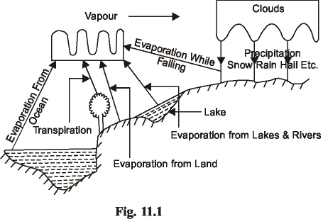
resources are very much unevenly distributed. As the country is committed to socialistic development of economy, there is a great need to have as uniform as possible the distribution of water resources throughout the country. The two ways to achieve this goal are, inter basin transfer and joint use of surface and ground water. Under the first scheme Ganga-Cauvery link is under active proposal, by which 12715 cumecs of water will be diverted from Ganga by constructing a barrage near Patna in Bihar. Of this total quantity, 285 cumecs (10000 cusecs) would be supplied for 300 days out of a year, to the drought affected areas in South U. P and South Bihar which are in the Ganga basin itself. The remaining 1430 cumecs (50000 cusecs) of water for 150 days will be diverted from the basin to meet partially the water demand of lingering drought affected areas of Madhya Pradesh, Rajasthan, Gujarat, Maharashtra, Andhra Pradesh, Mysore and Tamil Nadu. On its route, the link would connect the proposed Bargi reservoir on Narmada, the proposed Champalli reservoir on Godavari, the under construction Srisailam reservoir on Krishna and would finally meet the river Cauvery at the existing Grand Anicut. Of course, there is a problem of high head pumping (380 meters) from Ganga which would have to be resolved.
In the remaining chapter, the problem of generation of electric power will be dealt with. There are two reasons for the extensive development of the water power. One is that more and more electric power is needed for industrial; agricultural, commercial and domestic purposes. The other is the high cost of coal and its dwindling reserves. A water power site is usually developed to supply electric power to a newly and a specially established industry or town or to provide additional power to an already existing or a proposed interconnected electric system. Before a water power site is considered for development, the following factors must be thoroughly analyzed:
- The capital cost of the total plant.
- The capital cost of erecting and maintaining the transmission lines and the annual power loss due to transformation and transmission of electric power since the water power plants are usually situated in hilly areas away from the load center.
- The cost of electric generation compared with steam, oil or gas plants which can be conveniently set up near the load center.
Inspite of the above factors, the water power plants have the following advantages which make these suitable for large interconnected electric system:
- The plant is highly reliable and its maintenance and operation charges are very low.
- The plant can be run up and synchronized in a few minutes.
- The load can be varied quickly and the rapidly changing load de-mands can be met without any difficulty.
- The plant has no stand by losses.
- No fuel charges.
- The efficiency of the plant does not change with age.
- The cost of generation of electricity varies little with the passage of time.

However, the hydro-electric power plants have the following disadvantages also:
- The capital cost of the plant is very high.
- The hydro-electric plant takes much longer in design and execution.
- These plants are usually located in hilly areas far away from the load center.
- Transformation and transmission costs are very high.
- The output of a hydro-electric plant is never constant due to vagaries of monsoons and their dependence on the rate of water flow in a river.

RUN-OFF:-
Rain fall (used in a general sense) or “precipitation” may be defined as the total condensation of moisture that reaches the earth in any form. It includes all forms of rains, ice, snow, hail or sleet etc. “Evaporation” represents practically all of that portion of the rainfall that does not reach the point of ultimate use as stream flow. So, evaporation, includes all the rainfall that is returned to the atmosphere from land and water surfaces. Thus total evaporation is:
- Evaporation from land and water surfaces.
- Evaporation by transpiration which is the vaporization of water from the breathing pores of vegetable matter.
- Atmospheric evaporation (evaporation while precipitation is falling).
Rain-fall is measured in terms of centimeters of water over a given area and over a given period (usually one year). The portion of the total precipitation that flows through the catchment area is known as “Run-off”. The catchment area of a hydrosite is the total area behind the dam, draining water into the reservoir. Thus,
Run-off = Total precipitation – Total evaporation
Part of the precipitation is absorbed by the soil and seeps or percolates into ground and will ultimately reach the catchment area through the underground channels. Thus.
Total run-off = Direct run off over the land surface T Run-off through seepage.
The unit of run-off are m³/s or day-second meter.
Day-second meter = Discharge collected in the catchment area at the rate of 1 in 3/S for one day = 1 × 24 × 3600 = 86400 m³/day.
The flow of run-off can also be expressed in cms. of water on the drainage area feeding the river site for a stated period, or km, cm of water per unit of time.

FACTORS AFFECTING RUN-OFF
- Nature of Precipitation. Short, hard showers may produce relatively little run-off. Rains lasting a longer time results in larger run-off. The soil tends to become saturated and the rate of seepage decreases. Also, the humid atmosphere lowers evaporation, resulting in increased run-off.
- Topography of Catchments Area. Steep, impervious areas will produce large percentage of total run-off. The water will flow quickly and absorption and evaporation losses will be small.
- Geology of Area. The run-off is very much affected by the types of surface soil and sub-soil, type of rocks etc. Rocky areas will give more run-off while pervious soil and sub-soil and soft and sandy area will give lesser run-off.
- Meteorology. Evaporation varies with temperature, wind velocity and relative humidity. Run-off increases with low temperature, low wind velocity and high relative humidity and vice versa.
- Vegetation. Evaporation and seepage are increased by cultivation. Cultivation opens and roughens the hard, smooth surface and promotes seepage. Thick vegetation like forests consumes a portion of the rain fall and also acts as obstruction for run-off.
- Size and Shape of Area. Large areas will give more run-off. A wide area like a fan will give greater run-off, whereas, a narrow area like a leaf will give lesser run-off. In an area whose length is more than its width, the flow along its width will give more run-off than if the flow is along its length, since in the former case, seepage and evaporation will be less.
Measurement of Run-Off or Flow : The run-off or stream flow can be determined with the help of three methods:
1. From Rain-Fall Records. The run-off can be estimated from rain-fall records by multiplying the rain fall with “run-off coefficient” for the drainage area. The run-off coefficient takes into account the various losses and will depend upon the nature of the catchment area.
- Empirical Formulas. Empirical relations to determine the stream flow relate only to a particular site and can not be relied upon for general use.
- Actual Measurement. Direct measurement by stream gauging at a given site for a long period is the only precise method of evaluation of stream flow. The flow is measured by selecting a channel of fixed cross-section and measuring the water velocity at regular intervals, at enough points in the cross-section for different water levels. The velocity of flow can be measured with the help of current meter or float method. By integrating the velocities over the cross-section for each stage, the total flow for each stage can be calculated.

HYDROGRAPH & FLOW DURATION CURVE:-
A hydrograph indicates the variation of discharge or flow with time. It is plotted with flows as ordinates and time intervals as abscissas. The flow is in m³/sec and the time may be in hours, days, weeks or months.
A flow duration curve shows the relation between flows and lengths of time during which they are available. The flows are plotted as the ordinates and lengths of time as abscissas. The flow duration curve can be plotted from a hydrograph.

THE MASS CURVE:-
The use of the mass curve is to compute the capacity of the reservoir for a hydrosite. The mass curve indicates the total volume of run-off in second meter-months or other convenient units, during a given period. The mass curve is obtained by plotting cumulative volume of flow as ordinate and time (days, weeks by months) as abscissa. Fig. 11.2 shows a mass curve for a typical river for which flow data is given in Table 11.2.
The monthly flow is only the mean flow and is correct only at the beginning and end of the months. The variation of flow during each month is not considered. Cumulative daily flows, instead of monthly flows, will give a more accurate mass curve, but this involves an excessive amount of work. The slope of the curve at any point gives the flow rate in second-meter. Let us join two points X and Y on the curve. The slope of this line gives the average rate of flow during the period between X and Y. This will be = (Flow at Y-Flow at X)/Time Span
Month | Mean monthly | Accumulative | Month | Mean monthly | Accumulative
 | flow | flow second |  | flow | flow second
 | second-metre | metre-month |  | second-metre | metre-month
April | 7710 | 7710 | October | 3300 | 23280
May | 3850 | 11560 | November | 2330 | 25610
June | 860 | 12420 | December | 3880 | 29490
July | 1040 | 13460 | January | 5200 | 34690
August | 2500 | 15960 | February | 6000 | 40690
September | 4020 | 19980 | March | 12,100 | 52790

Let the flow demand be, 3000 sec-meter. Then the line X-Y may be called as `demand line' or ‘Use line’. If during a particular period, the slope of the mass Curve is greater than that of the demand line, it means more water is flowing into the reservoir than is being utilized, so the level of water in the reservoir will be increasing during that period and vice versa. Upto point X and beyond point Y the reservoir will be overflowing. being full at both X and Y.
The capacity of the reservoir is given by the maximum ordinate between the mass curve and the demand line. For the portion of mass curve between point X and Y, the storage capacity is about 4600 sec-meter-month. However, considering the entire mass curve, storage capacity will be about 15,400 sec-meter-months.
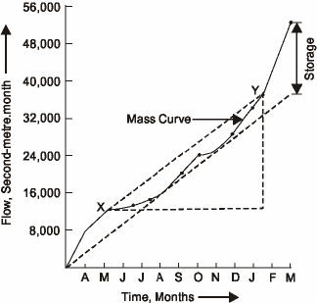

SELECTION OF SITE:-
While selecting a suitable site, if a good system of natural storage lakes at high altitudes and with large catchment areas can be located, the plant will be comparatively economical. Anyhow the essential characteristics of a good site are: large catchment areas, high average rainfall and a favorable place for constructing the storage or reservoir. For this purpose, the geological, geographical and meteorological conditions of a site need careful investigation. The following factors should be given careful consideration while selecting a site for a hydro-electric power plant:
- Water Available. To know the available energy from a given stream or river, the discharge flowing and its variation with time over a number of years must be known. Preferably, the estimates of the average quantity of water available should be prepared on the basis of actual measurements of stream or river flow. The recorded observation should be taken over a number of years to know within reasonable, limits the maximum and minimum variations from the average discharge. the river flow data should be based on daily, weekly, monthly and yearly flow ever a number of years. Then the curves or graphs can be plotted between tile river flow and time. These are known as hygrographs and flow duration curves.
The plant capacity and the estimated output as well as the need for storage will be governed by the average flow. The primary or dependable power which is available at all times when energy is needed will depend upon the minimum flow. Such conditions may also fix the capacity of the standby plant. The, maximum of flood flow governs the size of the headwords and dam to be built with adequate spillway.
- Water-Storage. As already discussed, the output of a hydropower plant is not uniform due to wide variations of rain fall. To have a uniform power output, a water storage is needed so that excess flow at certain times may be stored to make it available at the times of low flow. To select the site of the dam ; careful study should be made of the geology and topography of the catchment area to see if the natural foundations could be found and put to the best use.
- Head of Water. The level of water in the reservoir for a proposed plant should always be within limits throughout the year.
- Distance from Load Center. Most of the time the electric power generated in a hydro-electric power plant has to be used some considerable distance from the site of plant. For this reason, to be economical on transmission of electric power, the routes and the distances should be carefully considered since the cost of erection of transmission lines and their maintenance will depend upon the route selected.
- Access to Site. It is always a desirable factor to have a good access to the site of the plant. This factor is very important if the electric power generated is to be utilized at or near the plant site. The transport facilities must also be given due consideration.

ESSENTIAL FEATURES OF WATER POWER PLANT:-
A simplified flow sheet of a water power plant is shown in Fig. The essential features of a water power plant are as below:
- Catchment area.
- Reservoir.
- Dam and intake house.
- Inlet water way.
- Power house.
- Tail race or outlet water way.
- Catchment Area. The catchment area of a hydro plant is the whole area behind the dam, draining into a stream or river across which the dam has been built at a suitable place.
- Reservoir. Whole of the water avail-able from the catchment area is collected in a reservoir behind the dam. The purpose of the storing of water in the reservoir is to get a uniform power output throughout the year. A reservoir can be either natural or artificial. A natural reservoir is a lake in high mountains and an artificial reservoir is made by constructing a dam across the river.

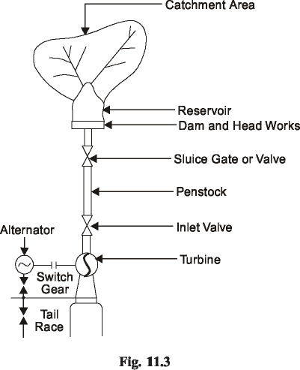

- Dam and Intake House. A dam is built across a river for two functions: to impound the river water for storage and to create the head of water. Dams may be classified according to their structural materials such as: Timber, steel, earth, rock filled and masonary. Timber and steel are used for dams of height 6 m to 12 m only. Earth dams are built for larger heights, upto about 100 m. To protect the dam from the wave erosion, a protecting coat of rock, concrete or planking must be laid at the water line. The other exposed surfaces should be covered with grass or vegetation to protect the dam from rainfall erosion. Beas dam at Pong is a 126.5 m high earth core-gravel shell dam in earth dams, the base is quite large as compared to the height. Such dams are quite suitable for a pervious foundation because the wide base makes a long seepage path. The earth dams have got the following advantages.
- Suitable for relatively pervious foundation.
- Usually less costlier than a masonary dam.
- If protected from erosion, this type of dam is the most permanent type of construction.
- It fits best in natural surroundings.
The following are the disadvantages of earth dams :
- Greater seepage loss than other dams.
- The earth dam is not suitable for a spillway, therefore, a supplementary spillway is required.
- Danger of possible destruction or serious damage from erosion by water either seeping through it or overflowing the dam.
The masonary dams are of three major classes: solid gravity dam, buttress dam and the arched dam.
The buttress or deck dam has an inclined upstream face, so that water pressure creates a large downward force which provides stability against overturning or sliding. An arch dam is preferable where a narrow canyon width is available. It can be anchored well and the water pressure against the arch will be carried by less concrete than with a straight gravity type. This dam has the inherent stability against sliding. The most commonly used dams are shown in Fig.
Dams must be able to pass the flood water to avoid damage to them. This may be achieved by : spillways, conduits piercing the dam and the tunnels by passing the dam.

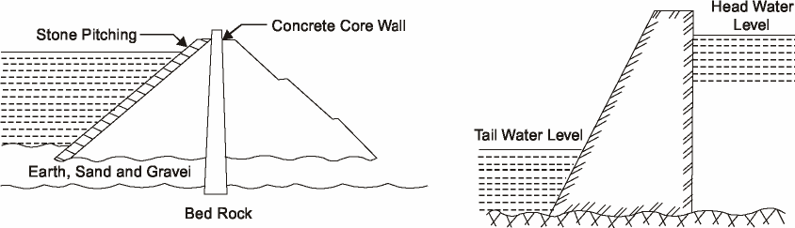

The intake includes the head works which are the structures at the intake of conduits, tunnels or flumes. These structures include booms, screens or trash racks, sluices for bypassing debris, and gates or valves for controlling the water flow. Booms pre-vent the ice and floating logs from going into the intake by diverting them to a bypass chute. Booms consist of logs tied end to end and form a floating chain. Screens or trash racks are fitted directly at the intake to prevent the debris from going into the intake. Debris cleaning devices should also be fitted on the trash racks. Gates and valves control the rate of water flow entering the intake.
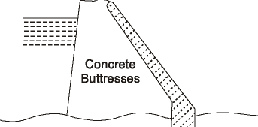

The different types of gates are radial gates, sluice gates, wheeled gates, plain sliding gates, crest gates, rolling or drum gates etc. The various types of valves are rotary, spherical, butterfly or needle valves. A typical intake house is shown in Fig. An air vent should be placed immediately below the gate and connected to the top of the penstock and taken to a level above the head water. When the head gates are closed and the water is drawn off through the turbines, air will enter into the penstock through the air vent and prevent the penstock vaccum which otherwise may cause col-lapsing of the pipe. A filler gate is also provided to balance the water pressure for opening the gate.

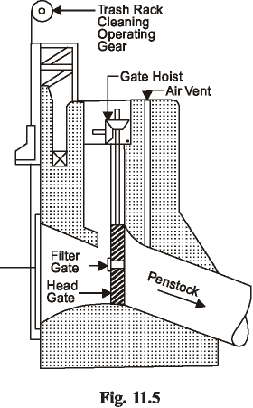

- Inlet Water Ways. Inlet water ways are the passages, through which the water is conveyed to the turbines from the dam. These may include tunnels, canals, flumes, forebays and penstocks and also surge tanks. A forebay is an enlarged passage for drawing the water from the reservoir or the river and giving it to the pipe lines or canals. Tunnels are of two types: pressure type and non-pressure type.
The pressure type enables the fall to be utilized for power production and these are usually lined with steel or concrete to prevent leakages and friction losses. The non-pressure type tunnel acts as a channel. The use of the surge tank is to avoid water hammer in the penstock. Water hammer is the sudden rise in pressure in the penstock due to the shutting off the water to the turbine. This sudden rise in pressure is rapidly destroyed by the rise of the water in the surge tank otherwise it may damage or burst the penstock.
- Power House. The power house is a building in which the turbines, alternators and the auxiliary plant are housed.
- Tail Race or Outlet Water Way. Tail race is a passage for discharging the water leaving the turbines, into the river and in certain cases, the water from the tail race can be pumped back into the original reservoir.

CALCULATIONS OF WATER POWER PLANT:-
These calculations are concerned with the river or stream flow and the available head through which the water falls to generate the electric power. Water in motion possesses three forms of energy ; kinetic energy due to its velocity, pressure energy due to its pressure and potential energy due to its height.
2
V
Kinetic energy = 2 , Nm per kg of water.
p
Pressure energy = , Nm per kg of water. Potential energy = gH, Nm per kg of waterV = velocity of flow in m/s, p = pressure in N/m²,
= density of water kg/m³
H = the height of the level of water above some datum level.
Theoretical power available from water = WQH, watts
Q = water flow in cumecs H = net head available in m.
= Total head minus the frictional losses.
If the turbine has an efficiency t, then the B.P. at turbine shaft
= W.Q.H._{t} watts
It the efficiency of the electric generator is g, then the effective power at switch board= W.Q.H._{t}._{g} watts ... In the above calculations, the following relations can be used to calculate the discharge. 1 cusecs = 1.3 sq.mile, ft. per year.
i.e. one foot of water over an area of 1.12 sq mile will give a discharge of one cusecs throughout the year, assuming the run off as 100%.

CLASSIFICATION OF HYDRO- PLANT:-
In hydro-plants, water is collected behind the dam. This reservoir of water may be classified as either storage or pondage according to the amount of water flow regulation they can exert. The function of the storage is to impound excess river flow during the rainy season to supplement the low rates of flow during dry seasons. They can meet the demand of load fluctuations for six months or even for a year. Pondage involves in storing water during low loads so that this water can be utilized for carrying the peak loads during the week. They can meet the hourly or weekly fluctuations of load demand. With poundage, the water level always fluctuates during operations It rises at the time of storing water, falls at the time ‘off drawing water, remains constant when the load is constant.
The hydro-power plants can be classified as below:
l. Storage plant
- High head plants
- Low head plants
- Medium head plants.
2. Run-of-river power plants
- With pondage
- Without pondage.
3. Pumped storage power Plants.
STORAGE PLANTS
These plants are usually base load plants. The hydro-plants cannot be classified directly on the basis of head alone as there is no clear line of demarcation between a high head and a medium head or between medium head and low head. The power plant can be classified on the basis of head roughly in the following manner:
- High head plants. About 100 m and above.
- Medium head plants. about 30 to 500 m.
- Low head plants. Upto about 50 m.
High Head Plants. Fig. 11.6 shows the elevation of a high head plant. The water is taken from the reservoir through tunnels which distribute the water to penstock through which the water is conveyed to the turbines. Alternately, the water from the reservoir can be taken to a smaller storage known as a forebay, by mans of tunnels. From the forebay, the water is then distributed to the penstocks. The function of the forebay is to distribute the water to penstocks leading to turbines. The inflow to the forebay is so regulated that the level in the forebay remains nearly constant. The turbines will thus be fed with under a constant static head. Thus, the forebays help to regulate the demand for water according to the load on the turbines. Trash racks are fitted at the inlets of the tunnels to prevent the foreign matter from going into the tunnels. In places; where it in not possible to construct forebays, vertical constructions known as `surge tanks' are built. The surge tanks are provided before the valve house and after the tunnel from the head works. The function of the surge tank is to prevent a sudden pressure rise in the penstock when the load on the turbines decreases and the inlet valves to the turbines are suddenly closed. In the valve house, the butterfly valves or the sluice type valves control the water flow in the penstocks and these valves are electrically driven. Gate valves are also there in the power house to control the water flow through the turbines. after flowing through tile turbines . The water is discharged to the tail race.
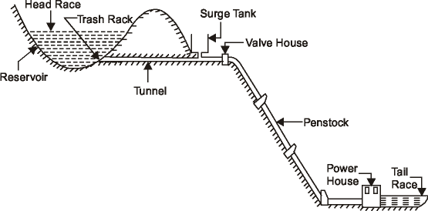

Low Head Power Plants. These power plants are also known as Canal power plants. Such a plant is shown in Fig.
A dam is built on the river and the water is diverted into a canal which conveys the water into a forebay from where the water is allowed to flow through turbines. After this, the water is again discharged into the river through a tail race. At the mouth of the canal, head gates are fitted to control the flow in the canal. Before the water enters the turbines from the forebay. It is made to flow through screens or trash-racks so that no suspended matter goes into the turbines. If there is any excess water due to increased flow in the river or due to decrease of load on the plant, it will flow over the top of the dam or a waste weir can be constructed along the forebay so that the excess water flows over it into the river. For periodic cleaning and repair of the canal and the forebay, a drain gate is provide on the side of the waste weir. The head gate is closed and the drain gate is opened so that whole of the water is drawn from the forebay and the canal for their cleaning and repair.
Medium Head Plants. If the head of water available is more than 50 m., then the water from the forebay is conveyed to the turbines through pen-stocks. Such a plant will then be named as a medium head plant. In these plants, the river water is usually tapped off to a forebay on one bank of the river as in the case of a low head plant. From the forebay, the water is then led to the turbines through penstocks. Such a layout is shown in Fig.

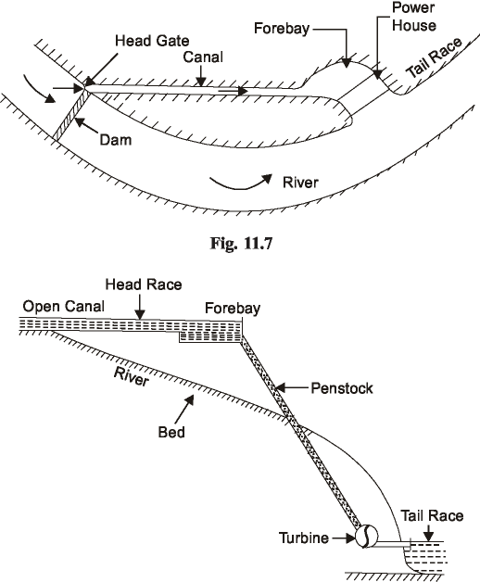
. RUN-OF-RIVER POWER PLANTS
These plants can be classified as either without pondage or with pondage. A run-of-river plant without pondage has no control over river flow and uses the water as it comes. These plants usually supply peak load. During floods, the tail water level may become excessive rendering the plant inoperative. A run-of-river plant with pondage may supply base load or peak load power. At times of high water flow it may be base loaded and during dry seasons it may be peak loaded.
PUMPED STORAGE POWER PLANTS
These plants supply the peak load for the base load power plants and pump all or a portion of their own water supply. The usual construction would be a tail water pond and a head water pond connected through a penstock. The generating pumping plant is at the lower end. During off peak hours, some of the surplus electric energy being generated by the base load plant, is utilized to pump the water from tail water pond into the head water pond and this energy will be stored there. During times of peak load, this energy will be released by allowing the water to flow from the head water pond through the water turbine of the pumped storage plant. These plants can be used with hydro, steam and i.e. engine plants. This plant is nothing but a hydraulic accumulator system and is shown in Fig. 11.9. These plants can have either vertical shaft arrangement or horizontal shaft arrangement. In the older plants, there were separate motor driven pumps and turbine driven generators. The improvement was the pump and turbine on the same shaft with the electrical element acting as either generator or motor. The latest design is to use a Francis turbine which is just the reverse of centrifugal pump. When the water flows through it from the head water pond it will act as a turbine and rotate the generator. When rotated in the reverse direction by means of an electric motor, it will act as a pump to shunt the water from the tail water pond to the head water pond
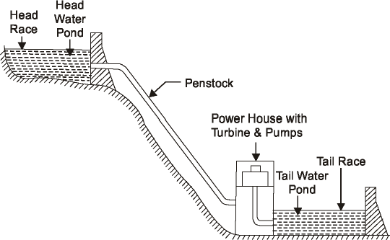

PRIME-MOVERS:-
The prime-mover in the hydraulic power plant converts the energy of water into mechanical energy and further into electrical energy. These machines are classified on the basis of the action of water an moving blades. As per the action of water on the prime-mover, they are classified as impulse turbine and reaction turbine. In impulse type turbine, the pressure energy of the water is converted into kinetic energy when passed through the nozzle and forms the high velocity jet of water. The formed water jet is used for driving the wheel.
In case of reaction turbine, the water pressure combined with the velocity works on the runner. The power in this turbine is developed from the combined action of pressure and velocity of water that completely fills the runner and water passage.
The casing of the impulse turbine operates at atmospheric: pressure whereas the casing of the reaction turbine operates under high pressure. The pressure acts on the rotor and vacuum underneath it. This is why the easing of reaction turbine is made completely leak proof.
The details of few turbines which are commonly used in hydro-electric power plants are given below.
Pelton Turbine:- Figure shows the layout of the Pelton turbine. This was discovered by Pelton in 1 880.This is a special type of axial flow impulse turbine generally mounted on horizontal shaft, as mentioned earlier A number of buckets are mounted round the periphery of the wheel as shown in Fig.. The water is directed towards the wheel through a nozzle or nozzles. The flow of water through the nozzle is generally controlled by special regulating system. The water jet after impinging on the buckets is deflected through an angle of 160° and flows axially in both directions thus avoiding the axial thrust on the wheel. The hydraulic efficiency of Peltan wheel lies between 85 to 95%. Now-a-days, Pelton wheels are used for very high heads upto 2000 meters.
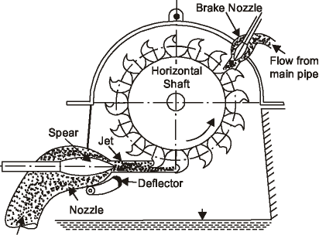

Any impulse turbine achieves its maximum efficiency when the velocity of the bucket at the center line of the jet is slightly under half the jet velocity. Hence, for maximum speed of rotation, the mean diameter of the runner should be as small as possible. There is a limit to the size of the jet which can be applied to any impulse turbine runner without seriously reducing the efficiency. In early twenties, a normal ratio of D/d was about 10 : I. In a modern Turgo impulse turbine, it is reduced upto 4.5 to I. The basic advantage of Turgo impulse turbine is that a much larger jet could be applied to a runner of a given mean diameter. The jet of pelton turbine strikes the splitter edge of the bucket, bifurcates and is discharged at either side.
With the turgo impulse turbine, the jet is set at an angle to face the runner, strikes the buckets at the front arid discharges at opposite side. The basic difference between the two is shown in Fig..
The Turgo impulse turbine bridges the gap of specific speed between the Pelton wheel and Francis turbine. Two turgo impulse turbines are used in a power house at Poonch which is 320 km from Jalnmu.
The reaction turbines are further divided into two general types as Francis and Propeller Type. The propeller turbines are further subdivided into fixed blade propeller type and the adjustable blade type as Kaplan Turbine.
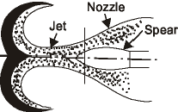
Pelton Turbine:-
Francis Turbine:- In Francis turbine, the water enters into a casing with a relatively low velocity, passes through guide vanes located around the circumference and flows through the runner and finally discharges into a draft tube sealed below the tail water level. The water passage from the headrace to tail race is completely filled with water which acts upon the whole circumference of the runner.

 | 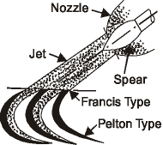
(a) Pelton | (b) Turge Impulse

Fig. 11.21

A large part of the power is obtained from the difference in pressure acting on the front and back of the runner buckets, and only a part of total power is derived from the dynamic action of the water.
There are mainly two types of Francis turbines known as open flume type and closed type.
In open flume type, the turbine is immersed under water of the headrace in a concrete chamber and discharges into the tailrace through the draft tube. The main disadvantage of this type is that runner and guide-vane mechanism is under the water and they are not open either for inspection or repair without draining the chamber.
In the closed type, the water is led to the turbine through the penstock whose end is connected to the spiral casing of the turbine. The open flume type is used for the plants of 10 meters head whereas, closed type is preferred above 30 meters head. The guide vanes are provided around the runner to regulate the water flowing through the turbine The guide vanes provide gradually decreasing area of flow for all gate openings, so that no eddies are formed, and efficiency does not suffer much even at part load conditions.
The majority of the Francis turbines are inward radial flow type and most preferred for medium heads. The inward flow turbine has many advantages over outward flow turbine as listed below :
- The chances of eddy formation and pressure loss are reduced as the area of flow becomes gradually convergent.
- The runaway speed of the turbine is automatically checked as the centrifugal force acts outwards while the flow is inward.
- The guide vanes can be located on the outer periphery of the runner, therefore, better regulation is possible.
- The frictional losses are less as the water velocity over the vanes is reduced.
- The inward flow turbine can be used for fairly high heads without increasing the speed of the turbine as centrifugal head supports considerable part of supply head.
A comparison of various types of reaction runners of the same power, but of different specific speed. The first three show the sections of Francis runners and the fourth one is a section of propeller runner. It is obvious from the figures that the flow through the runner changes from radially inward to nearly axial as the specific speed of the runner is increased. It is also obvious from the figure that the size of the runner decreases with an increase in specific speed for the same power.
Recent Development in Francis Turbines:- The last decade has seen considerable developments in the design of Francis turbines, and the modem trend, is to go in for large sizes of machines with high speeds so as to economies in the cost of plant and civil work and at the same time improve the working characteristics efficiency of the Francis runner.
The largest Francis runner in operation until 1955 was of 147 mW capacity in Sweden. The recent move towards the higher capacities has resulted in sets of 580 mW (680,(I00 B .I3F.) capacity unit at Krasnoyarsk Power Station in Russia. This station has 10 such sets in operation under the head of 103 meters. The Canada Electricity Board has planned to manufacture 11 units of 485 mW capacity to be used at Churchill Fails plant. Me 660 mW capacity unit has been designed in U.S.A. for the Grand Coulee power station and these are the largest Francis turbines in the world so far developed. The water turbines of 650 mW capacity are reported to be under design in Russia, for the Sayano-Shush enkaya station on the river Yenisei in Siberia. It is also said that 800 to 1000 mW hydro sets are also being planned for huge hydro-power station coming up in Siberia.
The largest Francis turbine of 172 mW capacity in India at present is under manufacture for the Dehar project by Heavy Electrical Ltd., Bhopal. The manufacture of 200l2S0 mW capacity units which will be used in hydro projects planned in the Himalayas is also undertaken by the same company. Manufacture of high capacity units in India is largely limited by the lack of transport facilities, the small power grids and long transmission lines.
Propeller Turbine:- The propeller runner may be considered as a development of a Francis type in which the number of blades is greatly reduced and the lower band omitted. It is axial flow turbine having a small number of blades from three to six as shown in Fig.. The propeller turbine may be fixed blade type or movable blades type known as Kaplan Turbine.
The fixed blade propeller type turbine has high efficiency (88°l0) ; at full load but its efficiency rapidly drops with decrease in load.The efficiency of the unit is hardly 50% at 40% of full load at part load operation. The use of propeller turbine is limited to the installations where the units run at full load conditions at all times. The use of propeller turbine is further limited to low head installations of 5 to 10 meters.
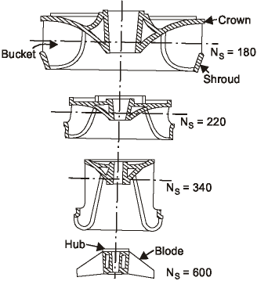
Kaplan Turbine. Great strides are made in last few decades to improve the performance of propeller turbine at part load conditions. The Kaplan turbine is a propeller type having a movable blade instead of fixed one. This turbine was introduced by Dr. Vitkor Kaplan. This turbine has attained popularity and rapid progress has been made in recent years in the design and construction of this turbine:
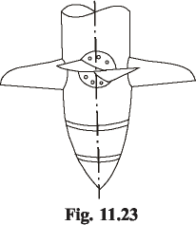
The rotor of the Kaplan turbine is shown in Fig. 11.23. The blades are rotated to the most efficient angle by a hydraulic servo-motor. A cam on the governor is used to change the blade angle with the gate position so that high efficiency is always obtained at almost any percentage of full load.
These turbines are constructed to run at speeds varying from 60 to 220 r.p.m. and to work under varying head from 2 to 60 meters. These are particularly suitable for variable heads and for variable flows and where the ample quantity of water is available.
The specific speed of Kaplan lies in the range of 400 to 1500 so that the speed of the rotor is much higher than that of Francis Turbine for the same output and head or Kaplan turbine having the same size as Francis develops more power under the same head and flow quantity.
The velocity of water flowing through Kaplan turbine is high as the flow is large and, therefore, the cavitations is more serious problem in Kaplan than Francis Turbine. The propeller type turbines have an outstanding advantage of higher speed which results in lower cost of runner, generator and smaller power house substructure and superstructure. The capital and maintenance cost of Kaplan turbine is much higher than fixed blade propeller type units operated at a point of maximum efficiency.
For a low head development with fairly constant head and requiring a number of units, it is always advisable to install fixed blade propeller type runners for most of them and Kaplan type for only one or two units. With this combination, the fixed blade units could be operated at point of maximum efficiency and Kaplan units could take the required variations in load. Such combination is particularly suitable to a large power system containing a multiplicity of the units.
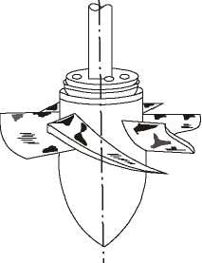
Francis Versus Pelton. The Francis turbines are used for all available heads on the other hand. Pelton wheels are used for very high heads only (200 m to 2000 m).
The Francis turbine is preferred over Pelton for the following reason :
- The variation in the operating head can be more easily controlled in Francis than in Pelton.
- The ratio of maximum and minimum operating head can be even two in case of Francis turbine.
- The operating head can be utilized even when the variation in the tail water level is relatively large when compared to the total head.
- The size of the runner, generator and power house required is small and economical if the Francis is used instead of Pelton for the same power generation.
- The mechanical efficiency of Pelton decreases faster with wear than Francis. The drawbacks of the Francis compared with Pelton are listed below :
- 1. Water which is not clean can cause very rapid wear in high head Francis turbine. In passing through the guide vanes and cover facings, it can quickly reduce overall efficiency of the turbine by several percent. The effect is much more serious in turbines of small diameter than in large ones. Particles of solid matter in the water will wear the lip of the spear, the nozzle and after several years the runners also. The first two are easily removable, renewable and repairable. The runner repairing by welding can often be done without removing the runner from the shaft or casing. The inspection and overhaul of a Francis is much more difficult job than that of the equivalent Pelton turbine. The badly worn-out parts will have to be replaced by new ones and it will take a considerable time.
- Cavitations is an ever-present danger in Francis as well as in all reaction turbines. The raising of power house floor level to reduce the danger of flooding may be followed by endless cavitations troubles.
- Usually below 60% load, the Pelton is much better as it gives more efficiency than Francis of low specific speed. If there is possibility of running the prime-mover below 50% load for a long period, the Francis will not only lose its efficiency but the cavitation danger will become more serious.
- The water hammer effect with the Francis is more troublesome than the Pelton turbine. Kaplan versus Francis Turbine.
The advantages of Kaplan over Francis are listed below :
- It is more compact in construction and smaller in size for the same power developed.
- Its part-load efficiency is considerably high. The efficiency curve remains more or less flat over the whole load range.
- The frictional losses passing through the blades are considerably lower due to small number of blades used.
SELECTION OF TURBINE:-
The major problem confronting the engineering is to select the type of turbine which will give maximum economy. The hydraulic prime-mover is always selected to match the specific conditions under which it has to operate and attain maximum possible efficiency.
The choice of a suitable hydraulic prime-mover depends upon various considerations for the given head and discharge at a particular site of the power plant. The type of the turbine can be deter-mined if the head available, power to be developed and speed at which it has to run are known to the engineer beforehand.
The following factors have the bearing on the selection of the right type of hydraulic turbine which will be discussed separately.
- Rotational Speed.
- Specific Speed.
- Maximum Efficiency.
- Part Load Efficiency.
- Head.
- Type of Water.
- Runaway Speed.
- Cavitation.
- Number of Units.
- Overall Cost.
1. Rotational speed. In all modern hydraulic power plants, the turbines are directly coupled to the generator to reduce the transmission losses. This arrangement of coupling narrows down the range of the speed to be used for the prime-mover. The generator generates the power at constant voltage and frequency and, therefore, the generator has to operate at its synchronous speed. The synchronous speed of a generator is given by
Nsysn =
p
where f = Frequency and p = Number of pairs of poles used. For the direct coupled turbines, the turbine has to run at synchronous speed only. There is less flexibility in the value of _{Nsysn} as f is more or less fixed (50 or 60 cycles/sec). It is always preferable to use high synchronous speed for generator because the number of the poles required would be reduced with an increase in _{Nsysn} and the generator size gets reduced. Therefore, the value of the specific speed adopted for the turbine should be such that it will give synchronous speed of the generator. The problems associated with the high speed turbines are the danger of cavitation and centrifugal forces acting on the turbine parts which require robust construction. No doubt, the overall cost of the plant will be reduced adopting higher rotational speed as smaller turbine and smaller generator are required to generate the same power. The constructional cost of the power house is also reduced.
2. Specific speed. The equation indicates that a low specific speed machine such as impulse turbine is required when the available head is high for the given speed and power output. On the other hand, propeller turbines with high specific speed are required for low-heads.
The specific speed can be calculated using the equations and if the available head is known. The specific speed versus head are shown in Fig. 11.29 for different turbines.
It is obvious from Fig. 11.29 that there is a considerable latitude in the specific speed of runners which can be used for given conditions of head and power provided that the height of the runner above tailrace level is such as to avoid the danger of cavitation as discussed earlier.
In all modern power plants, it is common practice to select a high specific speed runner because it is more economical as the size of the turbo-generator as well as that of power house will be smaller.
High specific speed is essential when the available head is low and power output is high because otherwise the rotational speed will be very low and it will increase the cost of turbo-generator and the power house as the sizes of turbine, generator and power house required at low speed will be large. On the other hand, there is no need of choosing high specific speed runner when the available head is sufficiently large because even with low specific speed, high rotational speeds can be attained.
- Now it has been shown with the above discussion that if the speed and power under a given head are fixed (Ns is fixed), the type of the runner required is also fixed. Maximum Efficiency. The maximum efficiency, the turbine can develop, depends upon the type of the runner used.
In case of impulse turbine, low specific speed is not conducive to efficiency, since the diameter of the wheel becomes relatively large in proportion to the power developed so that the bearing friction and windage losses tend to become too large in percentage value. The value of NS for highest efficiency is nearly 20.
The low specific speed of reaction turbine is also not conducive to efficiency. The large dimensions of the wheel at low specific speed contribute disc friction losses. In addition to this, the leakage loss is more as the leakage area through the clearance spaces becomes greater and the hydraulic friction through small bracket passages is larger. These factors tend to reduce the efficiency as small values of specific speed are approached.
The high specific speed reaction turbines are associated with large discharge losses (Vc ²/2g) as mentioned earlier. The friction and leakage losses are reduced with an increase in specific speed but the discharged losses increase rapidly and the net effect of increase in specific speed is to decrease the efficiency total loss (friction, leakage and discharge) is minimum at medium specific speed. Therefore, it is always preferable to select the reaction turbines of medium specific speed if they operate at constant load conditions. Me effect of specific speed on the maximum efficiency is shown in Fig. .
Higher efficiencies have been attained with reaction turbines than with Pelton wheels. The maximum recorded efficiency till now for reaction turbine is 93.7% but quite a large units have shown efficiencies over 901 -W the highest recorded value of efficiency for impulse Turbine is 89% but usual maximum is 82%.
The efficiency of the Pelton wheel is not dependent on its size like reaction turbine. Hence the Pelton wheel may have higher maximum efficiency than the reaction turbine for smaller powers.
- Part Load Efficiency. Full load is defined as the load under which a turbine develops its maximum efficiency anything above that is known as overload and anything below that is known as part load.
The part load efficiency differs greatly for different specific speed and types of turbines. fig shows the variations in part load efficiencies with different types of wheels.
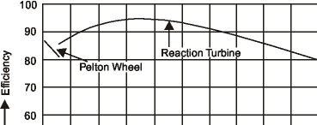
In case of Pelton wheel, only the jet diameter through which the water flows is reduced by the governing mechanism when the load on the turbine is reduced below full load. The velocity diagrams at inlet and outlet remain practically unaltered in shape at all loads except for very low and very high loads. Thus the absolute velocity at inlet does not change and discharge loss remains same. Therefore, the part load efficiency curve is more flat in case of Pelton turbine.
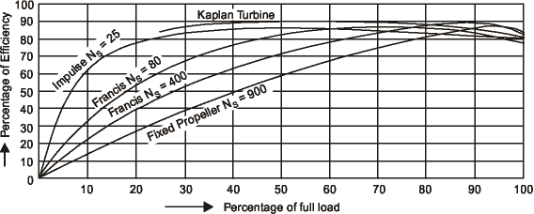

ADVANTAGES & DISADVATAGES:-.

ADVANTAGES:-

Flexibility
Hydro is a flexible source of electricity since plants can be ramped up and down very quickly to adapt to changing energy demands.

Low power costs
The major advantage of hydroelectricity is elimination of the cost of fuel. The cost of operating a hydroelectric plant is nearly immune to increases in the cost of fossil fuels such as oil, natural gas or coal, and no imports are needed. The average cost of electricity from a hydro plant larger than 10 megawatts is 3 to 5 U.S. cents per kilowatt-hour.
Hydroelectric plants have long economic lives, with some plants still in service after 50–100 years. Operating labor cost is also usually low, as plants are automated and have few personnel on site during normal operation.
Where a dam serves multiple purposes, a hydroelectric plant may be added with relatively low construction cost, providing a useful revenue stream to offset the costs of dam operation. It has been calculated that the sale of electricity from the Three Gorges Dam will cover the construction costs after 5 to 8 years of full generation.

Suitability for industrial applications
While many hydroelectric projects supply public electricity networks, some are created to serve specific industrial enterprises. Dedicated hydroelectric projects are often built to provide the substantial amounts of electricity needed for aluminium electrolytic plants, for example. The Grand Coulee Dam switched to support Alcoa aluminium in Bellingham, Washington, United States for American World War II airplanes before it was allowed to provide irrigation and power to citizens (in addition to aluminium power) after the war. In Suriname, the Brokopondo Reservoir was constructed to provide electricity for the Alcoa aluminium industry. New Zealand's Manapouri Power Station was constructed to supply electricity to the aluminium smelter at Tiwai Point.

Reduced CO2 emissions
Since hydroelectric dams do not burn fossil fuels, they do not directly produce carbon dioxide. While some carbon dioxide is produced during manufacture and construction of the project, this is a tiny fraction of the operating emissions of equivalent fossil-fuel electricity generation. One measurement of greenhouse gas related and other externality comparison between energy sources can be found in the ExternE project by the Paul Scherrer Institut and the University of Stuttgart which was funded by the European Commission.^{[16]} According to that study, hydroelectricity produces the least amount of greenhouse gases and externality of any energy source.^{[17]} Coming in second place was wind, third was nuclear energy, and fourth was solar photovoltaic.^{[17]} The extremely positive greenhouse gas impact of hydroelectricity is found especially in temperate climates. The above study was for local energy in Europe; presumably similar conditions prevail in North America and Northern Asia, which all see a regular, natural freeze/thaw cycle (with associated seasonal plant decay and regrowth).

Other uses of the reservoir

Reservoirs created by hydroelectric schemes often provide facilities for water sports, and become tourist attractions themselves. In some countries, aquaculture in reservoirs is common. Multi-use dams installed for irrigation support agriculture with a relatively constant water supply. Large hydro dams can control floods, which would otherwise affect people living downstream of the project.

Disadvantages:-

Ecosystem damage and loss of land
Hydroelectric power stations that use dams would submerge large areas of land due to the requirement of a reservoir.
Large reservoirs required for the operation of hydroelectric power stations result in submersion of extensive areas upstream of the dams, destroying biologically rich and productive lowland and riverine valley forests, marshland and grasslands. The loss of land is often exacerbated by the fact that reservoirs cause habitat fragmentation of surrounding areas.
Hydroelectric projects can be disruptive to surrounding aquatic ecosystems both upstream and downstream of the plant site. For instance, studies have shown that dams along the Atlantic and Pacific coasts of North America have reduced salmon populations by preventing access to spawning grounds upstream, even though most dams in salmon habitat have fish ladders installed. Salmon spawn are also harmed on their migration to sea when they must pass through turbines. Turbine and power-plant designs that are easier on aquatic life are an active area of research. Mitigation measures such as fish ladders may be required at new projects or as a condition of re-licensing of existing projects.
Generation of hydroelectric power changes the downstream river environment. Water exiting a turbine usually contains very little suspended sediment, which can lead to scouring of river beds and loss of riverbanks. Since turbine gates are often opened intermittently, rapid or even daily fluctuations in river flow are observed. For example, in the Grand Canyon, the daily cyclic flow variation caused by Glen Canyon Dam was found to be contributing to erosion of sand bars. Dissolved oxygen content of the water may change from pre-construction conditions. Water exiting turbines can be warmer or colder than downstream, due to it being pulled from a higher or lower part in the reservoir level. This can change aquatic faunal populations, including endangered species, and prevent natural freezing processes from occurring. Some hydroelectric projects also use canals to divert a river at a shallower gradient to increase the head of the scheme. In some cases, the entire river may be diverted leaving a dry riverbed. Examples include the Tekapo and Pukaki Rivers in New Zealand.

Siltation and flow shortage
When water flows it has the ability to transport particles heavier than itself downstream. This has a negative effect on dams and subsequently their power stations, particularly those on rivers or within catchment areas with high siltation. Siltation can fill a reservoir and reduce its capacity to control floods along with causing additional horizontal pressure on the upstream portion of the dam. Eventually, some reservoirs can become completely full of sediment and useless or over-top during a flood and fail.

Changes in the amount of river flow will correlate with the amount of energy produced by a dam. Lower river flows because of drought, climate change or upstream dams and diversions will reduce the amount of live storage in a reservoir therefore reducing the amount of water that can be used for hydroelectricity. The result of diminished river flow can be power shortages in areas that depend heavily on hydroelectric power. The risk of flow shortage may increase as a result of climate change. Studies from the Colorado River in the United States suggest that modest climate changes, such as an increase in temperature in 2 degree Celsius resulting in a 10% decline in precipitation, might reduce river run-oﬀ by up to 40%. Brazil in particular is vulnerable due to its heaving reliance on hydroelectricity, as increasing temperatures, lower water ﬂow and alterations in the rainfall regime, could reduce total energy production by 7% annually by the end of the century.

Methane emissions (from reservoirs)

Lower positive impacts are found in the tropical regions, as it has been noted that the reservoirs of power plants in tropical regions may produce substantial amounts of methane. This is due to plant material in flooded areas decaying in an anaerobic environment, and forming methane, a potent greenhouse gas. According to the World Commission on Dams report, where the reservoir is large compared to the generating capacity (less than 100 watts per square metre of surface area) and no clearing of the forests in the area was undertaken prior to impoundment of the reservoir, greenhouse gas emissions from the reservoir may be higher than those of a conventional oil-fired thermal generation plant. Although these emissions represent carbon already in the biosphere, not fossil deposits that had been sequestered from the carbon cycle, there is a greater amount of methane due to anaerobic decay, causing greater damage than would otherwise have occurred had the forest decayed naturally.
In boreal reservoirs of Canada and Northern Europe, however, greenhouse gas emissions are typically only 2% to 8% of any kind of conventional fossil-fuel thermal generation. A new class of underwater logging operation that targets drowned forests can mitigate the effect of forest decay.

Relocation
Another disadvantage of hydroelectric dams is the need to relocate the people living where the reservoirs are planned. In February 2008 it was estimated that 40-80 million people worldwide had been physically displaced as a direct result of dam construction. Historically and culturally important sites can be flooded and lost. Such problems have arisen at the Aswan Dam in Egypt between 1960 and 1980, the Three Gorges Dam in China, the Clyde Dam in New Zealand, and the Ilisu Dam in Turkey.^{[citation needed]}

Failure risks
Because large conventional dammed-hydro facilities hold back large volumes of water, a failure due to poor construction, terrorism, or other cause can be catastrophic to downriver settlements and infrastructure. Dam failures have been some of the largest man-made disasters in history. Also, good design and construction are not an adequate guarantee of safety. Dams are tempting industrial targets for wartime attack, sabotage and terrorism, such as Operation Chastise in World War II.
The Banqiao Dam failure in Southern China directly resulted in the deaths of 26,000 people, and another 145,000 from epidemics. Millions were left homeless. Also, the creation of a dam in a geologically inappropriate location may cause disasters such as 1963 disaster at Vajont Dam in Italy, where almost 2000 people died.
Smaller dams and micro hydro facilities create less risk, but can form continuing hazards even after being decommissioned. For example, the small Kelly Barnes Dam failed in 1967, causing 39 deaths with the Toccoa Flood, ten years after its power plant was decommissioned.

Comparison with other methods of power generation
Hydroelectricity eliminates the flue gas emissions from fossil fuel combustion, including pollutants such as sulfur dioxide, nitric oxide, carbon monoxide, dust, and mercury in the coal. Hydroelectricity also avoids the hazards of coal mining and the indirect health effects of coal emissions. Compared to nuclear power, hydroelectricity generates no nuclear waste, has none of the dangers associated with uranium mining, nor nuclear leaks. Unlike uranium, hydroelectricity is also a renewable energy source.

REFERENCE
WWW.WIKIPEDIA.ORG
Thermal Power Plant Simulation and Control by Damian Flynn
Thermal Power Station by Fredric P Miller, Agnes F Vandome
Power-plant control and instrumentation: the control of boilers and HRSG systems By David Lindsley, Institution of Electrical Engineers

