A POSTER PRESENTATION ON

APPLICATIONS OF ARTIFICIAL INTELLIGENCE
HUMANOID ROBOTS

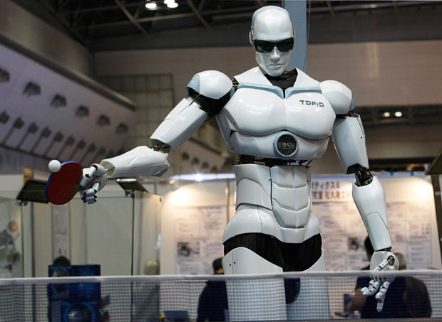

BY

D.S. DASTHAGIRI G.SRI HARSHA

III B.Tech(ECE) III B.Tech(ECE)

mob:9704852239 mob:9441449025

SRI KRISHNADEVARAYA UNIVERSITY

COLLEGE OF ENGINEERING AND TECHNOLOGY

ANANTAPUR-515001

ANDHRA PRADESH

Abstract

This document describes the hardware and software architecture behind the ELVIS robot. ELVIS is a bipedal robot with human-like geometry and motion capabilities | a humanoid. ELVIS is also the first robot in a series of planned humanoid experiments, all of which will be primarily controlled by evolutionary adaptive methods. The final goal of our research project is to build a human-sized robot based on a plastic human skeleton to ensure geometric authenticity.

Keywords: Humanoid, Robotics, Genetic Programming, Genetic Reasoning, Brain Building

1 Introduction

The field of autonomous mobile robotics attracts an accelerating interest. Application areas are plentiful in both industry and academia, but an autonomous mobile robot system also demands high performance of both mechanical components and control software. The many degrees of freedom in a light mobile robot create new problem spaces in control and navigation where conventional methods often fall short. A relatively new and promising area for control of autonomous agents is evolutionary algorithms, which are inspired by the main adaptation method in nature | natural selection. Most challenging of all autonomous robots are robots that move using legs in-stead of wheels. Walking robots have very large potential in environments created for humans as well as in more natural terrain. The largest potential is associated with robots of human-like dimensions walking on two legs | humanoid robots. Man is the standard for almost all interactions in our world where most environments, tools and machines are adapted to the abilities, motion capabilities and geometry of humans. However, a bipedal humanoid robot demands extreme performance in everything from power supply to computer
Capacity and control algorithms, but if we succeed in building humanoids, it could be more efficient to control various machines by t hese robots than to re-build all machines for direct computer control. It has been argued that humanoid robots could be the next dominating mechanical industry, as large as or larger than the auto industry. In this paper we briefly describe an evolutionary control architecture that will be the basis for several humanoid robotics experiments.

2 The ELVIS Humanoid

ELVIS is a scale model with a height of about 60 cm, built with 42 servos giving a high degree of freedom in legs, arms and hands, see Figure 1. The robot will be guided by microphones, cameras and touch sensors. The imminent goals are to walk upright and to navigate through vision. Seven onboard micro-controllers control the servos and sensors. ELVIS is not yet fully autonomous, but the plan includes onboard power sup-ply and main processing unit. The current status is that the robot is assembled with servos and controllers, and that software development has been carried out in parallel with the construction process, see Figure 2. ELVIS has some similarities with robots constructed at the University of Tokyo, but ELVIS is intended to have onboard control capabilities [3].

2.1 Software Architecture

The software architecture is built mainly on evolutionary algorithms and specifically Genetic Programming. Evolution is thus used to induce programs, functions and symbolic rules for all levels of control [1, 4, 2]. Three hierarchical layers are used for control:

- Reactive Layer

- Model Building Layer

- Reasoning Layer

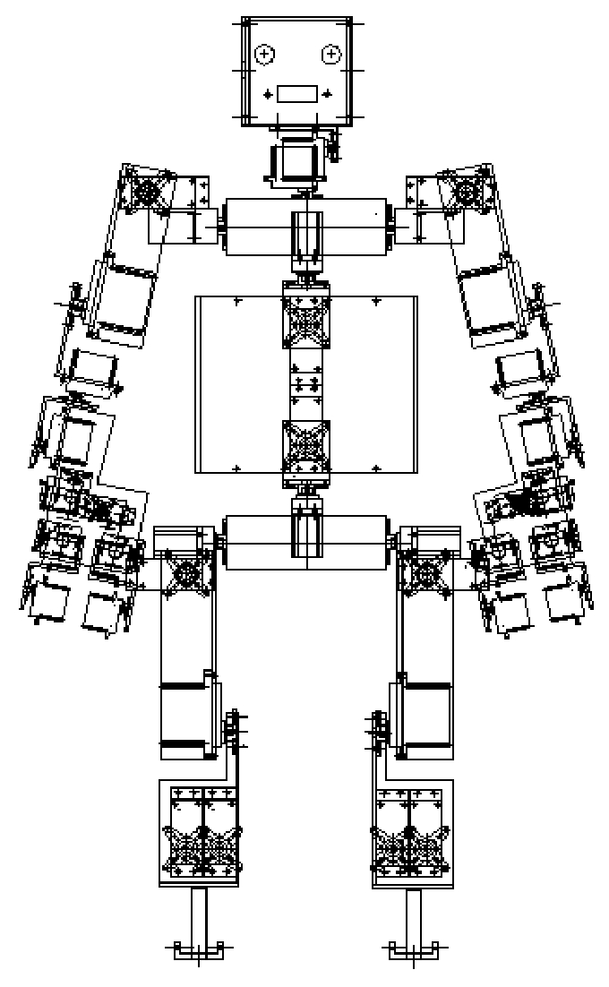

Figure 1: The ELVIS Humanoid Robot

2.1.1 Reactive Layer

The first layer is a reactive layer based on on-line evolution of machine code. This method assumes that all fitness feedback is obtained directly from the actual robot. The disadvantage is that the GP individuals spend most of their time waiting for feedback from the physical environment. This results in moderate learning speed, and the constant movement shortens the life-span of the hardware. The benefit of the method is its simplicity, and that the only constraints needed for the models being learned are that they should fulfill their task as a black box. This layer is used for reactive behaviors such as balancing.

2.1.2 Model Building Layer

To achieve higher learning speeds and more generic behavior there is a second control layer that works with memories of past events. In this genetic reinforcement learning framework, the system tries to evolve a model of the underlying hardware system and problem. The model maps sensor inputs and actions to a predicted goodness or fitness value. The currently best model is then used to decide what action results in optimal predicted

fitness given current sensor inputs. This layer allows the genetic programming system to run at full speed without having to wait for feedback from the environment; instead it fits the programs to memories of past events. The machine code genetic programming approach used is called Automatic Induction of Machine Code GP (AIMGPÑ [5]. AIMGP is about 40 times faster than conventional GP systems due to the absence of any interpreting steps. In addition, the system is compact, which is beneficial when working onboard a real robot. The model building layer is also used for basic control tasks.

2.1.3 Reasoning Layer

The third layer is a symbolic processing layer for higher "brain functions" requiring reasoning. The objective of this layer is to handle high level tasks such as navigation, safety, and energy supply. This layer is built on "genetic reasoning", a method where evolution is used as an inference engine, requiring less heuristics to guide the inference procedure [5].

Each of these layers consists of modules for various tasks such as balancing, walking and image processing
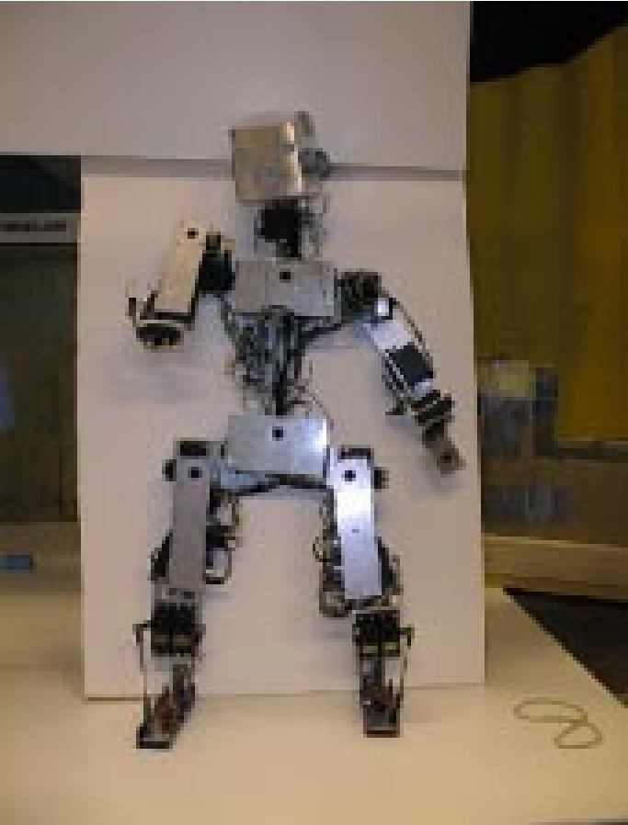

Figure 2: ELVIS without hands

. Some system functions are represented as several modules spanning different layers.

3 Experiments

Several experiments are being performed in parallel on ELVIS:

- Balancing

- Walking

- Vision

- Navigation

- Audio orientation

- Manipulation

3.1 Balancing

In this experiment, the robot is set up to learn balanc-ing. The sensory inputs used to learn to balance are touch sensors and two electronic gyros. The actuators are a subset of the more than 40 servos controlling the robot. In the first initial experiments, the robot is sus-pended in a safety harness, that prevents it from falling to the ground if it loses its balance. If this happens, a sensor in the safety lines is activated, and a servo

lifts the robot and returns it to an upright position. Experiments on balance are performed both in the re-active and model building layers. The model building layer puts less stress on the mechanical parts of the robot by checking hypotheses mainly against data in the memory vectors, which results in simple smooth behavior. On the other hand, it is a less complex task to get the system to learn in the purely reactive layer. The fitness or goodness criterion of the experiments is a combination of three inputs:

- Inputs from pressure sensors on the feet giving information on the center of gravity.

- Input from the two gyros in the top of the head trying to minimize head movements.

- Information from the safety line sensor indicating total loss of balance.

The robot is provoked by disturbances of adjustable size obtained from random arm movements and wind pressure from a rotating fan.

3.2 Walking

The walking experiments are performed in the reactive and model building layer. Two different approaches are used:

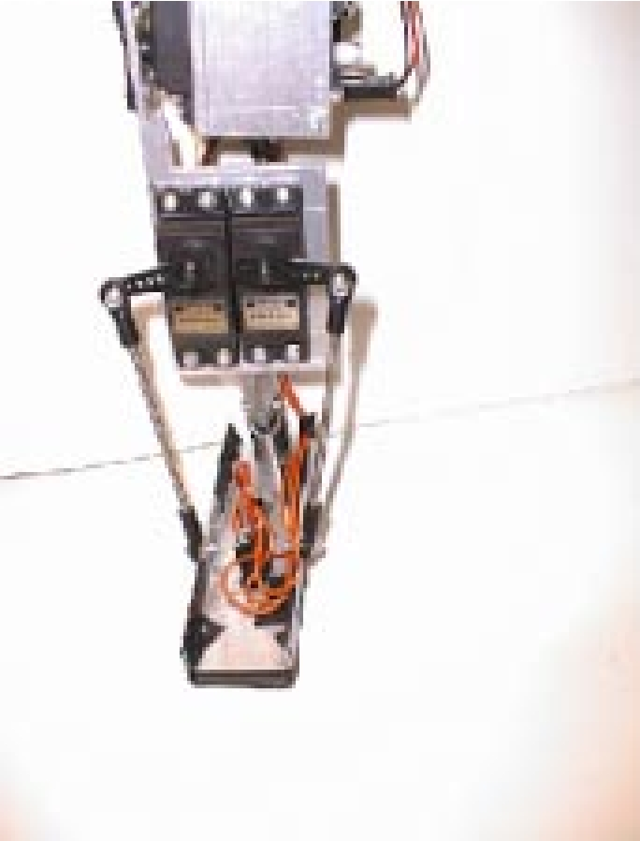

Figure 3: The leg and foot of ELVIS

- A simple setup where the goal of the robot is to move forward without constraints as long as it maintains balance. This experiment is conducted using the reactive layer.

- Another set of experiments solves the problem by dividing the task into subtasks first shifting from two legs to one, then shifting the weight from one foot to the other, and finally dividing weight on both feet. These experiments are performed both in the reactive and model building layers, see Figure 3.

The controlling hardware that has been constructed can measure the power consumption of each servo individually, and we plan to incorporate efficiency in the fitness of the walking model. This will potentially also give a smoother, more natural way of moving.

3.3 Vision

The vision experiments are aimed at creating a 3-D model of the environment. The hardware of the sys-tem uses two CCD cameras for stereo vision. In the initial phase, the following two experiments are being performed:

- First we evolve a program which produces a 3-D map of the environment directly from the pixels of the two cameras. Using the pixels directly gives

a higher potential for efficient execution since the evolutionary system is free to evolve any heuristic filter it may need, instead of forcing a set of pre-defined heavy computations on the system. The price one has to pay is that it is harder for the evolutionary system to ₃nd all information in the raw data.

- The second experiment uses the 3-D map from the first experiment to evolve representations of 3-D objects. The genetic system tries to general
- ize from the 3-D map to a list of 3-D geometric shapes such as boxes, cones and spheres. This results in more complete hypothesis that includes extrapolation of hidden surfaces.

3.4 Navigation

The goal of the navigation module is to integrate the modules described above, and to give the robot the ability to walk in an office following walls and avoid-ing obstacles. Navigation also includes planning of the path to follow in order to arrive at a certain point. The navigation task is mostly achieved in the third symbolic reasoning layer, using information from vision, balancing and walking. Genetic Reasoning [5] is used to evolve plans and prove that they fulfill the goals to an acceptable level.

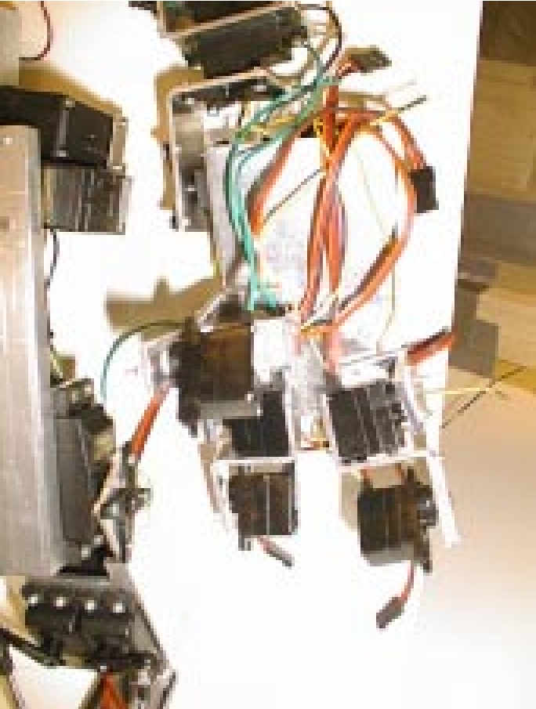

Figure 4: The leg and hand of ELVIS

3.5 Audio Orientation

The robot has two microphones in the head for stereo-phonic hearing. At present, these are mainly used for focus of attention. A GP system is used to evolve a function or program, which can give the direction of a sound. Future experiments include separation of sound sources and recognition of commands.

not yet autonomous. It is so far controlled by remote computers and has a remote power supply. The aim is to have the humanoid controlled by a handheld PC running NT or possibly LINUX. Space is also reserved for battery packs. The total weight of the autonomous version of ELVIS is expected to be less than 5 kg.

3.6 Manipulation

ELVIS has arms and hands with three fingers each including a highly maneuverable thumb. The fingers are equipped with touch sensors reacting to pressure from 10 g up to tens of kilograms. The manipulation experiments take place in the symbolic layer and integrate movement, touch sensors and vision to isolate an object and pick it up with one hand and then moving it to the other hand.

5 Future Work

The final goal of our research project is to build a human-sized robot based on a plastic human skeleton to ensure geometric authenticity, see Figure 5. The software architecture of ELVIS will be used for the larger robots with small adjustments. The main objective of the skeleton based robot is a very light humanoid (60 KgÑ with less sophisticated hardware compensated for by a more sophisticated adaptive control architecture.

4 Current Status

ELVIS has been now been assembled, and is complete with the exception of CCD-cameras and fingers. The software architecture has been evaluated on offline experiments. Initial experiments in simulations confirm the feasibility of the method, but major evaluations using the robot are still under way. ELVIS is

6 Summary and Conclusions

The ELVIS humanoid robot is a very complex sys-tem both as far as hardware and software are con-cerned. It is unique in many ways: size, weight, de-grees of freedom, possibility of autonomy and control method.

Figure 5: A future humanoid platform

Nature has shown that evolution is a very power-ful tool for controlling complex systems in an adaptive way. Our hypothesis is that evolutionary systems such as Genetic Programming and AIMGP are very well suited for control of complicated systems. We have chosen to build the control architecture almost exclu-sively on EAs operating on a wide variety of tasks and using several di‒erent methods for evolution and representation. The experiments are still at an initial stage, but we believe that the hardware and software architecture may be of interest to the research com-munity in EAs, robotics and control. We will use the experiences from ELVIS for the construction of a full-size humanoid robot built on a plastic human skeleton.

tions and Problems. In Proceedings of the ₃rst European Workshop of Evolutionary Robotics, (EvoRobot98Ñ. Paris April 1998 (edsÑ Husbands, P., Meyer, J-A., Springer Verlag.

- Kanehiro, F., Kagami, S., Inaba, M. and In-oue, M.(1994Ñ A study on visually guided walking behaviors of remote-brained apelike robot. In Proc. JSME Annual Conference on Robotics and Mechatronics(ROBOMEC '94Ñ, pp. 197-202, 1994.

[4] http://robotics.stanford.edu/
[5] http://en.wikipedia.org/wiki/Artificial_intelligence

References

- Banzhaf, W., Nordin, P., Keller, R. E., and Francone, F. D. (1997Ñ. Genetic Programming – An Introduction. On the automatic evolution of computer programs and its applications. Morgan Kaufmann, San Fransisco, and dpunkt, Heidelberg.

- Husbands, P., Meyer, J-A, and Harvey, I. (1998Ñ Evolutionary Robotics: a Survey of Applica-

